LED Font Generator 2.0

User's Manual

Personal Page
(mahdipour.net/projects/led-font-generator)

LED Font Generator home on github

(https://www.github.com/momahdipour/led-font-generator)

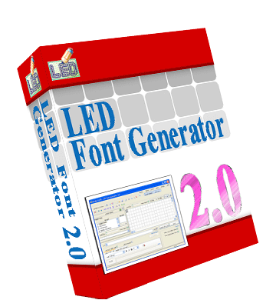
COPYRIGHT NOTICE

All rights reserved.
Free for personal and commercial use.

E-Mail:
mo.mahdipour@gmail.com

Personal Page:
http://www.mahdipour.net/projects/led-font-generator

LED Font Generator home on github:
https://www.github.com/momahdipour/led-font-generator

Contents

Introduction 1
Main Features 2
Installation 3
Software Overview 8
Interface Language Settings 9
Program Settings 10
Creating and editing a design 11
Design Settings 12
The Character Library 13
Using the Character Library Manually 13
Using the Character Library Automatically 13
Using Special Characters in the Character Library 14
Organizing the Character Library 16
Create Custom Fonts in the Character Library 17
How to design a character 17
Using System Fonts 19
Program Output 20
The Export Design Window 20
Normal Output 20
Advanced Output 22
Other Output Settings 23
Quick Export 24
Send Design via Serial Port 25
Import Pictures 28
Save Design as Picture 29
Convert Code to Design 30
Other Tools 31
LED Character Designer 32
Design Animator 34
Print a Design 35
Keyboard Shortcuts 36
General 36
Edit 36

Introduction

LED Font Generator, The best LCD and LED Font Designer on the market

LED Font Generator is the best and the most complete software for designing LED and LCD font and text. The environment of this software provides powerful features to ease the process of designing dot-matrix fonts and texts.
By using this software, with its professional tools and features, you can design and create interesting fonts and texts easily. The output of this application is completely customizable to meet your programming requirements.

Main Features
- Multilingual interface
- Output the design via the serial port
- Support for English, Farsi, and Arabic font design
- Convert text to dot-matrix design using all the fonts available on your system
- Overall preview of the design
- Zoom in and zoom out
- Convert text codes to LED and LCD font
- Undo and redo functions during design
- Editing functions (Cut, Copy, Paste)
- Character Library feature for organizing designed fonts
- Character Library Organizer tool
- Import pictures (GIF, JPG, BMP, ...) into the design
- Save design as a picture
- Fully customizable output (normal and advanced output)
- Quick export function to speed designing during test stage
- Full screen view
- Support for many operations on the design (Rotate, Shift, Toggle, ...)
- External character designer tool for designing individual characters even more easily
- Scrolling LED Panel simulator
- Keyboard shortcuts for more functionality

Installation
This program is not compatible with Windows 98 and older versions of windows. So you cannot install it on this operating system.
To start installing, run the setup program to start the setup wizard.

Press Next to go to the License Agreement page. You must accept this license to continue installing the software on your computer.

In the next window, enter your user information. This information is optional.

Press Next. In the new window you can select where to install the application. To select another folder, press Change button and select your destination folder.

Click Next to continue. In the Setup Type window, you can choose how you want the program to be installed on your computer. In Typical type, all the program features will be installed. If you want to select which parts to install, select Custom setup type. Then press Next button to proceed to the next step.

If you would choose Custom setup type in the previous stage, in the new window, you can select which program features to install. After customizing your installation, press Next to continue.

In the new stage, a summary of the setup settings is shown. If these information is correct, click Install to start installation process.

After the installation is complete, click the Finish button to finish the setup.

After installing the software, you can run it directly from the desktop,

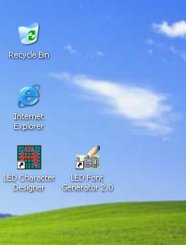

Or go to the Start menu, into Programs group, the LED Font Generator 2.0 submenu and run the installed application.

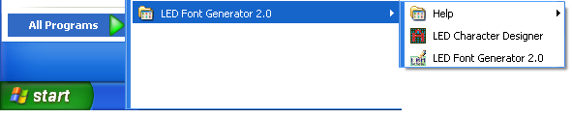
Software Overview
The following picture shows the main environment of the LED Font Generator 2.0 when English is selected as the interface language.

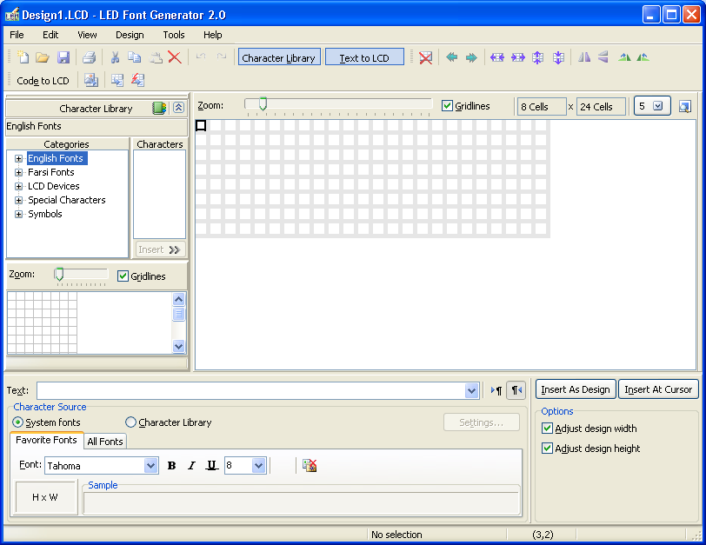
Toolbars
Text to LCD Converter
Character Library
Menu bar
Design Area

Interface Language Settings
LED Font Generator is a multilingual program. By default, there are two languages contained in the setup package. You can choose the interface language of this program from these two languages: Farsi and English. To change the language, go to the Tools menu and select the Language command. The Language form will be shown. Select your desired language and press OK to apply.

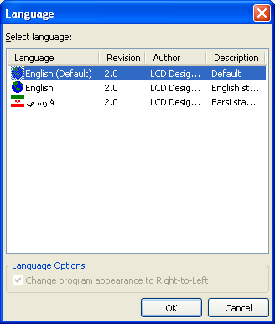

Program Settings
To change the program settings, from the Tools menu select Options. The Options window will appear.

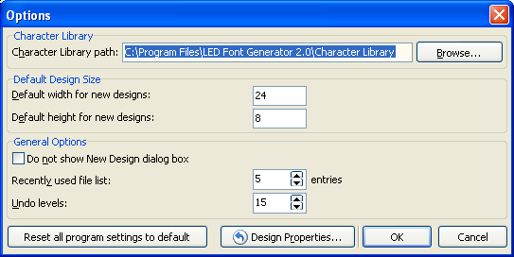

In the Character Library section, you can change the path of the Character Library where your fonts and characters are stored. As default, this value is set to the Character Library folder in the installation folder.
The Default Design Size values define the size of the new designs. You can start a new design by choosing the New Design command from the File menu.
As default, when you create a new design, the New Design dialog box appears and allows you to set the size of the new design.

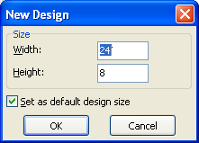

You can prevent this dialog from showing by selecting the "Do not show the New Design dialog box" in the program options window.
To change the number of files stored in the Recently Used File List, which lists the recently used files in the File menu, change the value of "Recently used file list: # entries" in the Options form of the program. A value of 0 disables the Recently Used File List.
One of the important features of the LED Font Generator is the Undo/Redo feature which allows you to undo changes made to a design file during the design process. You can set the number of undo levels in the program Options form.
The "Reset all program settings to default" button resets all of the program settings to their default values.
Creating and editing a design
In the LED Font Generator, each LCD text is saved as a separate design file with extension ".LCD". This allows you to work on your designs continuously.
To start a new design, select New Design from the File menu or press Ctrl+N on your keyboard.
On a design, a cell is called ON when it is filled and is called OFF when it is empty. To change the state of a cell on the design, just click on it. After click, if you hold the mouse button down and move the mouse on the design, the state of all the cells under the mouse pointer will be set to ON. If you hold the Shift key while moving the mouse, all the cells under the mouse pointer will be set to OFF. When you want to do an operation on a group of cells, first you should select the cells. To select a group of cells, use Shift and arrow keys on the keyboard. To change the cursor location on the design, right click on the new cell.
The main commands for editing the design are located under the Design menu. Also for quick access to these commands, there are shortcuts to them on the Design toolbar.
Design Settings
To change the design page settings, select Properties from the Design menu. The shortcut to this command is F4. Also you can double-click on an empty area on the design to show the Design Properties dialog box.

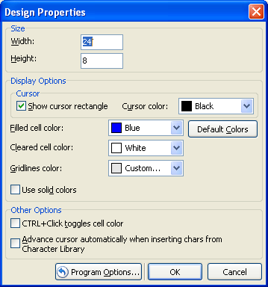

In the Size section, you can change the size of the current design. Also it is possible to change the size of the design directly from the design appearance settings section on top of the design page:

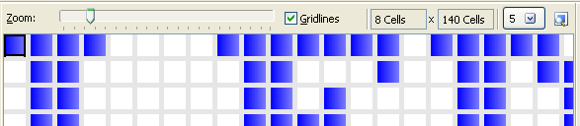

In the Display Options section, you can change the colors of the design page.
The "Use solid colors" option is used to have solid colors on the design. When this option is not selected, the filled cells of the design page have a gradient effect to have a better appearance. The following picture illustrates the difference between these two modes:

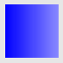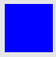

The "Advance cursor automatically when inserting…" option controls how the characters are placed on the design from the Character Library. This option will be explained further in this manual.
The Character Library
The Character Library stores a set of predefined characters to be used for writing LED and LCD texts. Using this powerful feature, you can define and create your personal custom fonts. Also it is possible to share your fonts with other designers.

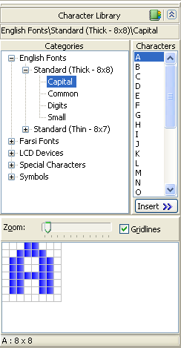

Using the Character Library Manually
You can use the Character Library in two modes: Manual and Automatic. In manual mode, you should pick up individual characters from the Character Library and put them on the design. To do this, first navigate through the character groups on the left side of the Character Library section as shown in the picture above. After finding your desired character, press the Insert button to place it on the design in the current cursor location. Also it is possible to drag and drop characters onto the design using the mouse.
If you want to automatically change the cursor location on the design when inserting new characters, select the following option in the Design Properties dialog box:

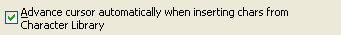

Using the Character Library Automatically
Although you can place individual characters on the design, it is possible to let LED Font Generator to automatically choose appropriate characters from the Character Library and put them onto the design.
To use this feature, select the Character Library as the character source in the Text to LCD section. (To show the Text to LCD section, select Text to LCD command from the View menu.)

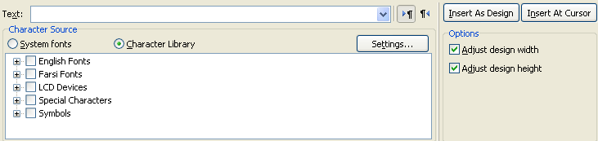

We illustrate this feature through an example. First, enter your text in the Text field. Then you should define which character groups to be used when converting your text into design. In other words, each of these character groups are a font that you have already created them and put them in the Character Library. By selecting these fonts, you define which font to be used for writing your text.

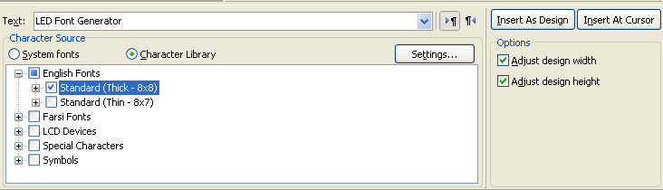

After selecting your desired fonts, press the Insert As Design button to convert your text using the selected fonts and put it onto the design. The Insert As Design button clears previous contents of the design and replaces with the new text. If you want to place the converted text in a specific location on the design, first put the cursor on that cell and press the Insert At Cursor button to place the converted text in the current cursor location on the design.
The "Adjust design width" and "Adjust design height" options define whether the width and/or height of the design should be adjusted to fit the resulting converted text.
Using Special Characters in the Character Library
There are some special characters that we cannot save them with the name of the corresponding character in the Character Library. Some of these characters which are frequently used are: Space character, ? (Question mark), / (Slash), \ (Backslash), and : (Colon). You should define special names for these characters so that this name will be used to access the character in the Character Library on the disk.
To define or change these names, click the Settings button in the Text to LCD section. This will show up the "Map Characters To Character Names" window. As you see in the following picture, some of the frequently used characters are defined by default. You can change or remove them in this list.
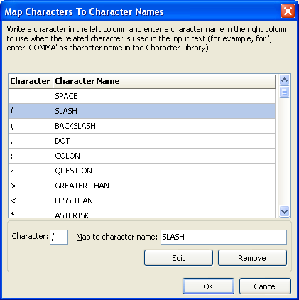

After settings these names, you should save the characters with these names so that they can be used in the Character Library. For example, when you want to create a custom character pattern for the colon (:) character, you should save it with the name COLON.
It is not necessary to remember these names. When saving a character, there is an option that lists all user-defined names:

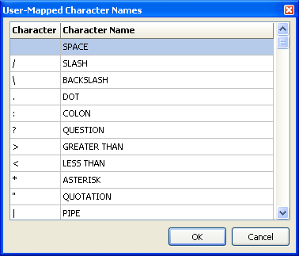

Organizing the Character Library
The Character Library Organizer tool is used to manage and organize characters into character groups. The Character Library Organizer window is shown in the picture below:

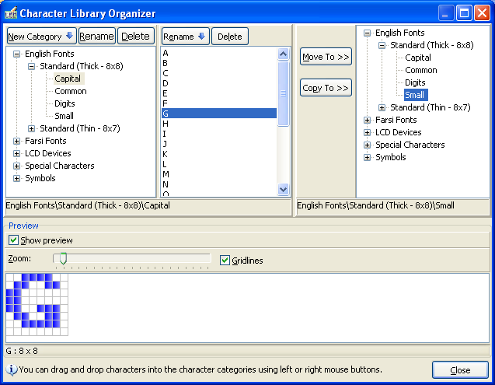

When you select a character group in the left panel, all the characters in that group are shown in a list. You can view, copy and move characters to other character groups easily. Also you can create new character groups (or fonts) in this window.
Using the Rename buttons you can rename a character group or an individual character. To delete a character, select it and then press the Delete button in the middle panel. To delete a character group, select it and press the Delete button in the left panel. Please note that to delete a character group, it should be empty.
To move or copy characters from a character group to another character group, you can use the Copy To and Move To buttons. Another easier way to do this is to use mouse. You can drag and drop characters into the character groups. If you drag characters with the left mouse button, the character will be moved to the new character group. If you do this using the right mouse button, a menu with three options will appear which allow you to copy, move, or cancel the operation:

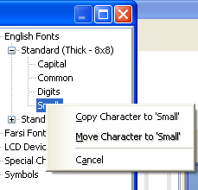
Create Custom Fonts in the Character Library
To create a new custom font in the Character Library, do the following steps:
- Create a new character group in the Character Library for your new font (by using the Character Library Organizer tool). The characters you design for your new font will be stored in this new character group. You can create subgroups for this new font for easier management of its characters in the future.
- Design each of the characters and store them in the Character Library in the newly created font. In the next section we explain how you can create characters.
- After designing all the characters, your font is ready to be used.
How to design a character
If you use main window of the LED Font Generator to design your characters, select the area on the design page which contains your character. Then go to the Design menu and select the "Create Character from Selection" command or simply press Ctrl+H. This will show the Save Character window as shown in the picture below:

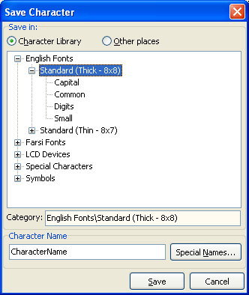

In this window, after selecting the destination folder and defining a name for the character, press the Save button to store the character in the character Library. To access to special character names or user-define character names, press the Special Names button.
Another way to design your characters is to use the Character Designer tool. This tool has a simple interface and allows you to create your characters easily. This tool is explained in the Character Designer Tool section in this manual. The following picture shows the Character Designer tool. To access this tool, choose the Character Designer command from the Tools menu.
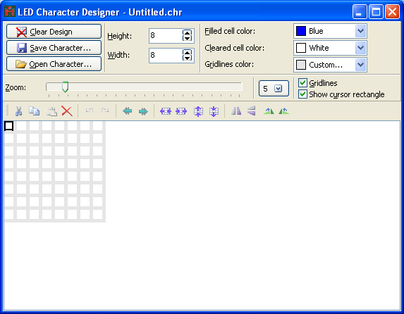
Using System Fonts
In addition to the fonts you design, you can use the fonts installed on your system to convert your texts into LED and LCD texts.
To use this feature, go to the Text to LCD section and enter your text. (To show the Text to LCD section, select Text to LCD command from the View menu.) Then, select System Fonts as the character source for your text.

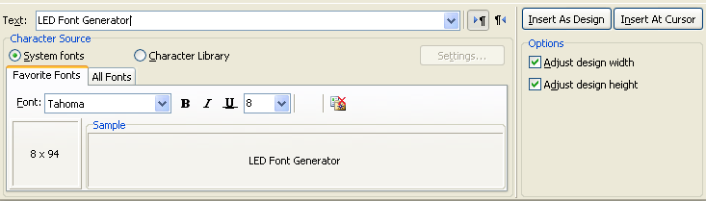
Remove from favorite fonts

Then, you should select a font to be used when converting your text. The Favorite Fonts tab lists your favorite fonts. You can add any font to this list. To remove a font from the favorite fonts list, select that font and press the "Remove from favorite fonts" button.
In the All Fonts tab, all the fonts installed on your system are listed.

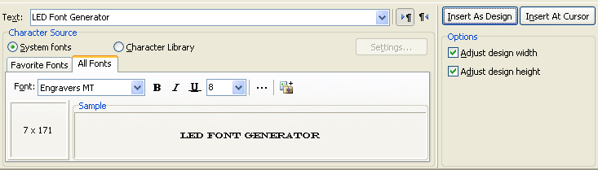
The size of your text after it is converted to LED/LCD text.
Add to favorite fonts

To add a font to the favorite fonts list, press the "Add to favorite fonts" button. As you can see, when you change the selected font, the program automatically calculates the size of the converted text. This helps you to select a font which is suitable for you.
To convert your text using the selected font, press the Insert As Design button. Pressing this button clears previous contents of the design page and puts converted text on the design. To put the converted text in a specific cell on the design, first move the cursor to that cell and press the Insert At Cursor button.
The two options in this section allow you to control how the text is put on the design. These options are described earlier in this manual.
Program Output
The LED Font Generator allows you to completely customize the output code to meet exactly your programming requirements.
The Export Design Window
The Export Design window contains all the options for customizing the output code. The Basic Output tab contains basic output settings. The Advanced Output tab allows you to have more control on the output format. The Other Settings tab contains other miscellaneous options.

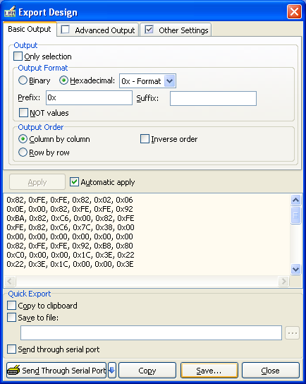
The output

To save the output in a file, press the Save button. Also you can copy the output to windows clipboard by pressing the Copy button.
To send the data to serial port, press the Send Through Serial Port button. This feature is more described later in this manual. The Quick Export is also explained in the following sections.
Normal Output
The following picture illustrates all the options in the Basic Output tab:

If selected, only the selected area on the design will be converted to the output code.

Hexadecimal output format
Binary output format

NOT each data byte of the output
This prefix is appended to the beginning of each line in the output.
This suffix is appended to the end of each line in the output.
When selected, the design is converted to output code in inverse order. In normal mode the output is generated beginning from the first row/first column, but when this option is selected, the output will be generated starting from the last row/last column.
When "Column by column" is selected, the design is converted to output code column by column (first column will be first line in the output, second column second line, and so on). Otherwise, each row of the design will be one line in the output (first row will be the first line in the output, second row second line, and so on). Selecting between these two modes depends on your case.

Advanced Output

If this options is selected, after every n bytes/nibbles/bits (which n is the number specified here), the text entered in the "Separated text" area will be added to the output.

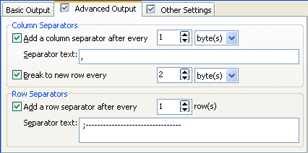
To break lines into short lines, select this option.
If selected, after every n lines (which n is the number specified here), the text in the "Separator text" area will be added to the output.

Other Output Settings
The Other Settings tab contains miscellaneous options to control the program output.

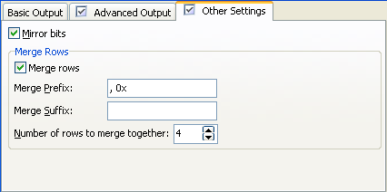

When you select the "Mirror bits" option, the program will mirror bits of every data output. For example consider the following design:

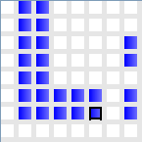

By selecting the "Mirror bits" option, the output code will be as shown in the picture below. For instance, in normal mode the last column of the design will be converted to 36 (=00110110), but when the bits are mirrored, it will be 6C (=01101100). The following picture illustrates this mode:
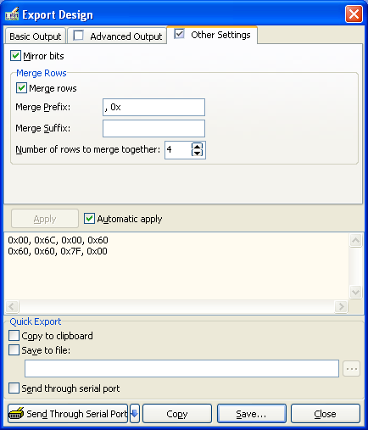

Also, the "Merge rows" option makes it possible to merge short lines of code into long lines. This allows you to have fewer lines of code in the output. The picture above, demonstrates this feature, too.
Quick Export
The Quick Export feature allows you to quickly save the program output in the specified destination when you press F8 key. This helps you to save time when you are in design and test stage. For example, you can set this output to an include file contained in your project. After that, just press F8 to refresh your code and compile and test it again, without any need to manipulate your code manually. The following picture illustrates Quick Export options.
When selected, the Quick Export feature will copy the output onto the clipboard.

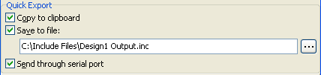
When selected, the output will be sent to serial port.
When selected, the output will be saved to the specified file.

Send Design via Serial Port
It is possible to send the program output to external devices via serial port of your computer. The external device can be a microcontroller or any other device that have serial communication capabilities.
Before you use this feature, you should set the serial communication settings. To do this, go to the Tools menu and select the Serial Communication Settings command. This will show the following window:

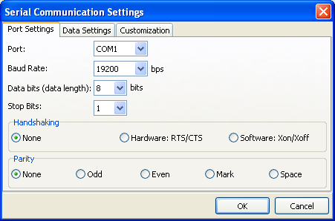

In the Port Settings tab you can set the serial port settings (speed, data size, …) to be compatible with the external device settings.
The Data Settings tab allows you to have more stable communication with your device. In this tab, you can define some initialization bytes (in hex format) that will be sent to the external device before sending the original data. Also, it is possible to define some finalization bytes that will be sent to the serial port after the original data has been sent. The following picture shows the Data Settings tab:

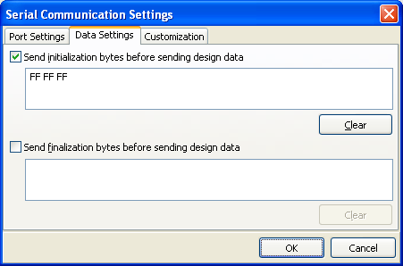

Press OK to apply your settings.
Now whenever you want to send your design data via serial port go to the Export Design window (from File menu, Export Design command) and press the Send Through Serial Port button. The data will be output to the serial port based on the settings you have defined.

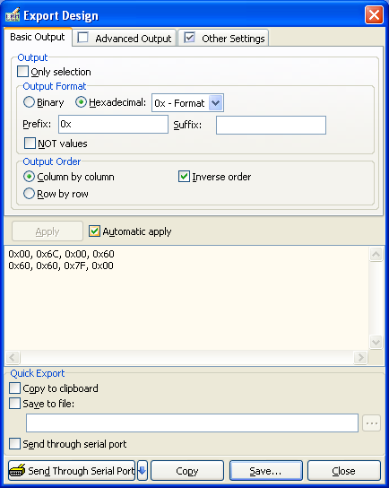
This buttons sends the data to serial port based on the specified settings in the Serial Communication Settings window.
Use this button for quick access to the Serial Communication Settings window.

The Customization tab in the Serial Communication Settings window allows you to change the caption of the Send Through Serial Port button in the Export Design window. For example to change the button caption to "Send Data", we can do as the following picture shows:
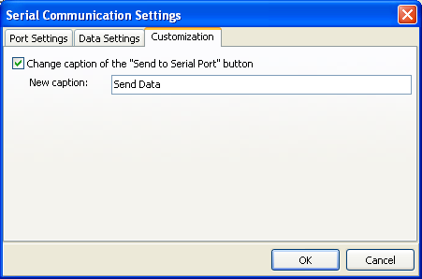

After confirming this dialog, if you go to the Export Design window, you will notice that the button caption has been changed to "Send Data":

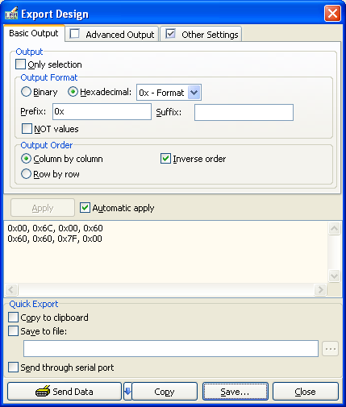

This option allows you to make the output screen more familiar with your needs.
Import Pictures
The current version of the LED Font Generator supports importing these types of graphic files: BMP, JPG, GIF, TIF, and PCX.
To import a picture go to the Import Picture window from File menu, Import Picture command. Select you picture file, set some options and press the Insert As Design or Insert At Cursor button to put it onto the design. The following picture shows the Import Picture window.

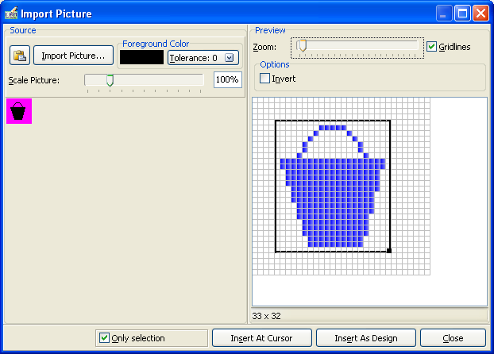

This window provides some options to prepare the image before import. You can scale the image to any size, set the foreground color, and select to import only a region on the picture.
Save Design as Picture
To save the current design as a bitmap file, open the Design Picture Preview window. This window displays an overall preview of the current design. Then, right click on any area on this window and choose the Save As Picture command from the popup menu. Select target file name and location and press the Save button to save the picture. The following figure illustrates this task:

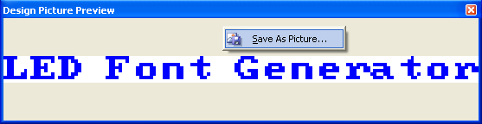
Convert Code to Design
The Code to LCD window allows you to convert program codes which contain data definitions of a design to a graphical design. To show this window, press the "Code to LCD" button on the "Import and Export" toolbar. (If this toolbar is not shown, go to the View menu, in the Toolbars submenu select the Import & Export command.)

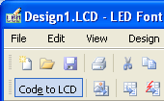

The following picture illustrates different parts of the Code to LCD window:

Pastes clipboard contents into the code area.

Clears the code area.

When selected, the program automatically detects the format of the input code.
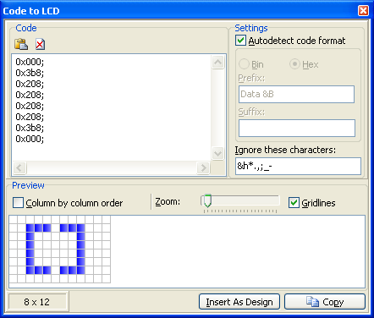
A preview of the result is shown in this area.
If the "Autodetect code format" option is not selected, you can define the code format here. Usually it is not necessary to do this by yourself, but in some cases where the program is unable to detect the code format correctly, you should define it manually.
The characters you enter here will be ignored during code conversion.
Other Tools
Size of the result (Height x Width)
Enables column by column mode. For more information about this mode, see the Program Output section in this manual.
The LED Font Generator includes several tools that help you create and test you designs.
LED Character Designer
The Character Designer tool provides a simple and easy to use environment for designing LED/LCD characters. This tool completely supports all the editing features of the main program.
To start this tool, go to the Tools menu and select the Character Designer command. Also you can run this tool directly from the program group in the windows start menu:

The following picture illustrates different parts of this tool.
Design page color settings
Size of the character

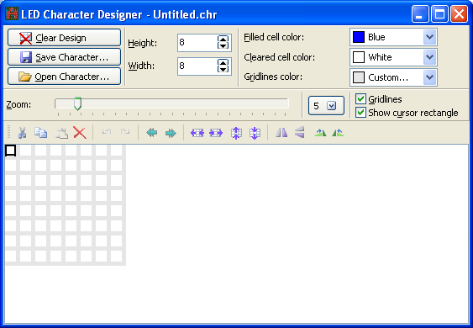
Character design area
The "Edit and Design" toolbar containing all the editing commands

To start a new character, just click the Clear Design button. This will clear the design page and make it ready to design a new character.
To save the current character, click the Save Character button. This will show the Save Character dialog box which has been explained in the previous sections of this manual.

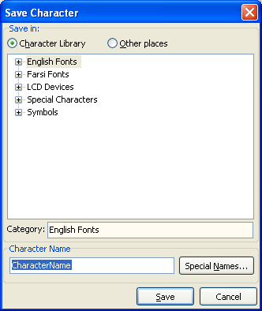

To edit a previously designed character, you should first open it in this tool. To open a character, press the Open Character button. This will show the Open Character dialog box:

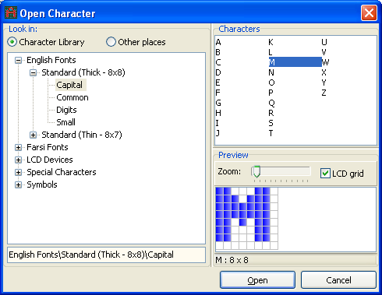

In this dialog, you can navigate through your Character Library to select a character. After selecting a character, press the Open button to open it. If your character file is not located in the Character Library, you can select the "Other places" option and go to the folder which contains your character file.
Design Animator
The Design Animator tool is used to animate the current working design like in LED scrolling displays. It provides several options to control the scrolling. The following picture illustrates different parts of this tool:

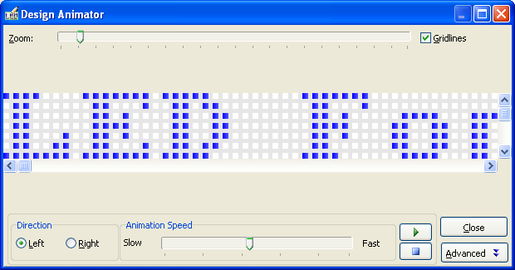

Scrolling direction
Start/Pause scrolling

Scrolling speed
Stop and reset scrolling

View advanced options

To view the advanced options click the Advanced button:

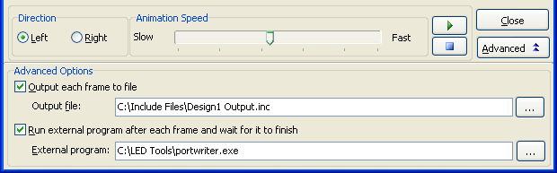

If the "Output each frame to file" option is selected, each animation frame will be saved to the file specified here. Each time a new frame is saved, previous contents of this file is cleared. But you can use the "Run external program after…" option so that the program will wait until the external program is finished and then generates the next animation frame. The external program, for example, can be a program that sends the animation data stored in the file to a communication port.
Print a Design
To print your design, go to the File menu and select the Print command. This will show the Print Setup command. After selecting the printer, click OK to start printing your design.
In addition to that, there is a print button on the General toolbar (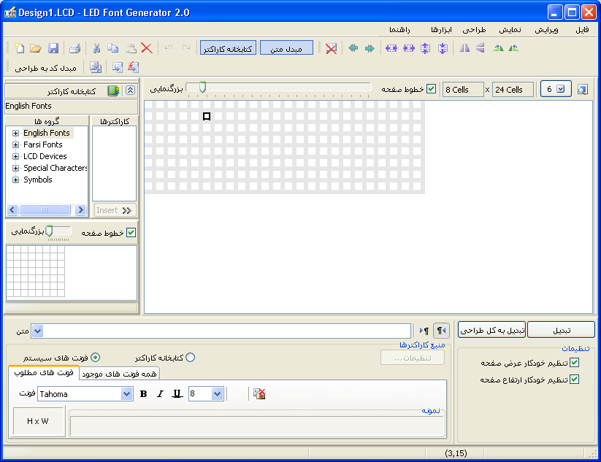) for quick access to this command.
Keyboard Shortcuts
General

Description | Keyboard Shortcut
Create a new design | Ctrl+N
Open a design file | Ctrl+O
Save changes to the current design | Ctrl+S
Show the "Export Design" window | Shift+F8
Quick Export | F8
Import picture | Ctrl+I
Print the design | Ctrl+P
Show/hide the Character Library | Ctrl+Q
Full screen mode | F11
Refresh Character Library | F5
Design properties | F4
Character Library organizer | Ctrl+Shift+G
The Design Animator tool | Ctrl+Shift+N
Program options | Ctrl+J
Displays help in the default help language | F1

Edit
The keyboard shortcuts listed in the table below, are also supported in the Character Designer tool.

Description | Keyboard Shortcut
Undo the last change made to the current design | Ctrl+Z
Redo the previously undid change | Ctrl+Shift+Z
Cut the selected area and copy it onto the clipboard | Ctrl+X
Copy the selected area onto the clipboard | Ctrl+C
Paste cells from the clipboard into the design in the current cursor location | Ctrl+V
Clear selected cells on the design | Del
Select all cells on the design | Ctrl+A
Clear all the cells of the design | Ctrl+Shift+A
Toggles state of the selected cells | Ctrl+Space
Rotate selected cells left | Ctrl+L
Rotate selected cells right | Ctrl+R
Rotate selected cells up | Ctrl+U
Rotate selected cells down | Ctrl+D
Shift cells left | Ctrl+Shift+L
Shift cells right | Ctrl+Shift+R
Flip selected cells horizontally | Ctrl+Shift+H
Flip selected cells vertically | Ctrl+Shift+V

