Dia de Despesca

Mozart Marinho-Jr.

2020-07-23

At the end of a production cycle you have to decide the best day to harvest your crop. This cannot be considered without taking into account factors such as: average body weight, prices, condition of the shrimp (molt stage, color, texture), cash flow, etc. Small farmers, like me, do not utilize any formal management tools for determining the optimal harvesting schedules for a shrimp pond. So, the decision has to take a more subjective approach. After you follow your decision process and conclude to harvest, it has to occur during some day of the week. This led me, out of curiosity, to the following question: “In what day of the week did most harvests occur?” I got the answer digging through one of my harvest datasets, spanning more than 5 years. Except for the weekends, I did not expect the frequencies present much difference. Results are shown on the graph above. It is easy to spot that most of the harvests turned out to happen from wednesday through friday, peaking on friday, with over 31% of the events.

## Harvests by day of the week

## Warning: The `size` argument of `element_line()` is deprecated as of ggplot2 3.4.0.  
## ℹ Please use the `linewidth` argument instead.

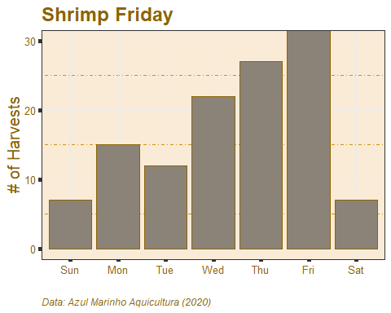

## Percentual por Dia da Semana

Percentual por Dia da Semana.

dow

harvests

percent

Sun

7

5.691057

Mon

15

12.195122

Tue

12

9.756098

Wed

22

17.886179

Thu

27

21.951220

Fri

33

26.829268

Sat

7

5.691057

despesca_semana <- Biom %>% mutate(dow = lubridate ::wday(data_desp, label = TRUE, locale = “English_United States.1252”))