Tourism Industry Analytics
Visitor Trends, Seasonal Demand, Economic Impact, and Travel Pattern Analysis
By : Momin Butt
Data Analytics Project Report
July 2026

Abstract
This report presents a comprehensive analysis of the global tourism and hospitality industry using a dataset of 500 records spanning 20 countries, 56 cities, and the years 2020 to 2024. The analysis covers visitor trends, seasonal demand, tourist spending behavior, hotel performance, tourism revenue, economic contribution, and environmental impact. Twenty visualizations and a correlation analysis were used to surface actionable business insights, culminating in a set of concrete recommendations for tourism organizations and destination managers.

Introduction
Tourism is one of the largest contributors to global GDP and employment, yet destination managers and hospitality businesses frequently lack a clear, data-driven view of visitor behavior, seasonal fluctuation, and revenue drivers. This project applies exploratory data analysis and statistical methods to a multi-country tourism dataset to uncover patterns that can guide strategic decisions in marketing, pricing, infrastructure investment, and sustainability planning.

Problem Statement
The tourism industry plays a major role in economic growth and employment generation worldwide. However, tourism businesses often struggle to understand visitor behavior, seasonal demand fluctuations, spending trends, and destination performance. This project aims to analyze tourism and hospitality data to identify meaningful patterns in tourist arrivals, hotel occupancy, tourism revenue, customer behavior, and travel trends. The findings can help tourism organizations improve business strategies, customer satisfaction, and revenue generation.

Objectives
- Analyze visitor trends across destinations
- Identify seasonal tourism demand
- Study tourist spending behavior
- Analyze hotel occupancy and ratings
- Examine tourism revenue patterns
- Discover economic impact of tourism
- Build an interactive analytics dashboard

Data Collection
The dataset, Tourism_Hospitality_Industry_Analysis.csv, contains 500 records across 23 columns covering tourist arrivals, purpose of visit, length of stay, spending, hotel occupancy and ratings, room prices, tourism revenue, employment, GDP contribution, flights, airport traffic, transport infrastructure quality, eco-tourism revenue, carbon footprint, waste management rating, satisfaction score, and online review volume.

Data Cleaning
The dataset was checked for missing values and duplicate rows; none were found. A data-quality issue was identified and corrected: one record had a blank/whitespace Country value paired with the city 'Dubai' and was corrected to 'United Arab Emirates'. Column data types were verified, and outlier checks were performed on key numeric fields such as Tourism_Revenue_USD.

Methodology
Analysis followed a standard data analytics workflow: data loading and exploration, cleaning and validation, feature engineering (deriving Season from Month and Revenue_Per_Tourist from Tourism_Revenue_USD / Number_of_Tourists), exploratory visualization (20 charts), correlation and descriptive statistical analysis, and synthesis of insights into business recommendations. Python (pandas, numpy, matplotlib, seaborn) was used for analysis, and Streamlit/Plotly for the interactive dashboard.

Exploratory Data Analysis & Visualizations
All 20 visualizations were generated as part of the analysis. The charts below highlight the most business-critical findings; the complete set of 20 charts is included in the /visuals folder and the accompanying notebook.

Top Countries by Number of Tourists
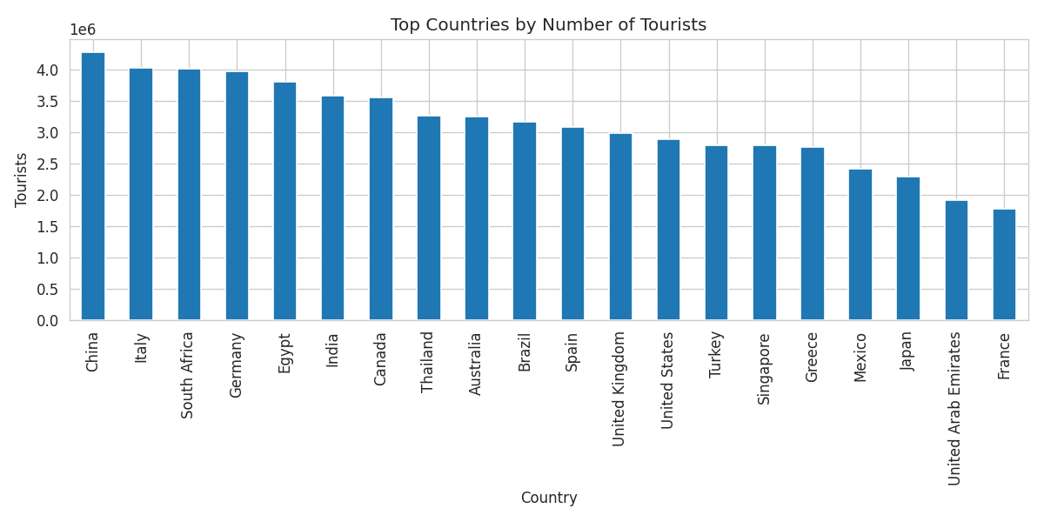
China leads by total tourist volume. Destinations with the highest tourist counts should be prioritized for infrastructure investment.

Monthly Tourism Trend
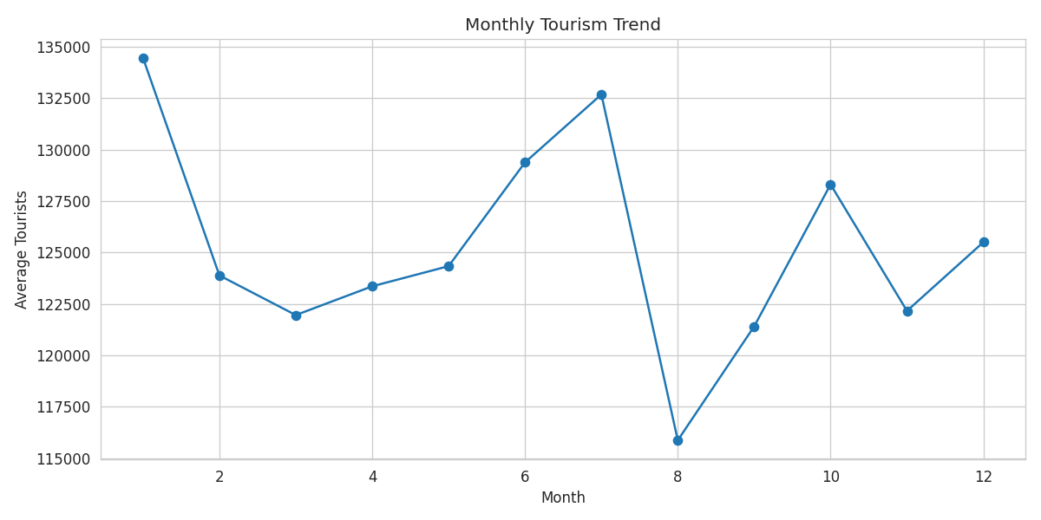
January is the peak demand month and August the weakest, confirming a clear seasonal cycle for staffing and capacity planning.

Hotel Rating vs Tourism Revenue
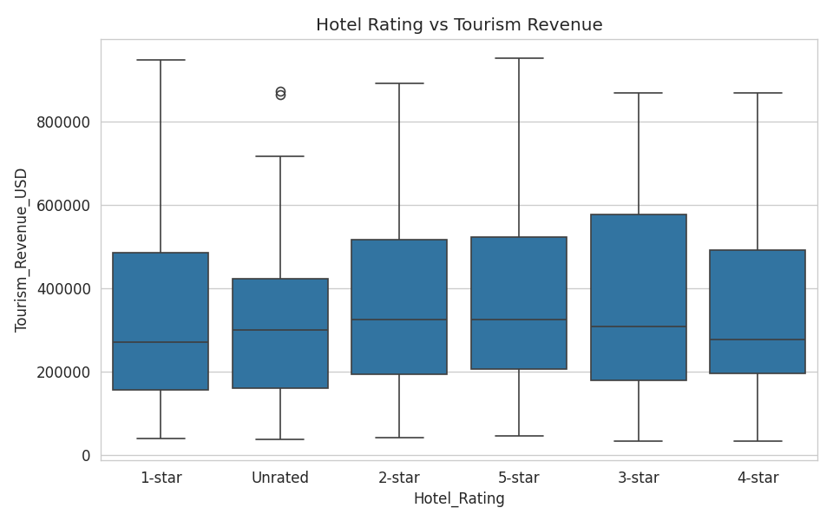
5-star properties generate the highest average tourism revenue and unrated properties the lowest, linking hotel quality directly to destination revenue.

Correlation Heatmap
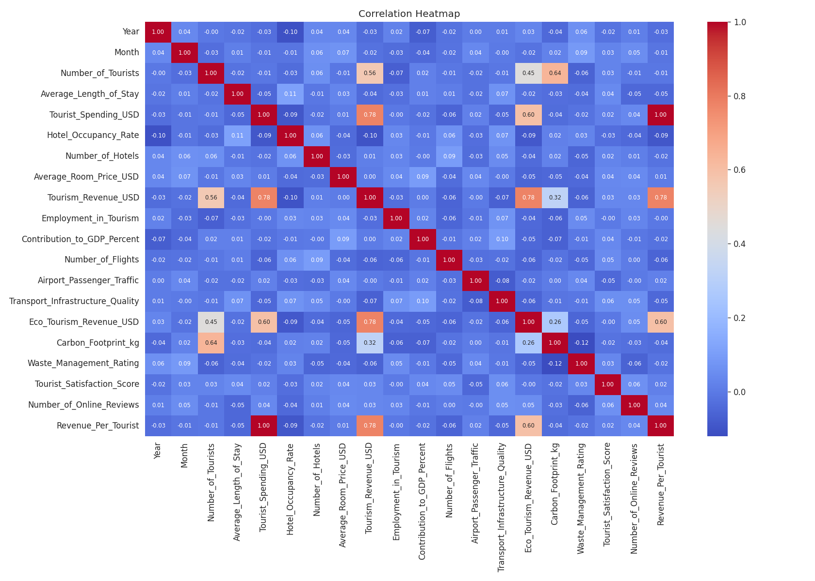
Tourism revenue correlates most strongly with tourist spending and eco-tourism revenue (~0.78), and moderately with tourist volume (~0.56).

Seasonal Tourism Revenue
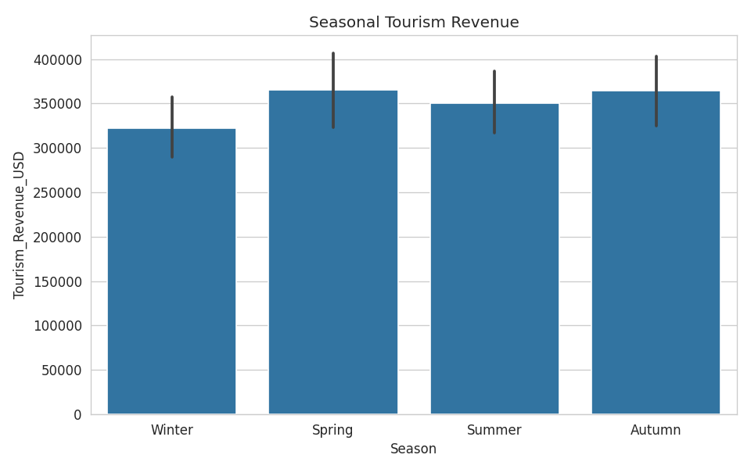
Spring and Autumn generate the highest average revenue, slightly ahead of Summer, with Winter lowest.

GDP Contribution by Country
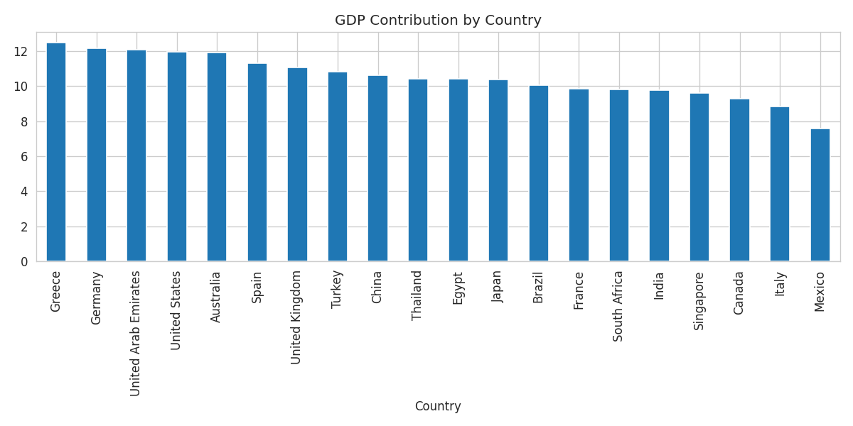
Greece shows the highest average tourism contribution to GDP, marking it as an economy where tourism is a critical growth pillar.

Eco Tourism Revenue by Country
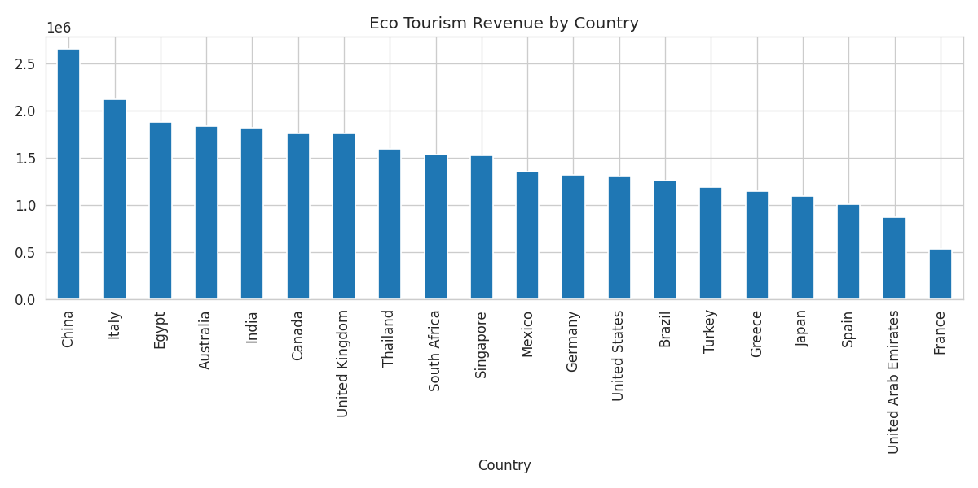
China leads in total eco-tourism revenue, signaling strong potential for further sustainable-travel investment.

Tourism Revenue Trend
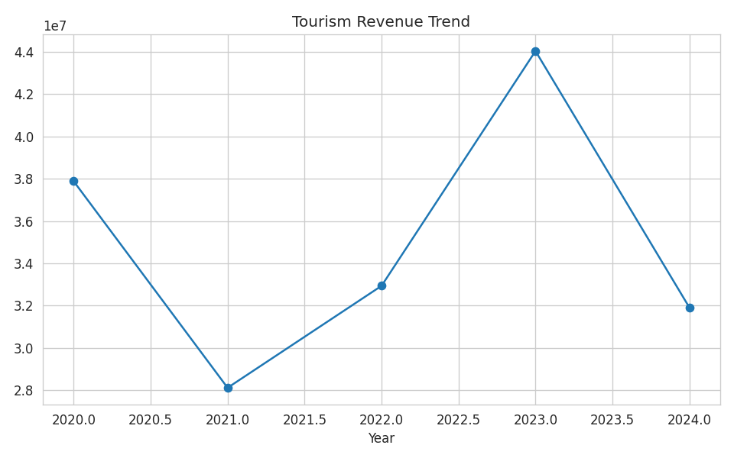
Total tourism revenue peaked in 2023 and dipped in surrounding years, indicating year-to-year volatility rather than steady growth.

Statistical Analysis

Dataset Overview
Metric | Value
Total records | 500
Countries covered | 20
Cities covered | 56
Years covered | 2020 - 2024
Missing values | 0
Duplicate rows | 0
Top country by tourists | China
Top city by revenue | Luxor
Peak demand month | January
Lowest demand month | August
Top GDP-contribution country | Greece (12.46%)

Correlation with Tourism Revenue
Variable | Correlation with Tourism Revenue
Tourist Spending (USD) | 0.78
Eco-Tourism Revenue (USD) | 0.78
Number of Tourists | 0.56
Carbon Footprint (kg) | 0.32
Number of Online Reviews | 0.03
Tourist Satisfaction Score | 0.03
Number of Flights | -0.01
Employment in Tourism | -0.07

Key Findings
- China draws the largest tourist volume and leads eco-tourism revenue, making it the dataset's dominant growth market.
- Hotel quality matters: 5-star properties post the highest average revenue, unrated properties the lowest.
- January is the peak demand month and August the weakest, confirming a strong seasonal cycle.
- Tourism revenue is driven mainly by tourist spending and eco-tourism revenue, not by flight capacity or online review volume.
- Tourism employment has remained stable (roughly 26,000-27,500 jobs on average) across 2020-2024 despite revenue volatility.
- Higher-revenue destinations tend to carry a larger carbon footprint, a sustainability trade-off worth monitoring.

Recommendations
- Increase marketing and promotional pricing during the August low season to smooth demand.
- Invest in upgrading unrated and 1-star hotel stock, since rating is tied to revenue performance.
- Expand eco-tourism offerings in high-traffic markets like China, where eco-revenue is already strongest.
- Prioritize transport infrastructure upgrades in the lowest-scoring cities to improve visitor experience.
- Target high-spending segments (e.g., business travel) with tailored packages rather than broad marketing.
- Track and offset carbon footprint growth in high-revenue destinations to balance economic and environmental goals.

Limitations
The dataset covers 500 records across 20 countries and 56 cities, which limits statistical power for country-level or city-level subgroup analysis. All correlations reported are linear (Pearson) and do not establish causation. The data is cross-sectional across years rather than a true longitudinal panel per destination, which limits trend forecasting precision.

Future Work
- Incorporate a larger, multi-year longitudinal dataset per destination for stronger trend forecasting.
- Apply predictive modeling (e.g., regression or time-series forecasting) to forecast future tourist demand and revenue.
- Segment analysis by tourist purpose and traveler demographics for more targeted marketing recommendations.
- Integrate real-time data feeds (flight bookings, hotel occupancy) into the dashboard for live monitoring.

References
Dataset: Tourism_Hospitality_Industry_Analysis.csv (provided dataset, 500 records, 23 columns).
Analysis tools: Python (pandas, numpy, matplotlib, seaborn), Jupyter Notebook, Streamlit, Plotly.

