Refactoring Analysis
Development norms can vary developer to developer and framework to framework.
I will assume only these two files BookingController and BookingRepository. Some of the changes might feel different and can be altered or modified based on the rest of the application architecture, for example if middleware’s are known then authentication can be more precise about using in controllers or repositories.
My scoring
1-5 (Code that just works)
6-8 (Code that works and is kind of OK)
9-10(Perfect Code that rarely exists)
I will rate this code between 6-8 category as to me it seems 'OK' kind of code as its works but there are some modifications that I consider should be done which I tried to explain in points.
Better Approach
1 - UserId Logic is written again and again, can be centralized at one place and can be used everywhere and same goes with authenticated user, did some changes as well in constructor.
2 - env() , config and other supportive functions should not be used directly instead should be wrapped inside a custom function and that custom function should be utilized everywhere so in case if anything changes on the framework level there will be only one change in custom function and everything will work just fine without major changes.
3 - I’m not fully sure about the architecture of the application as whole but I guess in all controller methods its using response($object) , for a proper response it’s a lot better to use key=>value formation (i.e status, success, error, data) and it reduces handling for frontend and api utilization.
4 - I have removed some non-utilized variables and changed some conventions and I still think there is a lot of space in BookingRepository that need change especially in code management, type and conventions.
5 - I believe naming convention could be improved further because it’s not following any pattern, of course there are many ways to maintain variables names but there should be consistency i.e code is using camel casing, underscore, plain variable which makes it less readable and eventually it makes reader dull while improving code ( at least to me ).
6 - One point is very crucial and important that $userId and $authenticatedUser is utilized multiple time while more better approach is to define once and use everywhere , like in BookingController i tried to initiate the userId and user one only and same instance is used again and again. This approach reduces the code and make it more readable.

7 - About the architecture i would also add that couple of functions are using user_id while it can be designed in a way that Repository should be aware of user_id with every request and each time any specific operation is required against the user hence it should not be passed as parameter with each request, that can reduce writing more code.
8 - There are some functions that are not Repository specific rather they are General Helper functions but still defined inside BookingRepository and that just clutters the code nothing else when already the file is too big , example of such function is getUserTagsStringFromArray() , convertToHoursMins() or others.
9 - Booking Repository is too cluttered, helpers functions can be separated, notification functions can be separated into another helper and mail function can also be moved to mailerRepository.
10 - In booking Repository CurrentUser is being query each time in almost all funtions , better approach would be to initialzied it once at the top and utilized it again and again without calling user Model query each time.
11 - Despite being a repository pattern (& even specifying a model attribute at global level) the internal implementation of most functions is using hardcoded model i.e. should be using the models via global injection otherwise there's no use of it.
A lot of models are being used directly into the specific functions, it causes issues of code duplications, if its repo pattern, should simple be using functions defined in other repo, Instead of calling the model specific functions each time they are required i.e. find or fail, find, insert etc.

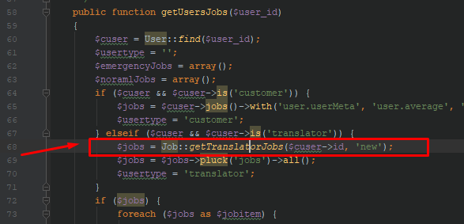
Code like this indicates that business logic functions are also defined in models, which isn’t consistent with the repository pattern. Such functions should be defined inside the repository itself.
The use of repository pattern isn’t proper in the code, it’s not consistent. Its concept is to add an extra layer between models but still there’s a lot of direct interaction with models in this code.
No use of OOP concepts, which can be easily be done with this pattern, to mainly avoid the duplication of code.
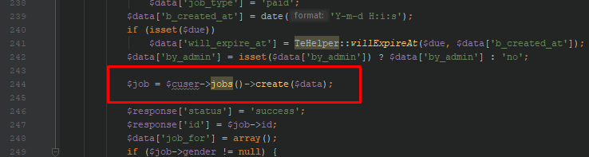
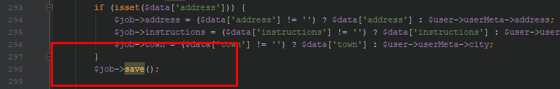
Functions dealing with saving data in DB should be accessed from only one place, so we can be sure there’s only one entry point in our model/table. i.e. either define a save/insert/create function at repo level and interact with it (preferable in current repo pattern) or simply define a function on model and call it whenever to insert new records. It avoid a lot of bug tracking as well when there’s any issue with data saving.

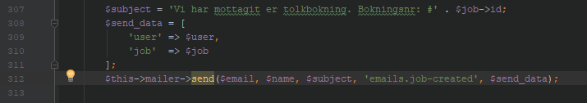
For better performance and practices email sending module shouldn’t be part of a script, as it might take quite some time in certain cases (considering load and other factors ) , which isn’t a good user experience as they might have to wait. In this case it sending male, building proper data and then also triggering event for certain purpose and all this can take quite good amount of time depending upon the traffic. So, preferably use queue jobs etc. for such tasks.
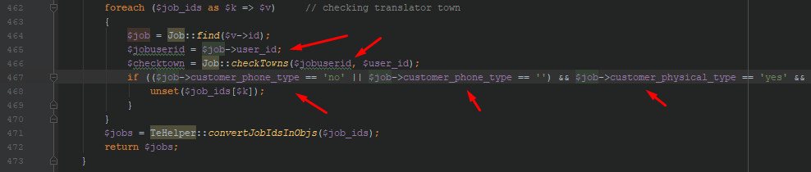
Certain places require better error handling, as in above image we are relying on the best case, that
$job->user_id will always exists (And then passing it to next function as well without checking if its null or empty), if due to any inconsistency on insertion time any of the attributes is missing it would crash the script, where we are checking for if condition of expected properties.

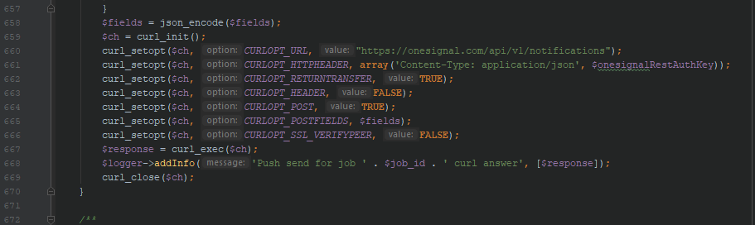
Curl should have a class of its own, and should be accessed from single point, in case we have to use curl at multiple place we are duplicating the same code at multiple places which isn’t feasible in any case.
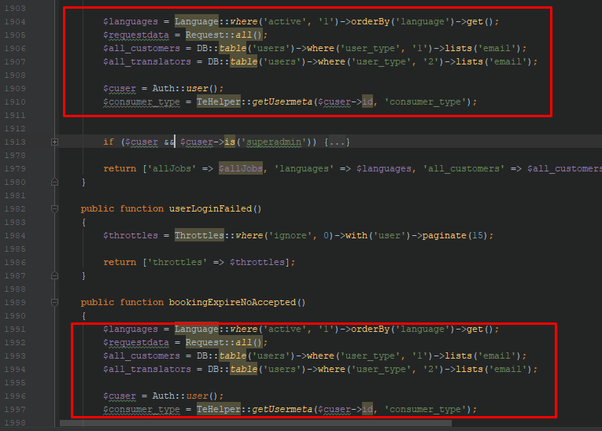
Many places we have duplicated queries, it should be avoided defining the same queries at different places. There should be a single function either in the targeted model or in the repository which should be returning the data and all the places should be using that, instead of defining the same queries again and again.

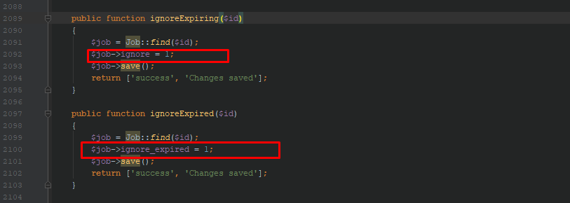
Cases like these can be easily avoided by using OOP with Repo pattern, we don’t have to redefine different functions for each specific column to update, we can make use of updateOrCreate, firstOrNew etc appropriately to avoid such implementations.
Summary:
In general code base can be improved in terms of performance by keeping the time taking tasks outside of the user specific scripts. Implementation of Repository pattern can be improved a lot by making interactions with models as are expected in a Repository pattern project. The use of OOP is missing and hence a lot of place have duplicated code which can be easily reduced. Direct interaction with models isn’t appreciated in a Repository pattern because the whole purpose of Repo pattern is to add an extra layer of transparency.

