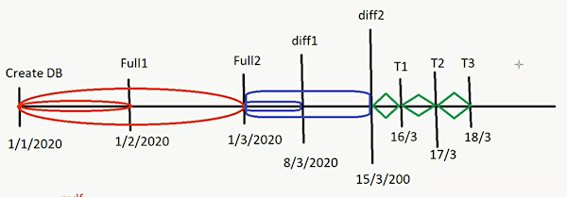 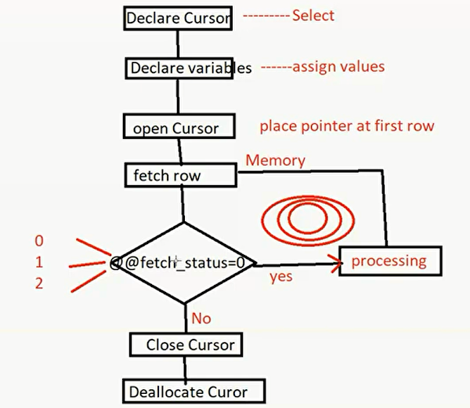

**D10**

- Cursor

*steps*

1) Declare cursor

2) Declare variables

3) Open cursor

4) Fetch row

5) Check @@fetch_status

If 0 means it fetched row

If 1 means there’s row but couldn’t be fetched

If 2 means there were rows but already fetched

6) Process

7) Close cursor

8) Deallocate cursor

*Code*

1) Declare [cursorName] cursor

     For [the select statement]

     For

     (a-read only

       b-update (dml will be executed)

       use [where current of [cursorName] ] to

       specify which row to be affected )

2) Declare variables

3) Open [cursorName]

4) Fetch [cursorName] into [variables]

5) While @@fetch_status=0

6) Process to be done

(last line in loop must be step 6 again to avoid infinite loop)

7) Close [cursorName]

8) Deallocate [cursorName]

- Backup

Types :

1) Full backup backs db up since creation

2) Diff backup backs db up since last full backup

3) Transaction log backup backs up queries from log file and empties the log file

- CLR

sp_configure 'clr_enable',1

go

reconfigure

- Steps to add C# function into sql server

New project,

sql server project,

add new item,

sql clr c#,

sql clr c# user defined function

After writing code.. write click on solution then publish and choose targeted database

Upcoming copied notes

- Bulk insert (ene ageb data mn file w 7otha fe gdwl hna)

bulk insert student

from 'F:\ITI\database iti\Day10\00.txt'

with (

fieldterminator =',')

- Snapshot

read only db

/*k2ny ba5od la2tt camera leldb bta3ty fe w2t mo3yn,

- btt create fadya w byb2a feha mogrd pointers 3la el data elle fel db elle wa5d mnha el snapshot

- a5f bkter mn el db

- 22dr a3ml mnha restore w lkn lazm ab2a 3la nfs el server

- file ss w malhosh mdf wla ldf wla ndf

- lma a5od snapshot mn db w a3ml nfs el query 3la el original db w el snapshot hla2y nfs el nateg

- awl ma abd2 a3'yr fel db hy7sl 7aga esmha copyon write, y3ny ai row ana 3mlt feh (delete or update) hay5do copy 2bl ma yt3'yr w y7oto as data fel snapshot w yshel el pointer mn el snapshot elle kan byshawr 3la el row da fel DB,

- lw 3mlt insert l7aga gdeda b3d ma 5dt el snapshot di, el snapshot msh ht7s beha

- 22dr a3ml kaza snapshot le nfs el db fe aw2at kter mo5lfa

*/

create database ITIsnap

on

(

name = 'iti',--mdf file

filename = 'F:\ITI\database iti\Day10\itisnap.ss'

)

as snapshot of iti