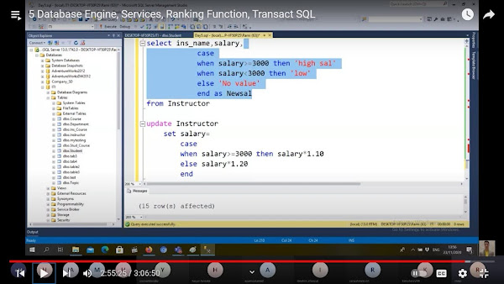 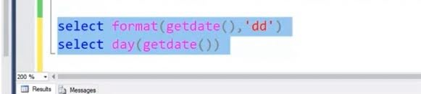 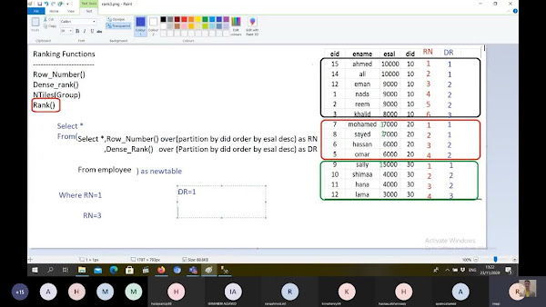 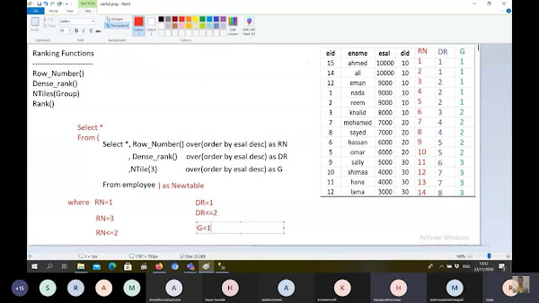

**Day5**

• Top with ties

- Can’t be done without order by

- Let it be order by age

Checks age of last extracted value then extract data that got same age

زي ما بنقول عاشر وعاشر مكرر

• newid()

- gets random value

- If order by newid(), it’ll get new order for every execution, good for randomization

• execution order

 From

 Join

 On

 Where

 Group

 Having

 Select [distinct+agg]

 Order by

 Top

 - if u define something in the select u can’t use it in the where as it comes b4 select in execution order, to solve use subquery select * from (your select query) as whatever where…

• you can extract data from a table in other database or even other server by writing the full path

[server name].dbName.schemaName(usually dbo).tablename

• select * into {T2}

   From {T1}

   - is a ddl that creates new table T2 as a copy of T1

   - you can extract the copy without data, just columns if you used (where 1=2) or any other condition that’s not possible

 OR right click on table and select script as

• insert into T2

  select * from T1

- inserts data exist in T1 into T2

- of course they must have same meta data if not just select what needed to T2

  insert into T2

  select name,age from T1

• iif(condition,if true,if false)

• format returns string

 While date(getdate()) returns int

• case statement in photo

• rank in photo

**Notes (AGG,having,U_fam)**

Grouping by 2 cols will make sense like cross join but grouped

Where

Group

Having

Union all ——> gets all

Union ———> gets elements distinct and ordered

Intersect ——> gets outputs occurs in both queries then does distinct and ordering

Except ———> gets outputs that occurs in the first and not in second then distinct and order