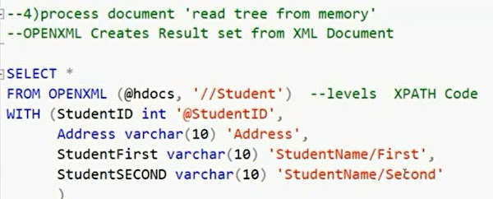 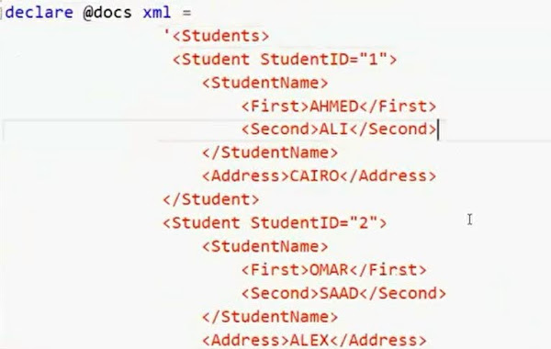 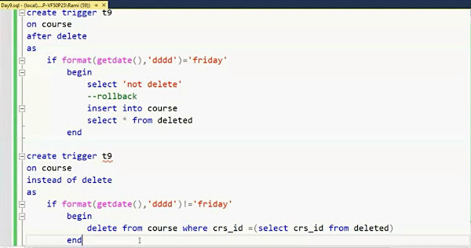

**Day9**

- Engine cycle

Parsing (syntax)

Optimization (metadata)

Query tree

Execution

- In sp return statement returns int only

to return other data types it will be declared while creating the sp as output

- Sp advantages

Can write all type of sentences

More secure

Better engine performance

Flexible

- Trigger on table

   create trigger [triggerName]

   on [tableName]

   after (insert, update,..)

   as

        Select ‘ whatever statement to appear ‘

- You can write (instead of) instead of after to deny the operation after it

- Trigger belongs to schema of it’s table automatically

- To stop trigger u cab disable instead of dropping

• alter table [tableName] disable trigger [triggerName]

this allows u to enable it later if wanted

# triggers example forbids editing data on Friday in upper photos

- XML

# for xml (converts our file into xml)

• For xml raw([name]), elements (puts columns in tags) xsinil (shows null columns),root([name]) (puts main root)

• For xml auto is useful in joins shows parent and children

—don’t put name after auto it automatically takes tables(parent,child) names

• For xml path

   Select id “@stID”,

                Fname “stName/firstName”

                Lname “stName/lastName”

                Address “address”

   From student

   For xml path(‘student’)

  **** in previous code in alias naming

  @ refers to attribute

  / refers to nested tag

  If none of them written it’s tag

# open xml (converts XML into table)

• First we declare xml in variable

 xml variable example in upper photos

• Declare document handle variable of int

• Create memory tree

 Exec sp_xml_preparedocument @int output, @xml

• Read from tree

 Select statement in upper photos

• Remove memory tree

 Exec sp_xml_removedocument @int

 # @int acts as pointer reads from memory tree as if every node has its own number identifying it