# File Upload Guide

Your homework, on this exercise, will not be in the Judge system. Instead, you will have to upload a zip file in the SoftUni website.

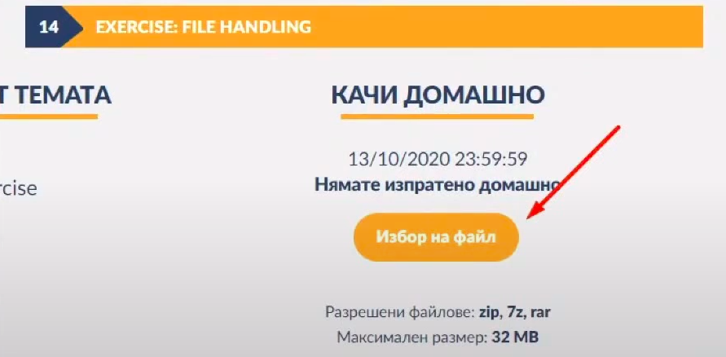You need to submit your project's folder, containing your solutions to the exercise's problems, excluding the .idea and venv folders. If you want to change your solution for some of the problems, you will need to upload a new zip file. The most resent uploaded solutions will be kept.

You will have a specific time frame for uploading your homework. After that period has ended, you will need to grade your colleagues' homework, in order for yours to be accounted for. You will need to grade at least 3 homeworks, submitted by your colleagues.