# Lab: Templates Advanced

# Pythons Wiki

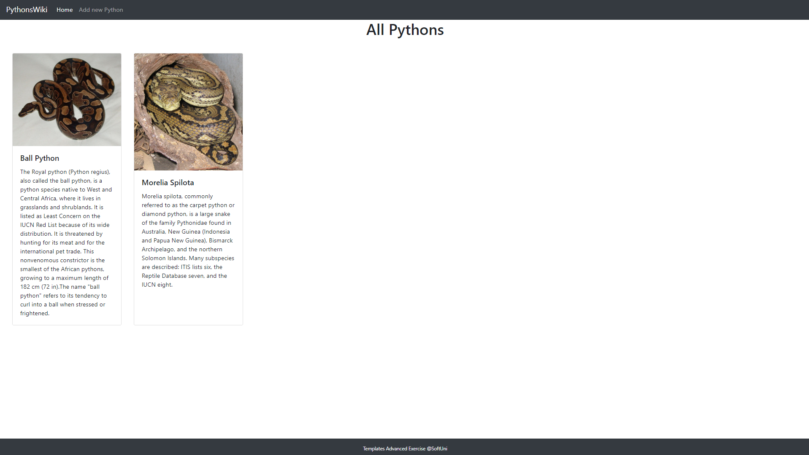

You are provided with a **working project**. **Refactor**all the templates, so you use **template inheritance**

### Tips

* Create a separate **folder** called **common**. In the folder create **two** separate **files** for the **header** and the **footer** (**header.html** and **footer.html**)
* Create a file called **base.html** in which the **header** and the **footer** templates are **included** and create a **block** called **content**
* **Refactor** the **create** and **index** files to **extend the base** file
* **Separate** the html for the **python details** in a **separate html** file
* In the **index.html** in the for loop **use** the created **template** for the **python details**

### Example Structure

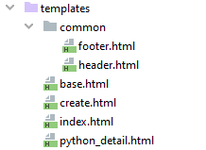

### base.html

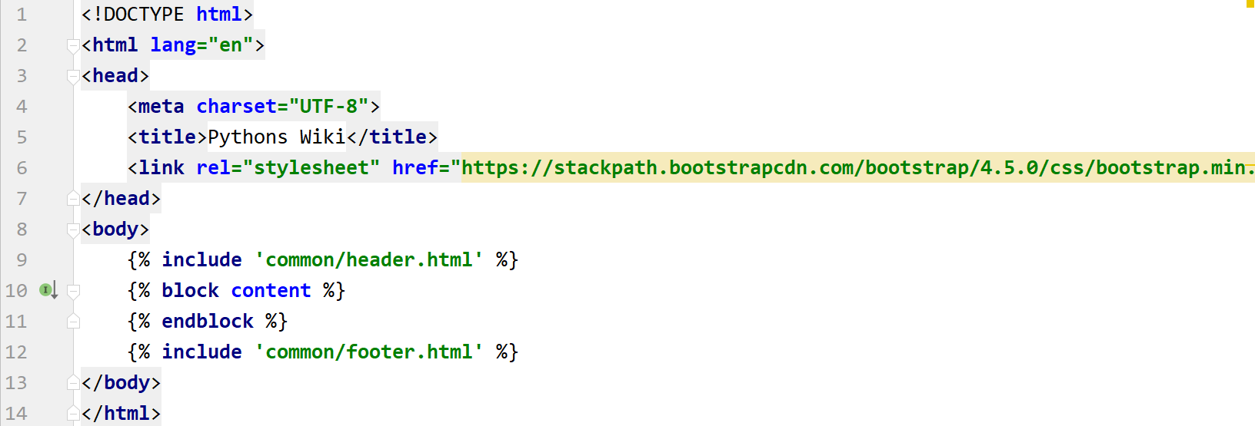

### create.html

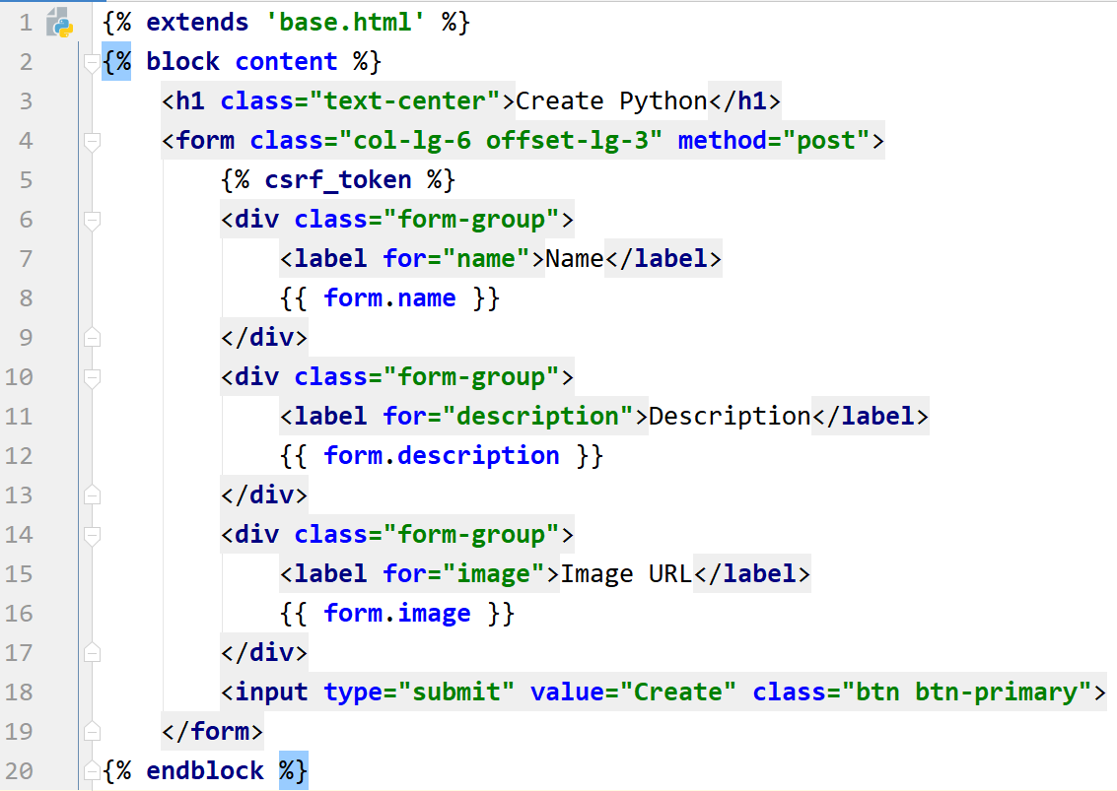

### index.html

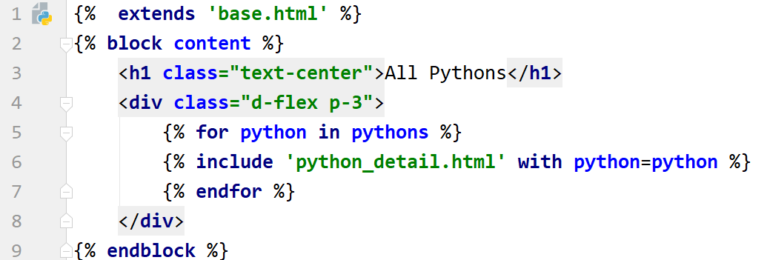

### python_detail.html

