 BACHELOR PROJECT

PROJECT TITLE: BUS TICKET MANAGEMENT SYSTEM

NAME: Arafat mahbub ID: 171-35-1982

Supervisor Name: Nusrat Jahan

Department: Software Engineering

Faculty of Science and Information Technology

Abstract

The project name is “Bus ticket management system”. Only administrator can use the system. First admin have to log in to the system. Admin can input all the documents of both the passenger and the driver. In case of any need, admin can search all the documents of the passenger and the driver by inputting name. Admin can also delete any documents.

Table of Contents page

Chapter 1 1

1. Introduction 1

1.1 About the System 2

1.2 Purpose 2

1.3 Scope 2

1.4 Vision 2

1.5 Why this system is necessary? 2

1.6 Proposed Solution 2

Chapter 2 3

2. Requirement Specification 3

2.1 Functional Requirement 4

2.2 Non Functional Requirement 4

Chapter 3 5

3. System Analysis 5

3.1 Use Case Model 6

3.2 Use Case Description (Brief) 7

Chapter 4 8

4. Implementation 8

4.1 Tools & Technologies 9

Chapter 5 10

5. System testing 10

5.1 Why Software Testing is Essential? 11

5.1.1 Black box testing 11

5.1.2 White box testing 11

5.2 Test Cases 12

Chapter 6 13

6. Conclusion 13

6.1 Good Features of the System 14

6.2 Limitations of the System 14

6.3 Future Enhancements 14

Appendices 15

7. User Manual 16

Chapter 1

Introduction

1. Introduction

1.1 About the System

1.2 Purpose

1.3 Scope

1.4 Vision

1.5 Why this system is necessary?

1.6 Proposed Solution

* 1. About the system: This system can only use by the admin. Here is a log-in option. First admin have to log-in in the system. Then the system will go main menu. Here are two option. 1. Passenger, 2. Driver. After select any option, it will go that menu. Here admin can add data, display all data, search data, delete data.
  2. Purpose: This system can use to save any kinds of data of the passenger and also the bus driver. Also search any data. Admin can also delete any data if it is not necessary.
  3. Scope: this system can only use in offline. It is connected with online. In order to save, delete or search any data this system can use.
  4. Vision: This system has some function that I implement.  
     1. Log-in   
     2. Add data  
     3. Display data  
     4. Search data  
     5. Delete data  
     In future I want to implement more function.

Such as: 1. Update data  
 2. Time function

* 1. Why this system is necessary?

This system is necessary because in this system admin can save all the information of passenger and driver. In any kind of problem, admin can communicate with the passenger and driver.

1.6 Proposed Solution: In future I will learn other programming language. I will also learn update function & time function.

Chapter 2

Requirement Specification

2.1 Functional requirement:

1. log-in

2. Add record

3. Display record

4. Search record

5. Delete record

6. Exit

2.2 Non-functional requirement:

1. Password

2. Username

Chapter 3

System Analysis

3.1 use case model

Admin

3.2 Use Case Description (Brief)

Here Admin is the only user of this system.

1. Log-in: Admin can log-in the system by using password & username.
2. Add record: Admin can add any record of the passenger & driver in this system.
3. Search record: Admin can search any record in this system.
4. Display record: Admin can display all record.
5. Delete record: Admin can delete any record.
6. Admin can exit from the system.

Chapter 4

Implementation

4.1 Tools & Technologies

* Computer
* Code Blocks (16.1)
* File. text
* C language

Chapter 5

System testing

5.1 Why Software Testing is Essential?

* Software testing is essential to find out the error that we made during the development phase. It is important because it ensure customer reliability on the product. It is very important to ensure the quality of the product.

5.1.1 Black box testing:

* Black box testing is a method of software testing, which is used to test the software without knowing the internal code.

5.1.2 White box testing:

* White box testing also known as clear box testing or glass box testing. It is a method in which the internal structure or design being tested is known to the tester.

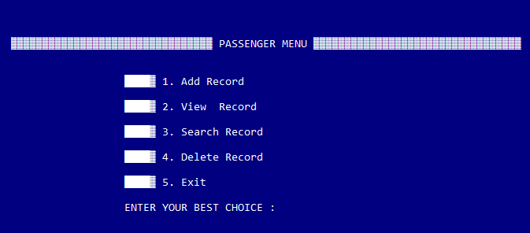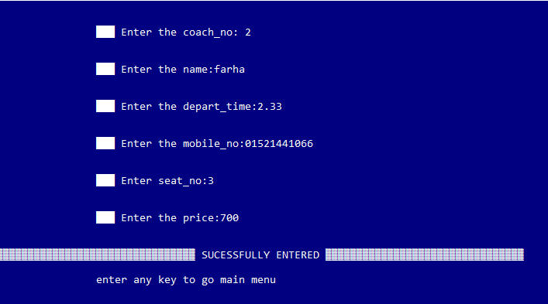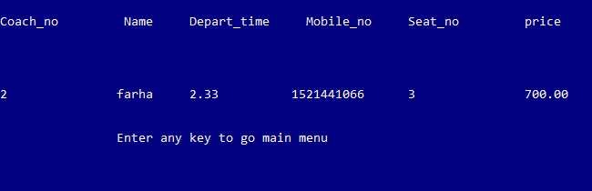

Chapter 6

Conclusion

* 1. Good Features of the System:
* Admin can add any kind of data of the passenger & driver. He can search & also delete any data he wants. This is a good features.
  1. Limitation of the system:
* The system can’t use on online. There is no edit option in this system.

* 1. Future Enhancements:
* In future I want to implement more function.

Such as: 1. Update data  
 2. Time function etc.

Appendices

User manual:

* Log-in
* Main menu
* Passenger menu & driver menu
* Passenger menu(add, display, search, delete record)
* Driver menu(add, display, search, delete record)
* Exit