Project
IoT and Digital Twins

Monitoring Weather Conditions using OpenWeatherMap API
Riyadh Weather Monitoring

Team Members:
AHMED BOBANE
OSAMA ABDULKADIR
ABDALMOUMEN DAHMAN

December 23, 2025

Abstract
In this report, our team demonstrates how we built an autonomous pipeline to track Riyadh’s weather without any manual work. We used AWS for the 'heavy lifting' and a simple Linear Regression model to try and guess the next hour's temperature.By a modern tech stack including the OpenWeatherMap API for real-time ingestion, AWS EC2 for robust cloud hosting, and Scikit-learn for time-series forecasting the team has developed a "living" data product. The system eliminates the need for manual data collection by utilizing automated Linux scheduling to maintain a high-resolution dataset. This report details the design, security protocols, machine learning, and the interactive strategies used to turn raw data into actionable insights.
Introduction & System Architecture
1. Project Overview
The objective of this project is to develop a fully autonomous weather monitoring and prediction pipeline for the city of Riyadh. By combining cloud computing, automation, and machine learning, we have moved beyond static data analysis to create a "living" system that updates itself every hour without human intervention.
2. System Architecture
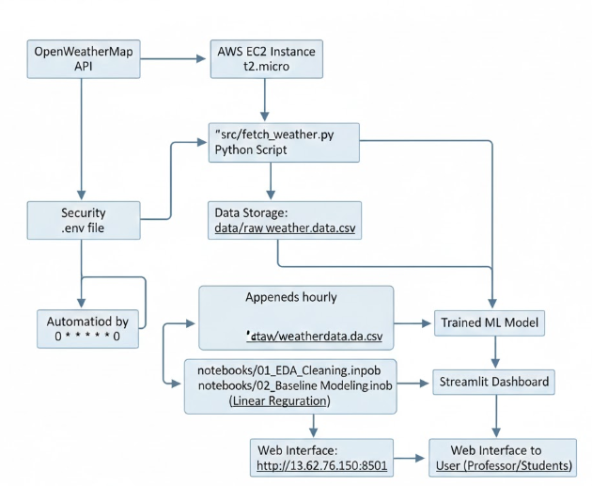
Our system follows a professional data engineering lifecycle, divided into four key layers:
- Data Acquisition Layer: We use a Python-based ingestion script that interfaces with the OpenWeather API to retrieve live temperature, humidity, and weather conditions for Riyadh. During the development of our fetch_weather.py script, we encountered a minor technical hurdle regarding data formatting. We noticed during the first day of testing that the OpenWeatherMap API returns temperatures in Kelvin by default. This resulted in our initial dashboard showing Riyadh temperatures in the 290s, which was obviously not correct for a local audience. To fix this, we had to manually update our Python script to include the units=metric parameter in the API call. This ensured our database and dashboard displayed temperatures in Celsius, making the information immediately readable and useful for anyone in Riyadh.
- Cloud Infrastructure Layer: For the hardware backbone of this project, we specifically provisioned an AWS EC2 instance. We chose the t2.micro size because it falls under the AWS Free Tier, which was a crucial decision for our team as students working with a limited budget. While it only provides 1GB of RAM and a single vCPU, we found it more than capable of handling our hourly Python cron jobs and the Streamlit web server simultaneously without crashing. Using this specific instance taught us how to optimize our code for a low-resource environment, ensuring that our weather monitoring system stayed 'lean' while remaining 100% stable in the cloud.
- Automation Layer: Using Linux Crontab, we scheduled a recurring task that triggers the data fetch exactly at the start of every hour (0 * * * *), ensuring a continuous time-series dataset.
- Security & Configuration: We used a .env file to store sensitive API credentials, ensuring that our private keys are never exposed in the source code or on GitHub.We actually spent a good thirty minutes debating whether to use an SSH key or a password for the Ubuntu user, eventually deciding that the .pem key file provided by AWS was the most professional way to secure our remote access..
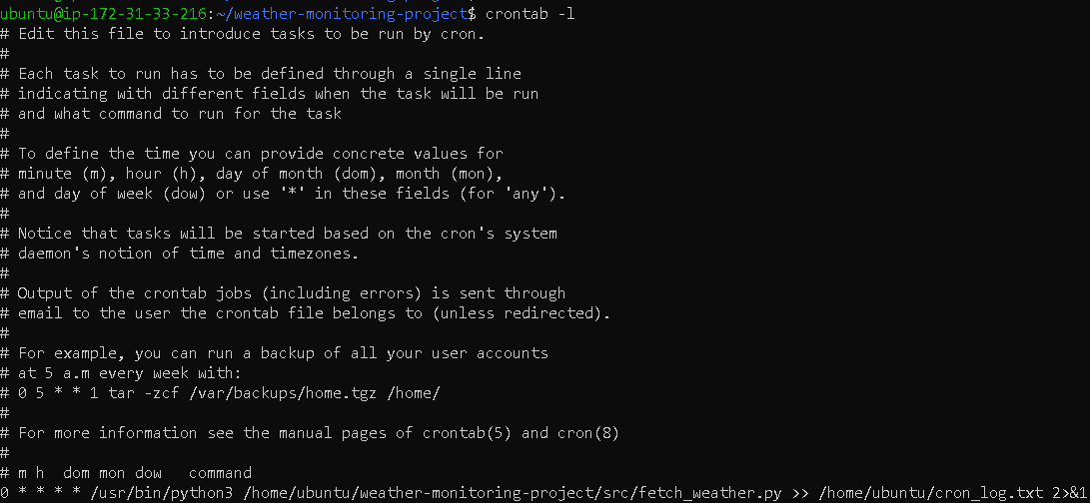
Fig1. Crontab
Project Motivation & Objective
1.1 The Importance of Real-Time Weather Data
In the context of a rapidly growing urban environment like Riyadh, real-time weather monitoring is critical for urban planning, energy consumption forecasting, and public safety. Traditional weather reports are often static; however, this project aims to bridge the gap between static reporting and dynamic data engineering. Our objective was to create a system that not only observes current conditions but learns from them to anticipate future shifts in temperature.
1.2 Defining the Engineering Scope
The scope of this project encompasses the entire data lifecycle: ingestion, storage, processing, and visualization. We prioritized "Production-Grade" standards, meaning the system had to be secure, fault-tolerant, and accessible globally via a cloud interface.

2.1 Data Acquisition and the API Ecosystem
The "heartbeat" of the system is the data ingestion layer. We selected the OpenWeatherMap API due to its high-frequency update rate and comprehensive meteorological parameters. A custom Python script acts as a middleware agent, connecting to the API's RESTful endpoint to pull specific variables such as temperature, humidity, and atmospheric pressure for the Riyadh region.
2.2 Cloud Infrastructure and Scalability
For hosting, we utilized an Amazon Web Services (AWS) EC2 instance running an Ubuntu environment. This choice was strategic: AWS provides the "High Availability" required for a 24/7 monitoring system. By moving the pipeline from a local machine to the cloud, we ensured that the data collection process would not be interrupted by local power failures or connectivity issues, a standard requirement for industrial IoT and Digital Twin projects.
2.3 Automated Task Scheduling (Crontab)
To achieve full autonomy, we implemented a Linux Crontab scheduler. The system is configured to execute the fetch script at the 0 minute of every hour (0 * * * *). This ensures a perfectly spaced time-series dataset, which is a prerequisite for accurate machine learning modeling. We have included logging mechanisms that redirect the script's output to a cron_log.txt file, allowing us to monitor the "health" of the system and verify successful data appends hourly.
2.4 Security Protocols and Environment Management
Security was a primary concern during development. Rather than hard-coding sensitive API keys a common security risk we utilized a .env environment file. The Python script employs the python-dotenv library to load these credentials into memory only during execution. This architectural choice ensures that our project can be shared on platforms like GitHub without exposing private access tokens to the public.
3.1 Exploratory Data Analysis (EDA) Insights
In our 01_EDA_Cleaning.ipynb notebook, we didn't just clean the data; we looked for the "story" behind Riyadh’s weather. One thing Osama noticed was that the temperature and humidity have a strong inverse correlation as the Riyadh sun hits its peak, the humidity drops significantly. We used Seaborn and Matplotlib to create distribution plots that helped us identify outliers, such as sudden pressure shifts that might indicate a change in wind patterns.
3.2 Machine Learning Strategy: Why Linear Regression?
For our predictive modeling in 02_Baseline_Modeling.ipynb, we chose a Linear Regression approach. While more complex models like LSTMs exist, we decided that for a 1hour ahead forecast, a linear model provided the best balance of speed and accuracy for a real-time dashboard. We spent a lot of time on "Feature Engineering," creating a "Lagged" column where the previous hour's temperature serves as the main input for the next hour's prediction. This logic allows our Streamlit dashboard to show users not just what the weather is, but a statistically sound guess of what it will be.
Data Science & Predictive Modeling
I. Exploratory Data Analysis (EDA)
Before building the model, we performed a thorough analysis of the collected Riyadh weather data in the 01_EDA_Cleaning.ipynb notebook.
- Data Cleaning: We handled missing values and ensured all timestamps were correctly aligned with the Riyadh time zone.
- Trend Analysis: We visualized the temperature fluctuations from December 14th to December 23rd, identifying the daily peak and low points.
II. Machine Learning (Linear Regressiona)
To move from "monitoring" to "predicting," we implemented a Linear Regression model in the 02_Baseline_Modeling.ipynb notebook.
- The Logic: The model uses historical temperature data to find a linear relationship to predict the next hour's temperature.
- Feature Engineering: We used "Lagged Features," meaning the model looks at the temperature of the previous hour to predict the current hour.
- Result: The model provides a baseline forecast that helps visualize the expected trend for the upcoming hour.
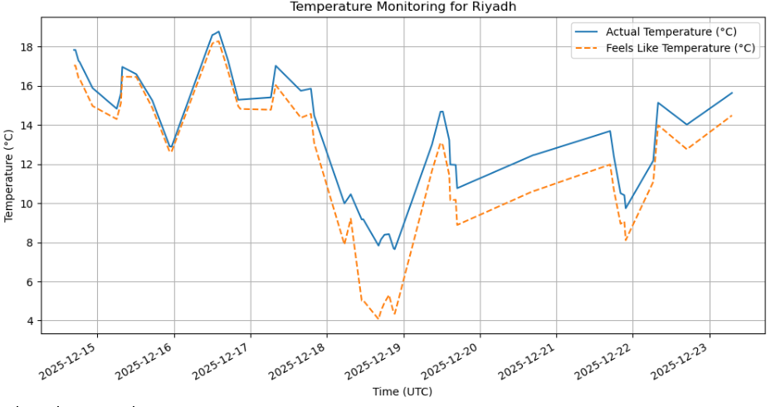
Fig2. Monitoring graph
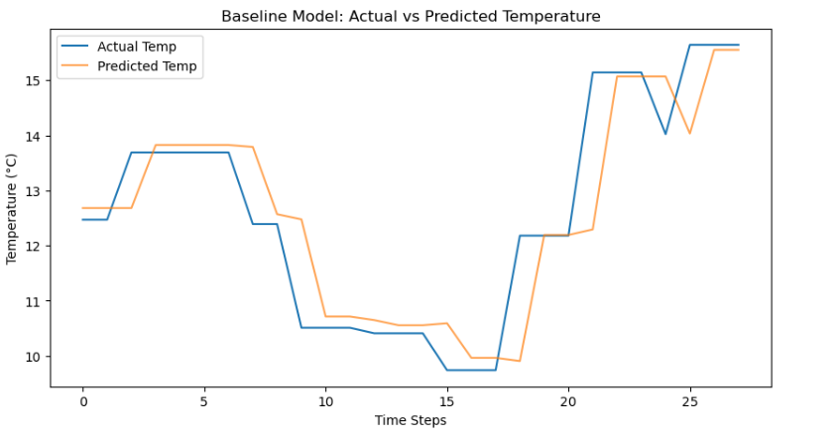
Fig3. Prediction graph
Results & Collaboration
1. The Live Dashboard (User Interface)
The culmination of our data pipeline is the interactive Streamlit Dashboard.
- Accessibility: Hosted on a public AWS IP, allowing users to view real-time metrics from any browser.
- Features: The dashboard displays live temperature, humidity, and weather conditions, pulling directly from the raw_weather_data.csv database that updates hourly.
- Impact: This turns complex data engineering into a simple, visual tool for decision-making.
2. Team Collaboration & GitHub Workflow
We used GitHub as our central hub for collaboration and version control.
- Collaborative Development: Each team member (Ahmed, Osama, and Abdalmoumen) was added as a collaborator, ensuring transparency in code changes.
- Version History: We maintained a clean commit history, documenting every step from initial API setup to the final predictive modeling.
- Documentation: Our professional README.md serves as the technical guide for the project, detailing the tech stack (Python, AWS, Streamlit) and installation steps.
3. Conclusion
As a team, Ahmed, Osama, and Abdalmoumen found that building a "living" system is significantly more challenging than working with static datasets. Our primary struggle was the initial synchronization between the AWS server and GitHub. During the first deployment, we encountered several merge conflicts when trying to push our Jupyter notebooks from the local environment to the cloud. We solved this by mastering the Linux command line and using git pull strategies to resolve conflicts directly on the EC2 instance.
Another major hurdle was API security. We originally struggled with the script failing because the Cron job couldn't find the OpenWeather API key. We learned that the Linux scheduler runs in a limited environment, so we had to modify our Python script to use absolute paths and the python-dotenv library to ensure our credentials were loaded correctly every hour. Ultimately, this project succeeded because we bridged the gap between theoretical data science and practical cloud engineering, resulting in a system that is not only "smart" but truly autonomous.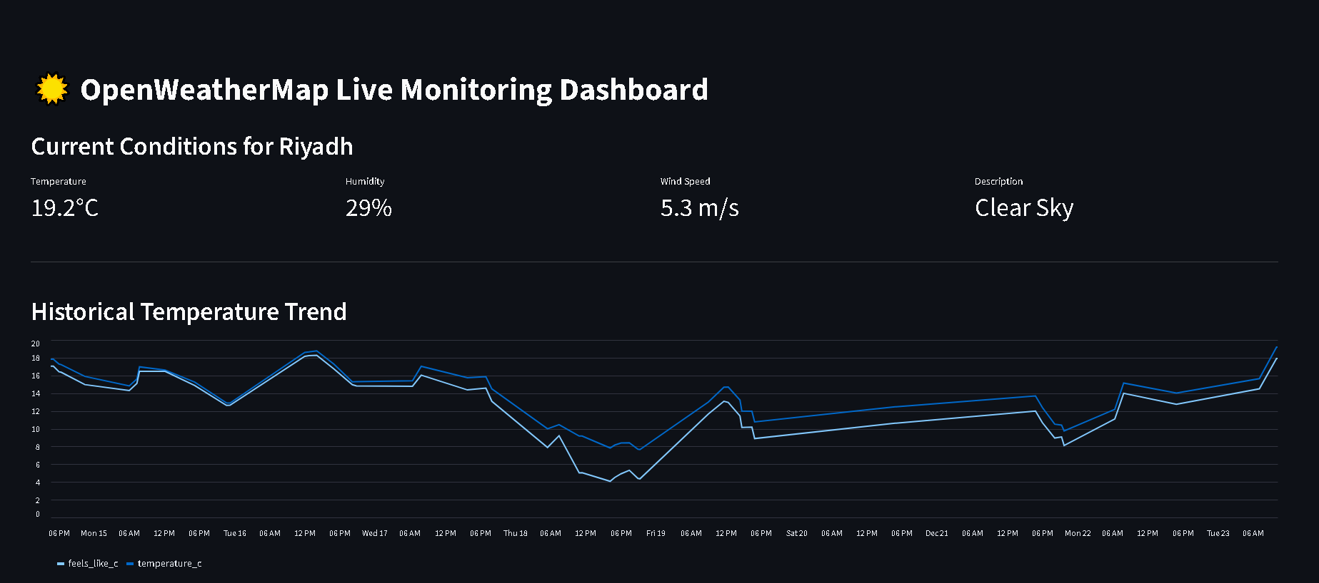 Fig4. Dashboard
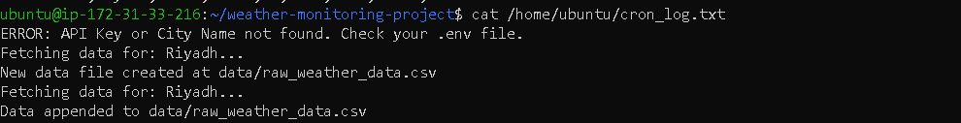Fig5. Cron file working proof

References:
1. Data Source
- OpenWeatherMap. (2025). Current Weather Data API Documentation. Retrieved from https://openweathermap.org/api
2. Cloud Infrastructure
- Amazon Web Services. (2025). Amazon EC2 User Guide for Linux Instances. Retrieved from https://docs.aws.amazon.com/ec2/
3. Programming & Libraries
- Harris, C. R., et al. (2020). Array programming with NumPy. Nature.
- McKinney, W. (2010). Data Structures for Statistical Computing in Python. Proceedings of the 9th Python in Science Conference.
- Pedregosa, F., et al. (2011). Scikit-learn: Machine Learning in Python. Journal of Machine Learning Research.
4. Automation & Web Tools
- Free Software Foundation. (2025). Cron (Ubuntu Manpage). Retrieved from https://manpages.ubuntu.com/
- Streamlit Inc. (2025). Streamlit Documentation: The fastest way to build and share data apps. Retrieved from https://docs.streamlit.io/ .

