**San Francisco Bay University**

**CS483 - Fundamentals of Artificial Intelligence**

**Homework Assignment #6**

**Due day: 8/15/2022**

**Instruction:**

1. **Push the source code to Github**
2. **Overdue homework submission could not be accepted.**
3. **Take academic honesty and integrity seriously (Zero Tolerance of Cheating & Plagiarism)**

1. Assuming that there are 3 m&m candy bottles (labeled B1, B2, B3) with red, green and yellow colors, one of the candies from 3 bottles will be randomly taken out in a series. Given the transition probability matrix *A*, emission probability *B* and initial probability *π* as follows, if observation sequence is *red-red-yellow-green-yellow*, write python program by the functions from *"hmmlearn"* model to find probability of observation sequence *P(rrygy),* and what most likely bottles in series they are coming from.

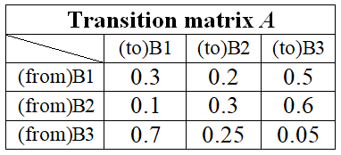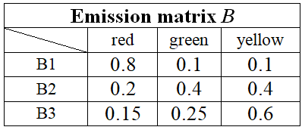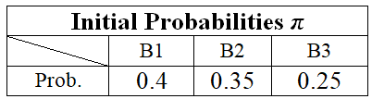

**Solution:**

|  |
| --- |
| # %%  """      Given observations, find hidden state sequence by viterbi algorithm  """  import numpy as np  from hmmlearn import hmm  states = ["B1", "B2", "B3"]  n_states = len(states)   # =3  observations = ["red", "red", "yellow", "green", "yellow"]  n_observations = len(observations)  start_probability = np.array([0.4, 0.35, 0.25])  transition_probability = np.array([    [0.3, 0.2, 0.5],    [0.1, 0.3, 0.6],    [0.7, 0.25, 0.05]  ])  emission_probability = np.array([    [0.8, 0.1, 0.1],    [0.2, 0.4, 0.4],    [0.15, 0.25, 0.6]  ])  model = hmm.MultinomialHMM(n_components=n_states)  # MultinomialHMM: observation distribution in Multinomial  model.startprob_=start_probability  model.transmat_=transition_probability  model.emissionprob_=emission_probability  seen = np.array([[0,0,1,2,1]]).T        # 0: red;     1: yellow   2: green => r r y g y  logprob, box = model.decode(seen, algorithm="viterbi")  seen = [0,0,1,2,1]  print("If Observation sequence is:", ", ".join(map(lambda x: observations[x], seen)))  print("Then the Bottle Series will be:", ", ".join(map(lambda x: states[x], box)))  """      Find probability of observation sequence  """  seen = np.array([[0,0,1,2,1]]).T                   # P(rrygy) =?  print(f"The model Score is: {model.score(seen)}") |

2. Suppose there are only two average annual temperatures, "Hot" and "Cold" in Fremont city of California, and also suppose that current observation in Mission San Jose district indicates a correlation between the tree size of palm, small(s)/medium(m) /large(l) and temperature, as follows are the transition matrix A, emission matrix B, and initial probabilities π.

|  |  |  |  |
| --- | --- | --- | --- |
| Emission matrix B | | | |
|  | s | m | l |
| H | 0.1 | 0.4 | 0.5 |
| C | 0.7 | 0.2 | 0.1 |

|  |  |  |
| --- | --- | --- |
| Transition matrix A | | |
|  | H | C |
| H | 0.7 | 0.3 |
| C | 0.4 | 0.6 |

|  |
| --- |
| Initial Prob. π |
| P(H) = 0.6 |
| P(C) = 0.4 |

**Solution:**

|  |
| --- |
| #Given Transition Probabilities  p_11 = 0.7  p_12 = 0.3  p_21 = 0.4  p_22 = 0.6  #Given Initial Probabilities  p_1 = 0.6  p_2 = 0.4  #Given Emission Probabilities  p_1s = 0.1  p_1m = 0.4  p_1l = 0.5  p_2s = 0.7  p_2m = 0.2  p_2l = 0.1  seq = ['S','M','L']  probabilities = []  out = []  if seq[0] == 'X':        probabilities.append((p_1*p_1s, p_2*p_2s))  else:       probabilities.append((p_1*p_1l, p_2*p_2l))  for i in range(1,len(seq)):      hot_prev, cold_prev = probabilities[-1]      #Given sequence has only X and Z, so we consider these cases only      if seq[i] == 'X':          hot_today = max(hot_prev*p_11*p_1s, cold_prev*p_21*p_1s)          cold_today = max(hot_prev*p_12*p_2s, cold_prev*p_22*p_2s)          probabilities.append((hot_today, cold_today))      else:          hot_today = max(hot_prev*p_11*p_1l, cold_prev*p_21*p_1l)          cold_today = max(hot_prev*p_12*p_2l, cold_prev*p_22*p_2l)            probabilities.append((hot_today, cold_today))  for p in probabilities:      if(p[0]>p[1]):          out.append('S')      elif(p[1]>p[0] ):          out.append('M')      else :          out.append('L')  #  (a) p = P(smsl HHCC) ?    p = p[0]*p[0]*p[1]*p[1]        # where 0-> H and 1-> C  print("P(smsl HHCC) = ", p)  #  (b) Calculate 𝛼2(1) 𝑎𝑛𝑑 𝛼2(2) in forward algorithm    𝛼2_1 = 0.06*0.7*0.4  𝛼2_2 = 0.028*0.6*0.4  print("𝛼2(1) = ", 𝛼2_1)  print("𝛼2(2) = ", 𝛼2_2) |