Machine Learning - Supervised Learning Linear Regression using Normal Equation

Student Name: Mahmud Omer ID: 19660

Week2_hw2



Importing files from local disc to google Colab

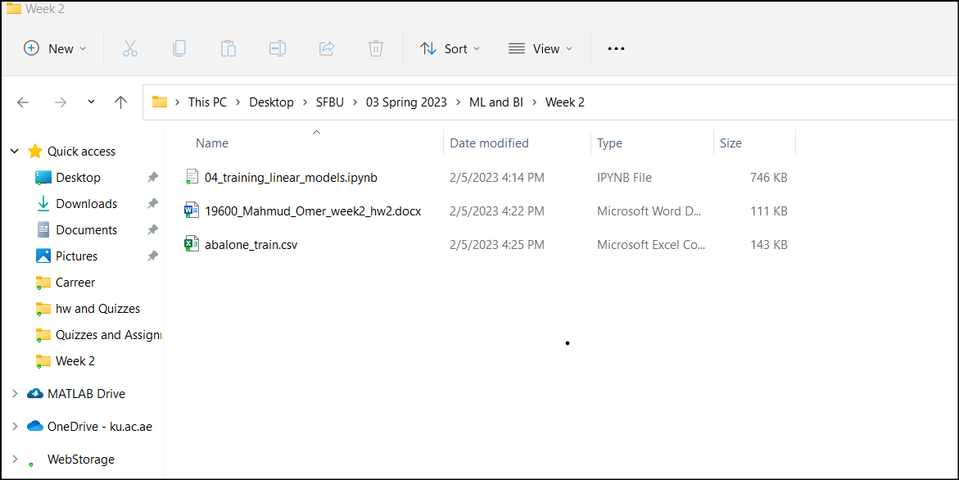

Setting up:

Modifying original code in linear regression using Normal equation:

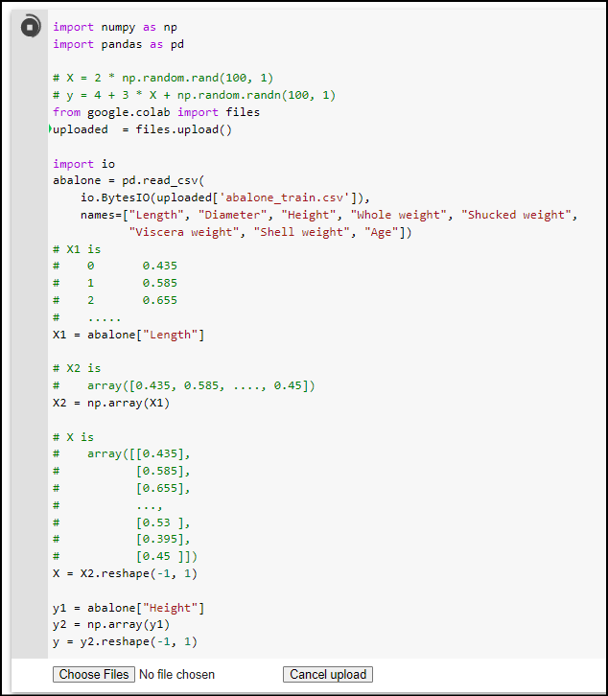

Uploading csv file from local drive to google colab and testing the code



Updating code by changing 100 to 3320

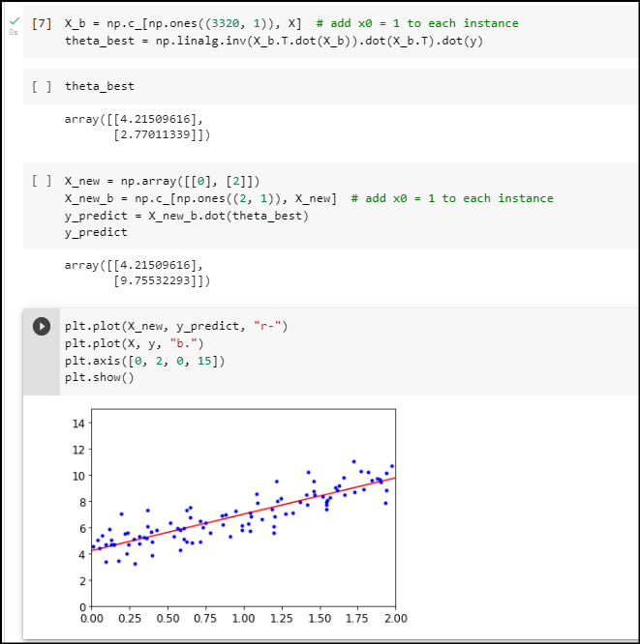

We can also update the code by specifying the number of rows as follows to solve the initially generated error.

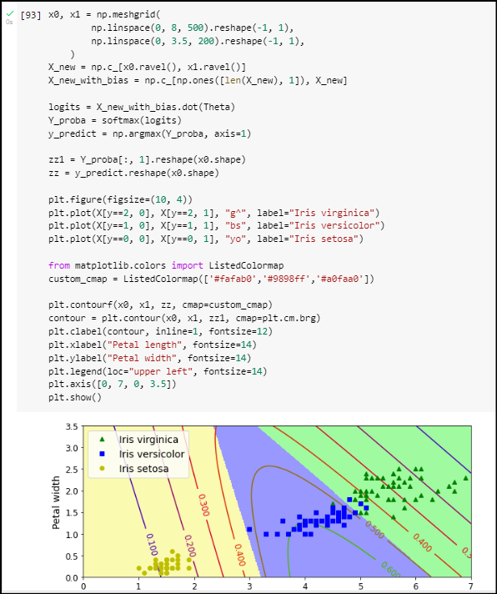

End of code running successfully, showing code is working as desired

