Name: Mahmud H. Omer ID: 19660

Week6_Hw_2: Compare Bayes Classifier and KNN

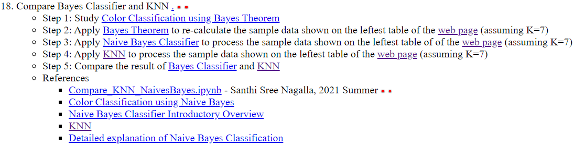

Solution:

Using KNN, K = 7

|  |  |  |  |  |  |  |  |  |  |  |  |  |  |  |  |  |  |  |  |  |  |  |  |  |  |  |  |  |  |  |  |  |  |  |  |  |  |  |  |  |  |  |  |  |  |  |  |  |  |  |  |  |  |  |  |
| --- | --- | --- | --- | --- | --- | --- | --- | --- | --- | --- | --- | --- | --- | --- | --- | --- | --- | --- | --- | --- | --- | --- | --- | --- | --- | --- | --- | --- | --- | --- | --- | --- | --- | --- | --- | --- | --- | --- | --- | --- | --- | --- | --- | --- | --- | --- | --- | --- | --- | --- | --- | --- | --- | --- | --- |
| |  |  |  |  |  | | --- | --- | --- | --- | --- | | **X1 =Years of working experience** | **X2 =Number of kids** | **Y =Credit card is approved or not** | **Distance to each neighbor = (TargetX1-DataX1)^2 +(TargetX2-DataX2)^2 = (6-X1)^2+(6-X2)^2** | **K= 7** | | 3 | 4 | + | (6-3)^2+(6-4)^2 = 9+4 = 13 | + | | 2 | 5 | + | (6-2)^2+(6-5)^2 = 16+1 = 17 | + | | 7 | 3 | - | (6-7)^2+(6-3)^2 = 1+9 = 10 | - | | 5 | 3 | - | (6-5)^2+(6-3)^2 = 1+9 = 10 | - | | 1 | 5 | + | (6-1)^2+(6-5)^2 = 25+1 = 26 |  | | 2 | 6 | + | (6-2)^2+(6-6)^2 = 16+0 = 16 | + | | 3 | 2 | - | (6-3)^2+(6-2)^2 = 9+16 = 25 | - | | 5 | 1 | - | (6-5)^2+(6-1)^2 = 1+25 = 26 |  | | 2 | 6 | + | (6-2)^2+(6-6)^2 = 16+0 = 16 | + | | 6 | 6 |  |  | + | |

For K = 7 , for some one with 6 years of work experience and 6 kids , credit card approval is positive (+)

**Applying Bayes classifier ( k = 7) :**

Calculate Prior Probability

Prior probability for [“+”]:

P (+) = Number of ["+"] sample / Total number of samples = 5/9 = 0.56

Prior probability for ["-”]:

P (-) = Number of [“-”] sample / Total number of samples = 4/9 = 0.44

Calculate Conditional probability :

Likelihood of X given ["+”]

Probability of X given ["+"]

count (+, X) / count (+) ⇒ Number of [“+”] in the vicinity

(Nearest neighbors) of X P (X | P (X | +) = ---------------------------------------------------------------------------------------

Total number of [“+”] case

= 4/5

Likelihood of X given ["-”]

Probability of X given ["-"]

count (-, X) / count (+) ⇒ Number of [“-”] in the vicinity

(Nearest neighbors) of X P (X | P (X | -) = ---------------------------------------------------------------------------------------

Total number of [“-”] case

= 3/4

Final probability of X being “+ “ = P (+) * P (X | P (X | +) = 0.56 *0.8 = 0.448

Final probability of X being “- “ = P (-) * P (X | P (X | -) = 0.44 *0.75 = 0.33

The probability of X being “+” is greater than the probability of X being “-“ , which agrees with the output result obtained using KNN. Hence, Both KNN and Bayes classifier achieved the same result.

Coding:

KNN

Csv file:

Note:

The input are represented by x and y values , and the output by z. z = 1 is used for “+” and 0 for “-“

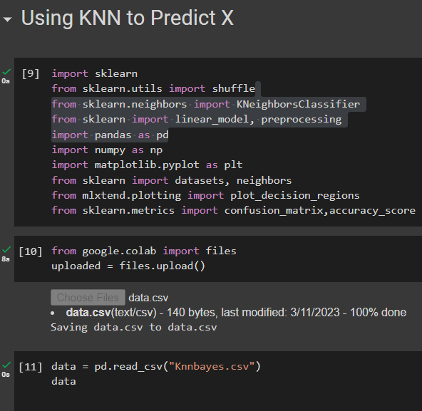

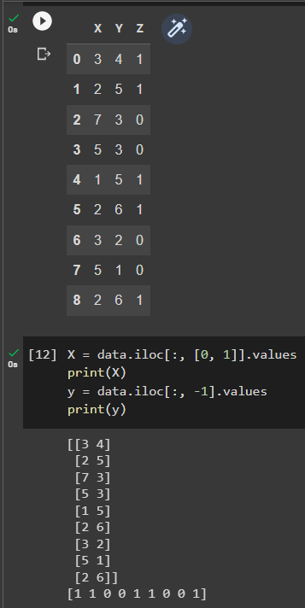

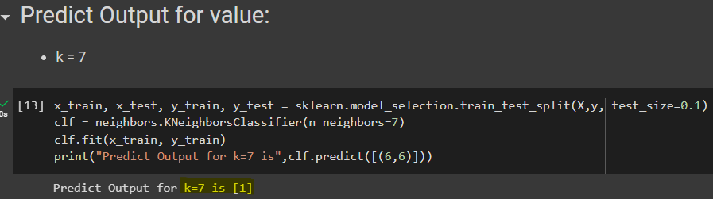

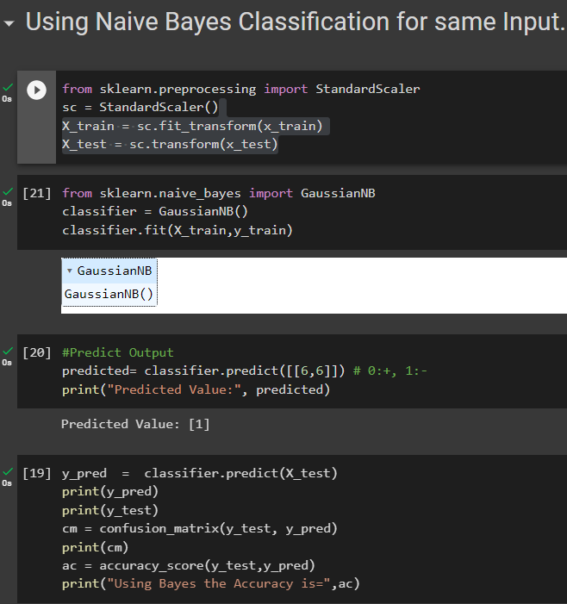

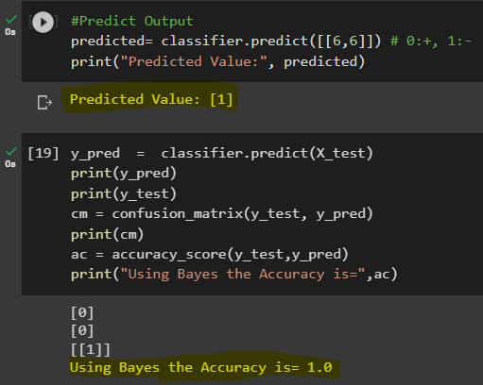

Conclusion:

In conclusion, both KNN and Bayes classifiers are effective machine learning algorithms that can be used for classification tasks. KNN is a simple and intuitive algorithm that works well for datasets with few features and large sample sizes. Bayes classifier, on the other hand, is a probabilistic approach that works well for datasets with complex distributions and high-dimensional feature spaces. In general, KNN performs better than Bayes when the dataset is small and the features are simple, while Bayes performs better when the dataset is large and the features are complex. Ultimately, the choice between KNN and Bayes depends on the specific characteristics of the dataset and the classification problem at hand. In this case study, both classification methods obtained the same X result, which is “+”.