POC

3-11-2023

**Linux Basic Commands:**

**Ls and cd:**

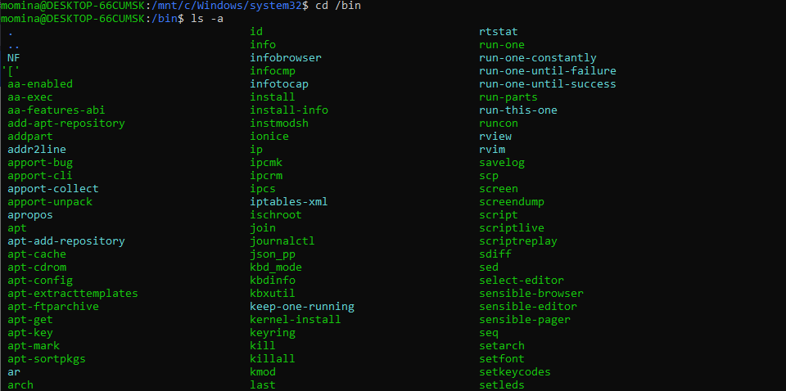



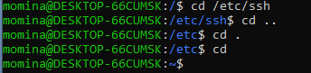

Mkdir and rmdir:

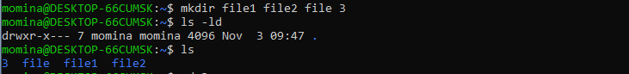

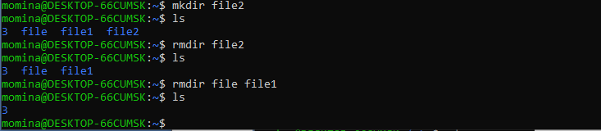

Mv:

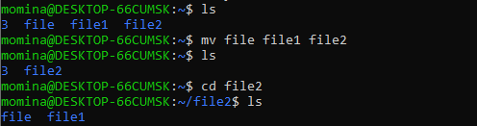

Cp:

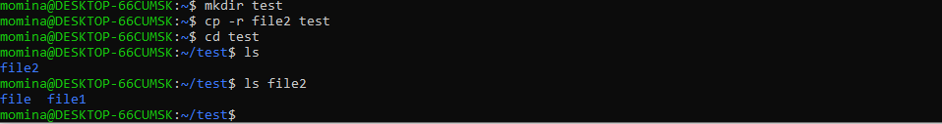

**Soft link and hard link:**

|  |  |
| --- | --- |
| **Hard link** | **Soft link** |
| Can’t be created for directories and different file systems | Can be created for directories and different file systems |
| The hard link is indistinguishable from ordinary file | The hard link is distinguishable from ordinary file as it contains “l” as file type |
| Remains there even if original file is removed | Doesn’t remain |
| Inode number increases | It remains same |
| Command: ln | Command: ln -s |

Compression:

