



Electronic Circuit and Design
(EE -313)
DE-45 Mechatronics
Syndicate – C
Project Report

Names of Members:
- NC Momina Rizwan
Reg # 473318
2. NC Unzila Zeb
Reg # 467557
3. NC Eman Khurram
Reg # 457438
4. PC Ibrahim Nazir
Reg # 482332

Submitted to: LE Muhammad Kashan

- Abstract:
This project addresses critical aspects of audio amplification in the presence of noise, focusing on achieving high performance through careful design and analysis of multi-stage amplifiers. By optimizing noise suppression techniques and ensuring stability in circuit operation, the goal is to enhance audio quality for listeners experiencing disturbances from stereo noise.
- Introduction:
- Butterworth filter:
The Butterworth filter is a type of signal processing filter known for its maximally flat frequency response in the passband, making it ideal for applications where a smooth output is crucial. This filter design aims to provide a frequency response that is as flat as possible within the desired frequency range, avoiding ripples that can distort the signal. The Butterworth filter is designed to have no ripples in the passband, which means that the gain remains constant. The cutoff frequency is a critical parameter for Butterworth filters. The cutoff frequency determines the point at which the filter begins to attenuate higher frequencies. The order of a Butterworth filter influences both the steepness of the roll-off and the transition from the passband to the stopband. Higher-order filters provide sharper transitions but may introduce more complexity in design and implementation. The poles of a Butterworth filter are evenly distributed on a semicircle in the left half of the s-plane (for continuous-time filters), which contributes to its flat frequency response.
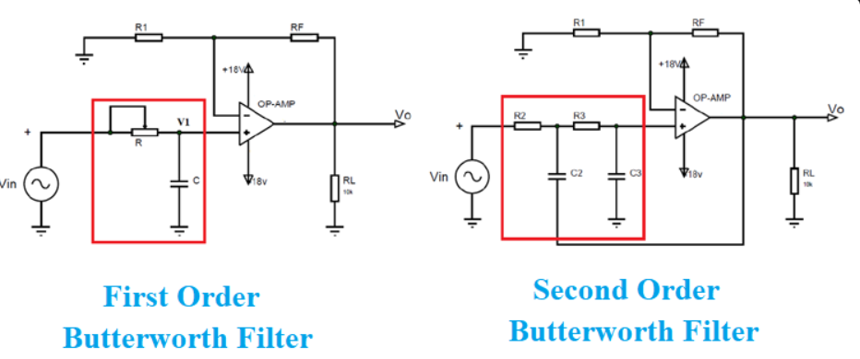
Figure 1 : first and second order filter
Features | First-order butterworth filter | Second-order butterworth filter
Roll-Off Rate | -20 dB per decade (-6 dB per octave) | -40 dB per decade (-12 dB per octave)
Cutoff Frequency | Defined, gradual transition | Defined, sharper transition
Design Complexity | Simpler design (1 resistor, 1 capacitor) | More complex design (2 resistors, 2 capacitors)
Circuit Configuration | Typically RC circuit with op-amp | Typically involves two reactive components with op-amp
Performance in Applications | Suitable for minimal filtering needs | Better noise suppression and sharper cutoff characteristics
Ideal Filter Approximation | Less ideal, smoother response | Closer to ideal filter behavior
Table 1: difference between first order and second order filter
- Sallenkey filter:
The Sallen-Key filter is classified as a voltage-controlled voltage source (VCVS) filter. It typically employs an operational amplifier (op-amp) configured as a buffer or non-inverting amplifier, along with two resistors and two capacitors to form the desired filter response.Sallen-Key filters can be configured as low-pass, high-pass, band-pass, or band-stop filters. The most common implementations are low-pass and high-pass configurations, which allow for effective frequency selection.One of the defining features of the Sallen-Key topology is its ability to provide a maximally flat gain in the passband, similar to that of Butterworth filters. This characteristic ensures minimal distortion and smooth frequency response across the desired range.The Sallen-Key design allows for controlled positive feedback, which can enhance the quality factor (Q) of the filter. By adjusting the gain of the op-amp, designers can achieve higher Q values than those possible with passive filters alone. The Sallen-Key topology allows for easy cascading of multiple stages without significant interaction between them, making it suitable for applications requiring multiple poles.The transfer function for a second-order Sallen-Key low-pass filter can be expressed as:
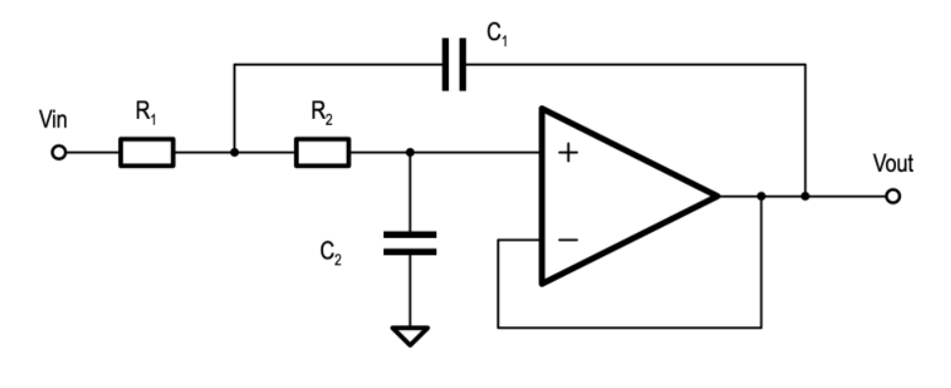
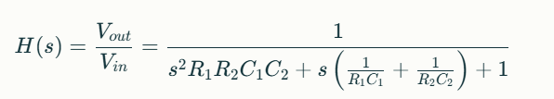

Figure 2: sallenkey filter schematic

- Combined circuit of Sallenkey and Butterworth filter on proteus:
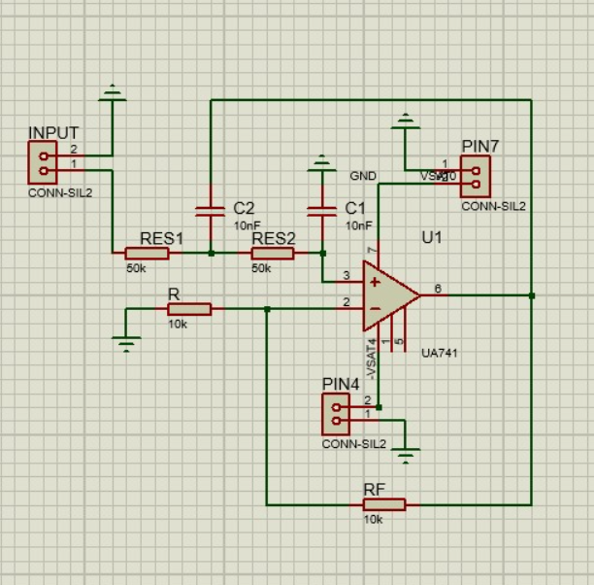

Figure 3 : Combined circuit of Sallenkey and Butterworth filter on proteus
- Calculations :
fc value varies from 318 to 500Hz
Sallenkey 2nd order equation is:
$$fc=\frac{1}{2π{(RC)}^{\frac{1}{2}}}$$
If fc = 318Hz and C = C₁ = C₂ = 10nF
So,
$$318 = \frac{1}{2π\sqrt{R(10x{10}^{-9})}}$$
$$\sqrt{R(10x{10}^{-9})}= \frac{1}{2πx318}$$
$$R= \frac{1}{10x{10}^{-9}}x({\frac{1}{2πx318})}^{2}$$
$R= 25.0487$ ohms

If fc = 500Hz and C = C₁ = C₂ = 10nF
So,
$$500 = \frac{1}{2π\sqrt{R(10x{10}^{-9})}}$$
$$\sqrt{R(10x{10}^{-9})}= \frac{1}{2πx500}$$
$$R= \frac{1}{10x{10}^{-9}}x({\frac{1}{2πx500})}^{2}$$
$R=$10.132 ohms
Gain will become:
$$k=1+\frac{Rf}{R1}$$
According to the table: k=1.586, V_{ds} = 2V , V_{gs} = 2.5V, V_{th}=2.1V, V_{dd} = 5V, I_{ds}=3.3mA and Res1=Res2, C1=C2. The amplifier used common source configuration using 2N7000 in voltage divider bias configuration.

Initial Approach

- MOSFET Circuits: Common Source and Common Drain Amplifiers
- Common Source (CS) Amplifier
The second stage of the circuit is a common source amplifier built using an n-channel MOSFET (2N7000). This configuration provides significant voltage amplification.
Working Principle
Input applied on gate of MOSFET.Since MOSFET is under saturation region, ID, the drain current, would vary by controlling gate to source voltage, VGS.The AC part of the drain current produces a voltage across RD, leading to an enhanced output signal.The bypass capacitor C4 also enhances the gain of the amplifier. This is done by shorting the AC signal across RS.

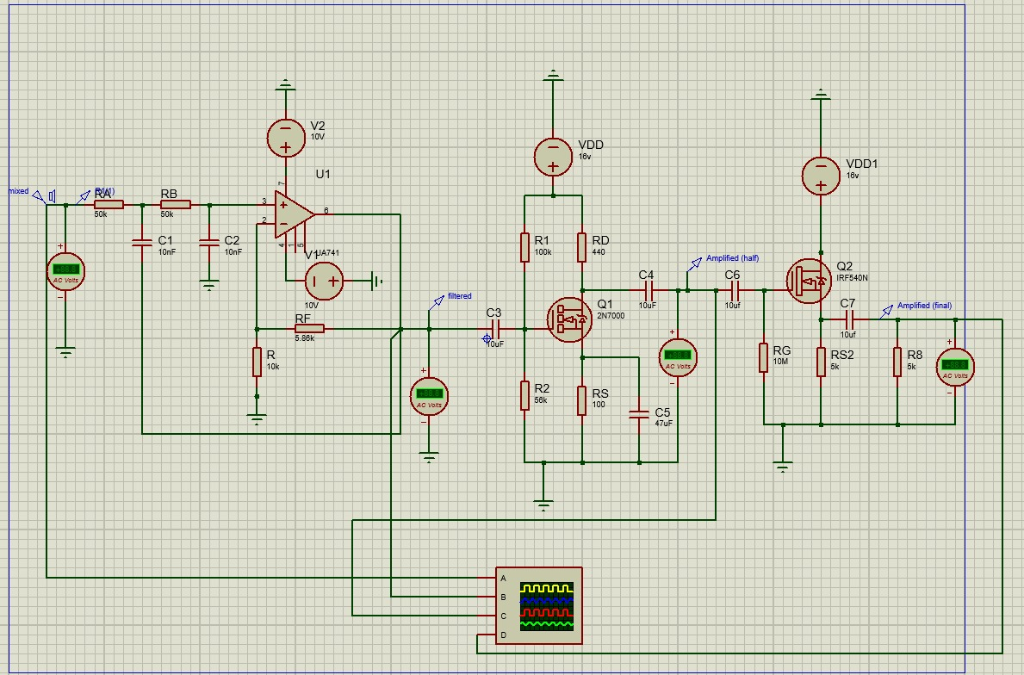
Fig 4.Common source

- Common Drain (CD) Amplifier (Source Follower)
This is the third stage as a common drain amplifier and is known as a source follower and implemented with the power n-channel MOSFET-IRF540N. This circuit is basically implemented for impedance matching, but it exhibits unity voltage gain, a characteristic of buffering.
Working Principle
The input signal is applied to the gate of the MOSFET.The source terminal follows the gate voltage and produces an output signal with the same voltage level as the input but of low impedance.This configuration does not amplify voltage but provides high current driving capability. The CD amplifier is ideal for impedance matching between high-impedance sources (previous stage) and low-impedance loads (next stage). It ensures minimal signal loss during transmission.

Fig 5. Common Drain

Despite the theoretical advantages of MOSFETs, such as high input impedance and ease of integration, we observed that the output signal was not amplified as expected. This prompted us to reconsider our design, as the gain achieved was insufficient for practical application.
Revised Approach

BJT-Based Amplification:
To address the shortcomings of the MOSFET-based design, we replaced the common source amplifier with a common emitter voltage divider configuration using a Bipolar Junction Transistor (BJT). The rationale behind this change was that BJTs inherently have higher amplification capabilities compared to MOSFETs due to their current-controlled nature.
Initial Gain Design (Av = 10):
For the BJT amplifier, we initially aimed for a voltage gain of 10. However, during calculations:
- Using β=250, ib=100uA, ic=25mA .
- We derived small resistor values for RE= 45.93 OHM , RC =154 OHM which were impractical for implementation due to heating and tolerance issues.
Adjusted Gain Design (Av = 2):
To overcome these issues, we set the gain to Av=2A_v = 2Av​=2. The design parameters were as follows:
Supply Voltage VCC : 14 V
Collector-Emitter Voltage VCE ​: $\frac{VCC}{2}$ = 7V
Voltage Across RC ​: VC =$7 ×\frac{3}{4}$ = 5.25V
Voltage Across RE​: VE = $7 ×\frac{1}{4}$ = 1.75V
Resistor Calculations:
From Av =2 , Av = $\frac{RC}{RE}$ = 2
Let RE=500ohm , then RC = 1K ohm
Voltage at VB = VBE + VE
VB = 0.7 + 1.75 = 2.45V
Using the voltage divider formula:
$VB=\frac{R2}{R1+R2 }*VCC$
$\frac{VB}{VCC } =\frac{R2}{R1+R2 }$ => $0.175=\frac{R2}{R1+R2 }$
Let R2 = 1k ohm , then R1 = 4.7K ohm
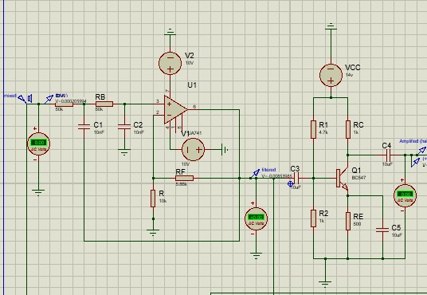
This design provided a practical resistor selection and achieved the desired gain.
Figure 6. Simulation

- Results and Discussion:
Advantages of BJT Configuration
The common emitter amplifier offered improved gain performance, achieving Av=2A_v = 2Av​=2 reliably. By choosing appropriate resistor values, we ensured that the circuit was practical and thermally stable.
Limitations of MOSFET Approach
The MOSFET-based configuration failed to provide adequate gain due to its dependency on precise biasing and higher input threshold voltage. Additionally, the buffer stage with the common drain amplifier did not compensate for the insufficient amplification in the first stage.
- Conclusion:
The final implementation using a Butterworth filter followed by a BJT-based common emitter amplifier successfully amplified the audio signal while maintaining stability and practicality. This project highlights the importance of iterative design and the trade-offs involved in selecting components for specific performance criteria.

