

**PAK-FREELANCE**

By

MOMINA NADEEM (BCS02121171)

TAYYABA ISHFAQ (BCS02121077)

**Project Supervisor**

**Sir Kashif Rizwan**

Final year project submitted in partial fulfillment of

the requirements for the degree of

**Bachelors in Computer Science**

**The University of Lahore**

**Lahore, Pakistan**

(July 2016)

**ACKNOWLEDGMENTS**

**At first we would like to thank ALMIGHTY ALLAH, the most merciful and beneficial and as well as the HOLY PROPHET HAZRAT MUHAMMAD (S A W) who always guided us the best way of life and to have faith and live wisely in the best way. We would like to thank Sir Kashif Rizwan for their keen guidance and constant encouragement for every single phase of our project. And a big thank to our parents who have been an inspiration and most helpful shoulder for us anytime without which our project would not have been possible.**

**ABSTRACT**

The objective of this project is to create a website as a platform for people by which they can earn a handsome amount without scattering to the different locations in order to find there their desired job or to have a contact with any of the third party and without any financial limitations. PAK-FREELANCE provides the user with the best platform from where the person who is seeking a job can get it online right at his doorsteps and one who is seeking his work to be done by someone else, he/she can get the best out of it.By using our system people from any background can get job for which they can get payed as per their chosen conditions, whether you are an accountant, designer, web developer, mobile developer, virtual assistant, customer service agent, sales and marketing experts or a writer everyone can earn here

**TABLE OF CONTENTS**

LIST OF ABBREVIATIONS v

LIST OF FIGURES vi

LIST OF TABLES vii

Introduction 9

1.1. Scope 10

1.2. motivation 11

1.3. Problem Statement 11

Background and Literature Survey 12

2.1. Existing solutions 12

2.2. proposed solution 12

Requirements analysis 13

3.1. system use cases 13

3.2. use case diagrams 13

3.3. system requirements 13

3.3.1. Functional Requirements 13

3.3.2. Non-Functional Requirements 13

3.4. user interface requirements 13

Software design description 14

4.1. SYSTEM ARCHITECTURAL DESIGN 14

4.2. user interface design 14

4.3. Database design (ER diagram) 14

4.4. data flow diagram 14

Implementation details 15

5.1. tools (Language, database overview, web server) 15

Evaluation and Testing 16

6.1. test cases 16

6.2. 16

conclusion and FUTURE enhancements 17

7.1. conclusion 17

7.2. future enhancements 17

appendices 18

8.1. appendix 1: user manual 18

references 19

# LIST OF ABBREVIATIONS

PF(PAK-FREELANCE)

# 

# LIST OF FIGURES

# 

# LIST OF TABLES

**Chapter 1**

Introduction

In Pakistan handsome earning is a major problem as unlike other countries, career opportunities are limited to larger infrastructures like industries, organization or a specific work environment. Online Freelancing System will provide right set of opening new windows of career development to the personnel of every caliber and nature, in order to earn a living and as well as show its skills to the world without any limitations such as location boundaries, financial muddle and involvement of third parties .Pakistanis can excel in their right at their home or anywhere without any commission deductions. The system will connote the skills of people in order to achieve the right job done and earn without inhibitions.

Scope

The website being produced is called PAK-FREELANCE. This website has the following main functions:

* Implementation of posting jobs
* Implementation of search for jobs, employee, skills
* Implementation of applying on specified jobs
* Implementation of hiring employee
* Implementation of profiles of users
* Management of all above operations with constant coordination of database.

motivation

It is the necessity of the present period of time, the system specially designed to fulfill the needs of the users seeking different to hire and to work as well.

A purpose that we want to achieve by this project:

1. Easy and effective solution
2. Attractive interface understandable by people
3. Create link between the employer and the job poster
4. Cover large intended audience

Problem Statement

In this modern era people are more eager to discover that how they can earn as easily as possible without conventional office bound jobs because as the needs are growing as well as the resources are to be gowned as soon as possible and for this reason freelancing is the biggest platform in order to make money. PAK-FREELANCE will give the user the best platform to earn at its doorstep.

**Chapter 2**

Background and Literature Survey



**Existing solution**

# There is no such website owned by Pakistan to provide platform to people in order to earn online. All the websites which are used by people belongs to foreign countries and users have to pay the cutting amount to them.

proposed solution

The proposed system introduced by keeping in view the demands of the emerging needs of the public of Pakistan. Our system is easy to use and the user can easily search for the desired job/employer to get the work done with most feasible conditions.

Our proposed system has following advantage:

* User Friendly Interface
* Explore employers profile
* Post a job
* Hire an employer

**2.1Overall Description**

This section includes details about what is and is not expected of PAK-FREELANCE in addition to which cases are intentionally unsupported and assumptions that will be used in the creation of the PAK-FREELANCE.

**2.2Product Perspective**

PF is a website allowing users to post jobs and to bid on jobs in order to get their work done and as well as to earn money while working online.

2.5 Specific Requirements

2.5.1 user interface

Each part of the user interface intends to be as user friendly as possible. The fonts and buttons used will be intended to be very fast and easy to load on web pages. The pages will be kept light in space so that it won’t take a long time for the page to load.

**2.5.2 SOFTWARE INTERFACE**

* Operating System : Windows
* Development tool : PHP ,CSS3 ,HTML 5, bootstrap, JavaScript, XAMPP
* DataBase : MySQL

**2.5.3 HARDWARE INTERFACE**

* + Processor: Pentium or higher
  + RAM: 312 GB or higher

**2.5.4 COMMUNICATION INTERFACE**

The system shall send an e-mail confirmation to the user about posting, biding jobs and about hiring also.

2.5.5 Major features

* Home Page
* Sign Up
* Sign In
* Search Jobs
* Apply on Jobs
* Manage Profile details
* View an employee who have applied on the job
* Hire an employee
* Update Job/profile
* Logout

**Chapter 3**

Requirements analysis



system use cases

***Use cases.*** *A use case describes a sequence of actions that provide something of measurable value to an actor and is drawn as a horizontal ellipse.*

***Actors.*** *An actor is a person, organization, or external system that plays a role in one or more interactions with your system. Actors are drawn as stick figures.*

***Associations.*** *Associations between actors and use cases are indicated in use case diagrams by solid lines. An association exists whenever an actor is involved with an interaction described by a use case.*

use case diagrams

3.2.1 User will sign up

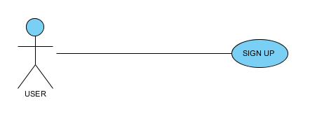

|  |  |
| --- | --- |
| **NAME** | **Sign UP** |
| **DESCRIPTION** | User will sign up to work/hire |
| **ACTORS** | **User** |
| **PRECONDTIONS** | User will be using the website |
| **BASIC FLOW OF EVENTS** | User will fill all the required fields |
| **ALTERNATIVE EVENT** | The information filled is incomplete |
| **KEY SCENARIOS** |  |
| **POST CONDITIONS** | User will be registered |
| **SPECIAL REQUIREMENTS** |  |
| **ADDITIONAL REQUIREMENTS** |  |

3.2.2 USER WILL SIGN IN

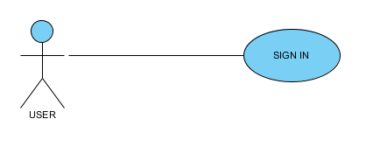

|  |  |
| --- | --- |
| **NAME** | **Sign In** |
| **DESCRIPTION** | User will sign in to website |
| **ACTORS** | **User** |
| **PRECONDTIONS** | User is registered |
| **BASIC FLOW OF EVENTS** | Fill the required fields |
| **ALTERNATIVE EVENT** | The provided information is incorrect |
| **KEY SCENARIOS** |  |
| **POST CONDITIONS** | User will be logged in |
| **SPECIAL REQUIREMENTS** |  |
| **ADDITIONAL REQUIREMENTS** |  |

3.2.3 user WILL LOGOUT

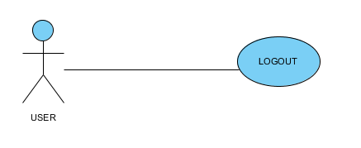

|  |  |
| --- | --- |
| **NAME** | **Logout** |
| **DESCRIPTION** | User will logout from the website |
| **ACTORS** | **Client/Employee** |
| **PRECONDTIONS** | User is logged in |
| **BASIC FLOW OF EVENTS** | Press the logout button |
| **ALTERNATIVE EVENT** |  |
| **KEY SCENARIOS** |  |
| **POST CONDITIONS** | User will be logged out |
| **SPECIAL REQUIREMENTS** |  |
| **ADDITIONAL REQUIREMENTS** |  |

3.2.4 USER WILL SEARCH JOBS

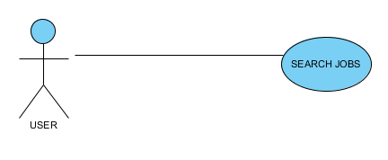

|  |  |
| --- | --- |
| **NAME** | **Search Jobs** |
| **DESCRIPTION** |  |
| **ACTORS** | **Employee / Guest** |
| **PRECONDTIONS** | User has opened the website |
| **BASIC FLOW OF EVENTS** | Searching |
| **ALTERNATIVE EVENT** | User have nit opened site |
| **KEY SCENARIOS** |  |
| **POST CONDITIONS** | User will search random or desired job |
| **SPECIAL REQUIREMENTS** |  |
| **ADDITIONAL REQUIREMENTS** |  |

3.2.5 User will APPLY FOR job

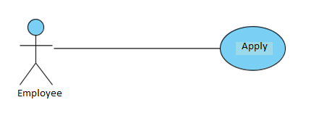

|  |  |
| --- | --- |
| **NAME** | **Apply job** |
| **DESCRIPTION** | User will apply on the desired job |
| **ACTORS** | **Employee** |
| **PRECONDTIONS** | The user have searched/viewed the job |
| **BASIC FLOW OF EVENTS** | Press bid/apply button |
| **ALTERNATIVE EVENT** | User does not find job according to its skills |
| **KEY SCENARIOS** |  |
| **POST CONDITIONS** | User applies for the job |
| **SPECIAL REQUIREMENTS** |  |
| **ADDITIONAL REQUIREMENTS** |  |
|  |  |

3.2.6 Client will HIRE THE EMPLOYEE

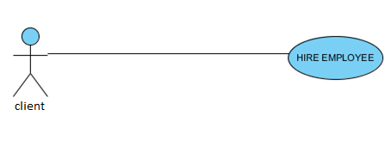

|  |  |
| --- | --- |
| **NAME** | **Hire Employee** |
| **DESCRIPTION** | User will hire employee for the posted job |
| **ACTORS** | **client** |
| **PRECONDTIONS** | The employees have bid/applied for the job |
| **BASIC FLOW OF EVENTS** | Press hire now button |
| **ALTERNATIVE EVENT** | Employee have not sent application or client does not finds it’s desired employee |
| **KEY SCENARIOS** |  |
| **POST CONDITIONS** | client hires an employee |
| **SPECIAL REQUIREMENTS** |  |
| **ADDITIONAL REQUIREMENTS** |  |
|  |  |

3.2.7 User will make its profile

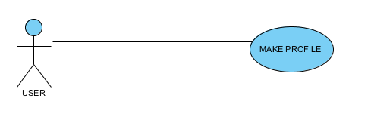

|  |  |
| --- | --- |
| **NAME** | **Make Profile** |
| **DESCRIPTION** | User will make its profile |
| **ACTORS** | **Employee / client** |
| **PRECONDTIONS** | Press the sign up button |
| **BASIC FLOW OF EVENTS** | Fill the required information |
| **ALTERNATIVE EVENT** | User doesn’t presses the sign up button |
| **KEY SCENARIOS** |  |
| **POST CONDITIONS** | User makes the profile and sign up |
| **SPECIAL REQUIREMENTS** |  |
| **ADDITIONAL REQUIREMENTS** |  |
|  |  |

3.2.8 client will view employee’s profile

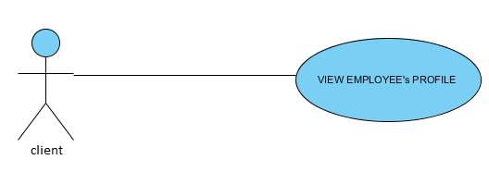

|  |  |
| --- | --- |
| **NAME** | **View Profile** |
| **DESCRIPTION** | client will view employee’s profile who have bid for the job |
| **ACTORS** | **client** |
| **PRECONDTIONS** | The client have posted a job and employee have bid on that |
| **BASIC FLOW OF EVENTS** | Press view profile button |
| **ALTERNATIVE EVENT** | User have not made profile |
| **KEY SCENARIOS** |  |
| **POST CONDITIONS** | client views the profile |
| **SPECIAL REQUIREMENTS** |  |
| **ADDITIONAL REQUIREMENTS** |  |
|  |  |
|  |  |

3.2.9 client will interview employee

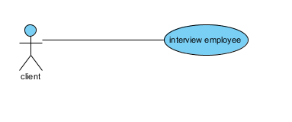

|  |  |
| --- | --- |
| **NAME** | **Client interviews employee** |
| **DESCRIPTION** | Client will interview the employee |
| **ACTORS** | **client** |
| **PRECONDTIONS** | Employee has sent application against the job which is posted by client |
| **BASIC FLOW OF EVENTS** | Press interview employee button ,views the interview page and fills the required information |
| **ALTERNATIVE EVENT** | User have not applied to its job |
| **KEY SCENARIOS** |  |
| **POST CONDITIONS** | client sends the interview questionnaire to employee |
| **SPECIAL REQUIREMENTS** |  |
| **ADDITIONAL REQUIREMENTS** |  |

3.2.10 employee fills the interview

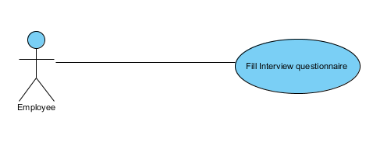

|  |  |
| --- | --- |
| **NAME** | **Employee fill interview** |
| **DESCRIPTION** | Employee will fill the interview questionnaire |
| **ACTORS** | **Employee** |
| **PRECONDTIONS** | Client has sent the interview questionnaire to employee |
| **BASIC FLOW OF EVENTS** | Press interview employee button ,views the interview page and fills the required information |
| **ALTERNATIVE EVENT** | User have not sent interview |
| **KEY SCENARIOS** |  |
| **POST CONDITIONS** | employee sends the interview questionnaire to client |
| **SPECIAL REQUIREMENTS** |  |
| **ADDITIONAL REQUIREMENTS** |  |

3.2.11 client will approve the interview

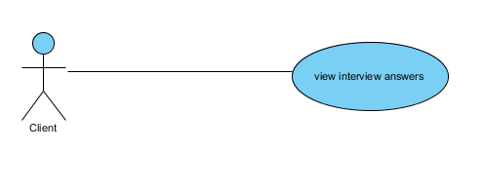

|  |  |
| --- | --- |
| **NAME** | **Client views interview** |
| **DESCRIPTION** | Client will view the interview questionnaire’s answers |
| **ACTORS** | **Client** |
| **PRECONDTIONS** | Employee has sent the interview questionnaire to client |
| **BASIC FLOW OF EVENTS** | Press view interview button in dashboard ,views the interview page |
| **ALTERNATIVE EVENT** | User have not sent interview |
| **KEY SCENARIOS** |  |
| **POST CONDITIONS** | Client views the interview ansers |
| **SPECIAL REQUIREMENTS** |  |
| **ADDITIONAL REQUIREMENTS** |  |

3.3 SYSTEM REQUIREMENTS

3.3.10 Functional Requirements

* + User can search jobs
  + Guest can search jobs
  + Only member employee can apply on job
  + Only member client can post a job
  + User can make/update its profile
  + Client can interview employee
  + Client can hire employee with / without interview
  + view record of job application and employee hiring
  + User can only pay online

3.3.20 Non-Functional Requirements

* + The system should be efficient
  + The system should be reliable
  + The system should load all the required data from database in a timely manner

3.3.3 user INTERFACE REQUIREMENTS

The website is made in such a way that its interface is simple, user friendly and can be understood by any type of user

**Chapter 4**

Software design description



4.1SYSTEM ARCHITECTURAL DESIGN

4.1.1 Architectural diagram

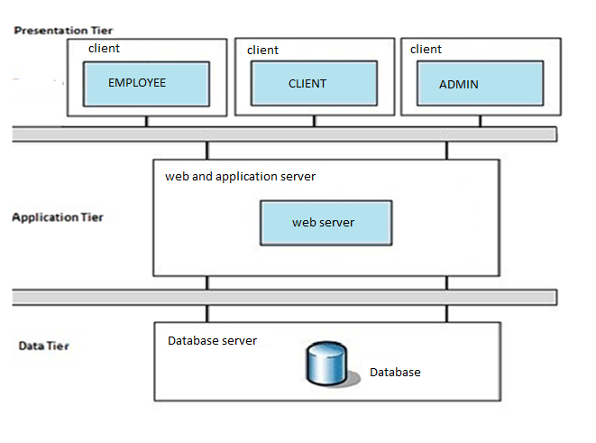

4.2 Activity diagrams

4.2.1 Activity diagram of system

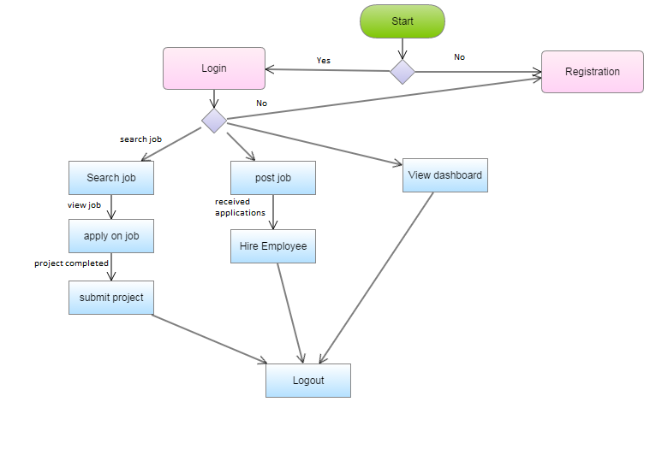

4.3data flow diagram

Data flow diagram tells us that how the data is flowing in the system. In this diagram user is logging into the system and then the system checks his/her details in the database and then updates and confirm the user.

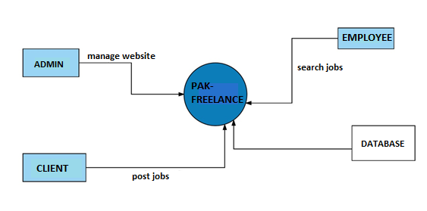

4.3.1 data flow diagram 2

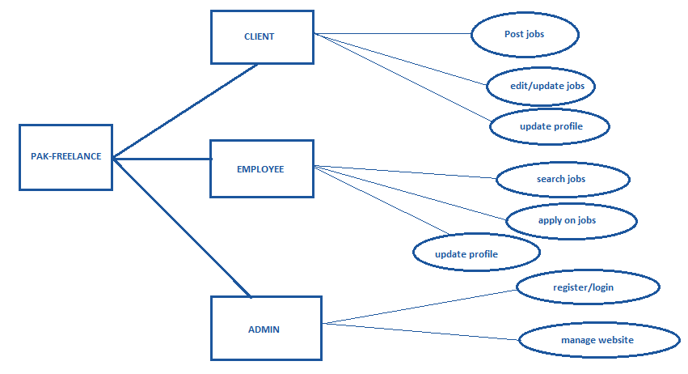

The data flow diagram 2 describes the basic actions performed by the client ,employee and admin.

4.3.2 admin

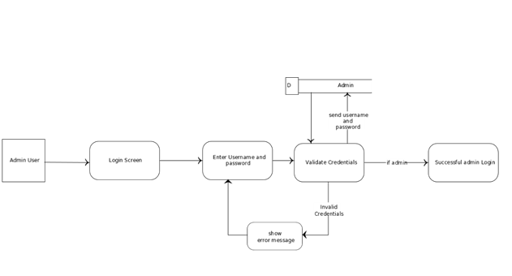

4.4 sequence diagrams

4.4.1 sign up

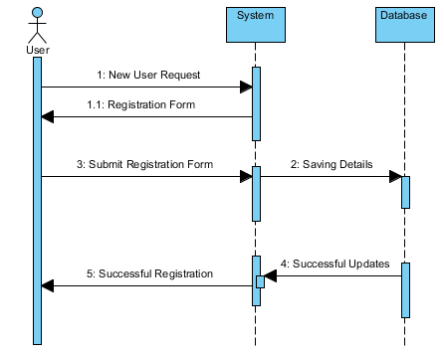

4.4.2 login

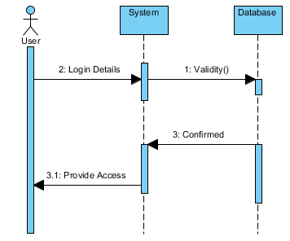

4.4.3 job search

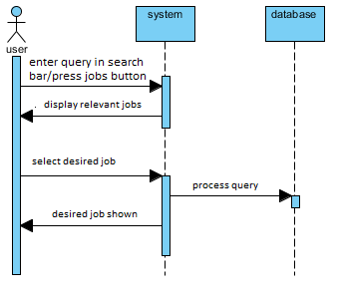

4.4.4apply on job

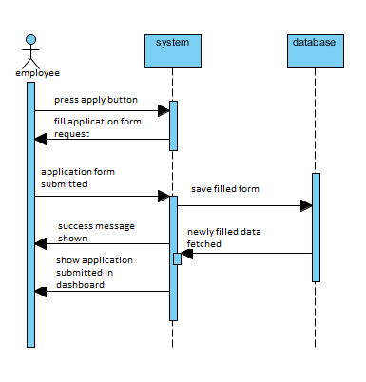

4.4.5 client view application by employee

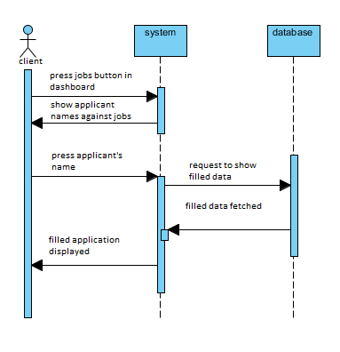

4.4.6 client interview the employee

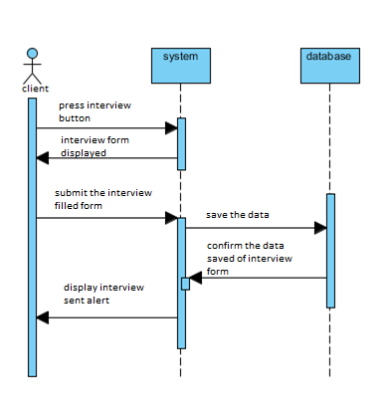

4.4.7 employee will fill the interview

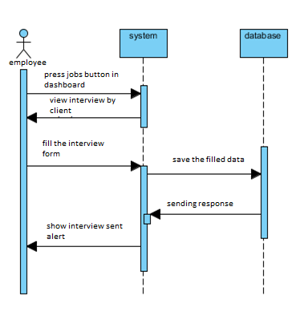

4.4.8 client will hire employee

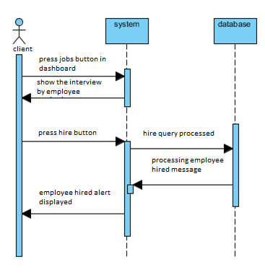

4.4.9 employee will submit the project

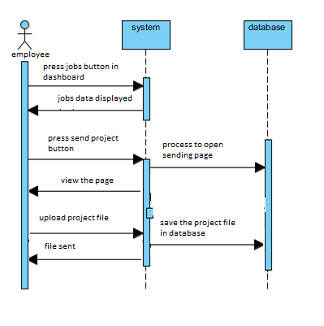

4.3.10 client will view and approve project

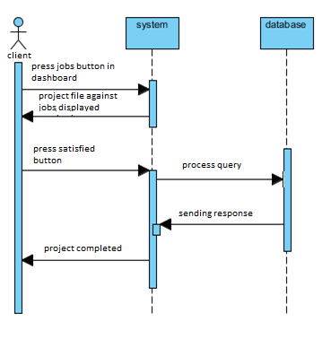

4.3.11 cliet disapprove the project

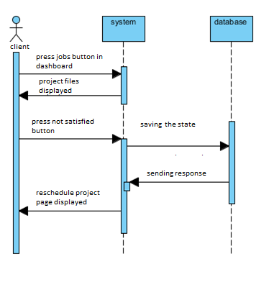

4.4user interface design

4.4.1 home page

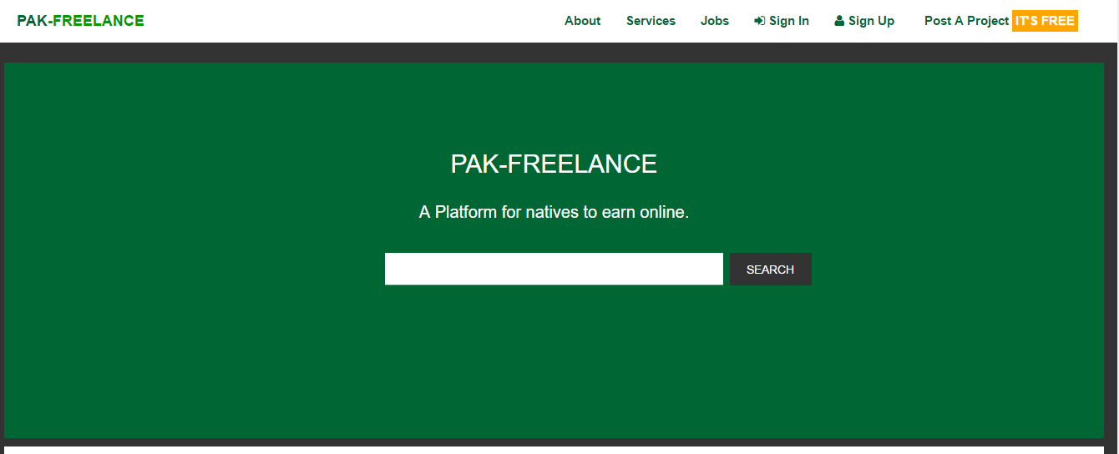

4.4.2 jobs page

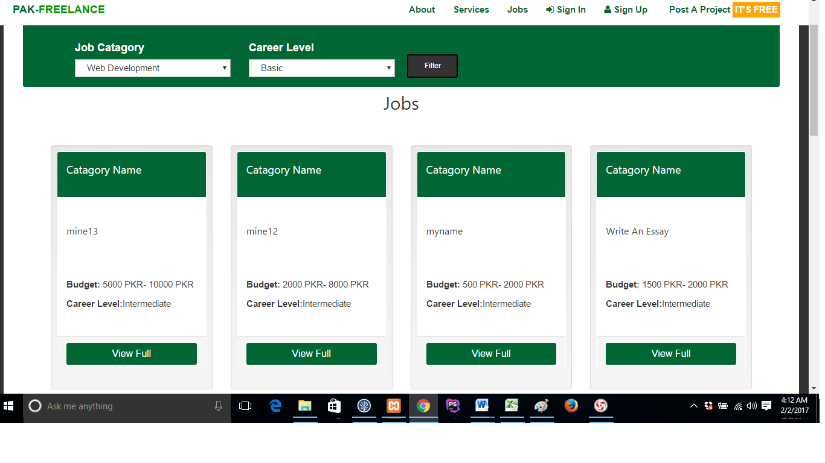

4.4.3 specific job page

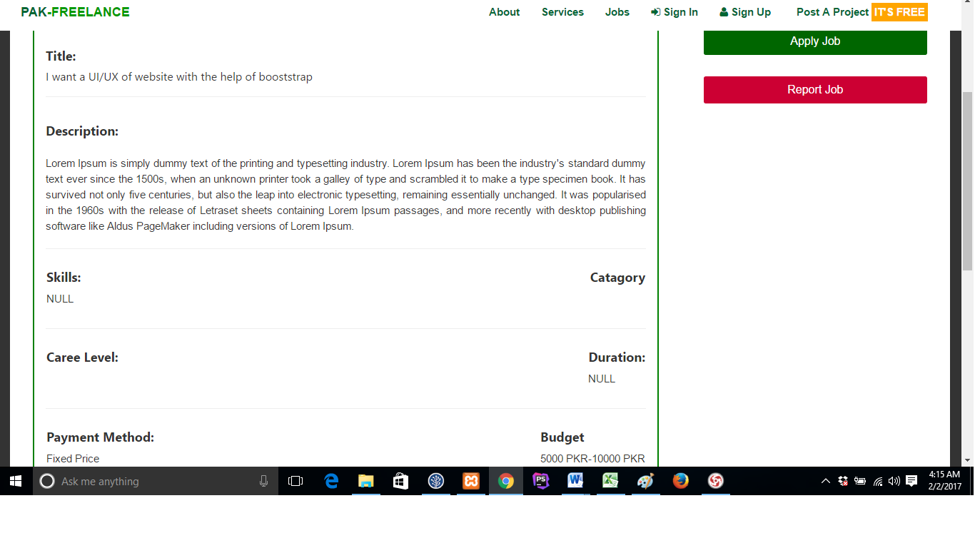

4.4.4 Apply job page

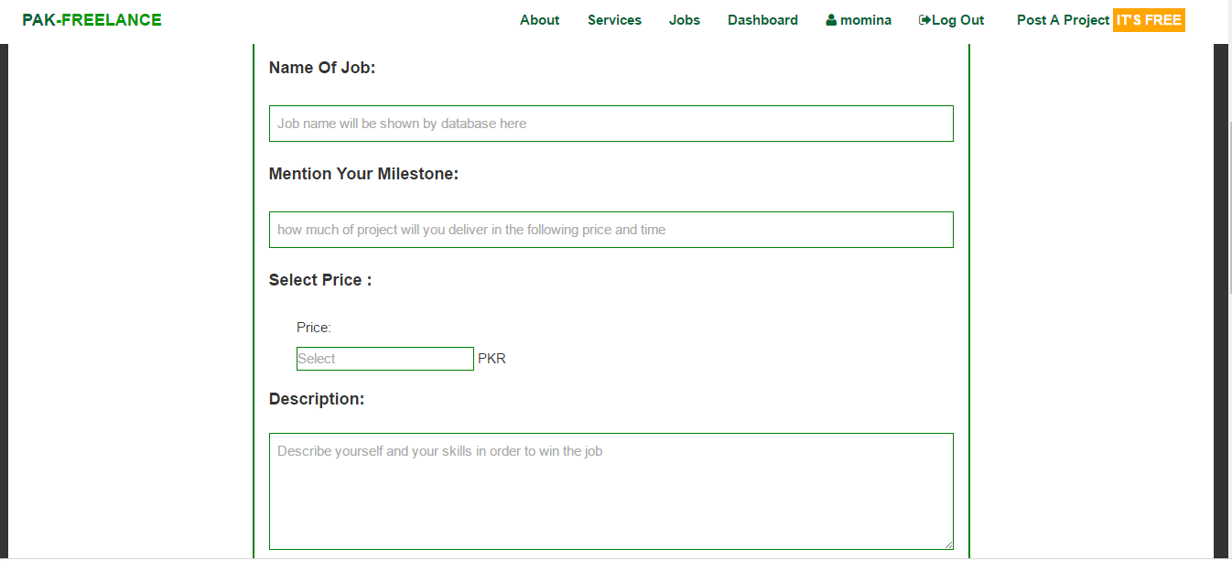

4.4.5 post job page

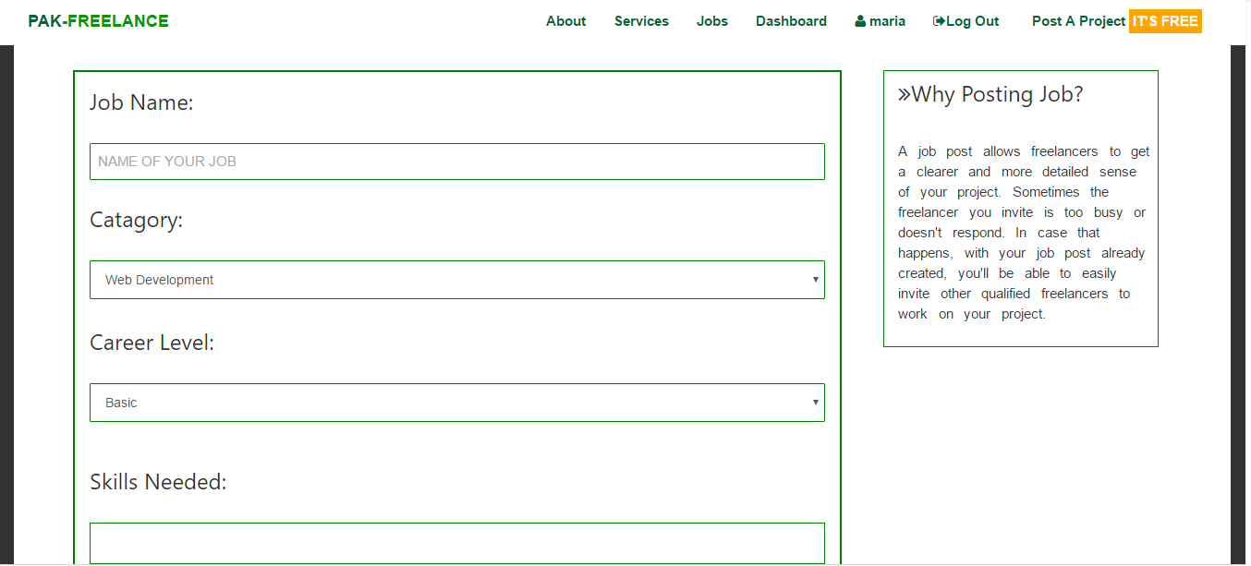

4.4.5.1

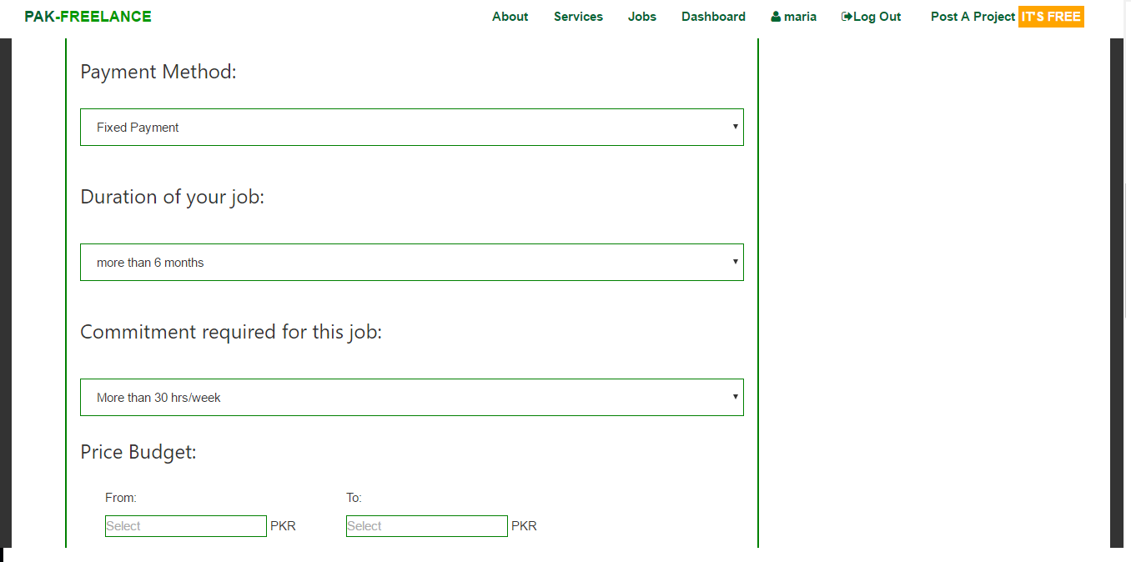

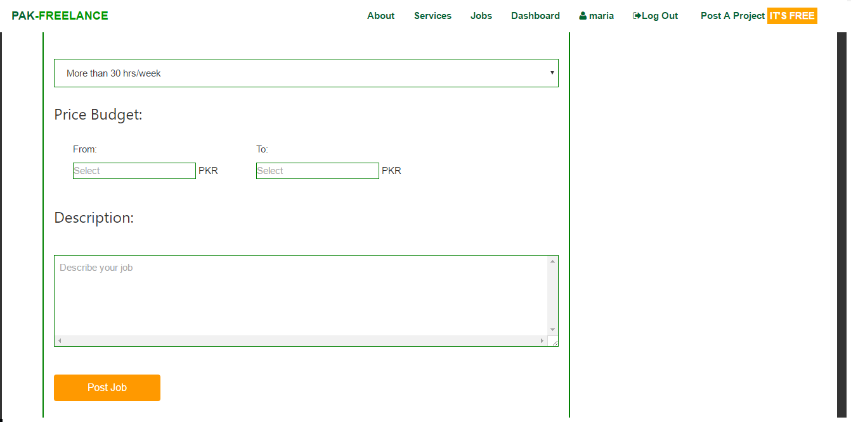

4.4.6 dashboard page

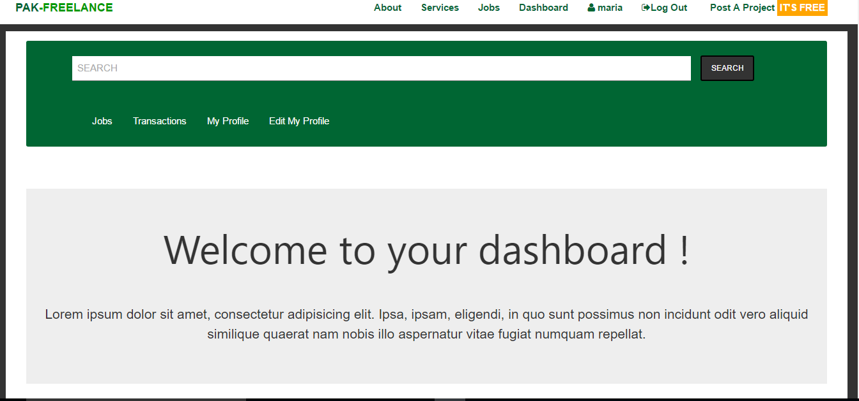

4.4.7 dashboard jobs

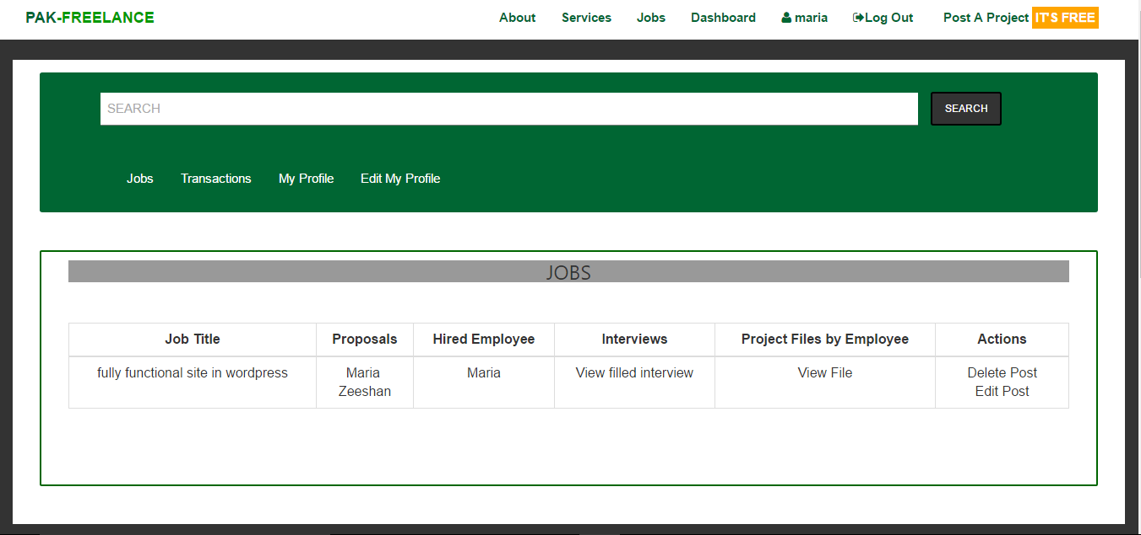

4.4.8 transactions

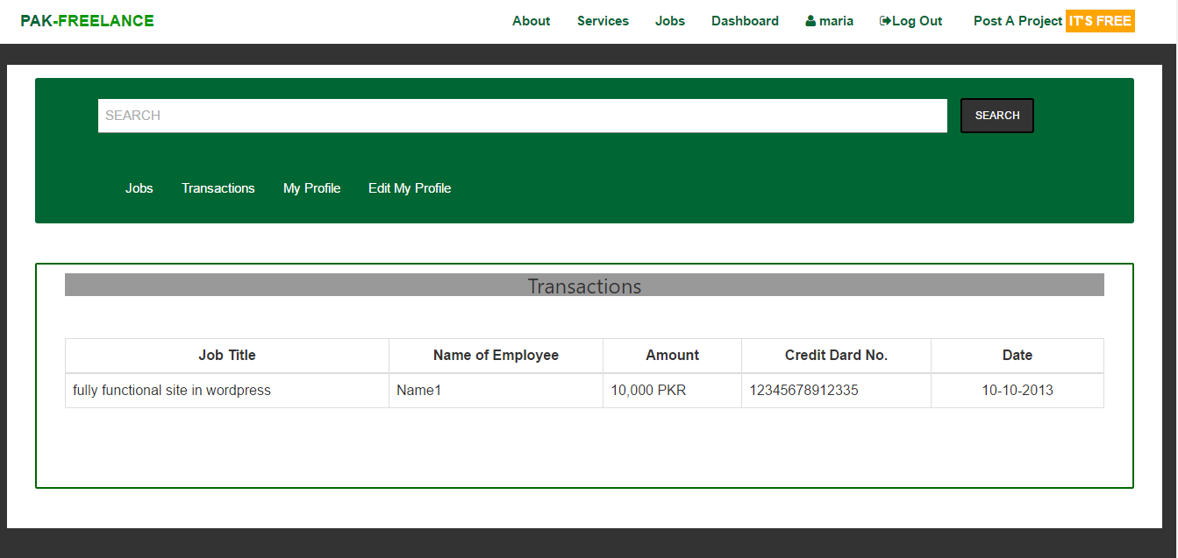

4.4.9 My Profile page

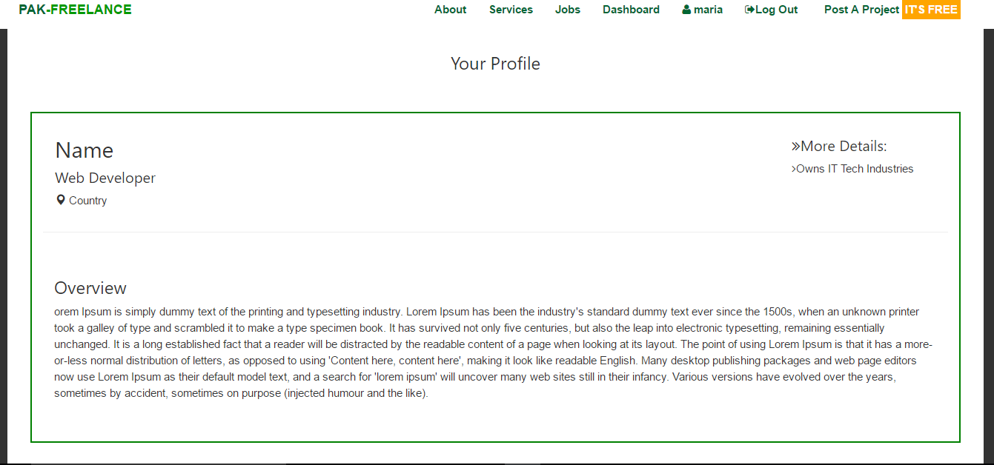

4.4.10 Edit profile page

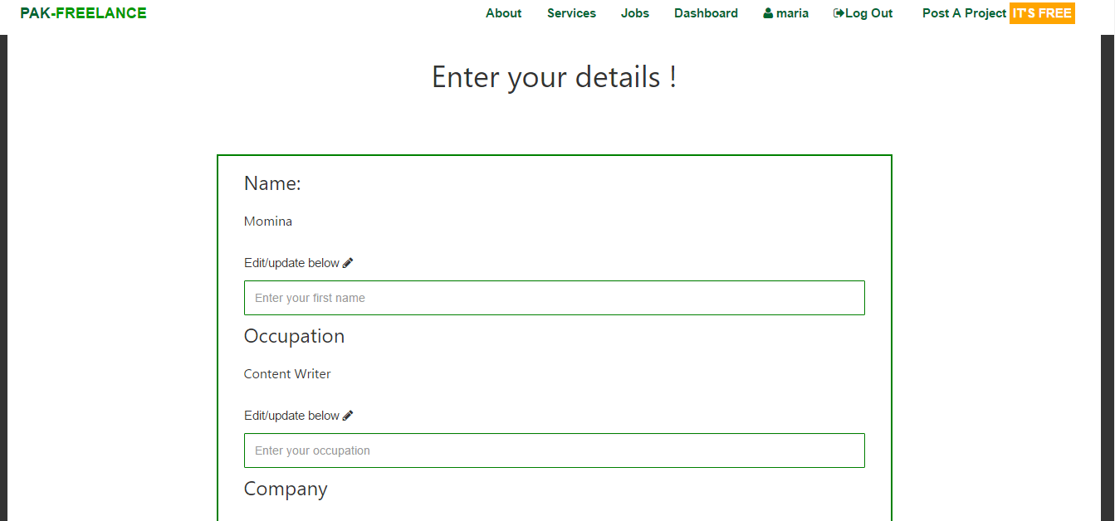

4.4.10.1

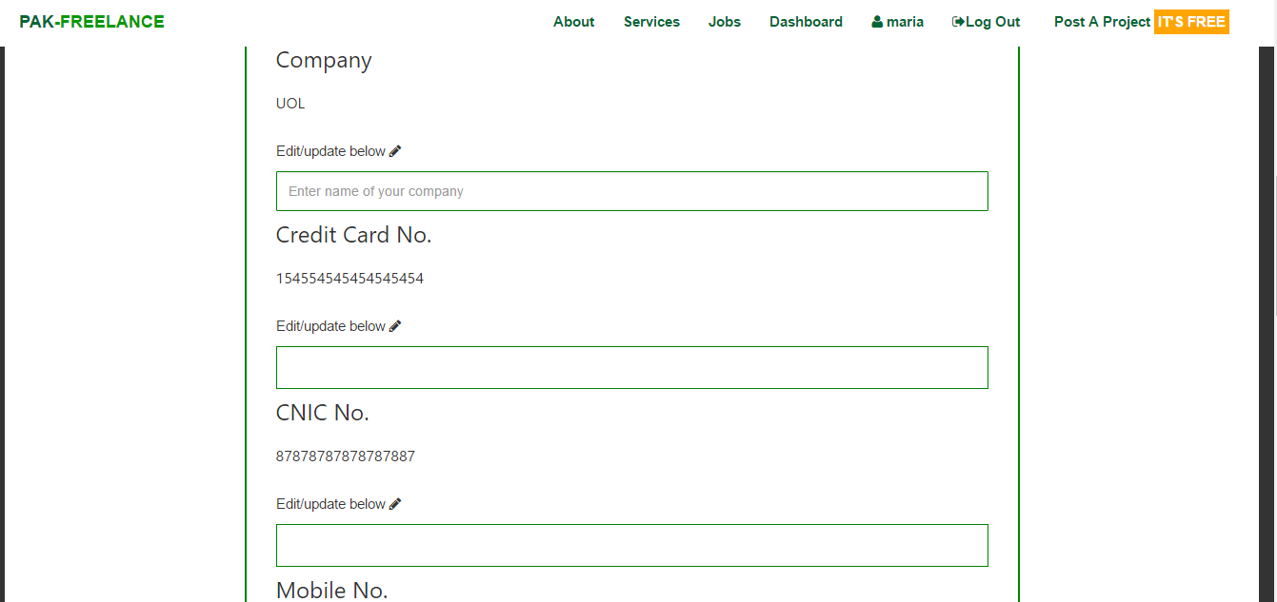

4.4.10.2

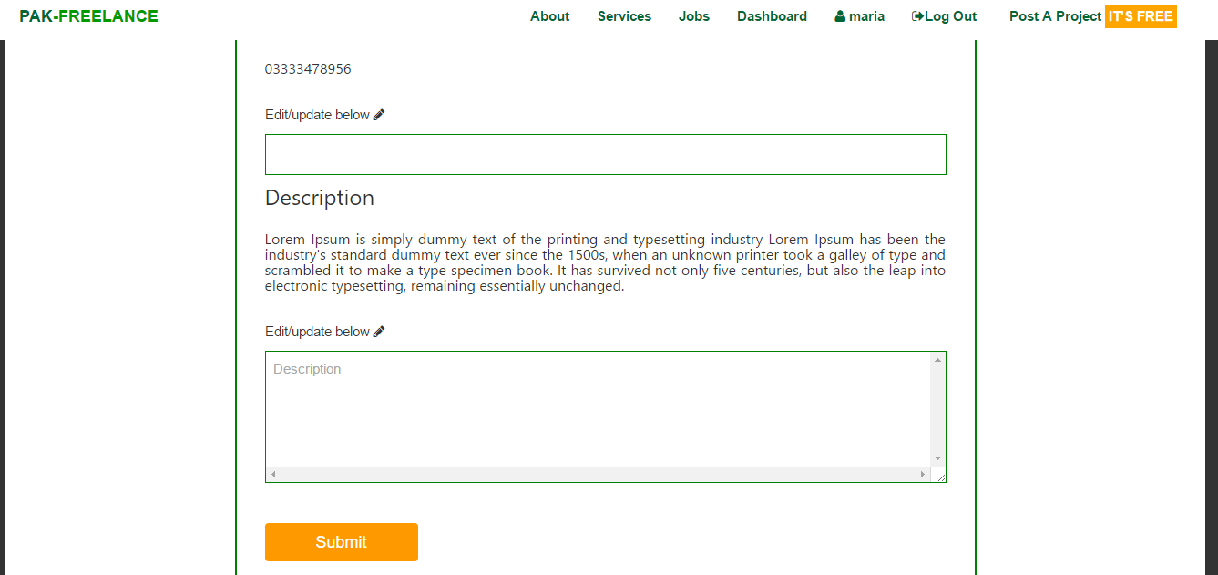

4.5Database design (ER diagram)

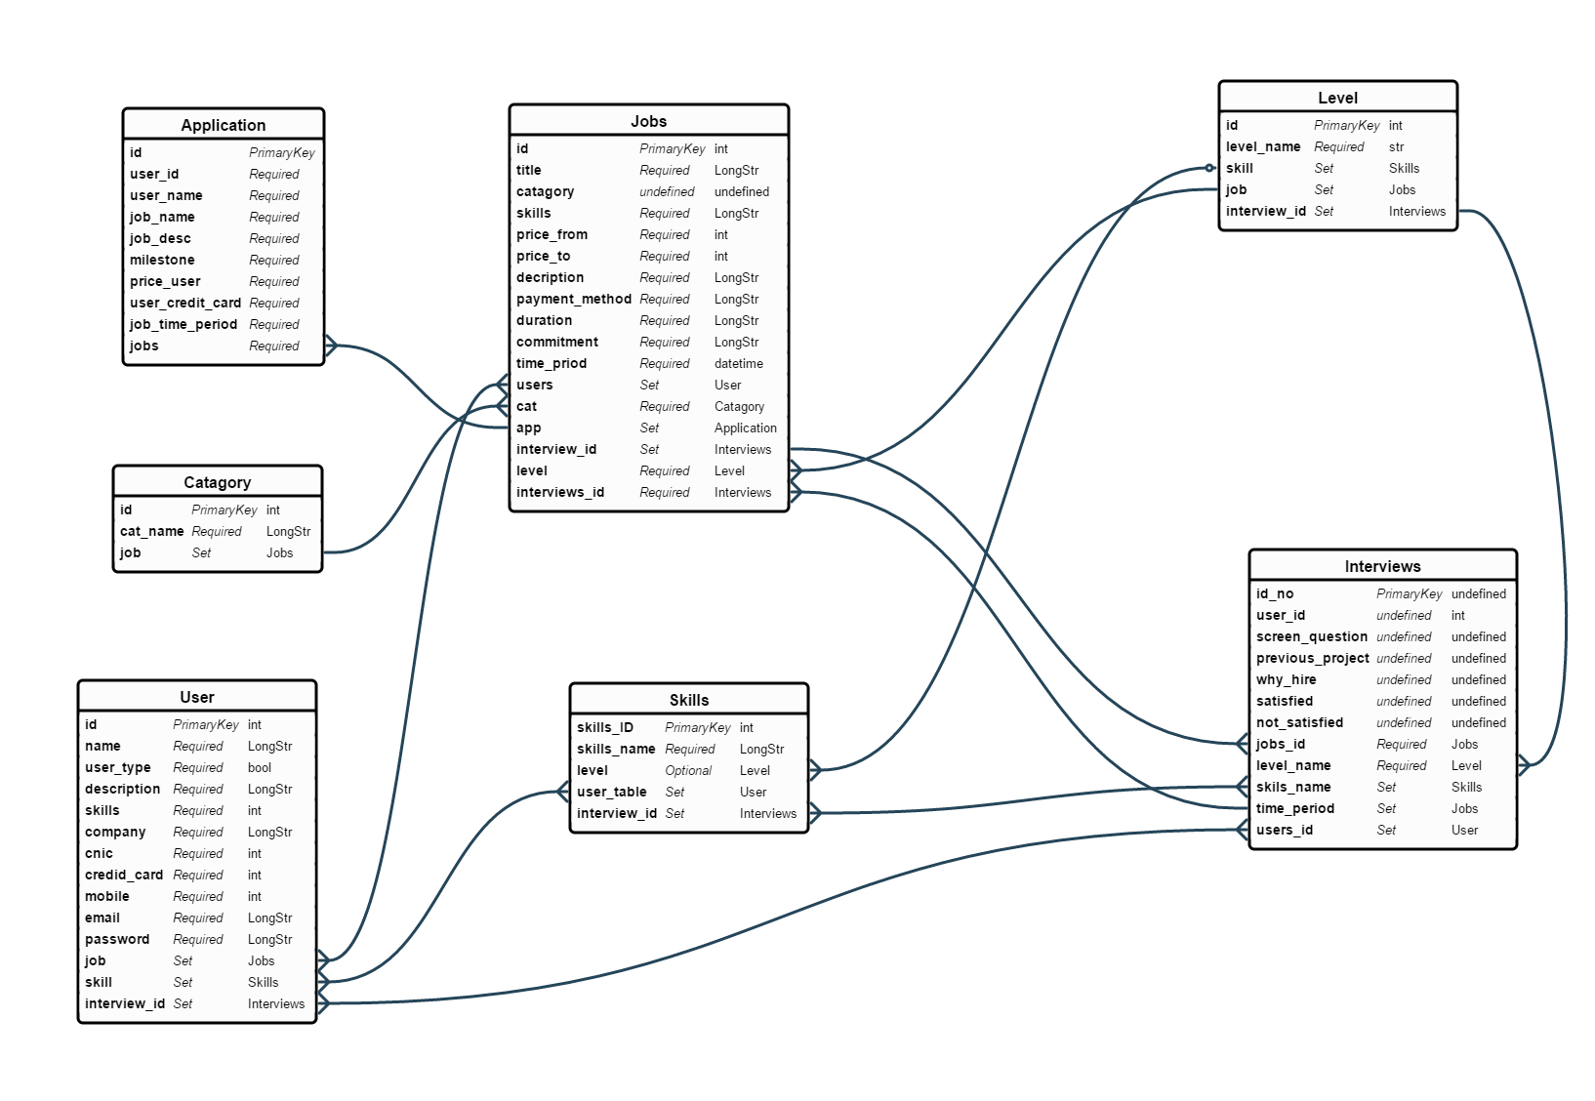

4.6state diagrams

4.6.1 state diagram for user

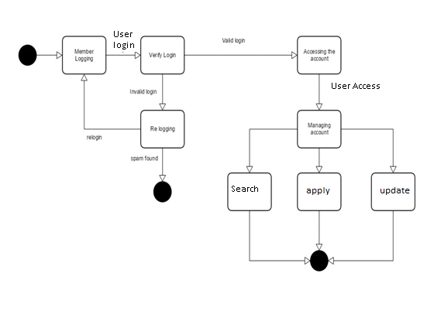

4.6.2 state diagram for client

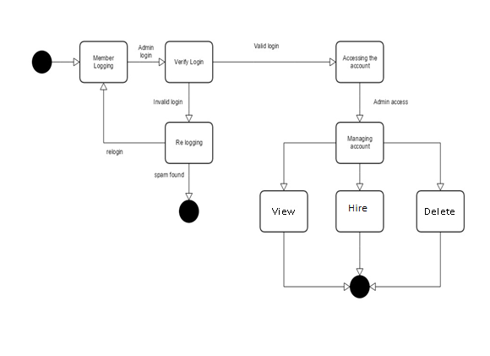

4.6.3 state diagram for admin

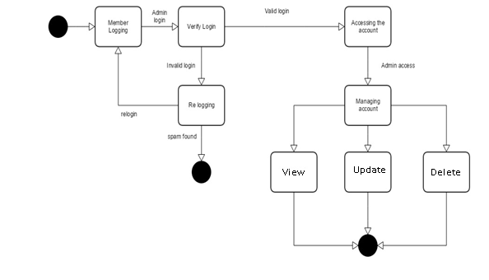

4.7deployment diagram

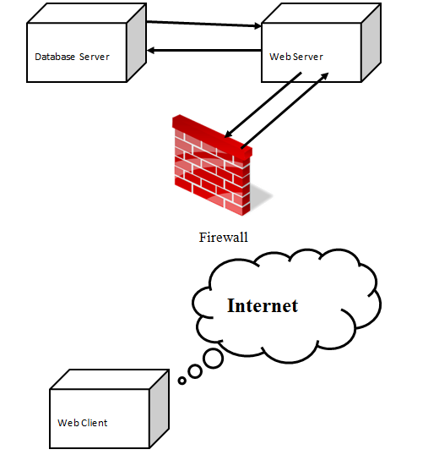

Chapter5

Implementation details



5.1tools (Language, database overview, web server)

5.1.0 Web servers

5.1.1 XAMPP

XAMPP is a [free and open source](https://en.wikipedia.org/wiki/Free_software) [cross-platform](https://en.wikipedia.org/wiki/Cross-platform) [web server](https://en.wikipedia.org/wiki/Web_server) [solution stack](https://en.wikipedia.org/wiki/Solution_stack) package developed by Apache Friends that  consists mainly of the [Apache HTTP Server](https://en.wikipedia.org/wiki/Apache_HTTP_Server), [MySQL](https://en.wikipedia.org/wiki/MySQL) [database](https://en.wikipedia.org/wiki/Database), and [interpreters](https://en.wikipedia.org/wiki/Interpreter_(computing)) for scripts written in the [PHP](https://en.wikipedia.org/wiki/PHP) and [Perl](https://en.wikipedia.org/wiki/Perl) [programming languages](https://en.wikipedia.org/wiki/Programming_language). XAMPP stands for Cross-Platform (X), Apache (A), MariaDB (M), PHP (P) and Perl (P). It is a simple, lightweight Apache distribution that makes it extremely easy for developers to create a local web server for testing and deployment purposes. Everything needed to set up a web server – server application (Apache), database (MariaDB), and scripting language (PHP) – is included in an extractable file. XAMPP is also cross-platform, which means it works equally well on Linux, Mac and Windows. Since most actual web server deployments use the same components as XAMPP, it makes transitioning from a local test server to a live server extremely easy as well.

5.1.2 My SQL

**MySQL** is an [open-source](https://en.wikipedia.org/wiki/Open-source) [relational database management system](https://en.wikipedia.org/wiki/Relational_database_management_system) (RDBMS). Its name is a combination of “My”, the name of co-founder “[Michael Widenius](https://en.wikipedia.org/wiki/Michael_Widenius)’ daughter” and "SQL", the abbreviation for [Structured Query Language](https://en.wikipedia.org/wiki/Structured_Query_Language). The MySQL development project has made its [source code](https://en.wikipedia.org/wiki/Source_code) available under the terms of the [GNU General Public License](https://en.wikipedia.org/wiki/GNU_General_Public_License), as well as under a variety of [proprietary](https://en.wikipedia.org/wiki/Proprietary_software) agreements. MySQL was owned and sponsored by a single [for-profit](https://en.wikipedia.org/wiki/Business) firm, the [Swedish](https://en.wikipedia.org/wiki/Sweden) company [MySQL AB](https://en.wikipedia.org/wiki/MySQL_AB), now owned by [Oracle Corporation](https://en.wikipedia.org/wiki/Oracle_Corporation). For proprietary use, several paid editions are available, and offer additional functionality.

5.2 PROGRAMMING LANGUAGES

5.2.1 HTML

HTML stands for Hyper Text markup language. It is used to create basic structure of web pages and web applications along with the Cascading Style Sheets and Java Script .It receives a HTML document from web server or from the local storage and then render them into the multimedia web pages.HTML describes the structure of the semantically and originally includes the cues for the appearances of the documents.

5.2.2 CSS3

Cascading Style Sheets (CSS) is a [style sheet language](https://en.wikipedia.org/wiki/Style_sheet_language) used for describing the [presentation](https://en.wikipedia.org/wiki/Presentation_semantics) of a document written in a [markup language](https://en.wikipedia.org/wiki/Markup_language). Although most often used to set the visual style of [web pages](https://en.wikipedia.org/wiki/Web_page) and user interfaces written in [HTML](https://en.wikipedia.org/wiki/HTML) and XHTML.  CSS is used by most websites to create visually engaging webpages, user interfaces for [web applications](https://en.wikipedia.org/wiki/Web_applications), and user interfaces for many mobile applications. Its latest version is **CSS3** with various features defining large new range of module specifications.

5.2.3PHP

**PHP** is a [server-side scripting](https://en.wikipedia.org/wiki/Server-side_scripting) language designed primarily for [web development](https://en.wikipedia.org/wiki/Web_development) but also used as a [general-purpose programming language](https://en.wikipedia.org/wiki/General-purpose_programming_language). Originally created by [Rasmus Lerdorf](https://en.wikipedia.org/wiki/Rasmus_Lerdorf) in 1994, the PHP [reference implementation](https://en.wikipedia.org/wiki/Reference_implementation) is now produced by The PHP Development Team.PHP originally stood for Personal Home Page, but it now stands for the [recursive acronym](https://en.wikipedia.org/wiki/Recursive_acronym) PHP: Hypertext Preprocessor.

5.2.4 Javascript

**JavaScript** is a [high-level](https://en.wikipedia.org/wiki/High-level_programming_language), [dynamic](https://en.wikipedia.org/wiki/Dynamic_programming_language) and [interpreted](https://en.wikipedia.org/wiki/Interpreted_language) [programming language](https://en.wikipedia.org/wiki/Programming_language).

5.3 Tools

5.3.1 php storm

JetBrains PhpStorm is a commercial, cross-platform [IDE](https://en.wikipedia.org/wiki/Integrated_Development_Environment) for [PHP](https://en.wikipedia.org/wiki/PHP) built on [JetBrains' IntelliJ IDEA](https://en.wikipedia.org/wiki/JetBrains" \o "JetBrains) platform.

PhpStorm provides an editor for [PHP](https://en.wikipedia.org/wiki/PHP), [HTML](https://en.wikipedia.org/wiki/HTML) and [JavaScript](https://en.wikipedia.org/wiki/JavaScript) with on-the-fly code analysis, error prevention and automated [refactorings](https://en.wikipedia.org/wiki/Refactoring" \o "Refactoring) for PHP and JavaScript code. PhpStorm's [code completion](https://en.wikipedia.org/wiki/Code_completion) supports PHP 5.3, 5.4, 5.5, 5.6 & 7. PhpStorm is built on IntelliJ IDEA, which is written in [Java](https://en.wikipedia.org/wiki/Java_(programming_language)). Users can extend the IDE by installing plugins created for the IntelliJ Platform or write their own plugins.

All features available in [WebStorm](https://en.wikipedia.org/wiki/WebStorm" \o "WebStorm) are included in PhpStorm, which adds support for PHP and databases. WebStorm ships with pre-installed JavaScript plugins (such as for [Node.js](https://en.wikipedia.org/wiki/Node.js)), which are available for PhpStorm as well at no cost.

5.3.2 dreamweaver

Dreamweaver is the web development tool used to make web applications working with HTML5, CSS3, JavaScript and various server-side scripting languages and frameworks.

5.3.3 visual paradigm suit 5

Visual paradigm suit 5 is a tool used for making UML diagrams .

5.3.4 php myadmin

PHP MyAdmin used for database management.

5.3.4 Sonata

Sonata is used for making and managing admin panel

chapter 6

Evaluation and Testing



6.0test cases

6.1.1Sign UP

|  |  |  |  |  |  |  |  |
| --- | --- | --- | --- | --- | --- | --- | --- |
|  | **Test Scenario** | | | | | | |
|  | **Project Name**: PAK-FREELANCE | | | | | | |
|  | **Test Scenario ID**: TS_01 | | | | | | |
|  | **Test Scenario Summary**: User /Admin have ability to register to system to be able to use it. | | | | | | |
| **Testing Description** | | **Test Case Objective** | **Pre-Conditions** | **Input Criteria** | **Expected Result** | **Actual**  **Result** | **Status**  **(Pass/Fail)** |
| User / Admin can access the website by signing up | | User will use to work or hire and admin will use site to manage it. | User/Admin have opened the sign up page | Full name  Email  Password  Hire/work  Description  Skills  Company  Cnic  Credit vard no.  Mobile no | Registered successfully. | Inputs are valid | Pass |

6.1.2 negative case of sign up

|  |  |  |  |  |  |  |  |
| --- | --- | --- | --- | --- | --- | --- | --- |
|  | **Test Scenario** | | | | | | |
|  | **Project Name**: PAK-FREELANCE | | | | | | |
|  | **Test Scenario ID**: TS_02 | | | | | | |
|  | **Test Scenario Summary**: User /Admin have ability to register to system to be able to use it. | | | | | | |
| **Testing Description** | | **Test Case Objective** | **Pre-Conditions** | **Input Criteria** | **Expected Result** | **Actual**  **Result** | **Status**  **(Pass/Fail)** |
| User / Admin can access the website by signing up | | User will use to work or hire and admin will use site to manage it. | User/Admin don’t have an active account on particular website | Full name  Email  Password  Hire/work  Description  Skills  Company  Cnic  Credit card no.  Mobile no | Account on website not signing up successfully. | Invalid inputs provided | Fail |

6.2.1 sign in

|  |  |  |  |  |  |  |  |
| --- | --- | --- | --- | --- | --- | --- | --- |
|  | **Test Scenario** | | | | | | |
|  | **Project Name**: PAK-FREELANCE | | | | | | |
|  | **Test Scenario ID**: TS_01 | | | | | | |
|  | **Test Scenario Summary**: User /Admin have ability to login to system to be able to use it. | | | | | | |
| **Testing Description** | | **Test Case Objective** | **Pre-Conditions** | **Input Criteria** | **Expected Result** | **Actual**  **Result** | **Status**  **(Pass/Fail)** |
| User / Admin can access the website by signing up | | User will use to work or hire and admin will use site to manage it. | User / Admin have an active account on the website | Email  Password | Registered successfully. | Inputs are valid | Pass |

6.2.2 sign in (negative case)

|  |  |  |  |  |  |  |  |
| --- | --- | --- | --- | --- | --- | --- | --- |
|  | **Test Scenario** | | | | | | |
|  | **Project Name**: PAK-FREELANCE | | | | | | |
|  | **Test Scenario ID**: TS_02 | | | | | | |
|  | **Test Scenario Summary**: User /Admin have ability to login to system to be able to use it. | | | | | | |
| **Testing Description** | | **Test Case Objective** | **Pre-Conditions** | **Input Criteria** | **Expected Result** | **Actual**  **Result** | **Status**  **(Pass/Fail)** |
| User / Admin can access the website by signing up | | User will use to work or hire and admin will use site to manage it. | User/Admin don’t have an active account on website | Email  password | Account on website not signing up successfully. | Invalid inputs provided | Fail |

**Chapter 7**

conclusion and FUTURE enhancements



7.1conclusion

* 1. future enhancements

**Chapter 8**

chapter 8

8.1 user manual

8.1.1 homepage

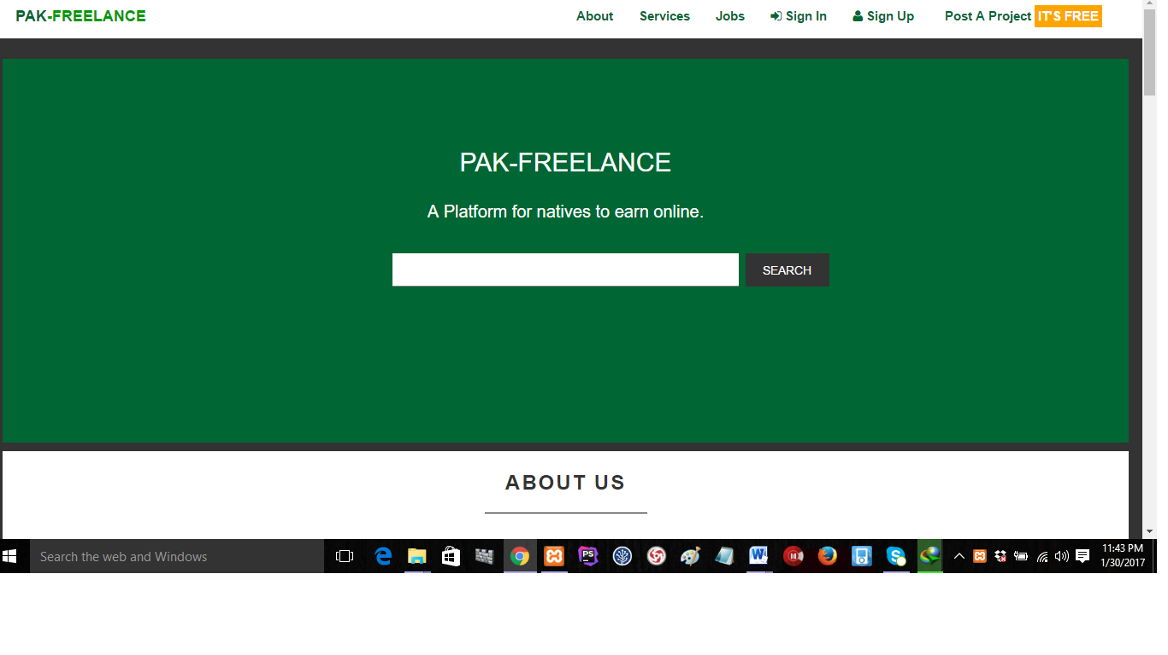

description

The homepage contains the following options and links

* About button
* Services button
* Jobs page link
* Sign in page link
* Sign up page link
* Post a project button
* Search bar

8.1.2 sign up page

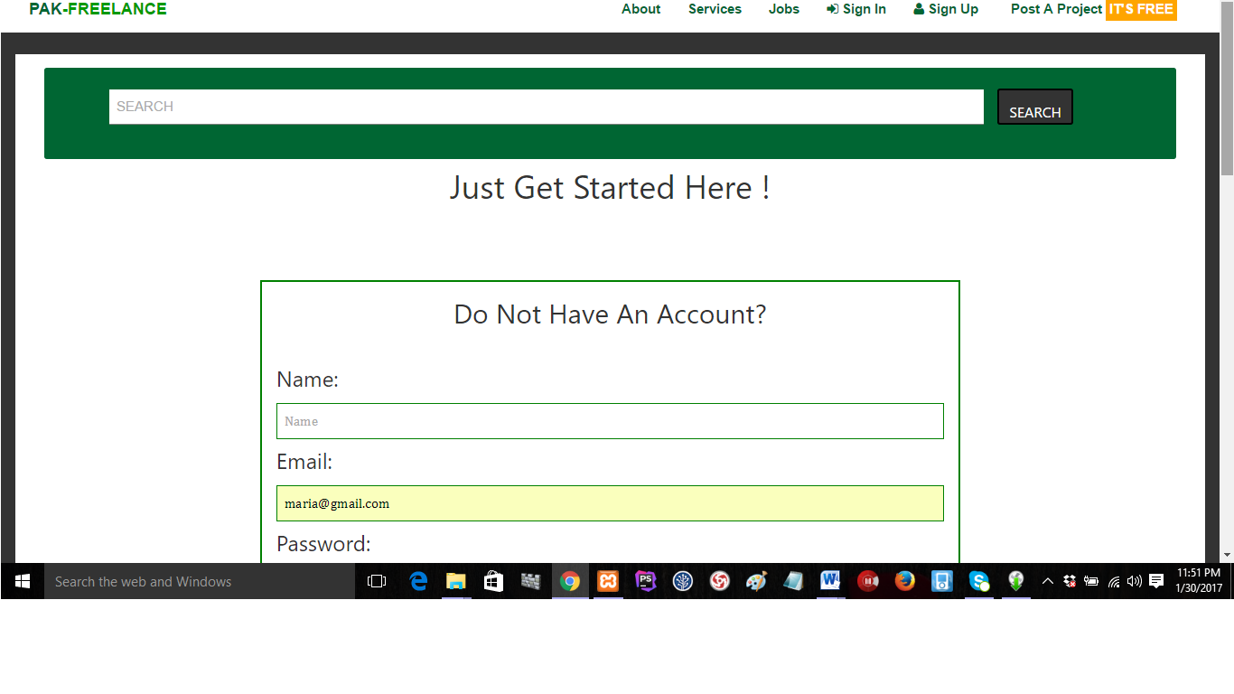

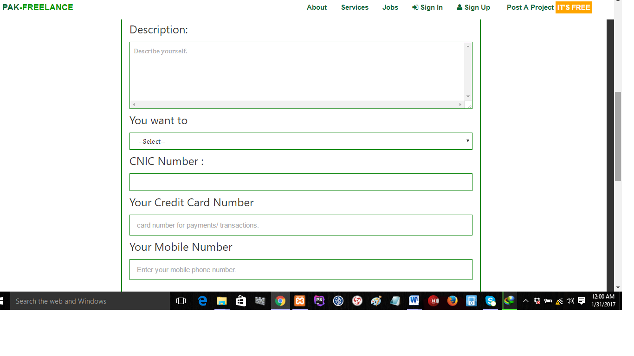



Description

The sign up page contains the following

* A search bar
* Name field
* Email field
* Password field
* Description field
* Account number field
* Credit card no field
* Mobile number field
* Company field(for client)
* Skills field (for employee)

8.1.3 sign in

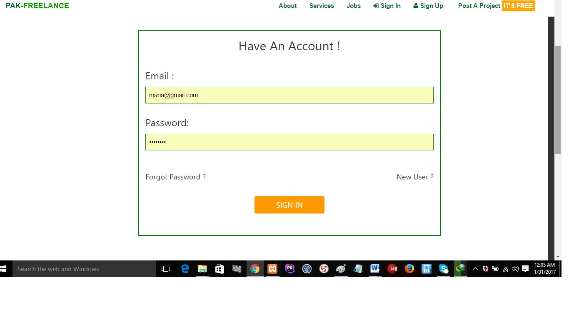

Description

The sign in page have the following

* Email field
* Password field
* Sign in button
* Forgot password link
* New user link

8.1.4 Apply job



appendices



9.1appendix 1: user manual

**Chapter 9**

references