Fatima Jinnah Women University
Submitted by:
Name:
Momina Asim
Roll no:
Fa24b1-se-069
Section:
A

Submitted to:
Name:
Sir Waqas
Course Title:
CC

Task 1: Install Gitea and Push a Repository from the Ubuntu Server
Objective: Install and run a Gitea service on the Ubuntu server, create a local Git repository, and push it to a Gitea repository using HTTP over the loopback interface.
Steps Performed:
- Installed Docker Engine and Docker Compose on the Ubuntu server using sudo apt install docker.io curl, then downloaded the Docker Compose CLI plugin from GitHub.
- Started the Docker service and added the current user (mominaasim-dev) to the docker group; signed out and reconnected so the group membership took effect.
- Verified installations:
  - git --version → git version 2.53.0
  - docker --version → Docker version 29.1.3
  - docker compose version → Docker Compose version 2.40.3
- Cloned the instructor-provided Gitea repository from https://github.com/WaqasSaleem97/Gitea.git.
- Started Gitea and PostgreSQL with docker compose up -d. Verified both containers were running with docker compose ps.
- Confirmed Gitea was responding locally: curl http://127.0.0.1:3000/ returned HTTP status 200.
- Opened Gitea in the browser at http://192.168.182.129:3000/ and completed the installation wizard with the required database settings:
  - Database type: PostgreSQL
  - Database host: db:5432
  - Database user: gitea
  - Database password: gitea
  - Database name: gitea
  - Server domain: 192.168.182.129
  - Gitea base URL: http://192.168.182.129:3000/
- Created the Gitea administrator account and completed installation.
- Created an empty public Gitea repository named Assignment01 (no README, .gitignore, or license).
- On the Ubuntu server, created a separate local repository at ~/Asignment01:
  - git init
  - git branch -M main
  - Created README.md with full name and registration number
  - git add README.md and committed with message "Add student information"
- Generated a personal access token in Gitea (ubuntu-server-token) with write:repository scope.
- Added the gitea remote without exposing the token in the URL:
  - git remote add gitea http://mominaasim-dev@127.0.0.1:3000/mominaasim-dev/Assignment01.git
  - Verified with git remote -v — no token visible in URL.
- Pushed to Gitea with git push -u gitea main, using the token as the HTTP password when prompted.
Result: Gitea is running on the Ubuntu server; the local repository was successfully pushed to Gitea and is publicly accessible.
Screenshots:
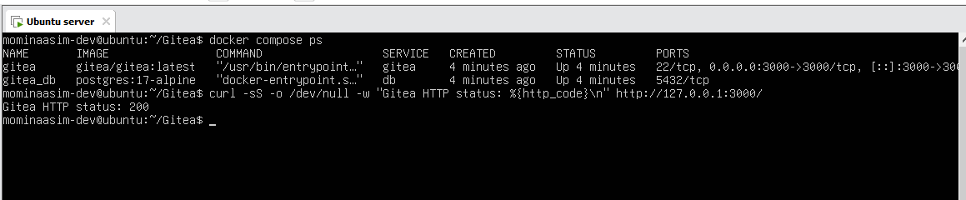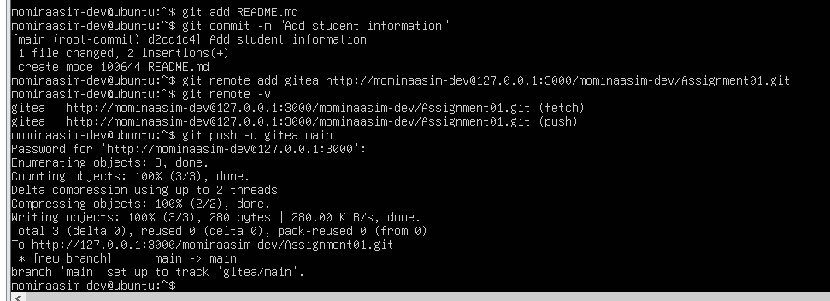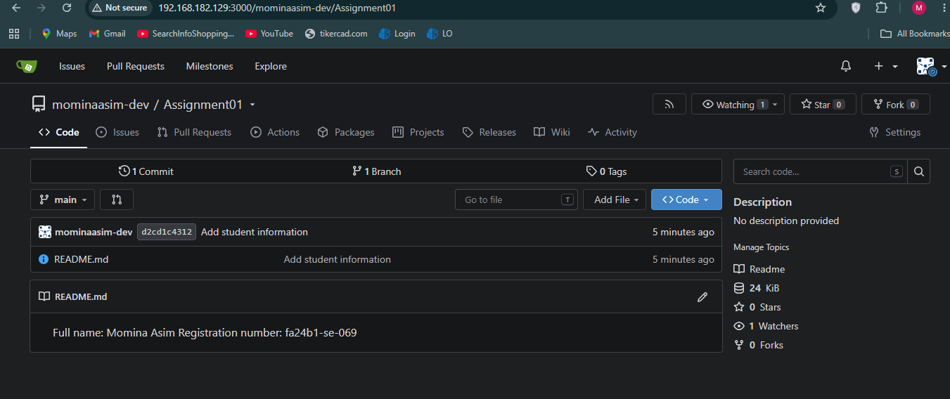
Task 2: Push the Same Repository to GitHub
Objective: Add GitHub as a second remote to the same local repository and push the main branch.
Steps Performed:
- Created an empty public GitHub repository named Assignment01 (no README, .gitignore, or license).
- On the Ubuntu server, navigated to the existing local repo at ~/Asignment01.
- Added GitHub as the second remote:
  - git remote add github https://github.com/mominaasim-dev/Assignment01.git
- Verified both remotes with git remote -v — output showed both gitea and github remotes with fetch/push URLs and no tokens embedded.
- Pushed to GitHub with git push -u github main, authenticating with a GitHub Personal Access Token.
Result: The same local repository is now connected to both Gitea and GitHub; the repository is publicly available at https://github.com/mominaasim-dev/Assignment01.
Screenshots:
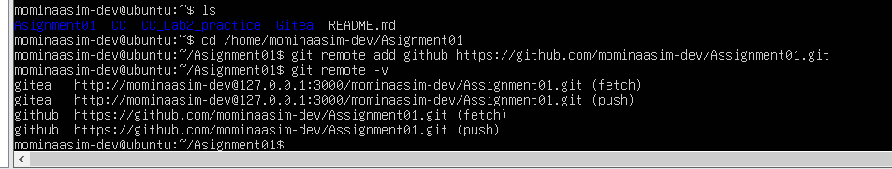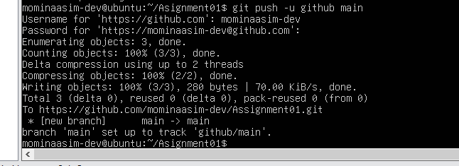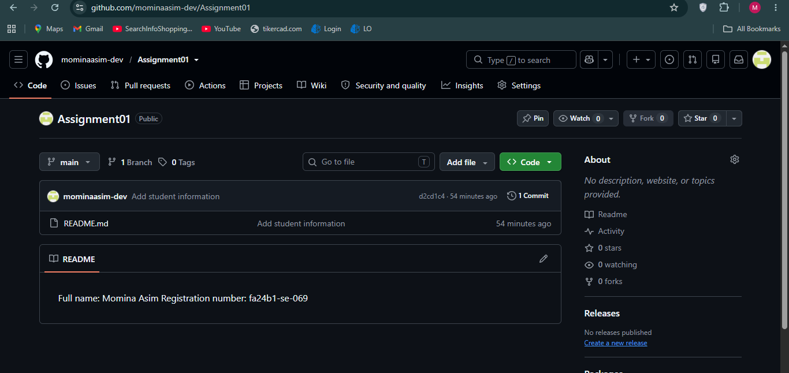

Task 3: Track Three Large Files with Git LFS
Objective: Configure Git LFS, track three files larger than 100 MiB each, and push them to GitHub.
Steps Performed:
- Navigated to the local repository: cd ~/Asignment01.
- Initialized Git LFS and configured .bin tracking:
  - git lfs install → Git LFS initialized.
  - git lfs version → git-lfs/3.7.1
  - git lfs track "*.bin" → Tracking "*.bin"
  - cat .gitattributes → *.bin filter=lfs diff=lfs merge=lfs -text
- Created three files larger than 100 MiB using truncate:
  - large-file-1.bin — 101 MB
  - large-file-2.bin — 102 MB
  - large-file-3.bin — 103 MB
- Staged the files: git add .gitattributes large-file-1.bin large-file-2.bin large-file-3.bin
- Verified LFS tracking with git lfs ls-files --size — all three files listed with sizes >100 MiB.
- Committed with message "Add three files using Git LFS".
- Pushed to GitHub with git push github main — the LFS upload completed at 100% (3/3).
Result: Three files larger than 100 MiB are tracked with Git LFS and successfully pushed to the GitHub Assignment01 repository.
Screenshots:
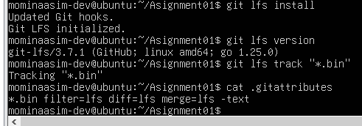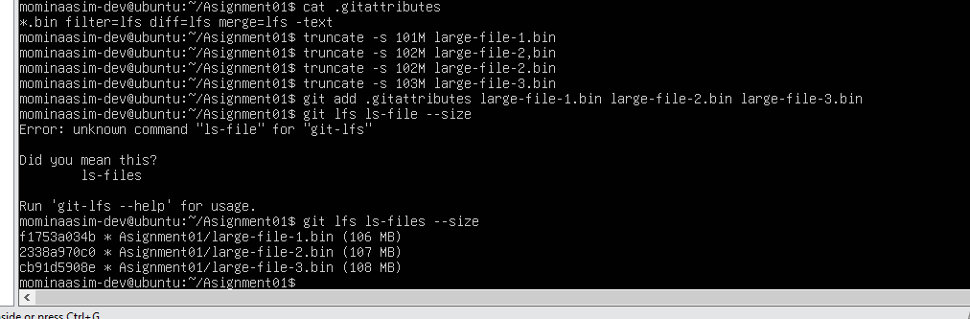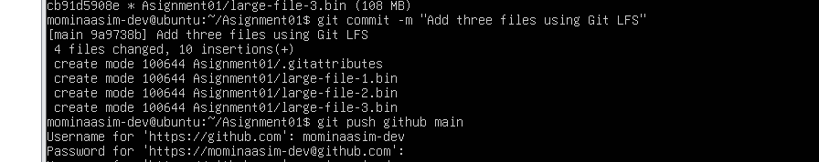

Task 4: Create a Portfolio or CV with GitHub Pages
Objective: Create a static portfolio website, host it in a public GitHub repository, and publish it via GitHub Pages.
Steps Performed:
- Created a new public GitHub repository named mominaasim-dev.github.io.
- Built a portfolio site with two files:
  - index.html — containing sections: About Me, Education, Skills, Projects
  - styles.css — for styling
- Committed and pushed the source files to the main branch.
- Enabled GitHub Pages:
  - Settings → Pages → Build and deployment → Source: Deploy from a branch
  - Branch: main / (root)
  - Saved
- Waited until GitHub reported: "Your site is live at https://mominaasim-dev.github.io/"
- Opened https://mominaasim-dev.github.io/ and verified the portfolio loads correctly with all required sections.
Result: The portfolio is stored in a public GitHub repository and is published as a live GitHub Pages site at https://mominaasim-dev.github.io/.
Screenshots:
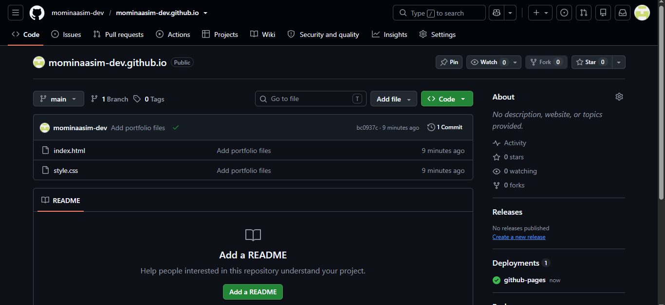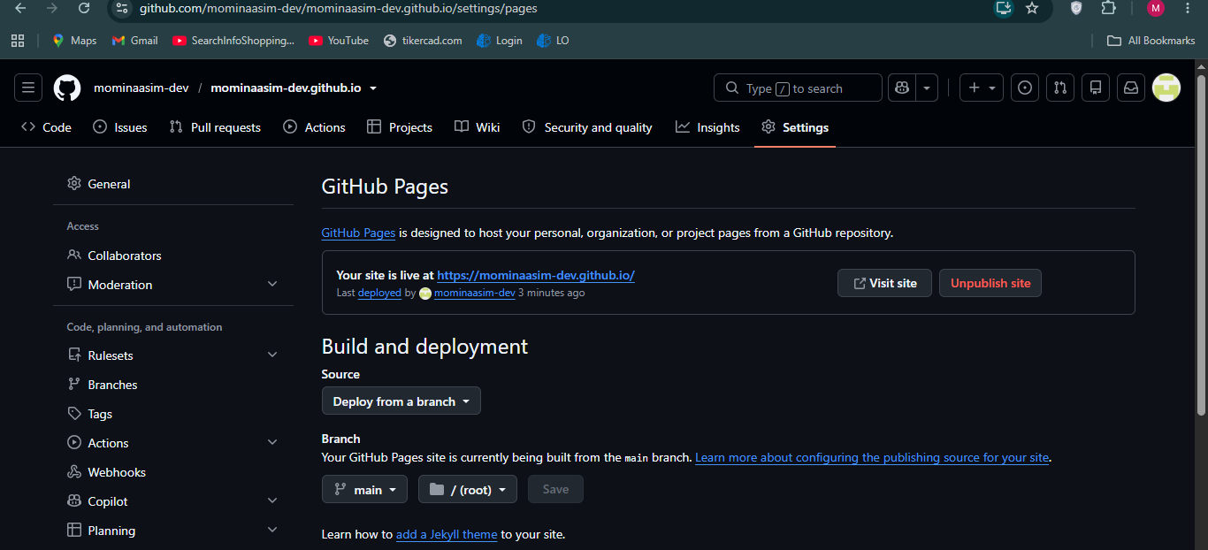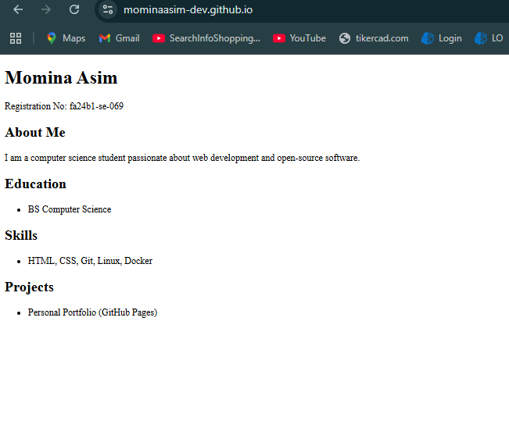

Summary
This assignment covered:
- Installing and running a Gitea service on an Ubuntu server
- Performing Git work from the Ubuntu server with the GitHub identity visible
- Pushing the same local repository to both Gitea and GitHub using two remotes
- Configuring Git LFS and pushing three large files (>100 MiB each)
- Creating and publishing a portfolio with GitHub Pages
Submission Links
- CC repository: https://github.com/mominaasim-dev/CC
- GitHub Assignment01 repository: https://github.com/mominaasim-dev/Assignment01
- Live Portfolio (GitHub Pages): https://mominaasim-dev.github.io/

