AIRLINE MANAGEMENT SYSTEM

**TABLE OF CONTENTS**

|  |  |  |
| --- | --- | --- |
| **1** | **Abstract** | **4** |
| 1.1 | Introduction | **5** |
| 1.2 | PROJECT AIMS AND OBJECTIVES | **5** |
| 1.3 | BACKGROUND OF PROJECT | **5** |
| 1.4 | SYSTEM REQUIREMENTS | **5** |
|  |  |  |
| **2** | **System Analysis** | **6** |
| 2.1 | System Objectives | **6** |
| 2.2 | System Documentation | **6** |
| 2.3 | Functional-Non-Functional Requirements | **7** |
|  |  |  |
| **3** | **CLASS DIAGRAM** | **8** |

**Abstract**

The Airline Management System (AMS) is a database application that stores information about the users in the systems, Users to whom flights are provided, Airline staff, and so on. Manually organizing this is quite difficult. Manually maintaining all of this data is a difficult task.

The organization has gotten considerably easier thanks to technological advancements. The Airline Management system was created to computerize and automate activities involving member information, book issues and returns, and other functions. This Airline's computerization aids in many aspects of its upkeep.

1. **INTRODUCTION**

### PROJECT AIMS AND OBJECTIVES

The project aims and objectives that will be achieved after completion of this project are discussed in this subchapter. The aims and objectives are as follows:

* User Registrations
* Flights
* Accounts
* Database Handling
* Login Functionality for Users

### BACKGROUND OF PROJECT

Airline Management System is a term used to describe Airline systems that are small or medium in size. It is used by users to administer the Airline with the help of a computerized system that allows them to do the manual work about the flight systems in a short and quick manner.

This system also includes users and maintenance modules, which maintain track of how many users are utilizing the system and provide a thorough description of the users available. There will be no loss of data or member records with this computerized method, which is common with non-computerized systems.

### SYSTEM REQUIREMENTS

|  |  |
| --- | --- |
| PROCESSOR | INTEL CORE PROCESSOR OR BETTER PERFORMANCE |
| OPERATING SYSTEM | WINDOWS VISTA, WINDOWS7, UBUNTU |
| MEMORY | 1GB RAM OR MORE |
| HARD DISK SPACE | MINIMUM 1 GB FOR DATABASE USAGE FOR  FUTURE |
| DATABASE | My SQL |

**2 SYSTEM ANALYSIS**

### SYSTEM OBJECTIVES

**Enhancement of control and output:** The system was created in order to address current Airline concerns and problems. The system is bug-free and can add and validate users.

**Save money:** Following the implementation of a computerized system, less human labor will be required to maintain the Airline, lowering overall costs.

**You will save time:** Users can search records with just a few mouse clicks and a few search terms, saving him time.

### SYSTEM DOCUMENTATION

**2.2.1 NON-FUNCTIONAL REQUIREMENTS**

* Product Requirements

**EFFICIENCY REQUIREMENTS**

When an Airline management system will be implemented users will easily access system and will book a flight as well as cancel it from the list of flights provided.

**RELIABILITY REQUIREMENT**

Member registration, member validation, report creation, data transactions, and search should all be done accurately by the system.

**USABILITY REQUIREMENT**

The system is meant to provide a user-friendly environment in which users and Airline personnel may do numerous tasks quickly and efficiently.

**ORGANIZATIONAL REQUIREMENT** **IMPLEMENTATION REQUIREMNTS**

The front end of the system is built with JAVAFX as front end or GUI of the program while the backend is purely written in java

**DELIVERY REQUIREMENTS**

The entire system is expected to be delivered in six months, with a weekly project guide evaluation

* + 1. **FUNCTIONAL REQUIREMENTS**
  1. **USER LOGIN**

**Description of feature**

The user uses this functionality to log into the system. Before they can access the system, users must first input their username and password. The username and password will be checked, and if an invalid username is found, the user will be denied access to the system.

**Functional requirements**

* The system must only allow users with valid username and password to enter the system.
* The system runs an authorization procedure that determines which user level has access to what.
* After the user has completed using the system, they must be able to logout.
  1. **REGISTER NEW USER**

**Description of feature**

All users can utilize this feature to register a new user and create an account.

**Functional requirements**

* System must be able to add his/her data to the database.
  1. **MAKE BOOKINGS**

Description of feature

The feature will allow the user to make booking to any flights available in the database.

After that it will update the total reserved seats for the flight user selected.

Functional requirements

* System must be able to add his/her record to the database.
* System must also validate the data entered by the user.
  1. **CANCEL BOOKING**

Description of feature

The feature as the name suggests will cancel the booking of any flight if a booking is made done, otherwise an error is shown to the user.

Functional requirements

* System must be able to update his/her record to the database.
* System must also decrement the number of seats reserved for the flight whose booking is cancelled.
  1. **FORGET PASSWORD**

Description of feature

This feature will make system much more reliable so that is a user can forget his/her password entered. He/she can get to know about the password and reset it so that their account gets recovered.

Functional requirements

* System will ask the security question and if valid answer is provided, then password is recovered.
* System must also be able to update the password of the user to the database.

**UML:**

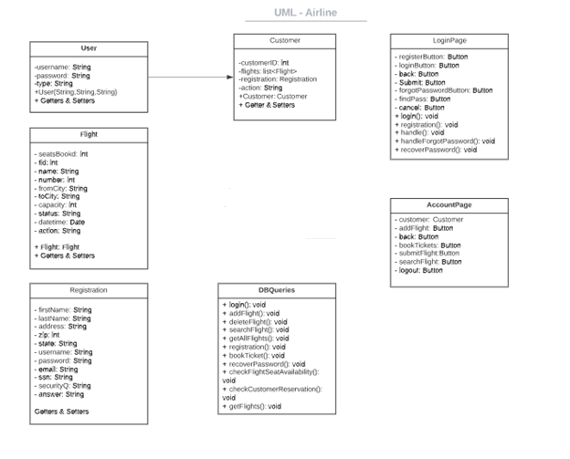

**Data Model:**

