TASK1

\*#include <iostream>

using namespace std;

int main ()

{

int sum ,num , x;

while(x<10)

{cout<<"Enter the numbers :";

cin>>num;

sum+=num;

x++;

}

cout<<"The sum of first ten natural numbers is : "<<sum<<endl;

return 0;

}\*/

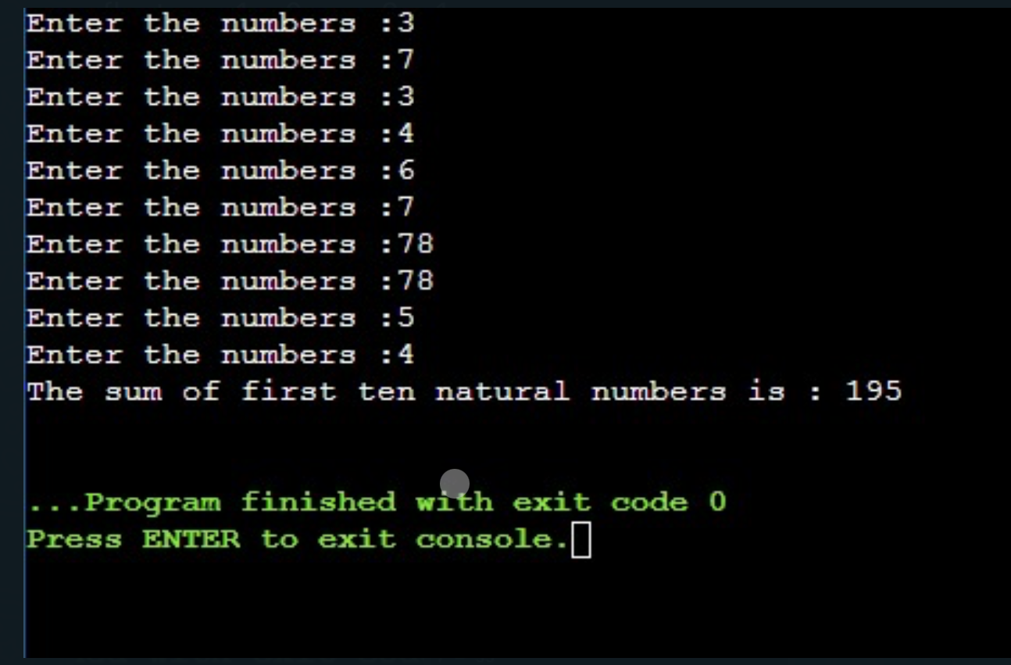

TASK2

/\*#include <iostream>

using namespace std;

int main ()

{

int num,a,table;

cout<<"Enter number : ";

cin>>num;

for (a=1; a<=10;a++)

{ table=num\*a;

cout<<num<<" x "<<a<<" = "<<table<<endl;

}

return 0;

}\*/

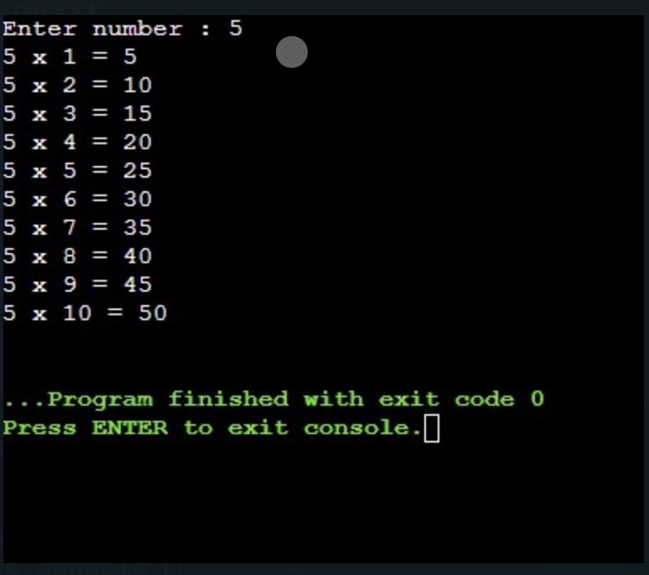

TASK3

/\*#include <iostream>

using namespace std;

int main()

{

int a,b=1,c;

cout<<"Enter number : ";

cin>>a;

for(c=1;c<=a;c++)

{b=b\*c;}

cout<<"Factorial of them given number is : "<<b<<endl;

return 0;

}\*/

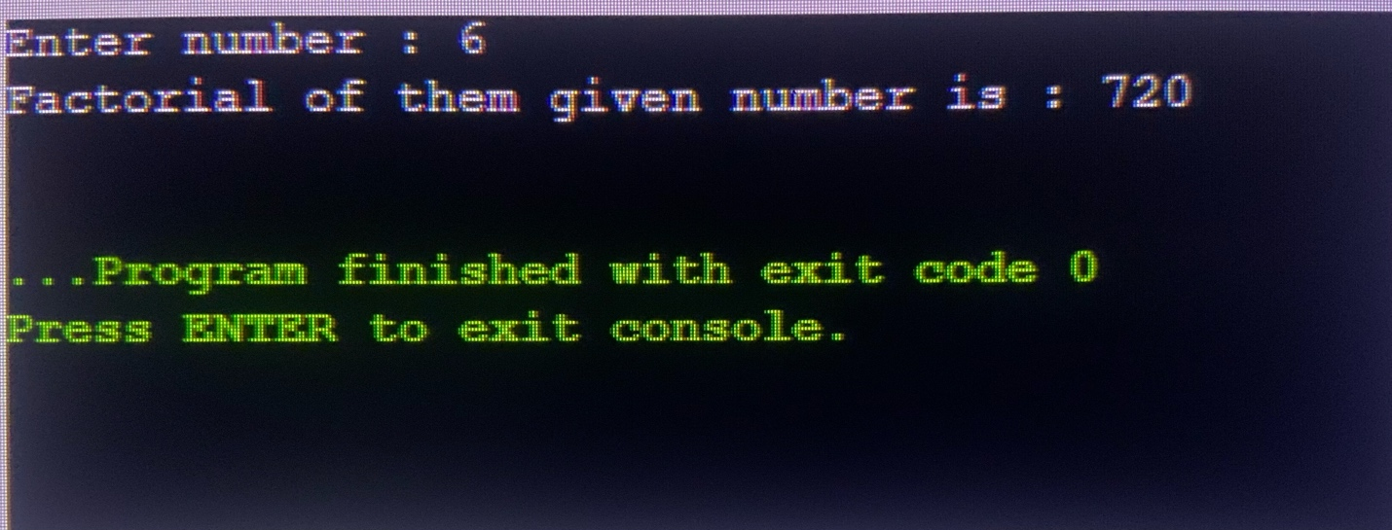

TASK4

#include <iostream>

using namespace std;

int main() {

int t;

cout << "Terms of the Fibonacci Sequence:";

cin >> t;

float num1 = 0, num2 = 1, x;

cout << "Fibonacci Sequence: "<<endl;

for (int a = 0; a< t; ++a) {

if (a <= 1) {

x = a;}

else {

x = num1 + num2;

num1 = num2;

num2 = x }

cout << x <<endl; }

return 0;

}

