**APItask**

**READ ME Document**

**6/23/2019**

**+ + +**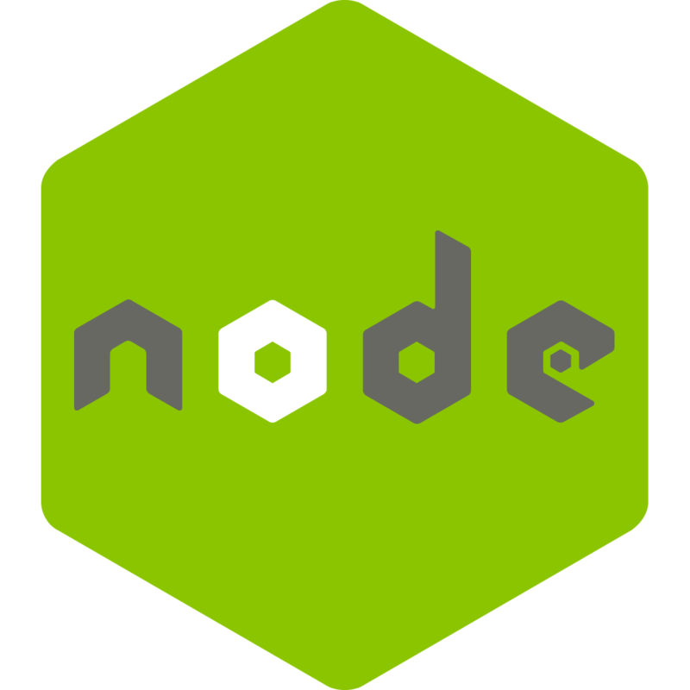

**Created By: Momin Ali**

# Setting Up Server:

1. Make a **database with title apitask** in mongodb.
2. Inside this database create **a collection with title fruits**.
3. Now, open the command prompt in the **apitask** directory.
4. Run the command **npm run dev.**
5. The server should be running now.
6. **Don’t close the command prompt yet, so that the server keeps running.**

# Setting Up React App:

1. Open the cmd in the **apitask/client** directory.
2. Now run the command **npm start.**
3. The react app should start running now.

# API’s Description:

This API is created using; MongoDB for database, Express for managing server and React for front-end. The API exposes two functions **addfruit()** and **getfruits()** which allow the user to add a fruit to a list of fruits and get the list of fruits respectively.

# Application Navigation:

Since I feel like the application is not very intuitive, therefore, following is a description of how to navigate through the app.

1. Once the app starts up user will be shown a list of fruits.
2. The user can add fruits to the list using add fruit button.
3. After entering each fruit click add button.
4. Once you have added all the fruits click save.
5. The fruit list will be updated ✌.