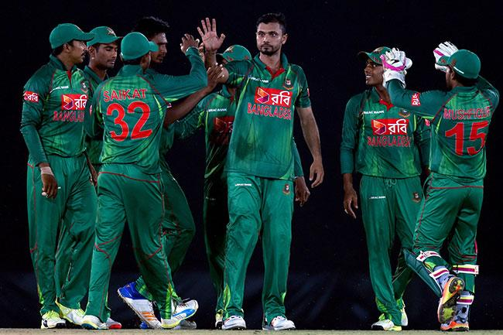

Cricket Scoreboard Management System

**Cricket Scoreboard Management System**



**Department of Computer Science and Engineering**

**By**

**Robiul Alam, ID: 16172103061**

**Fateha Israt, ID: 16172103066**

**MD.Rasel Hossain, ID: 16172103107**

**MD: Imran Hossain, ID: 16172103103**

**Supervised**

**By**

[**Shamim Ahmed**](https://www.facebook.com/shamim.6feb)

Assistant Professor

Department of Computer Science and Engineering(CSE)

Bangladesh University of Business and Technology

Mirpur-2, Dhaka-1216, Bangladesh

**Table of Content**

|  |  |  |
| --- | --- | --- |
|  | | **Page no** |
| Abstract | |  |
| Declaration | |  |
| Certification | |  |
| Acknowledgement | |  |
| Dedication | |  |
| **Chapter 01:** **Introduction** | |  |
| * 1. Introduction   2. Existing Theory | |  |
| * 1. Motivation   2. Objective | |  |
| 1.4 Contribution | |  |
| Chapter 02 : **Existing Theory** | |  |
| 2.1 Existing System | |  |
| **Chapter 3 :** **Proposed model** | |  |
| 3.1 Requirment analysis | |  |
| 3.2 Project Modules  3.2.1. Admin Modules  3.2.2. User modules  3.2.3. Commentor  3.3 System Design  3.3.1. ER-D  3.3.4. Flow chart | |  |
|  |
| **Chapter 4 :** **Experimental Result** | |  |
| 4.1 Result analysis | |  |
| **Chapter 5 : User Manual** | |  |
| 5.1 Introduction | |  |
| 5.2 System requirement  5.2.1 Hardware requirement  5.2.2. Software requirement  5.3 User Interface  **Chapter 6 :** **Study Design**  **6.1 Study period**  **6.2. Advantage**  **Chapter 7 :** C**onclusion**  **7.1 Conclusion**  **7.2 Future Work Extension** | |  |
| **List of Figures**   |  |  | | --- | --- | |  | **Page no** | | **Figure-1.1**: |  | | **Figure-1.2**: |  | | **Figure-1.3**: |  | | **Figure-2.1** | 10 | | **Figure-2.2**: |  | | **Figure-2.3**: |  | | |  |
| **List of Tables**   |  |  | | --- | --- | |  | **Page no** | | **Table-2.1**: |  | | **Table-2.2**: |  | | |  |
| References | |  |
| Appendix A | |  |
|  | |  |

**ABSTRACT**

    This Cricket Score Board project aims to make a cricket score board that will update the scores of a match along with commentary as it happens. Cricket being a special part of the lives of many people, there will be many takers for such a system and the ability to follow the match without seeing the video will make it interesting for many. The system can stream video feeds of cricket matches as well as official text commentary of the match. A user who is unable to watch the match, for e.g. for someone who is stuck at office and working on the computer, can easily check the commentary on a regular basis to get updates on what is happening. The Cricket Score Board system will keep posting updated scores and the team line-up during the match.The admin will store upcoming match details and ensure that the team information posted is accurate this will help the admin easily load information at the time of the match. Users can post comments during the match that will be visible to all during the match. On the system the commentary will take the centre of the screen, while the user comments will appear along the side and can be viewed if clicked. Users can choose to block comments from another user at any time, if they are abusive or irrelevant. The admin will go through the comments after the match and block any user not following the rules of the system.

**Declaration:**

We declare that this project and the work presented in it are our own and has been generated by us as the result of our own original research

We confirm that:

* This Work is done wholly or mainly while in candidature for a research degree at this University;
* This projejct work has not been previously submitted for any degree at this university or any other educational institutes;
* We have quoted from the work of others; the source is always given. With the exception of such quotations, this thesis is entire our own work;

**Dedication**

Dedicated to our parents for all their love and inspiration.

**Acknowladgement**

First of all, we are thankful and expressing our gratefulness to Almighty Allah who offers us His divine blessing, patient, mental and physical strength to complete this project work.

We are deeply indebted to our project supervisor Shamim Ahmed, Assistant Professor, Department of Computer Science and Engineering (CSE), Bangladesh University of Business and Technology (BUBT). His scholarly guidance, important suggestions, work for going through our drafts and correcting them, and generating courage from the beginning to the end of the research work has made the completion of this thesis possible.

We would like to express our deep gratitude to our Teacher Md.Shamim Reja Sajib, Assistant Professor, Department of Computer Science and Engineering (CSE), Bangladesh University of Business and Technology (BUBT). It was fantastic to get help from him and without his support it will be tough for us to reach the accurate goal.

A very special gratitude goes out to all our friends for their support and help to implement our works. The discussions with them on various topics of our works have been very helpful for us to enrich our knowledge and conception regarding the work.

Last but not the least; we are highly grateful to our parents and family members for supporting us spiritually throughout writing this project and our life in general.

**CERTIFICATE**

This is to certify that Robiul Alam , Fateha Israt , Md.Rasel Hossain and Md. Imran Hossain, students of B.Sc. in CSE have completed their project work titled “Cricket Scoreboard Management System”.They are fulfill of all the requirement of this project..

----------------- ------------------- --------------------- ------------------

Robiul Alam Fateha Israt Rasel Hossain Imran

ID: 16172103061 ID: 16172103066 ID: 16172103107 ID: 16172103103

--------------------------------

Project Supervisor

(Shamim Ahmed)

Assistant Professor

Department of Computer Science and Engineering (CSE)

Bangladesh University of Business and Technology (BUBT

**Copyright**

© Copyright by Robiul Alam (16172103061), Fateha Israt(16172103066), Rasel Hossain(16172103107) and Imran Hossain(16172103103)

All Right Reserved

**Chapter-1**

**Introduction**

* 1. **Introduction**

Cricket has been one of the most popular games since its birth in England. It has been a game that is known and played by many countries across the globe. India, being no exception to this, is another place where cricket is well spoken of. In spite of its national game being hockey, cricket is given even more importance.

This Cricket Score Board project aims to make a cricket score board that will update the scores of a match along with commentary as it happens. Cricket being a special part of the lives of many people, there will be many takers for such a system and the ability to follow the match without seeing the video will make it interesting for many. The system can stream video feeds of cricket matches as well as official text commentary of the match. A user who is unable to watch the match, for e.g. for someone who is stuck at office and working on the computer, can easily check the commentary on a regular basis to get updates on what is happening. The Cricket Score Board system will keep posting updated scores and the team line-up during the match.The admin will store upcoming match details and ensure that the team information posted is accurate this will help the admin easily load information at the time of the match. Users can post comments during the match that will be visible to all during the match. On the system the commentary will take the centre of the screen, while the user comments will appear along the side and can be viewed if clicked. Users can choose to block comments from another user at any time, if they are abusive or irrelevant. The admin will go through the comments after the match and block any user not following the rules of the system.

* 1. **Existing Theory**

The project is basically aimed at providing a detailed and complete Score Analysis of an ongoing Cricket Match, recording them for future reference, as well as at maintaining a database of player names of the teams and career records of players involved. Through the software, the Match Scorer would be entering the data regarding the ball-by-ball proceedings of the match on a particular workstation. Concurrently, the scorecard would be made available to various users on the network. The current score would be available on this software.

* 1. **Motivation**

The motivation behind this product is to keep up the entire data about the cricket matches held and to be held in better place, runs scored by each group, run scored by every batsman, general wickets taken by each group and general wickets by every bowler in each match. At first the administrator enters all the matches in the database with the goal that the watcher can see. On that specific match day, every one of the points of interest of the match will be shown, for example, tow groups, who are contending, put where the math is held, names of the considerable number of players in both the groups. While at scoring, the scorer would also be able to have a look at the scorecard as well as various analyses of the score, which include -details of the innings of the batsman, ,career record of a batsman or a bowler,The contest between a particular batsman and a bowler today,the run rates,the total run graph.

* 1. **Objective**

The main objective of the application is to automate the existing method of managing data manually to systematic storage of data & which can be searched and time as and when required.The other main objective of this application is to store all the player and match and ground-details. The other main objective of this project is to show score board when the match is going on. The system has an admin account where the scores are constantly updated by the admin. Users can login into the account to view the scores anytime. The system also provides a timetable of all the matches that would be going to be held for users to know in prior about the matches. Thus user can view cricket scores in real time.

* 1. **Contribution**

Cricket Score Board Management is a software application to manage all the activities concern to the cricket. This project will help the cricket organization to store all cricket related information.This application is useful store all the information of a match.This application software provide the live commentary of a cricket match.If there has no television then the people will know the update of the match.It is the main purpose of this software.

**Chapter-2**

**Existing System**

        The existing Cricket Score Board system of watching cricket is generally on the television. Most matches are not scheduled on holidays and this will allow people access to the match regardless of their location. Some sites do exist that display text commentary but they are very impersonal.In this software user see the commentary of the match of a match as like a T-20,Oneday game and Test cricket match.Here admin updated the main result of match.This read data from database.

**Chapter-3**

**Proposed Model**

**3.1 Requirment analysis**

The proposed Cricket Score Board system will allow people to stream the video of the match anywhere and read text based commentary as well, while making cricket viewing a social experience by allowing friends to share text and audio commentary. The commentary will be available post the match as well for review.

**3.2 Project Modulas**

**3.2.1. Admin Modulas:**

The admin will update details of upcoming cricket matches, create and block user accounts. Censoring of comments can be done during or after the match by the admin.

**3.2.2 User Modulas:**

This module will allow access to all the consumption features of the system, such as streaming video, listening to official or unofficial commentary, posting comments, viewing scores and cricket statistics, and creating friend groups.

**3.2.3 Commentor:**

This module can be used by any user to create commentary either for their friend groups or for public use. The module will adjust any lag and time itself accurately depending on the video stream. Viewers of the commentary may experience a lag which will depend on internet speed for the user and for the commentator.

**3.3 System design**

We are design the system requirement.We are complete the ER-Diagram of this project,

In cricket score board project,here we need to create 4 table for show the data of Batsman,Bowler,Total score ,and the match details .On this system,We also show the update of the result of a project ball by ball

Below we show the ER-D of cricket scoreboard management system

**3.3.1 ERD**

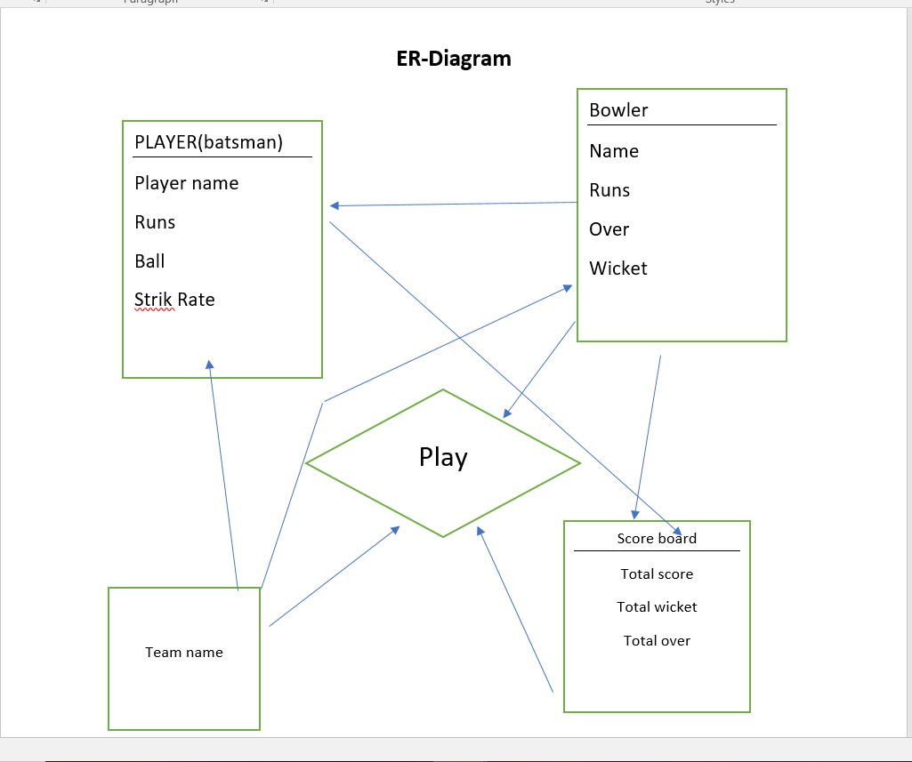

**3.3.4 Flow Chart**

**Chapter-4**

**Experimental Result**

**4.1 Result Analysis**

Cricket score board management system project mainly work about the all information of cricket match.In this project Here include the Team name,player name,Their all details in a match.By this project People can easily know about the full commentary of a cricket match.They also know how much score are here . people also get the information of their Favourite players history by this cricket score board management system.In below the main point of the result of cricket score board management system project ,

* Two Team name
* Players name
* Find vanue of the match
* Also know about the full commentary of full match
* Every single batsman and bowlers total performance
* Finally show the total run and a standard Score board

**Chapter-5**

**User Manual**

**5.1 Introduction**

Cricket score board management system software is mainly provide the full details of a cricket match like T-20 ,One-day match or Test match.The user can see the full commentary of a match.This provide users the batting and balling details.So it a will be a enjoyable software for cricket lovers.

**5.2 System requirement**

**5.2.1. Hardware requirement :**

* Processor: Pentium(R) Dual-core CPU to core i-3 Processor
* Minimum 2 GB RAM
* 256 MB or more hard disk

**5.2.2. Software requirement:**

Operating system :

* windows operating system
* Codeblocks
* cpp

**5.3 User Interface**

In this page ,This system show the total scoreboard of a cricket match.It contains the total run,wicket,over,batsman details and the final match result.

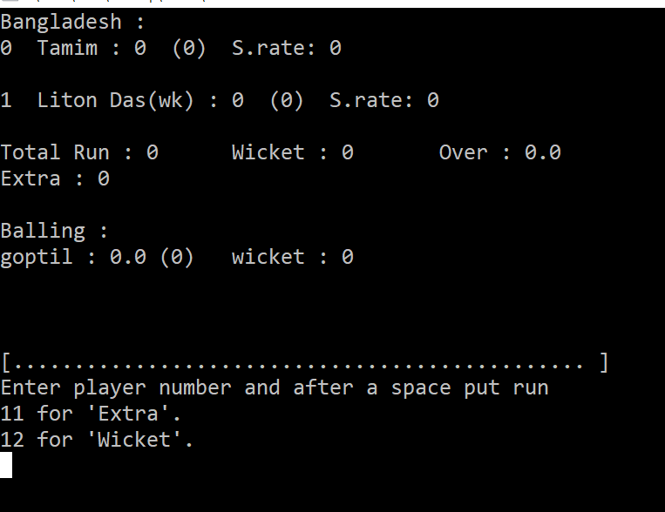

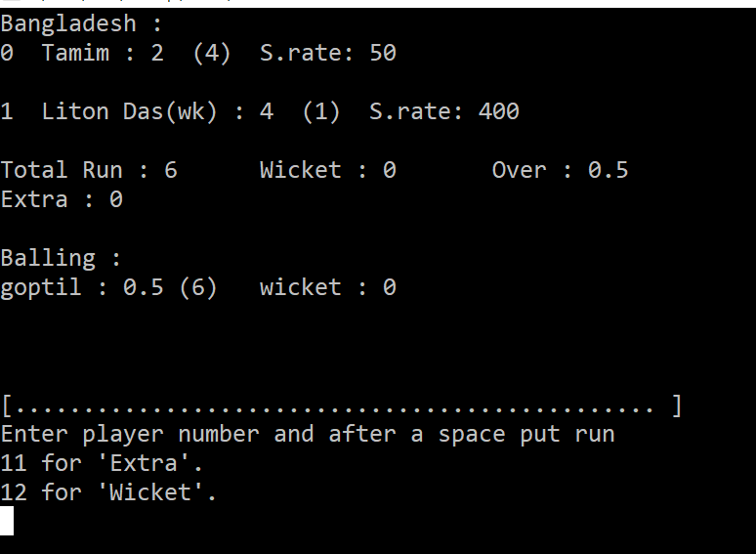

**Chapter-6**

**Study Design**

**6.1 Study period**

|  |  |  |
| --- | --- | --- |
| SL.No | **Duration** | **Work Title** |
| **1** | 24-11-2018  To  1-12-2018 | Planning of this project,  Collect Data |
| 2 | 1-12-2018  To  8-12-2018 | Proposal writing,  Design Interface ,  Select requirement,  Start Documenation |
| **3** | 8-12-2018  To  22-12-2018 | Collect more data;  Complete designing  Start implementation |
| **,**  **4** | 22-12-2018  To  12-01-2019 | Complete approximate of Implementation  Coding,  Report on project |
| **5** | 12-1-2019  To  26-1-2018 | Complete report  Complete all requirement |

**6.2 Advantages**

* The user can view the scores from anywhere through internet.
* Users can keep themselves updated about matches.
* The system is flexible to use and is cost-effective.

**Chapter-7**

**Conclusion**

**7.1 Conclusion**

Cricket is a popular game in the world.Almost all kind of people like and love the cricket. So by using this application , the cricket lover find all the news of their favourite team. This software provide the prople live score of a cricket match.

So this application is more use full for the people who like the cricket.Using of Cricket score board management system software , people can know full time update of a match.

So this software is more important for all kind of people.

**7.2 Future Work Extension**

This application can be used in cricket organizations. So through out the country this program is very useful. Also this program helps the organizer to store data in digital form.

**References**

* https://en.wikipedia.org/wiki/Scoring_(cricket)
* [https://projectsgeek.com](https://projectsgeek.com/)
* https://www.researchgate.net
* <https://pdf.wondershare.com/templates>