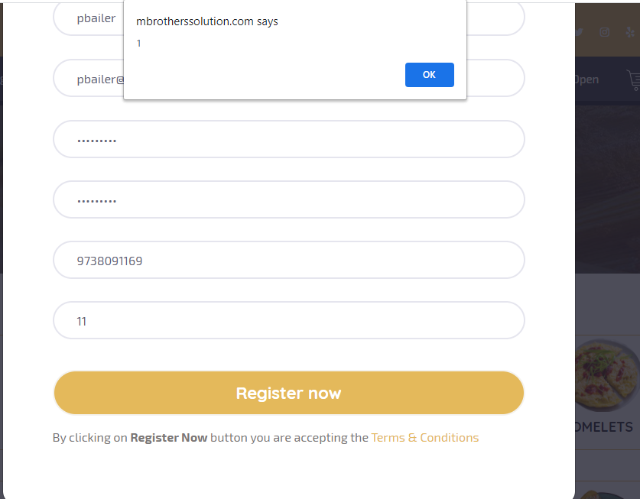

-Remove debugging mbrotherssolution.com that comes after registration

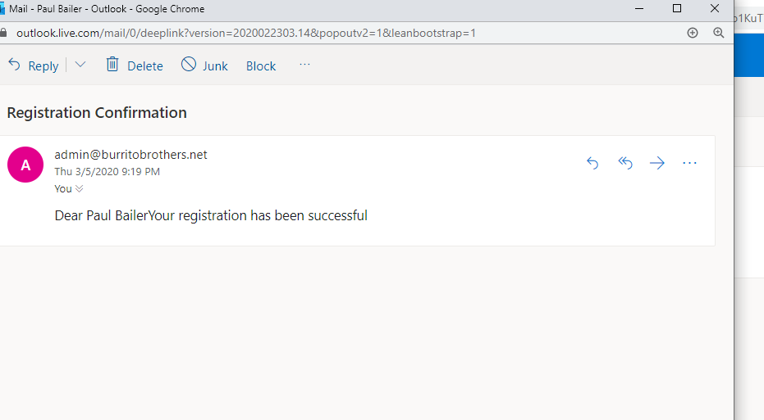

-Change registration email to come from support@burritobrothers.com

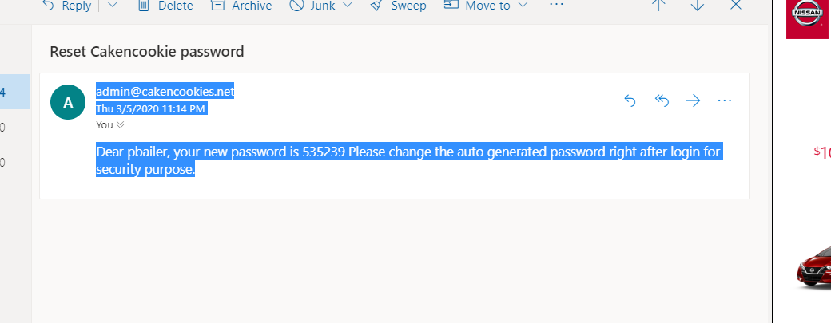

-Change password reset option to be a link instead of a number

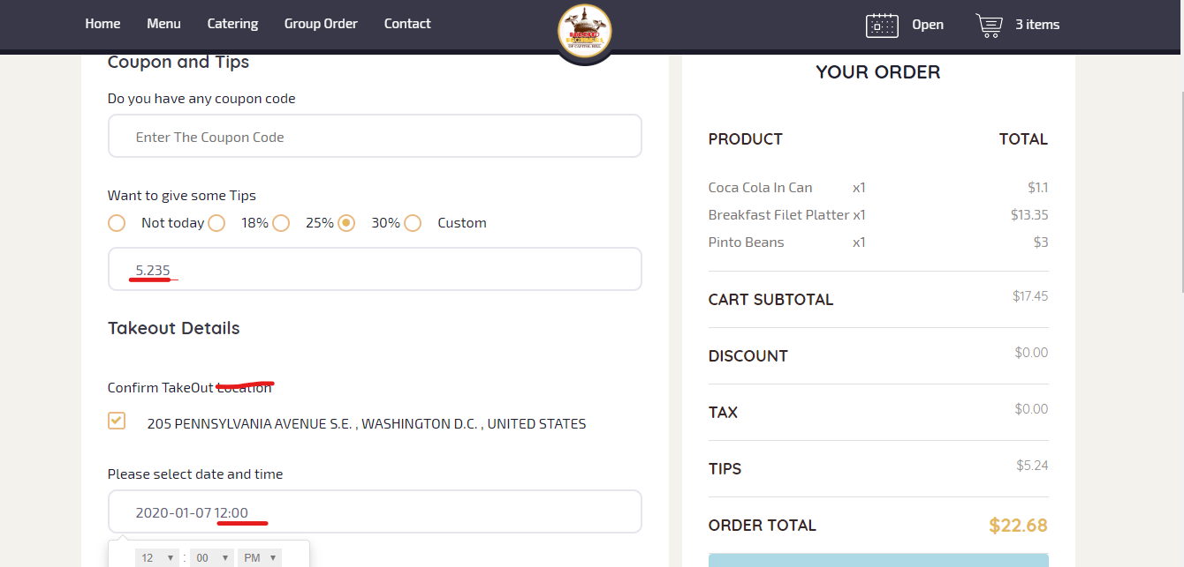

-2 decimal point for tip amount

-Confirm TakeOut at Address

-Add Date and Time- ASAP – Option that gives 15 minute Lead time as first option (Add 15 Minutes to current time)

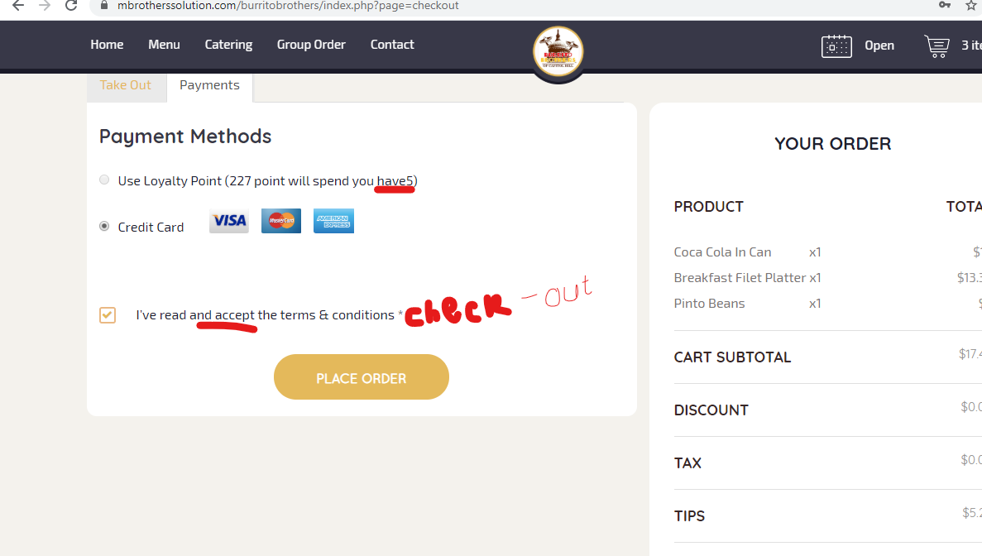

-Change message for using loyalty point. If loyalty points are unusable, make the option visible but greyed out. Should have clear message like ; This order needs __points, You have __ Points

-

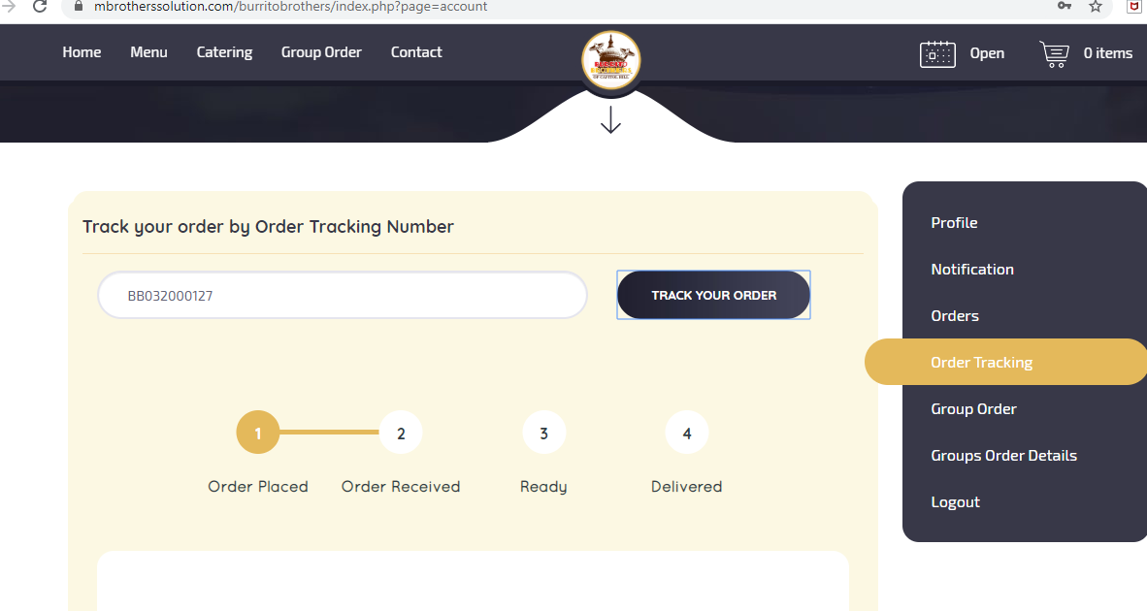

-It may not be convenient for customers to follow status of their orders by copy/pasting their order number on this screen. Can we have clickable order on this screen to track status in addition to copy paste or even just list the status of all current orders on this section ?

Order # Order Date

**BB032000127** Sat 3/7/2020 3:32 PM

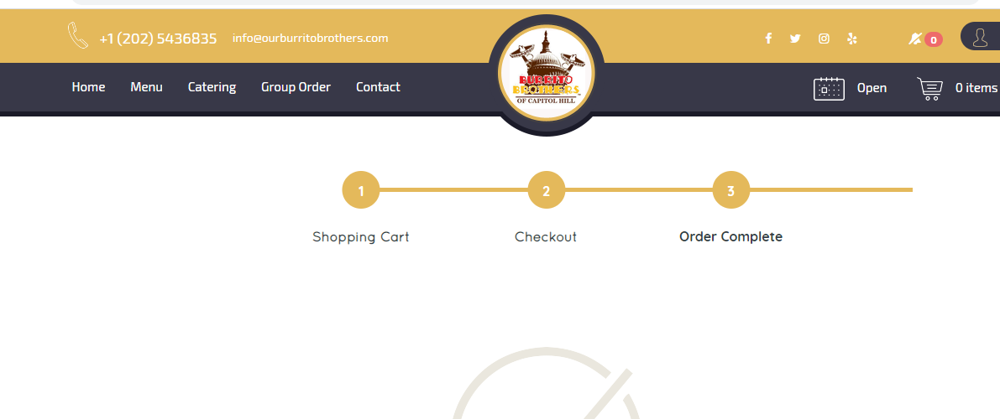

1. **.**

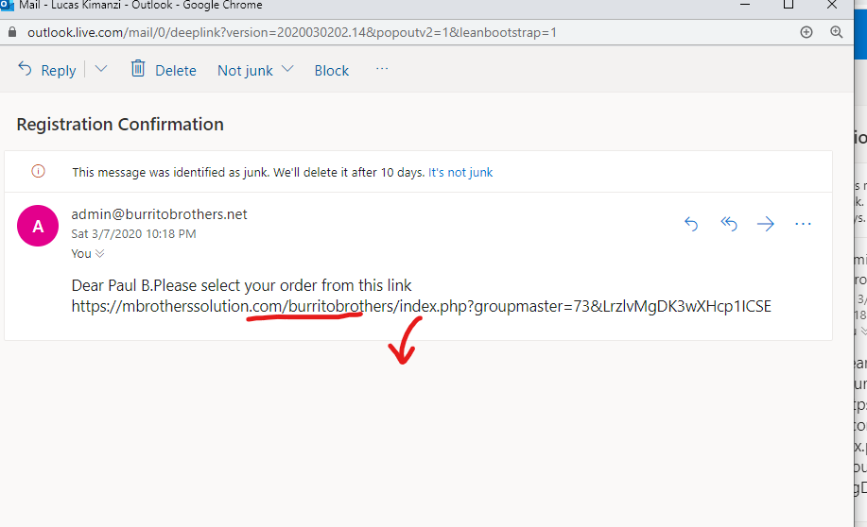

-Group order invite.- Make hyperlink and a button for easy access

1. **.**

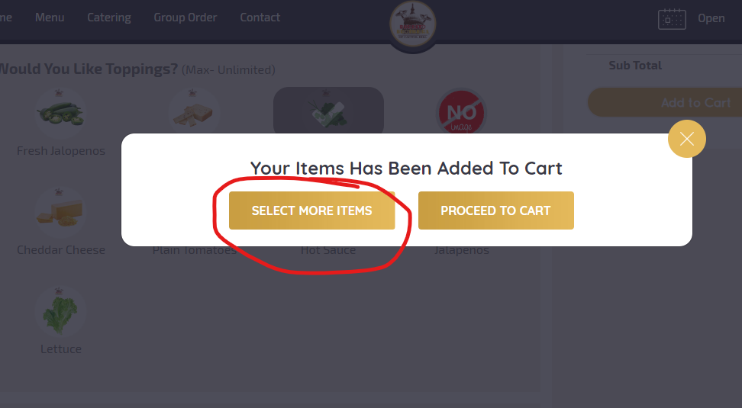

-On final checkout page, include button to go back and add more items.

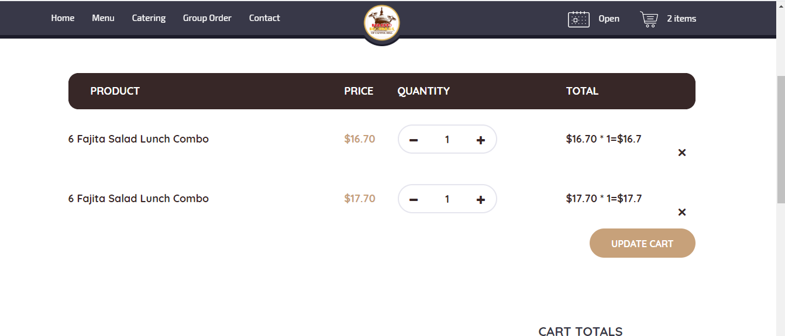

-Include same button to select more options on group order individual check out

1. **.**

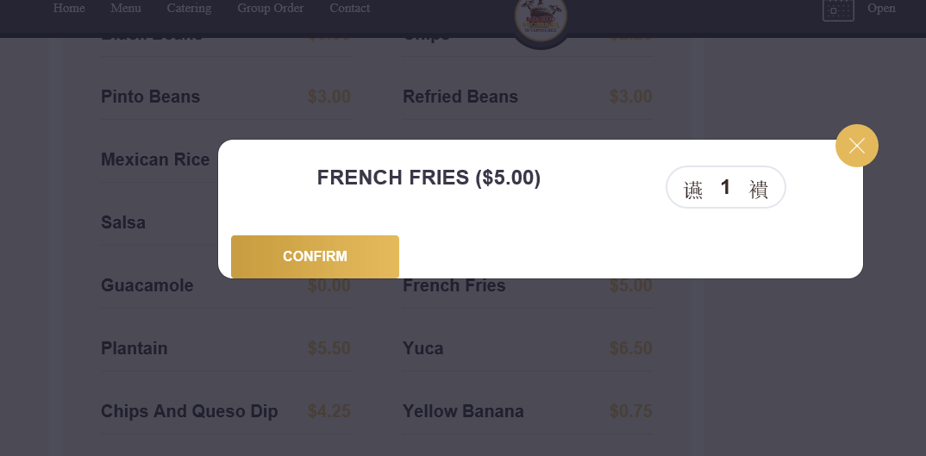

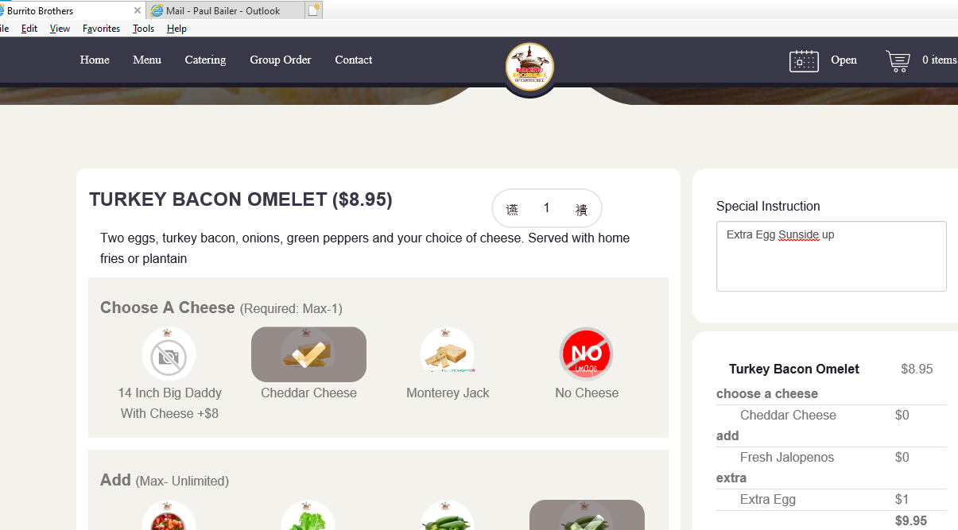

Sometimes the +/- to adjust quantities in IE browsers are showing Chinese characters

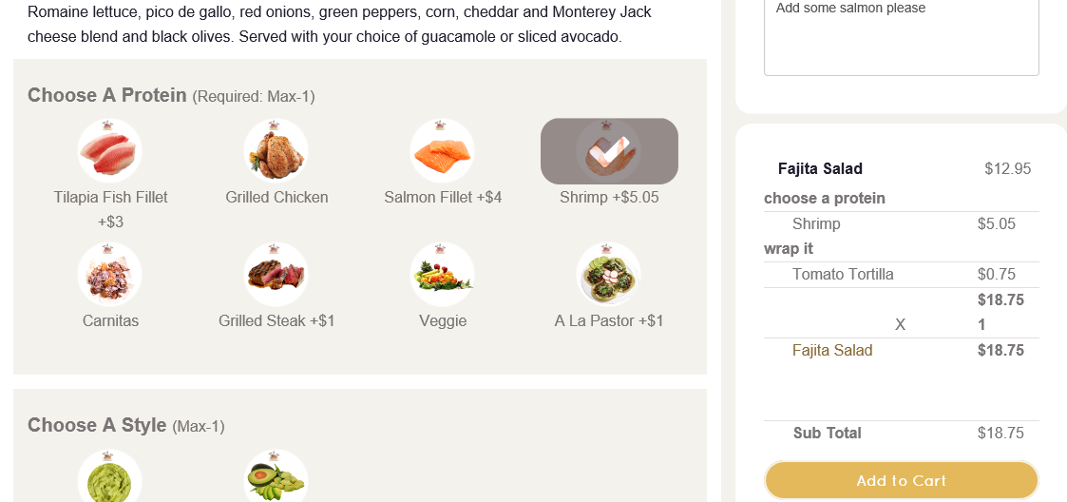

Not going to check out, no reason given!

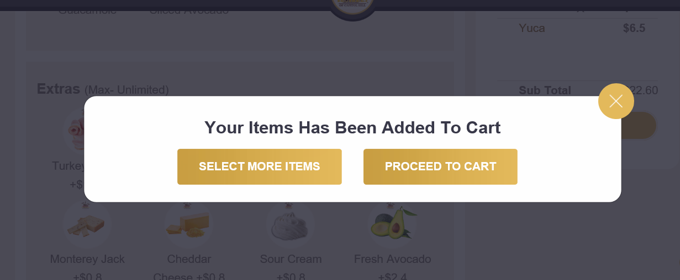

-Before checkout, when you X out of this pop-up as you would to see your option selections just before checkout, all options made disappear.