Student View

1. Books view not found.
2. Registration Pending course view problem. (Undefined offset: 0) [After login]
3. Course view not working from Ongoing Upcoming list page. Even some course are working some are not. [After Login]
4. Payment Button is not working. (Undefined offset: 0)
5. Batch transferred show in the every course details page. It’s not sure yet where the problem is. But here the logic. If any students transferred from any course, system should say the latest course view that (Transferred from other batch). On the other hand system should say (Transferred to other batch). If possible to write the batch number by replacing the word “other batch”.
6. Please reposition the results details for the student.

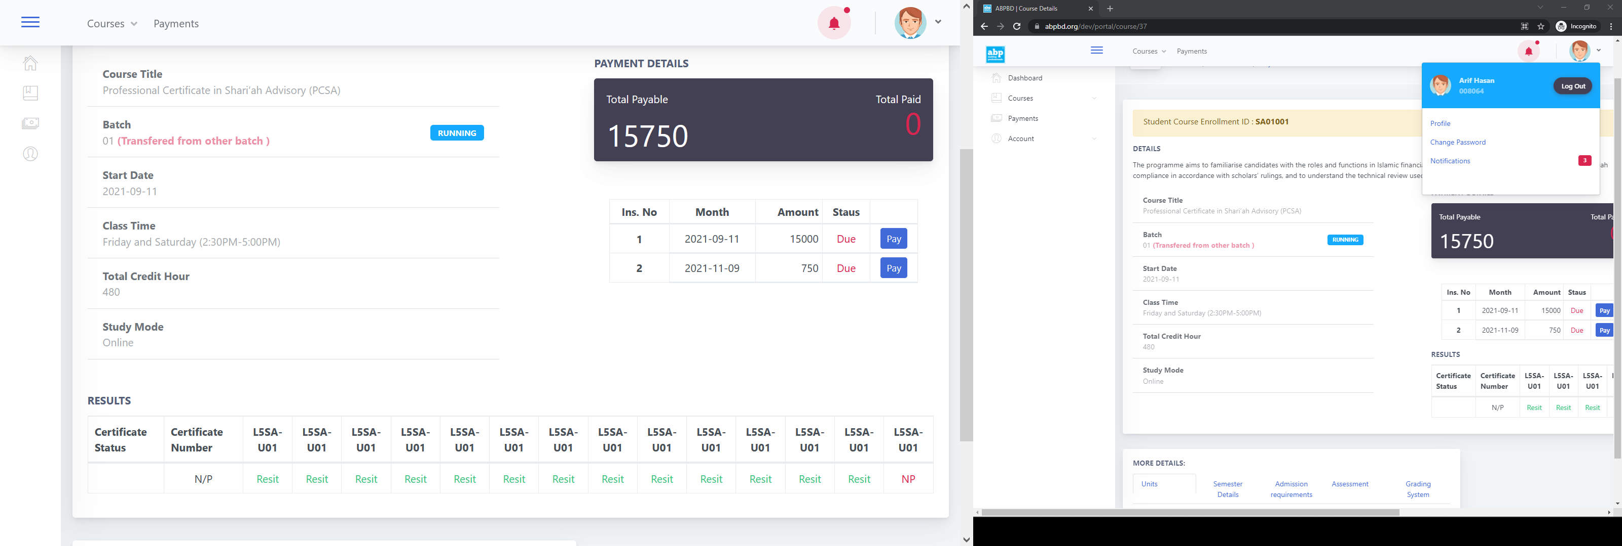

1. Attached file path need to change. It’s not working. This might be abpbd.org/dev/assets……

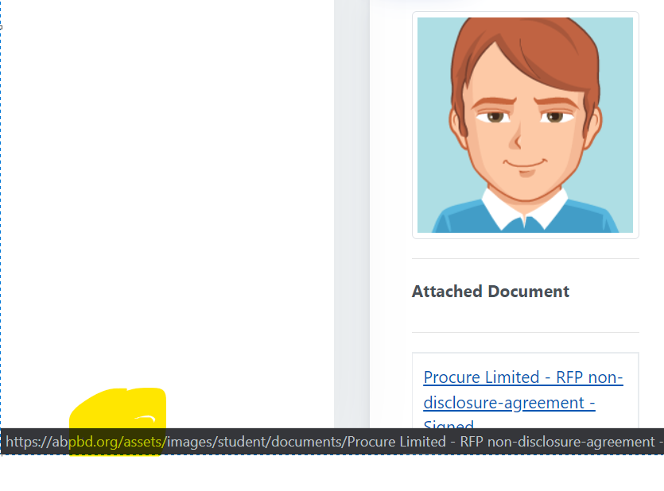

1. Please provide us the uploaded files details like accepted file types, limit etc.
2. Active menu problem doesn’t seem solved from my end. (the function never implemented, it is not a bug, the whole menu system for student need to re-organize, it will take time and resources)

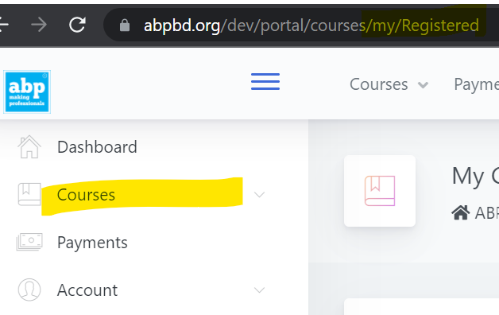

1. Bring whole admission going on section before ongoing batch list. *********
2. Profile edit-> passing year should be share the year list. If it not possible than make it input box for numbers only and it should be 4 digits long.

Admin

**Dashboard:**

Need some discussion on this.

**Batch**

* 1. Welcome email status has been changed but student never got that email.
  2. Need to add an option so that non-enrolled learners cannot see those batches but those will be visible to enrolled learners only. (specific cases)

The batch status will automatically change when today date = batch starts date. If there need to change the status we will do that manually. But it needs to change automatically. Need discussion

* 1. I think there was a download button for downloading the student information for a batch. But currently that button was not found. (I cant remember anything like this, it is not even in live)
  2. We need to implement Dropout for payment calculation as well. how ?????? give me logic
  3. There have some fields that cannot be updated like (Plan name, can’t delete if add another instalment payment plan)

**Student**

1. Uploaded file will also remove from the server.
2. I didn’t find any password reset option from admin end. (not a bug, need to add in next phase)

**Payment Collection**

* 1. Multiple filter buttons appear when I search multiple times in that screen. (need to change the full processs flow, need some time to do the fix)

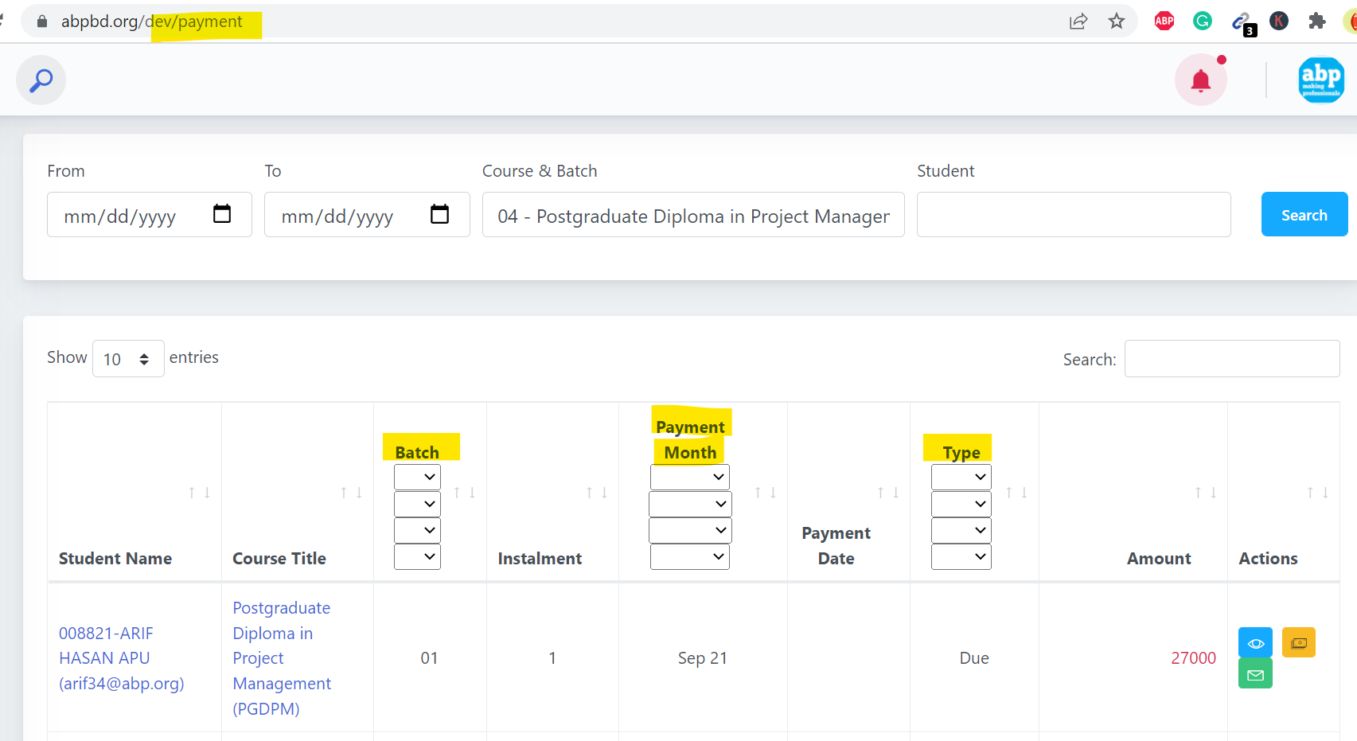

* 1. Is it possible to rename the invoice according to student information like invoice number+student id+student name?
  2. Can we have printable invoice view like as downloaded one? (Later)

**General:**

1. Batch Transfer menu needs transfer under student menu.
2. Book can transfer under academic section. (I just transfer books menu under the academic section but it still shows the course menu active) I will do that after uploading to live, it is all about configuration from admin panel

**Books**

1. First column should be the enrolment ID and it should be ascending order.
2. Book 1 will be the first column than the Book2 and so on with feedback.
3. Feedback creator name and date of feedback is needed.
4. By un-sending a book, student is also having e sending notification.
5. Un-sending book confirmation notification shows sending notification. It should be
6. How can I send books as bulk or multi-selected students?
7. How inactive is works on books?
8. How to remove a book?
9. Feedback (+) plus button title should show Add feedback rather Edit
10. How can I edit or delete existing feedback?

**Batch Transfer**

1. Is it possible to keep all the transfer history in the list even if student transfers more than one time for the same course? Yes but not tested

**Result**

1. Clear div on click filter
2. It’s not working. When I search 1st time it shows ok. But from the second time it shows the following view. Each search it increase the column values. Even o can’t update any results also.

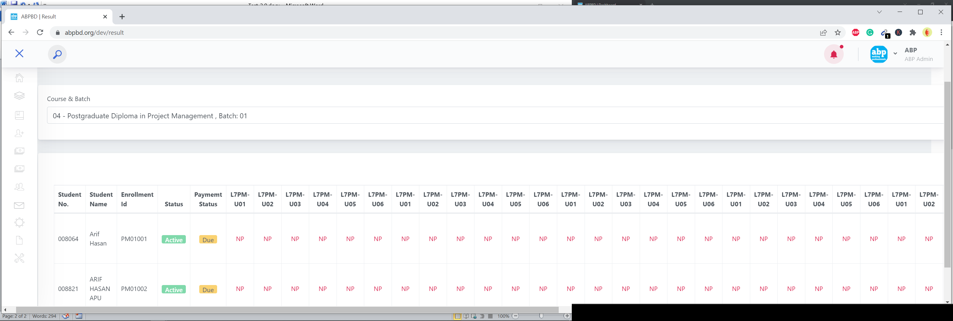

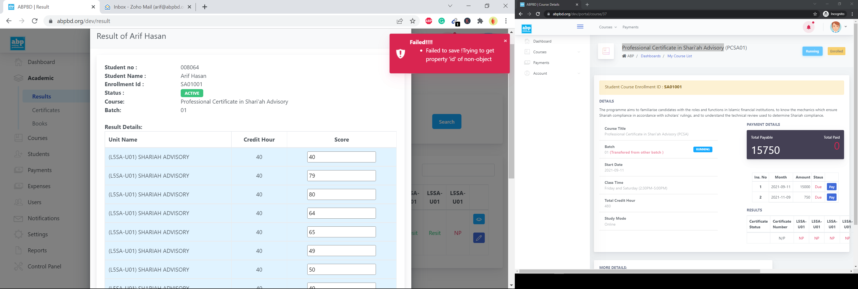

**Certificate**

1. Result Details and Edit button are not working.
2. Feedback (+) plus button title should show Add feedback rather Edit
3. How can I edit or delete existing feedback?
4. Feedback creator name and date of feedback is needed.

**Notification**

1. Need discussion.
2. All Students in a Course & Batch? is not working for both email and sms.
3. Please rename monthly email to Bulk Emails.

**Settings**

1. How can I save any changes on general settings? And what is site url and admin url.

