Student View

1. Some unnecessary white space at the bottom. (tostr-show) Bottom of index page with/without login.
2. Now student can see all the sent and unsent books. But they must see the book list if it has been sent.
3. Student enrolment doesn’t go to 3rd step for payment.
4. Enrolment pending user is also seeing the books list which should not be.
5. Attached file path need to change. It’s not working. This might be abpbd.org/dev/assets…… . (Not Solved – Maybe plan for live)

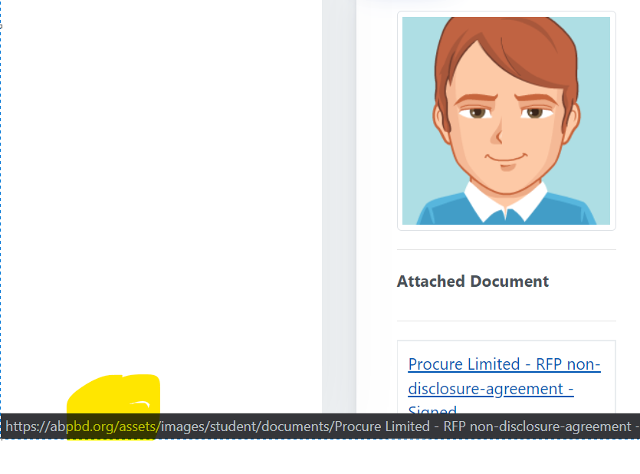

1. Please provide us the uploaded files details like accepted file types, limit etc. (I need a written document)
2. Active menu problem doesn’t seem solved from my end. (the function never implemented, it is not a bug, the whole menu system for student need to re-organize, it will take time and resources) (Keep listed for future ref.)

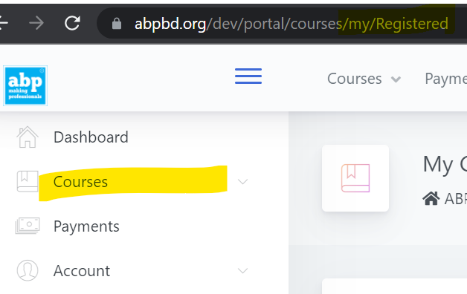

1. Profile edit-> passing year should be share the year list. If it not possible than make it input box for numbers only and it should be 4 digits long numbers only. Not solved in Self Enrolment Section.

Admin

**Dashboard:**

Need some discussion on this.

**Batch**

* 1. Need to add an option so that non-enrolled learners cannot see those batches but those will be visible to enrolled learners only. (specific cases) **change label as draft/hide.**
  2. The batch status will automatically change when today date = batch starts date. If there need to change the status we will do that manually. But it needs to change automatically. Need discussion
  3. Need a summary of total dropout student and financial statement. Monthly due collection report will show us the amount of total due amount and dropout amount with already collected amount so far. ( need report format)
  4. Dropout encounter problem. If I re-active a dropout student, system count it as a new enrolment and increase the enrolled total.

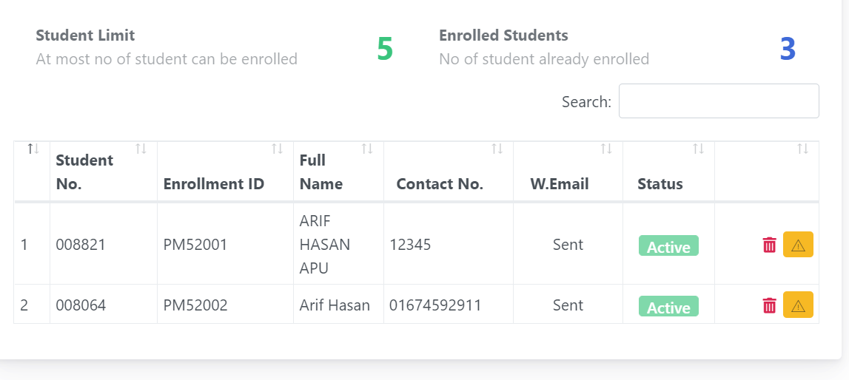

* 1. There have some fields that cannot be updated like (Plan name, can’t delete if add another instalment payment plan) (Not solved)

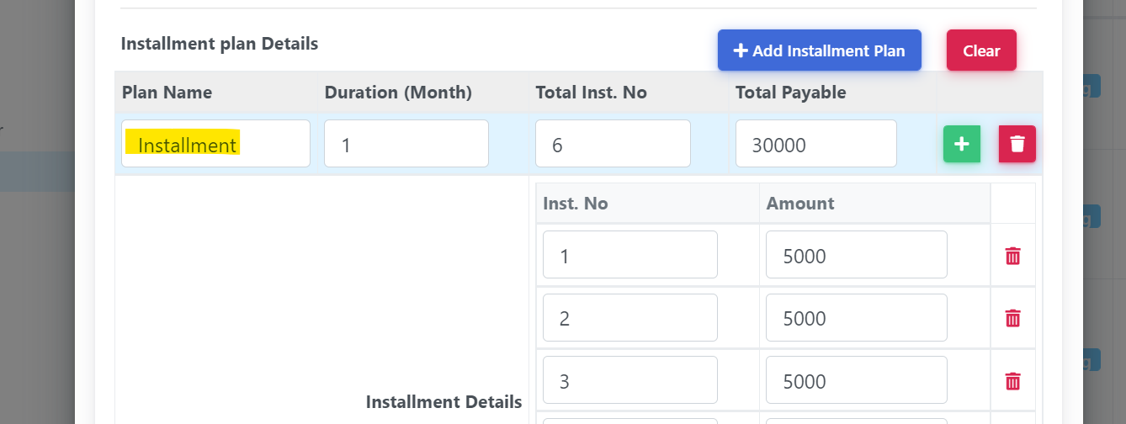

**Student**

1. Uploaded file will also remove from the server. (Discussion needed)
2. I didn’t find any password reset option from admin end. (not a bug, need to add in next phase) (But this one was listed in this phase)

**~~Payment Collection~~**

* 1. ~~Multiple filter buttons appear when I search multiple times in that screen. (need to change the full processs flow, need some time to do the fix) OK~~

~~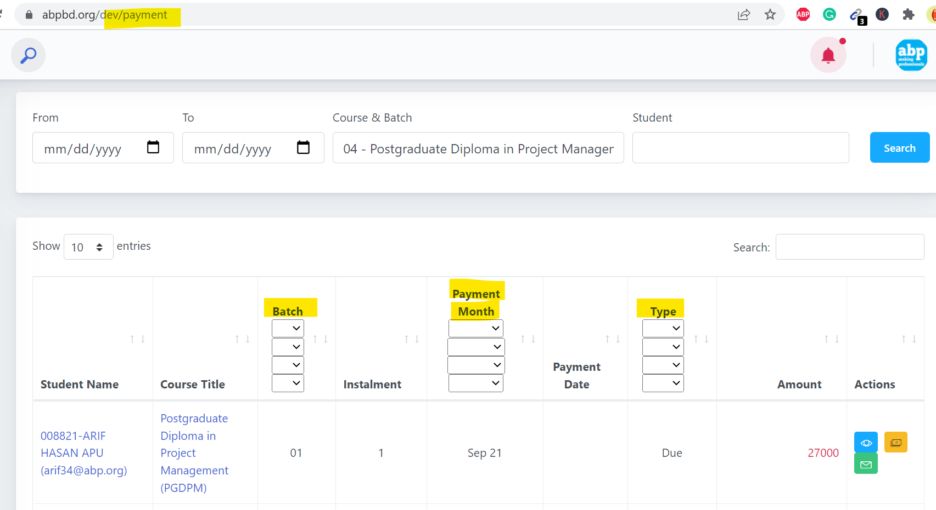~~

* 1. ~~Can we have printable invoice view like as downloaded one? (OK)~~

**Books**

1. ~~Book 1 will be the first column than the Book2 and so on with feedback. (Not fixed but we can work for now~~) course 04 batch 52 (book sends notification and dialog)
2. By un-sending a book, student is also having e sending notification. (By changing this, live notification has been stop for all) Book un-sending is not working now.
3. ~~How can I send books as bulk or multi-selected students? NXT~~
4. How inactive is works on books? Inactive books won’t show in the table.
5. Feedback book wise not showing.

**Batch Transfer**

1. Is it possible to keep all the transfer history in the list even if student transfers more than one time for the same course? Yes but not tested. (Need a decision) Multiple batch transfer not showing.

**Result**

1. It just shows the result of previous search. If I search the 13th batch results, it will shows the 13th batch details if I search for 52nd batch details.

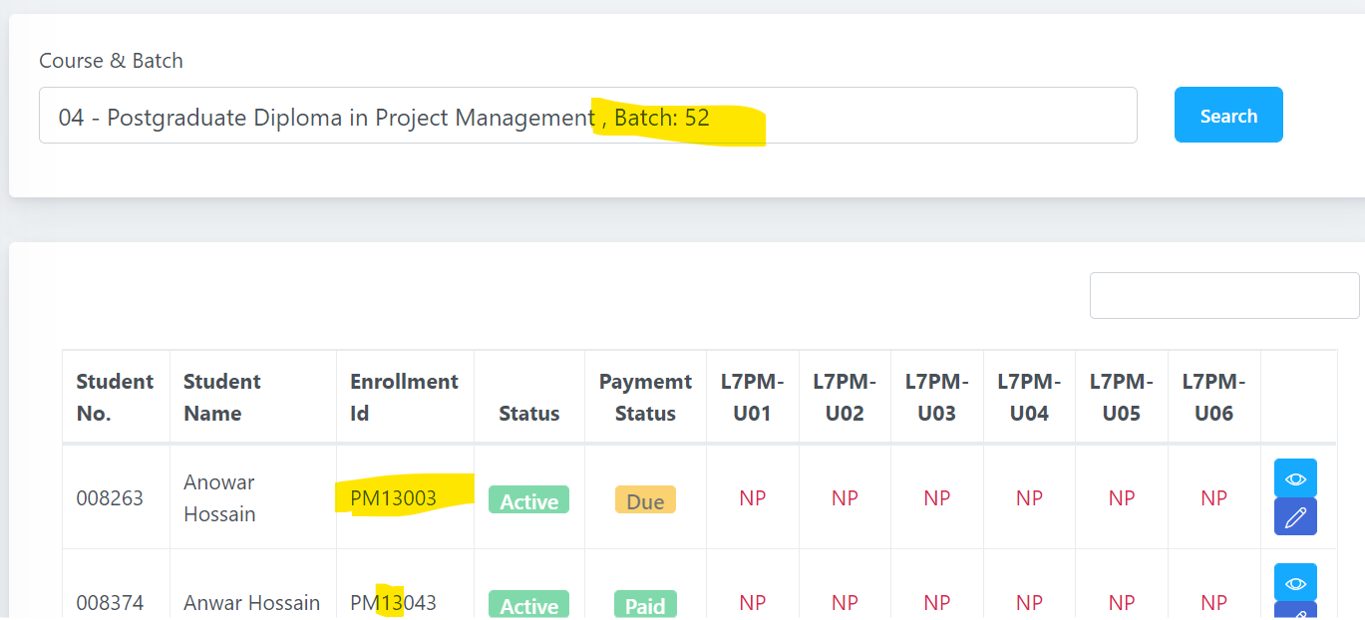

1. Fresh search shows the following blank result.

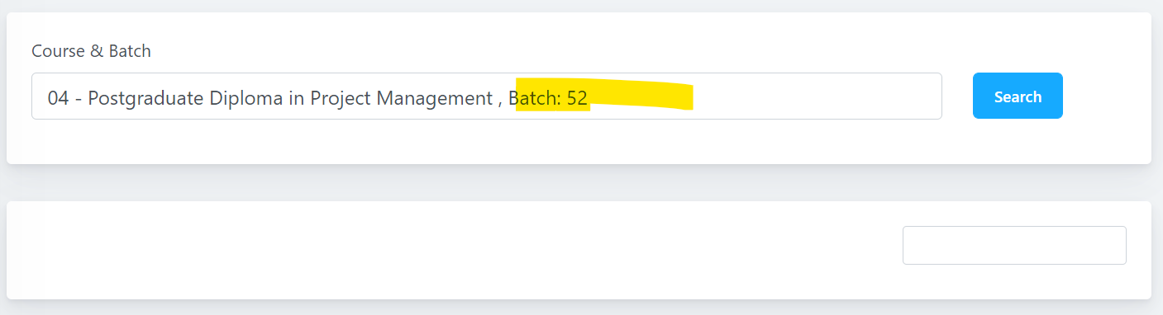

Multiple result can’t update at the same time.

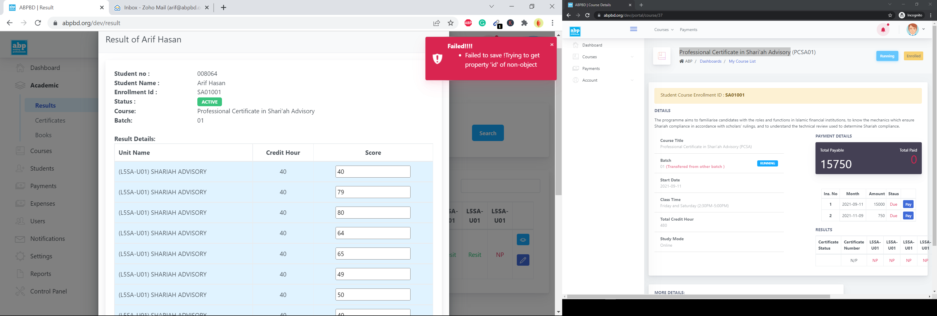

**Certificate**

1. Feedback (+) plus button title should show Add feedback rather Edit (I don’t see the feedback now)
2. How can I edit or delete existing feedback?
3. Feedback creator name is needed.

**Notification**

1. Need discussion.
2. Templates
   * 1. Welcome email template needs email as a placeholder.
     2. Need a general category where others email can be saved.
     3. Student email needs to add all the email template categories.

All:

1. Email>Student category> Same student gets same emails multiple times
2. Bulk email signature problem. [Add default signature checkbox]
3. Profile Edit>Current Employment Company and Current Designation auto search not working.
4. Duration change on dashboard is not working.