Student View

1. Some unnecessary white space at the bottom. (tostr-show) Bottom of index page with/without login.
2. Latest transferred batch details can’t view from registered list. Make a batch transferred and try to view that course from the registered course list. Didn’t see any bug (NEED TO SEE LIVE)
3. Student profile edit>
   * Last Qualification * shows mandatory but it’s not and it doesn’t fetch previous data.
   * Live search for Current Employment Company and Current Designation are not working.
   * Passing Year 4 digits number not working.
   * File delete confirmation dialog. (Also in self-registration)
4. Attached file path need to change. It’s not working. This might be abpbd.org/dev/assets…… . (Not Solved – Maybe plan for live)

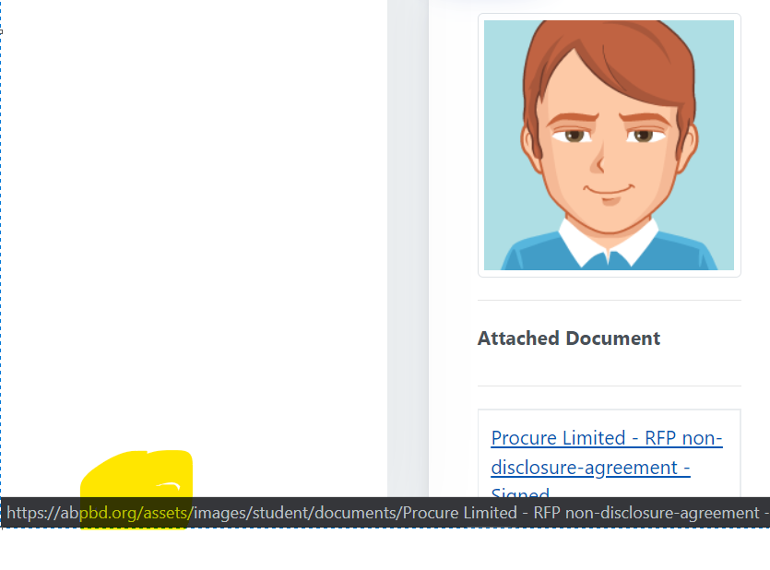

1. Active menu problem doesn’t seem solved from my end. (the function never implemented, it is not a bug, the whole menu system for student need to re-organize, it will take time and resources) (Keep listed for future ref.)

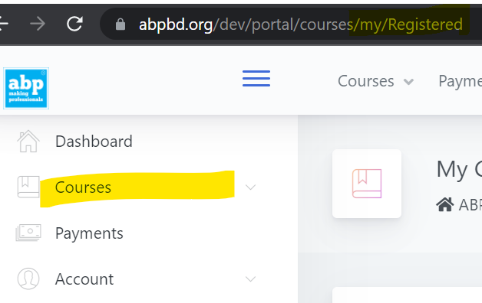

1. Profile edit-> passing year should be 4 digits long numbers only. Not solved in Self Enrolment Section.

Admin

**Dashboard:**

Need some discussion on this.

**Batch**

* 1. The batch status will automatically change when today date = batch starts date. If there need to change the status we will do that manually. But it needs to change automatically.

**Student**

1. Uploaded file will also remove from the server (Final).

**~~Payment Collection~~**

* 1. ~~Multiple filter buttons appear when I search multiple times in that screen. (need to change the full processs flow, need some time to do the fix) OK~~

~~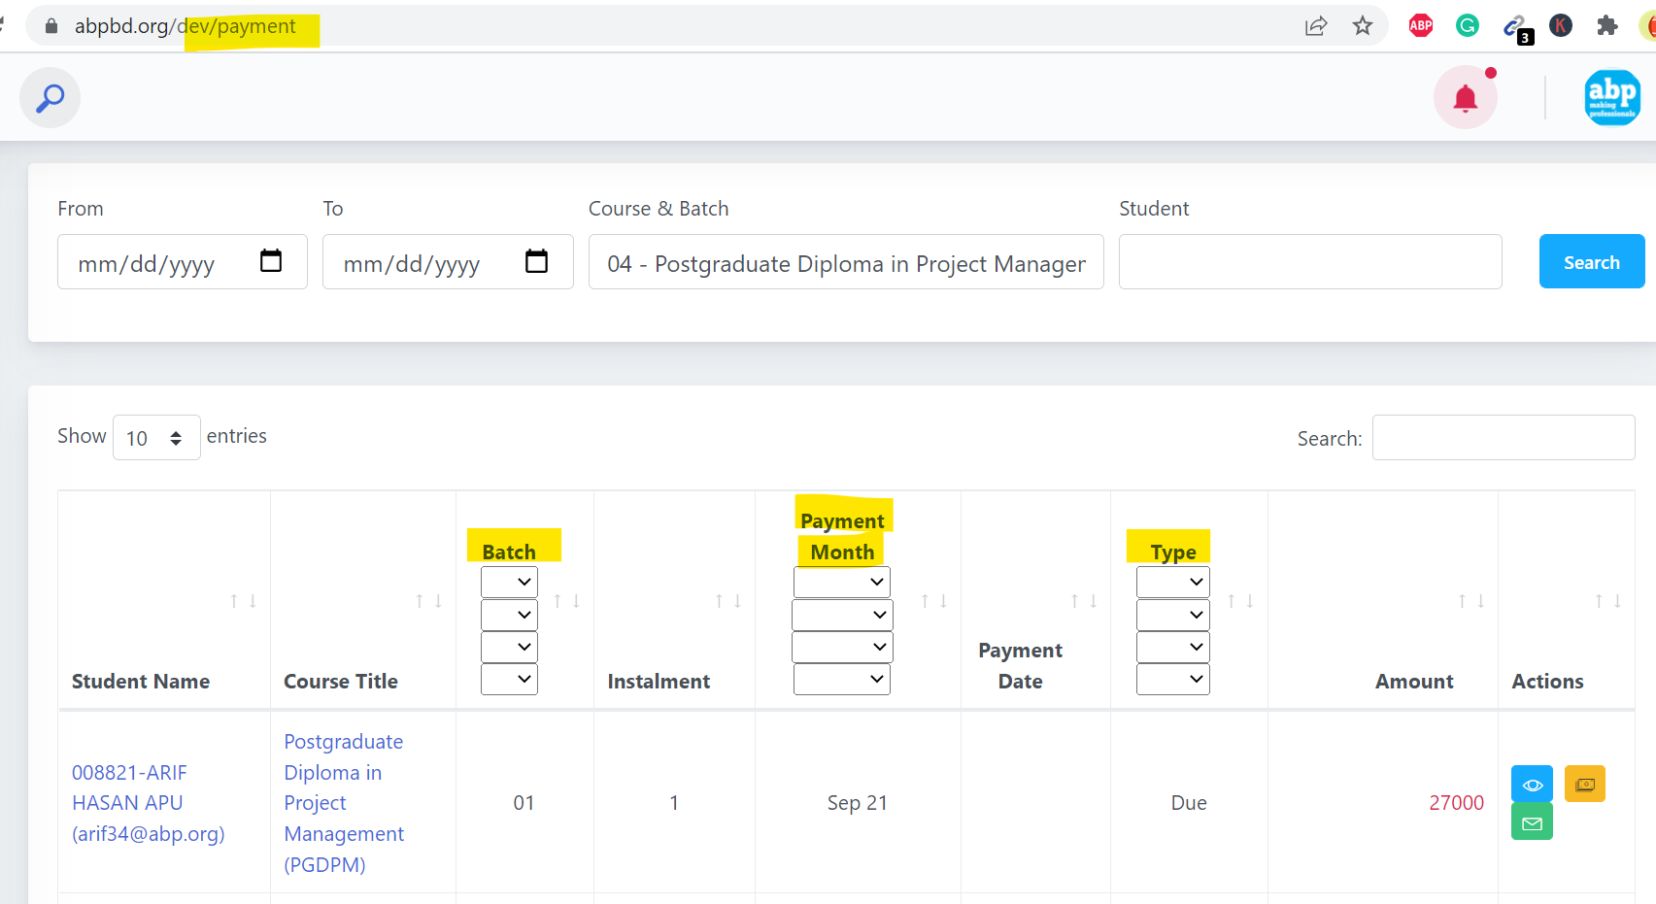~~

* 1. ~~Can we have printable invoice view like as downloaded one? (OK)~~

**Books**

1. ~~How can I send books as bulk or multi-selected students? NXT~~

**Batch Transfer**

1. Is it possible to keep all the transfer history in the list even if student transfers more than one time for the same course? Multiple batch transfer not showing. Please follow the picture below. ???

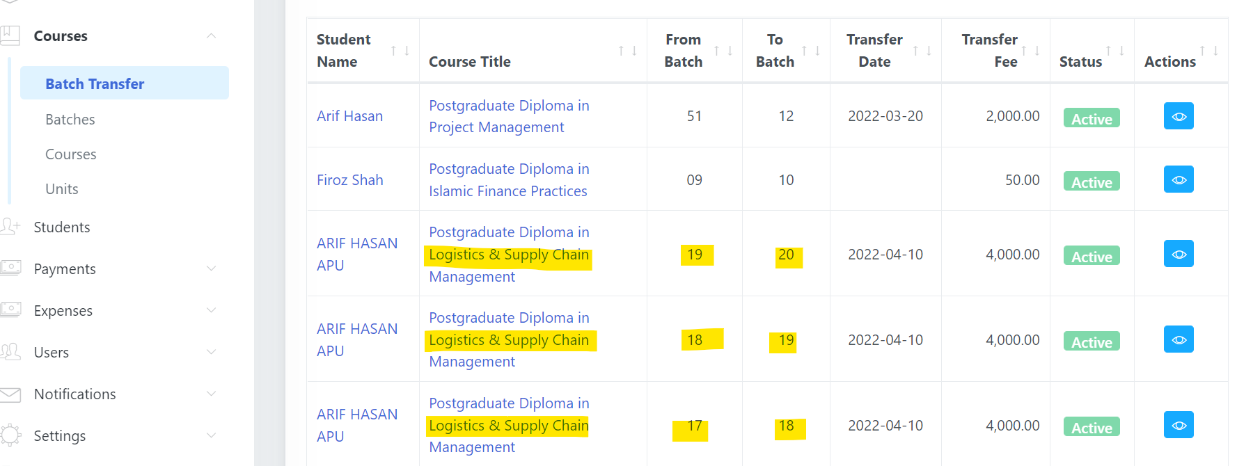

**Result**

1. Multiple results can’t update at the same time. There has a number condition. 49,51,64,65,79,80

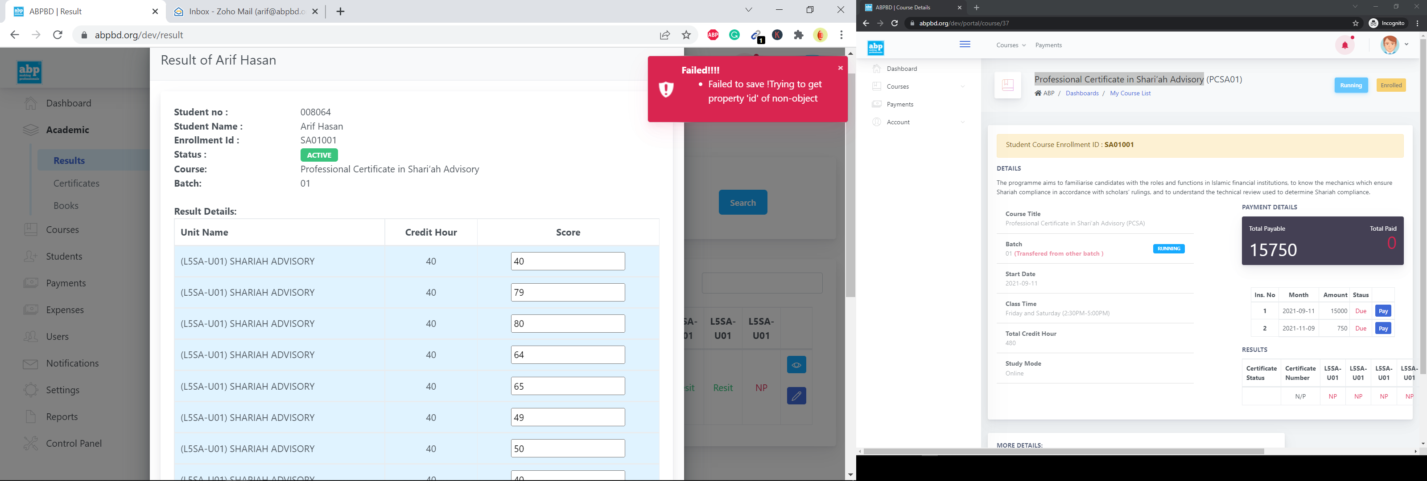

**Certificate**

1. Feedback (+) plus button title should show Add feedback rather Edit
2. Feedback creator name and date are needed.
3. Result view not working (FOUND WORKING ). Feedback history is also visible in the details view.

**Notification**

1. Need discussion.
2. Templates
   * 1. Welcome email template needs email as a placeholder.
     2. Need a general category where others email can be saved.
     3. Student email needs to add all the email template categories.

All:

1. Email>Student category> Same student gets same emails multiple times (NEED scenario)
2. Bulk email signature problem
3. Profile Edit>Current Employment Company and Current Designation auto search not working.
4. Duration change on dashboard is not working. ???