FundXprout: Decentralized Crowdfunding Platform

Final year project proposal
Session 2023-2027

A project submitted in partial fulfillment of the
COMSATS University Degree
Of
BS in Computer Science / Software Engineering (CUI)



Department of Computer Science
COMSATS University Islamabad, Lahore Campus
08 October, 2025

Project Registration
Project ID (for office use)
Type of project |  |  | [ü] Traditional [ ] Industrial [ ] Continuing
Nature of project |  |  | [ü] Development [ ] Research & Development
Sustainable Development Goals(SDGs) |  |  | [ ] Good Health and Well-Being [ ] Quality Education  [ü] Industry, Innovation, and Infrastructure [ ] Gender Equality  [ü] Decent Work and Economic Growth [ ] Climate Action
Area of specialization |  |  | [ü] Artificial Intelligence (AI) [ü] Blockchain [ ] Cybersecurity  [ ] Data Science and Analytics [ ] Game Development  [ ] Internet of Things (IoT) [ü] Natural Language Processing (NLP)  [ ] Mobile App Development [ü] Web Development
Project Group Members
Sr.# | Reg. # | Student Name |  | Email ID | Phone # | Signature
(i) | Group Leader  sp23-bse-096 | Momena Ahmed |  | sp23-bse-096@cuilahore.edu.pk | 03054049768 | 
(ii) | sp23-bse-069 | Hafsa Saleem |  | sp23-bse-069@cuilahore.edu.pk | 03328645204 | 
(iii) | sp23-bse-097 | Momna Shafqaat |  | sp23-bse-097@cuilahore.edu.pk | 03278344865 | 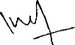
Declaration: FYP group members have cleared all prerequisite courses For FYP-I as per their degree requirements.
For BS(Computer Science) and BS(Software Engineering)
(CSC241 Object Oriented Programming, CSC291 Software Engineering Concepts, CSC270 Database Systems, HUM102 Report Writing Skills)
For BS(Artficial Intelligence)
(CSC291 Software Engineering Concepts, HUM102 Report Writing Skills)

Plagiarism Free Certificate
This is to certify that, I am Momena Ahmed S/D/o _______________________, group leader of FYP under registration no CUI /________/LHR at the Computer Science Department, COMSATS University Islamabad, Lahore Campus. I declare that my FYP proposal is checked by my supervisor and the similarity index is _____12__% that is less than 20%, an acceptable limit by HEC. The report is attached herewith as Appendix A.
Date: _________ Name of Group Leader: Momena Ahmed Signature: __________
Name of Supervisor: __________________ Co-Supervisor (if any):_________________
Designation: _____________________ Designation: _____________________
Signature: _____________________ Signature: _____________________

Abstract
Equity crowdfunding enables businesses to raise capital by selling shares to numerous investors, but traditional platforms suffer from high fees, opaque processes, and limited liquidity post-investment. This project meets these challenges by leveraging blockchain technology to create a transparent, secure, and decentralized solution, while integrating artificial intelligence to assess investment risks. We propose a full-stack decentralized application (Dapp) built on the blockchain where business equity is tokenized into ERC-20 tokens. In the equity-based model, investors receive blockchain-issued equity tokens, representing ownership shares in the startup. Smart contracts automate core processes including handling equity terms and issuing tokens for businesses, verifying documents for legal oversight and KYC obligations on the investor side. A secondary marketplace enables investors to trade equity tokens peer-to-peer, improving liquidity and investment flexibility. In parallel, the NLP risk assessment model will analyse project proposals to flag high-risk campaigns, check potential fraud, and provide investors with risk scores for informed decision-making. The expected outcome is a functional platform that not only reduces costs and enhances transparency through blockchain but also increases security and trust through AI-driven risk assessment. Together, these innovations aim to modernize equity crowdfunding by providing investors with liquidity, confidence, and data-driven decision support.

Table of Contents
1 Introduction 5
2 Problem statement 6
3 Objectives 6
4 Related work 6
5 Proposed methodology and architecture 8
5.1 MetaMask Wallet Integration 8
5.2 Equity Tokenization 8
5.3 KYC/AML Compliance Service 9
5.4 Marketplace 9
5.5 AI Risk Assessment 9
5.6 IPFS 9
6 Success Criterion 9
6.1 Tokenization of equity 9
6.2 Risk assessment module 9
6.3 KYC/AML compliance 9
7 Team Roles and Responsibilities 10
8 Gantt Chart 11
9 Tools and Technologies 11
9.1 Backend 11
9.2 Frontend 12
9.3 Database 12
9.4 Additional tools 12
10 Bibliography 13

Introduction
Crowdfunding facilitates entrepreneurs and startups to raise capital from a large pool of investors in a short period of time, compared to an extended period that is required when asking for a loan. In the same way, it helps investors make a profit by funding businesses which interests them and distribute risk across multiple investments. XBTO [1] describes how tokenization represents business equity ownership by issuing equity tokens to investors; these equity tokens are easy to exchange peer to peer compared to traditional equity, which is hard to sell due to a lack of a marketplace, and in turn, investors get stuck with their investment. The ownership of equity tokens, which also represent ownership of shares in a business is easy to track and immutable due to their presence on a public blockchain. Smart contracts handle the exchange, trade and issuance of equity tokens reliably and easily by reducing the number of intermediaries necessary for keeping track and records of ownership. Blockchain tokens are not location-based and can be invested anywhere in the world as a result offering an exemption from geographical limitations.
Traditional private equity platforms are centralized and lack investor liquidity. Extensive record keeping and third-party reliance are required to keep track of equity ownership. These third-party services require high operational costs and don’t provide transparency in transactions [2]. Investors lack the means to trade their shares in business, as well as the tools to make informed investment decisions. Moreover, there are no tools that assess the risk associated with a business by scrutinizing the business pitch. Investors are reluctant to invest through such platforms due to a lack of a marketplace to trade their shares, as shares are difficult to trade [3]. Therefore, there is a need for a platform that addresses the issues of transparency, liquidity and cross-border participation.
Our platform allows businesses to issue equity tokens through tokenization, which can be traded on a secondary marketplace, thus addressing the problem of liquidity. ERC-20 or ERC-1400 are used as standards, which are issued using smart contracts that eliminate the need for third-party system to track ownership. The transactions resulting from the purchase of equity tokens or trade of such tokens indicate the transfer of ownership and are recorded on a public blockchain, facilitating transparency and enabling trustless execution. Implementing smart contracts enforces conditions coded inside them, which reduces the overhead of manual operations carried out by third-party that incur high costs for carrying out these operations. Our platform will make use of IPFS (Interplanetary file system) as a distributed storage technology to ensure compliance with KYC/AML (Know your customer) standards [4]. Moreover, AI-powered approach will be used to scrutinize the credibility of startup pitches by using platforms that make use of large language models to predict startup success [5]. Integration of such innovations will help address issues with traditional crowdfunding platforms using a decentralized approach.
The expected outcome of a decentralized equity crowdfunding platform is to demonstrate the automated issuance of equity tokens and transfer of ownership using smart contracts that eliminate the need for intermediaries and intricate record keeping. To offer liquidity, an embedded marketplace will enable investors to trade shares among themselves once the funding target is reached. The development of this platform encompasses token issuance and transfer using smart contracts, development of a secondary marketplace for flexibility and integration of AI-driven tools to assess risk associated with investment.

Problem statement
Traditional crowdfunding platforms integrate third parties and intermediaries that handle transactions and equity ownership, which lack transparency due to obscure policies and incur high operational costs for carrying out transactions. Moreover, they don’t provide an opportunity to offload shares because a proper marketplace does not exist, so illiquidity prevails leading to reduced investor confidence. These platforms also don’t provide AI-driven tools for investors to evaluate the risks associated with their potential investments. This creates a need for a decentralized platform that tokenizes equity, which can easily be traded on a marketplace, providing liquidity and a transparent blockchain approach to transferring equity ownership.

Objectives
The objectives of proposed decentralized approach to crowdfunding are:
- To develop a decentralized platform that provides transparency through blockchain technology and AI-driven risk assessment.
- To tokenize equity whose ownership can be transferred through smart contracts using ERC-20/ERC-1400 standards, ensuring transparent ownership handoff.
- To provide AI-driven data analytics for risk assessment of startup pitches and detecting fraud using NLP techniques.
- To store compliance records and equity ownership data using IPFS decentralized storage.
- To provide investors with a marketplace where equity tokens can be traded between token holders.

Related work
Crowdfunding is an alternative financing mechanism in which many individuals contribute relatively small amounts of capital to support an entrepreneurial project, product, or venture in exchange for rewards or equity [6]. In the early stages, donation and reward-based crowdfunding were the early models to emerge, after which equity crowdfunding emerged as a market in the early 2000’s where contributors receive actual ownership stakes in ventures rather than rewards or products.
These traditional platforms further use intermediaries to handle payments and transactions, which only provide transparency to a certain extent. Blockchain decentralizes such platforms by introducing smart contracts where contract terms, equity distribution and funds transfer are enforced using code. Jayapal et al [7] explain that the use of blockchain helps eliminate the need for intermediaries that carry out transactions with far less transparency compared to blockchain, where every transaction is recorded on-chain, providing users with transparency and validation. Blockchain addresses this problem by offering immutability, reducing the operational overhead of such intermediaries and tokenizing equity which allows for decoupling the asset ledger from the crowdfunding platform, which is crucial for lowering the cost and expanding the scope of secondary market trading [8].
There is a proposed framework by Mustafa et al. [9] to integrate stable coins to prevent volatility concerns, smart contracts to enable transparency and tokenization to allow liquidity for such assets. These stable coins are a medium of exchange for equity tokens which can then be re-sold on the marketplace using stable settlement currency instead of volatile cryptocurrencies. Guggenberger et al. [10] propose a design theory for blockchain-based equity tokens in crowdfunding. They derive seven design principles for token issuance, transfer, regulatory compliance, and trading. Their prototype illustrates that equity tokens can improve efficiency, transparency, and interoperability while being regulatory compliant, as stablecoins are pegged to fiat currency simplifying regulatory concerns.
There are certain gaps and limitation with traditional equity crowdfunding platforms such as weFunder [11] where investor has no choice for exit after investing in a business, so such platforms suffer from illiquidity (once you invest, secondary trading is limited) and seedrs [12] which does provide a secondary marketplace but has limitations which can be solved substantially using equity tokens that can be traded across border and do not have a limited trade window unlike seedrs marketplace. This absence of a secondary marketplace and its limitation by the platforms offering it, is the usual cause investors hesitate to invest, because there is a long-term risk and no way out for them [13]. Our platform addresses this issue by introducing a secondary marketplace where the trading of equity tokens can take place P2P (peer to peer). Users can purchase shares of companies once the investment deadline has elapsed through this marketplace where companies shares are being sold by equity token holders [14].
However, few open-source or production-level systems combine equity tokenization, secondary token trading, and AI risk scoring in one integrated Dapp. The ones that do address these issues are fragmented, focusing on only a single component among tokenization, secondary marketplace or compliance through smart contracts. Our platform integrates these innovations and frameworks into a single decentralized platform providing equity tokens for ownership, exchange of said equity tokens through marketplace and AI-driven risk assessment of campaigns.

Proposed methodology and architecture
The Figure 1. Proposed system architecture is a transformative approach to revolutionizing the traditional crowdfunding ecosystem.
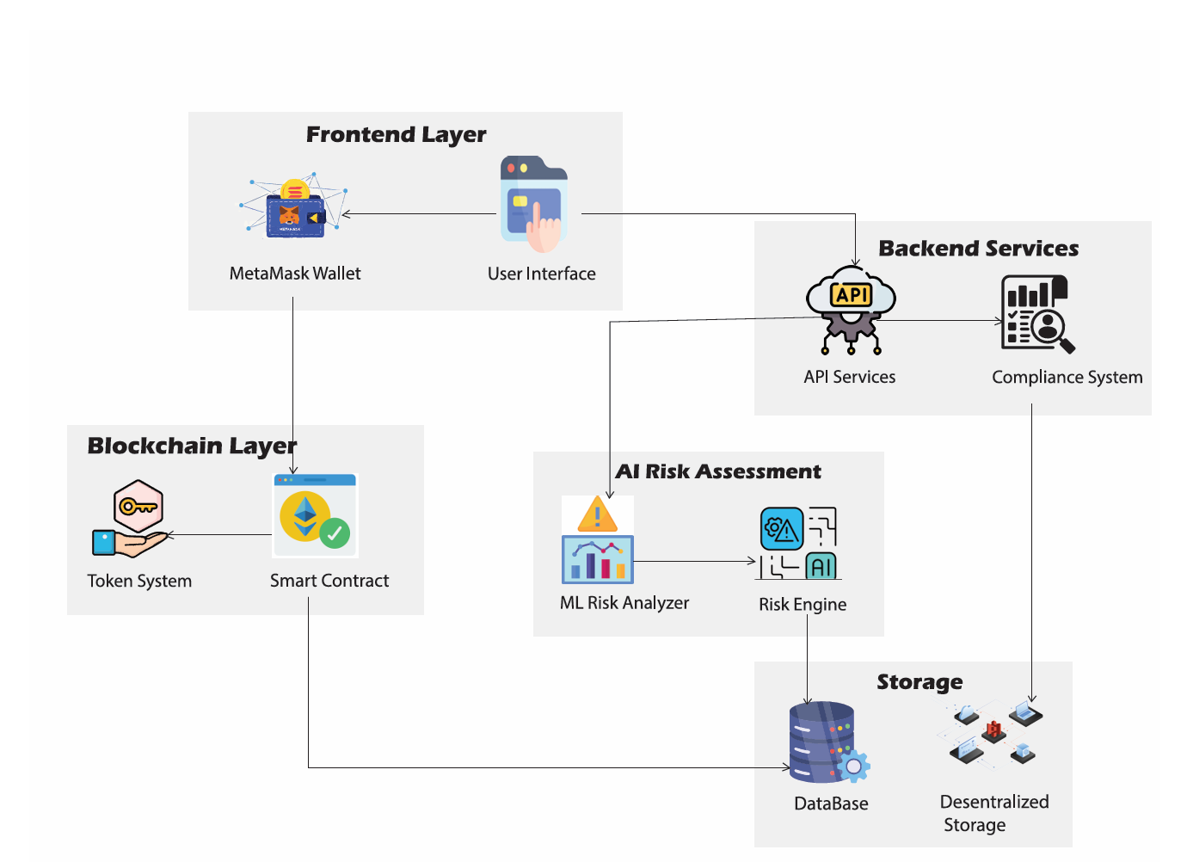
Figure 1. Proposed system architecture
The frontend layer provides an interface through which user can make transactions using an integrated wallet. These transactions are recorded using blockchain layer where ownership is tracked using smart contracts. All the transaction and ownership data is stored on a decentralized storage across nodes whereas user and business data is stored on a centralized database. AI risk assessment module helps investors analyse the risk associated with an investment

MetaMask Wallet Integration
A browser-supported cryptocurrency wallet integration that allows users to link their Ethereum wallets to the platform. This module handles wallet authentication, transaction signing, and secure communication with the Ethereum Sepolia testnet. It offers the connection between users' digital assets and the platform's smart contracts.

Equity Tokenization
ERC-20 or ERC-1400 standard smart contracts tokenize business equity into tradable digital assets. They handle token issuance, token ownership transfer, distribution of dividends, and securities regulation compliance. Every token is representative of fractional business ownership.

KYC/AML Compliance Service
Regulatory compliance platform which checks investor identities and ensures compliance with Know Your Customer (KYC) and Anti-Money Laundering (AML) regulations. This service checks government identification documents, conducts background checks, and stores compliance records.

Marketplace
A peer-to-peer trading platform that allows investors to purchase and sell equity tokens following the initial funding process. This feature resolves issues of liquidity by creating a decentralized market where holders of tokens can liquidate their holdings or invest in further shares, with all transactions being performed through smart contracts.

AI Risk Assessment
The AI layer propels smart decision-making, analyze startup pitches and business data. The Risk Analyzer mines information from proposals submitted to assess credibility, while Fraud Detection models highlight suspicious or inconsistent submissions. The Risk Scoring Engine proceeds to create a comprehensive risk profile based on predictive analytics from the Failure Dataset. While creating campaigns, every submitted pitch undergoes these models before smart contract deployment.

IPFS
Decentralized storage network to store KYC documents, legal contracts, and campaign content. IPFS support (through Third web or Pinata) provides document immutability, censorship resistance, and permanent access while keeping the content private through encryption.

Success Criterion

Tokenization of equity
The excellence of decentralized equity crowdfunding platforms will initially depend on their capacity to tokenize business equity locked up in audited smart contracts and to automatically issue equity ownership transfers in real-time without any intermediaries. Business equity tokens will have to reside on the blockchain in ERC-20 and ERC-1400 forms and be accompanied by transparent ownership records, real-time automated transfers, and structured secondary markets for peer-to-peer trading, and healthy liquidity.

Risk assessment module
The systems will also determine risk in equity crowdfunding and carry out NLP-based proposal analysis for detecting fraud in crowdfunding campaigns, and generating real-time risk scores to support investor decision-making, thus performing better than traditional equity crowdfunding sites.

KYC/AML compliance
There will be compliant, decentralized KYC/AML custodial KYC records with arc and share credit risking to decentralize KYC opacity in record-keeping. The system must be efficient, running smart contracts with fewer downtimes and lower costs than the conventional systems that have middlemen. The system must also entice entrepreneurs and capital with high campaign success rates as well as real investor secondary liquidity.
Ultimately, the platform will be distinguished by its ability to deliver efficiency, transparency, and trust—converting equity crowdfunding into a global, contemporary, and investor-friendly ecosystem.

Team Roles and Responsibilities
The expected individual task list with the tentative plan is given below.
Table 1 Team roles and responsibilities
Team Member | Activity | Tentative Date
Momna Shafqaat | Idea refinement and Concept development | 22th September, 2025
 | Requirement gathering | 8th March, 2026
 | Activity Diagram Sequence Diagram | 17th April, 2026
 | System Prototype | 20th May, 2026
 | System Implementation | 17th October 2026
Momena Ahmed | Requirement Analysis and Documentation | 6th October, 2025
 | Activity Diagram Sequence Diagram | 17th April, 2026
 | Architecture Design | 30th April, 2026
 | System prototype | 20th May, 2026
 | System implementation | 17th October,2026
Hafsa saleem | UML diagram | 20th February, 2026
 | Architecture Design | 30rd April, 2026
 | System Prototype | 20th May,2026
 | System Implementation | 17th October, 2026
 | System Testing | 8th November, 2026

Gantt Chart

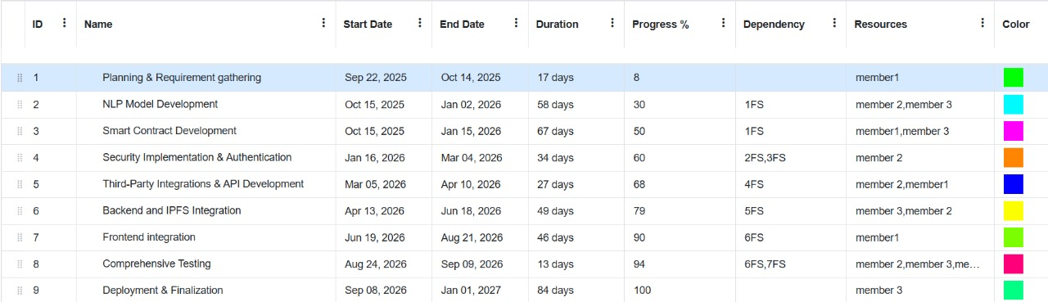

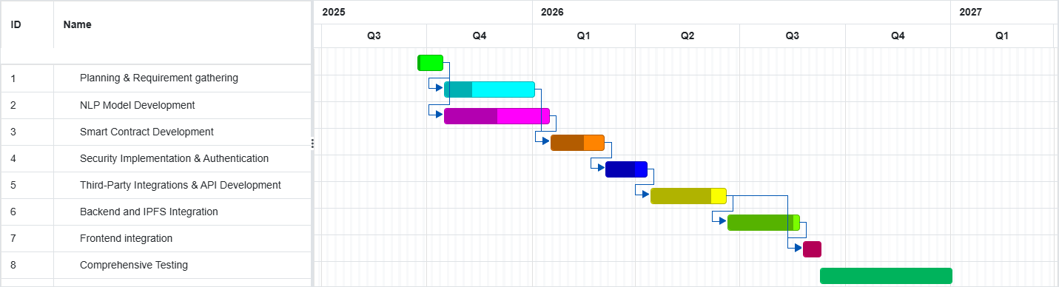
Figure 2. Project Gantt chart

Tools and Technologies
Following are the tools and technologies that we are planning to use in this project:

Backend
- Python – AI/ML and NLP models
- Flask / FastAPI – Serve AI models as APIs
- Node.js + Express – Backend server and APIs
- Solidity – Smart contracts
- Ethereum Sepolia Testnet – Blockchain testing
- MetaMask – Wallet and blockchain interaction
- IPFS (via Thirdweb/Pinata) – Decentralized storage
- Etherscan API – Smart contract verification

Frontend
- React + Next.js – Frontend UI and routing

Database
- IPFS (via Thirdweb/Pinata) – Decentralized storage
- Supabase - postgreSQL

Additional tools
- GitHub – Version control
- VS Code – Development environment

Bibliography

[1] | "XBTO," [Online]. Available: https://www.xbto.com/resources/7-key-benefits-of-tokenizing-real-world-assets.
[2] | L. a. P. A. a. M. M. Cocco, "Banking on Blockchain: Costs Savings Thanks to the Blockchain Technology," Future Internet, vol. 9, 2017.
[3] | A. S. Anna Lukkarinen, "Secondary market listings in equity crowdfunding: The missing link?," vol. 52, no. 1, 2023.
[4] | N. a. S. M. a. S. S. a. G. P. a. R. Y. Singhal, "Smart KYC Using Blockchain and IPFS," 2020.
[5] | S. F. N. P. Abdurahman Maarouf, "A Fused Large Language Model for Predicting Startup Success," European Journal of Operational Research, 2024.
[6] | T. Å. M. F. S. Nir Vulkan, "Equity crowdfunding: A new phenomena,," pp. 37-49, 2016.
[7] | C. X. A. A. P. Jayapal, Capitalizing on blockchain technology for efficient crowdfunding: An exploration of Ethereum's smart contracts., 2023.
[8] | J. &. S. F. Roth, "The Tokenization of Assets: Using Blockchains for Equity Crowdfunding," 2021.
[9] | M. S. Unsal, "Blockchain and Stablecoin Integration for Crowdfunding: A framework for enhanced efficiency, security, and liquidity," no. https://arxiv.org/abs/2501.11145, 2025.
[10] | T. S. B. v. W. V. &. U. N. Guggenberger, "Kickstarting blockchain: designing blockchain-based tokens for equity crowdfunding.," 2014.
[11] | "weFunder," [Online]. Available: https://wefunder.com/.
[12] | "seedrs," [Online]. Available: https://europe.republic.com/invest/marketplace/how-it-works.
[13] | Nasdaq., "What Tokenization Is and How It Can Unlock Illiquid and Opaque Markets," 2023.
[14] | c. wang, "Trading Securities as Digital Tokens: is a Secondary Market Practicable for Tokenized Exempt Securities?," 2023.

Appendix A
Refer to Fig. 4 for the Turnitin Originality Report.
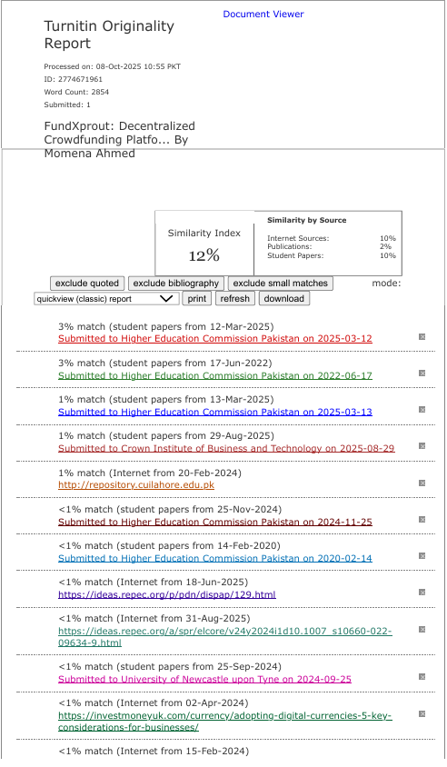
Figure 3. Turnitin originality report

