The University of Azad Jammu and Kashmir, Muzaffarabad


Course: computer networing
Course Code: CS-2203
Roll No: 2024-SE-33
Lab: 01 & 02
Submitted To: Engr. Asma javed
Submitted By: MomnaImran
Date: 4 march,2026

Department of software engneering

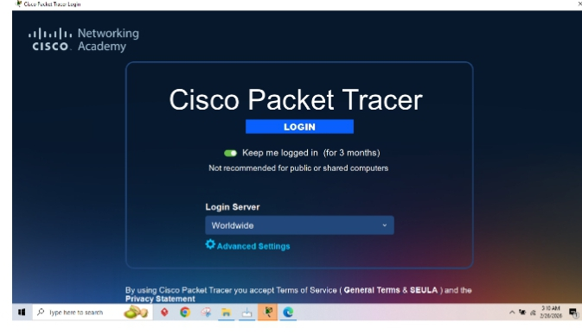

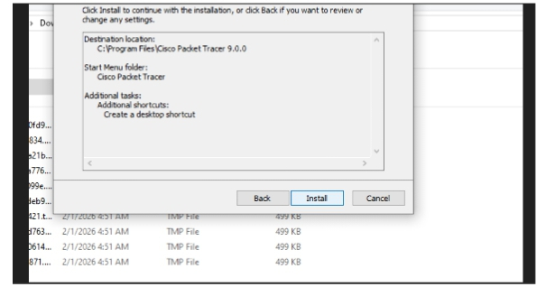
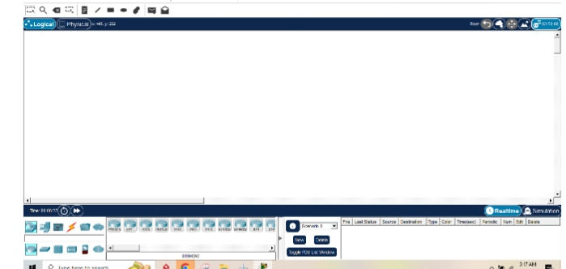

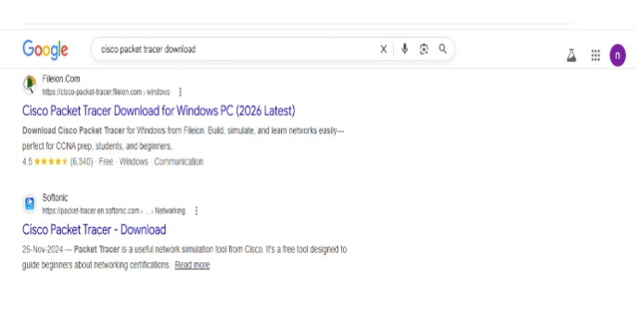

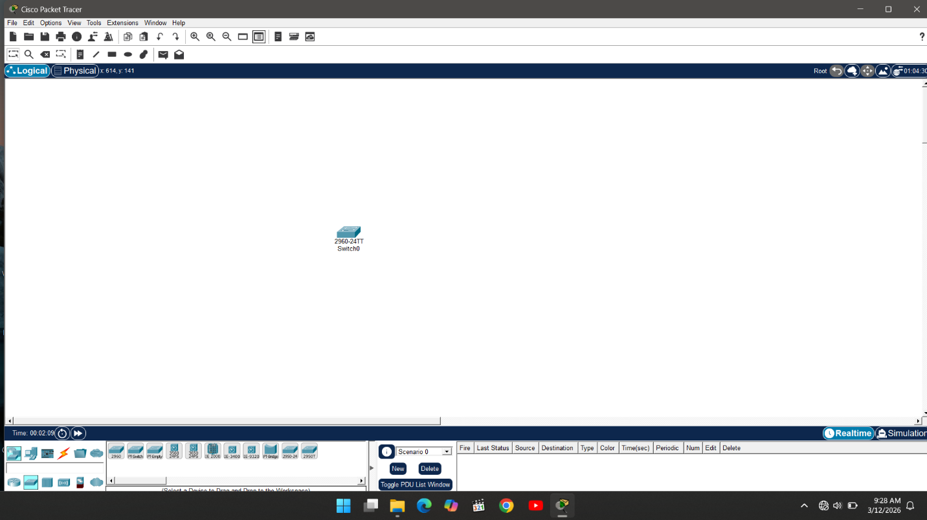
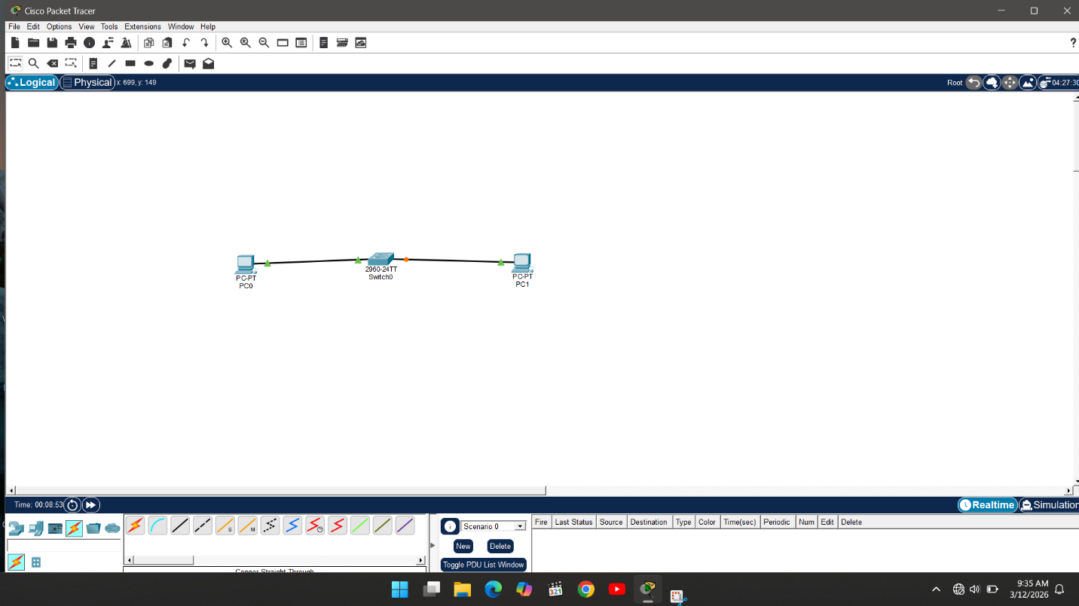

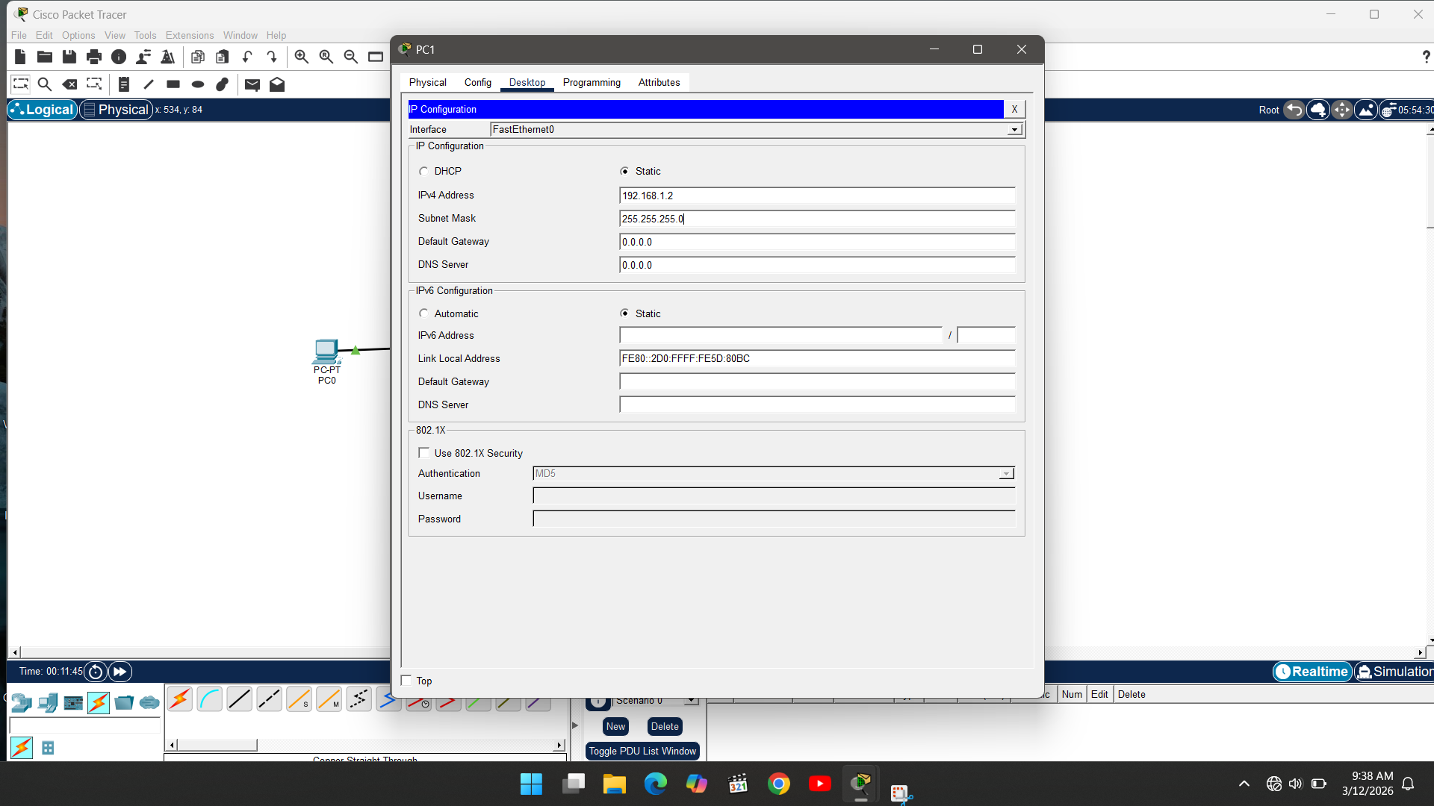
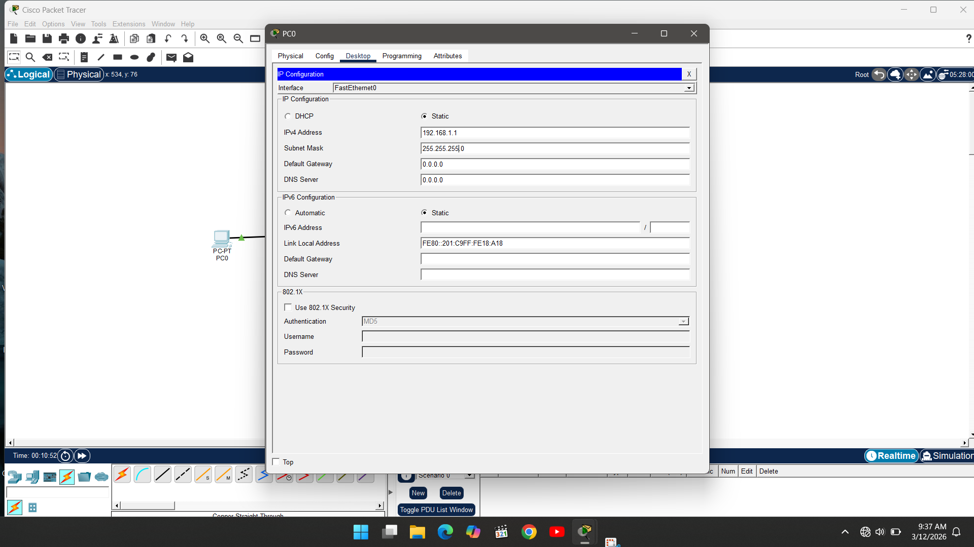

\
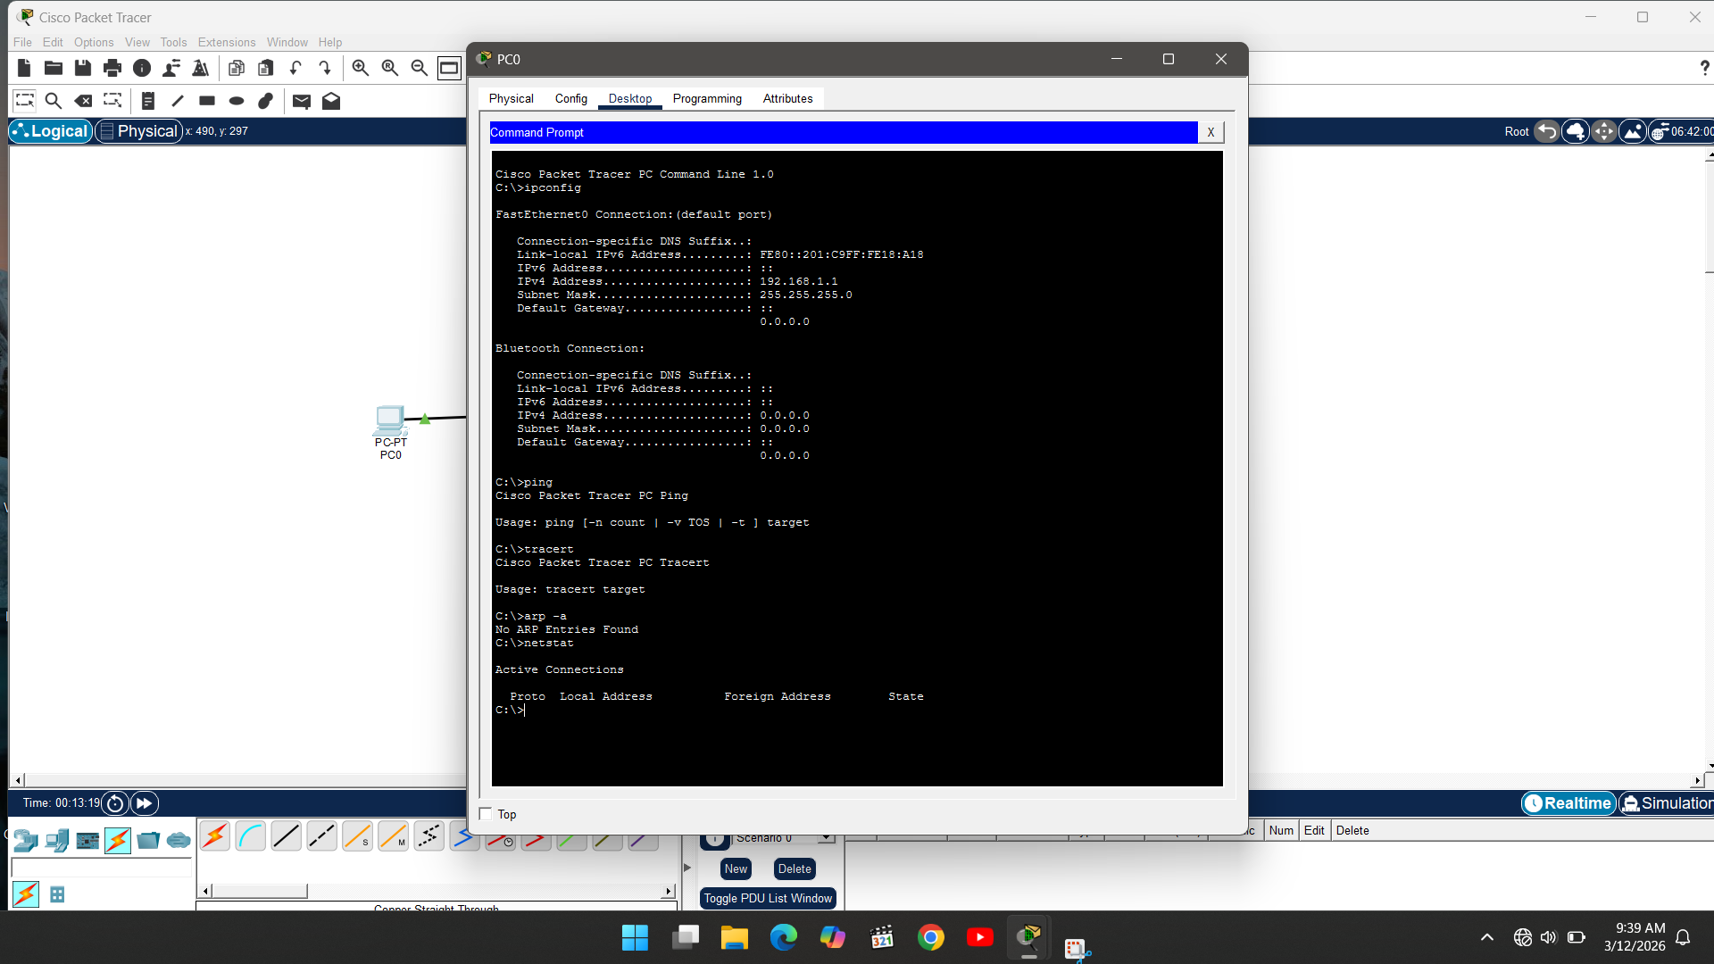

1.ipconfig:
Purpose:
Displays IP configuration of the PC.
2. Ping .
Purpose: Test connectivity b/w two devices.
3. tracert
Purpose: show the path taken by packets
4. arp -a
Purpose:
Display ARP table
5. netstat
Purpose:
Display active connection and statistic

