**Decision Tree Regression–**

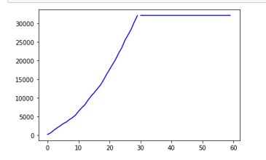**Total India**

R2 Score - 0.9148

Prediction comes

Constant . (New Cases 0)

**Total Maharasthra**

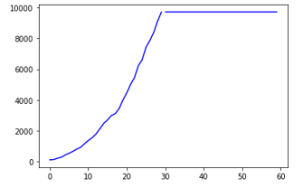R2 Score – 0.9627

Prediction comes constant

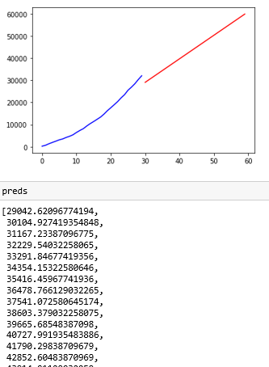**Multiple Linear Regression**

**Total India**

R2 score - 0.965483

(Cummulative)

**Total Maharashtra**

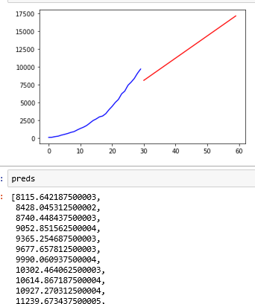R2 Score – 0.9269

(Cummulative cases)

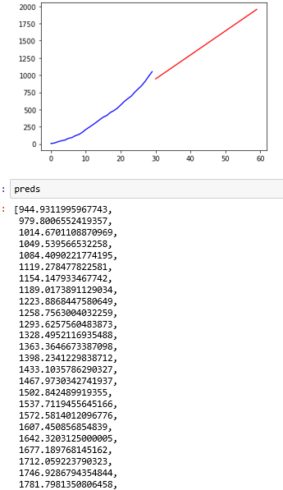

**Deaths India**

**R2 score – 0.9729**

**(Cumulative)**

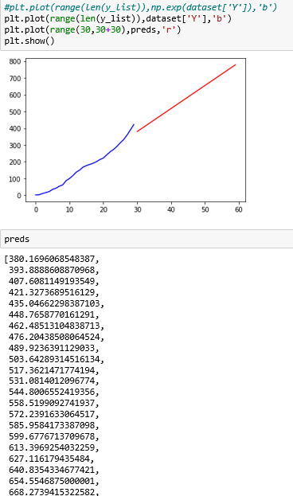

**Deaths Maharastra**

**R2 Score = 0.98**

**(Cumulative )**

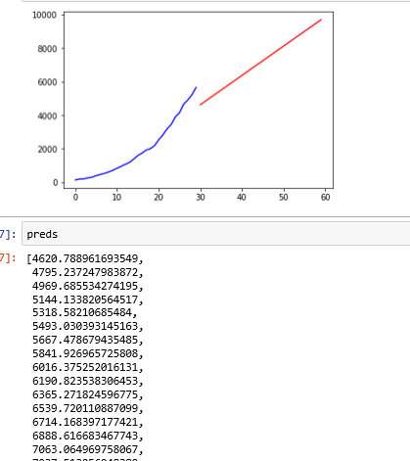**Gender Male**

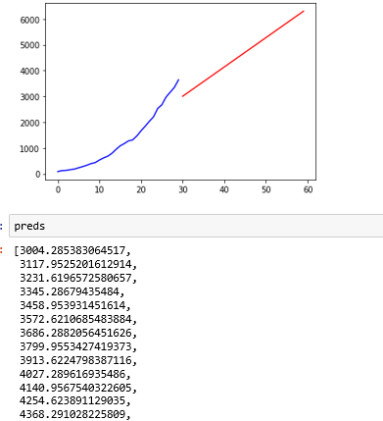

**Gender Female**

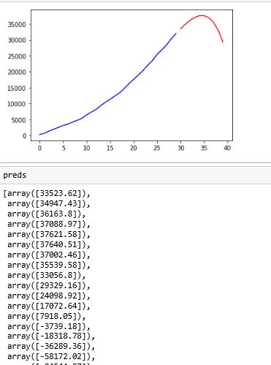**Polynomial Regression**

**India(Cummulative)**

**(poly dim. 6)**

**R2 value – 0.99**

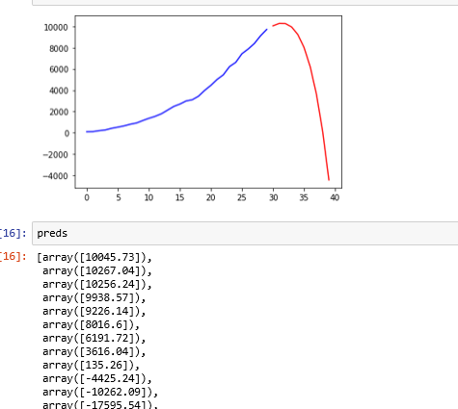**Maharashtra(Cumulative)**

**R2 value=0..999**

**(poly dim 6)**

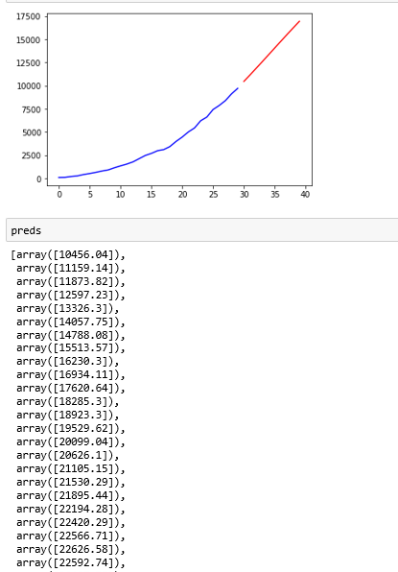**Maharashtra (poly 4)**

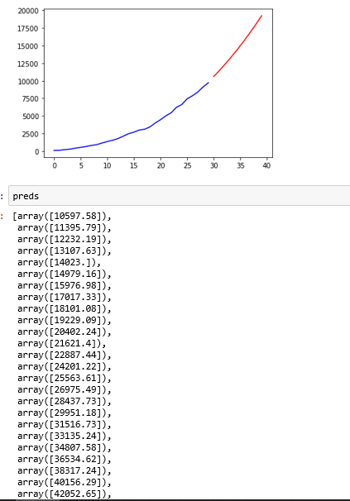

**(Poly 3)**

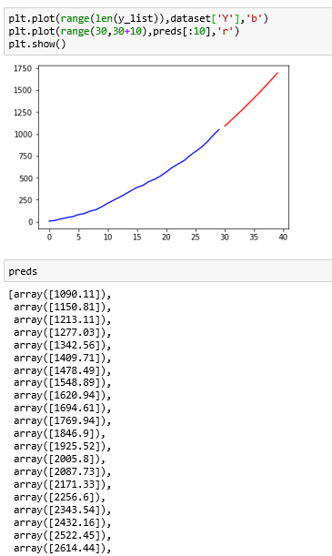**Deaths IND**

**(poly 3)**

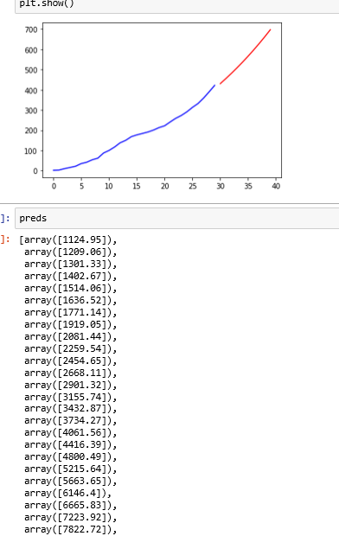

**Deaths MH (poly 3)**

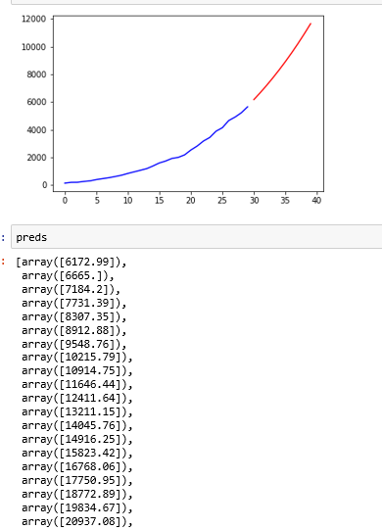**Gender Male (poly 3)**

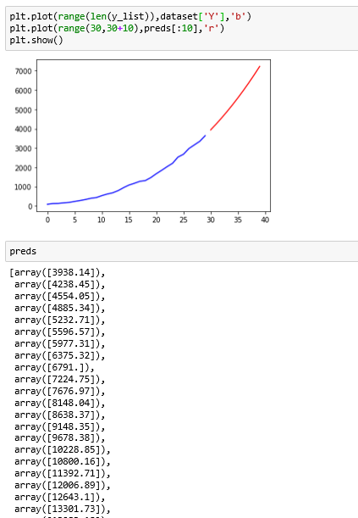

**Gender Female**

**Prophet**

Total cases india(Taking log of Cumulative)

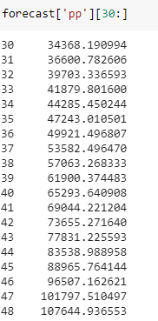

**(without log)**

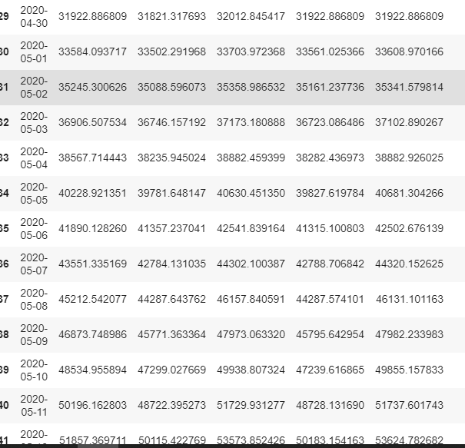

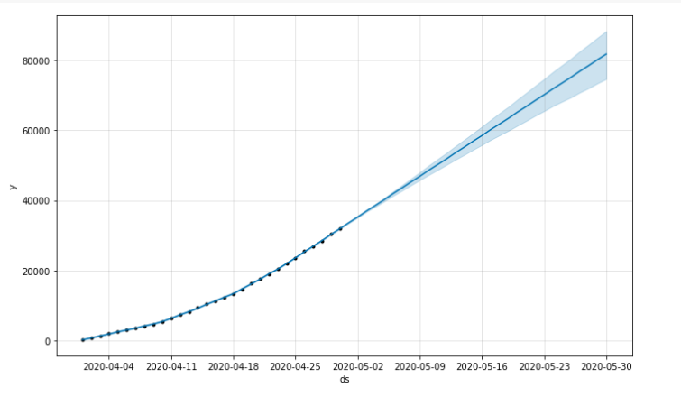

**(Daily)**

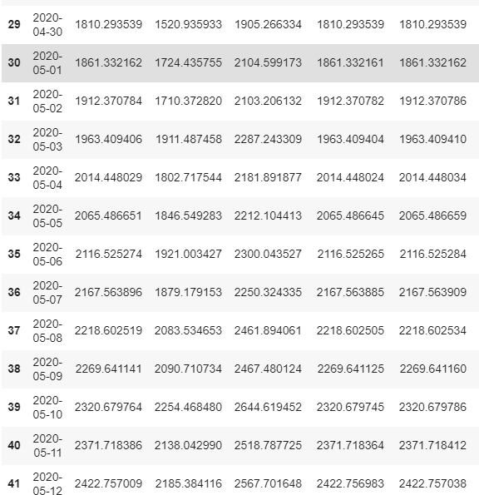

**Maharashtra cases (cumulative log)**

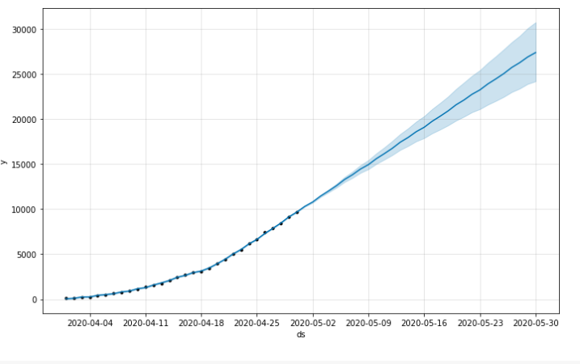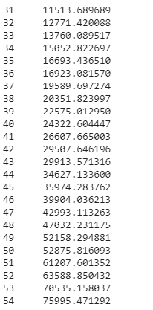

**(Cumulative)**

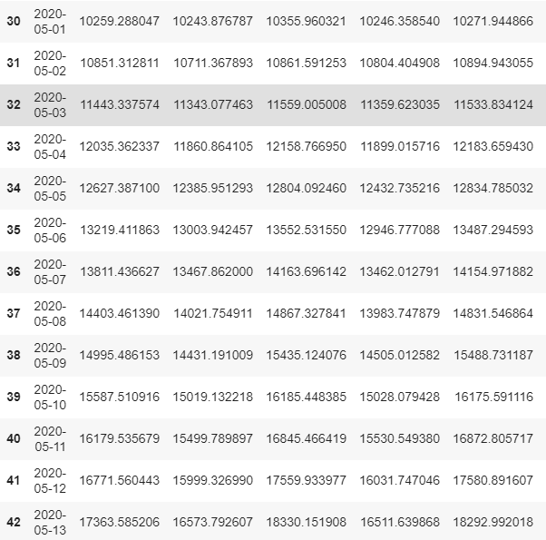

**Daily cases**

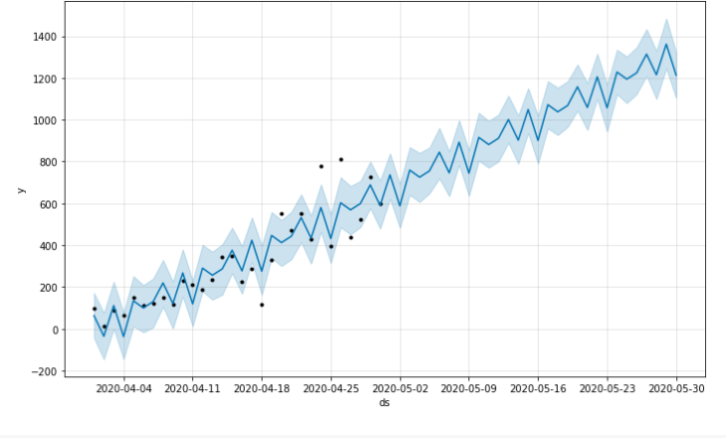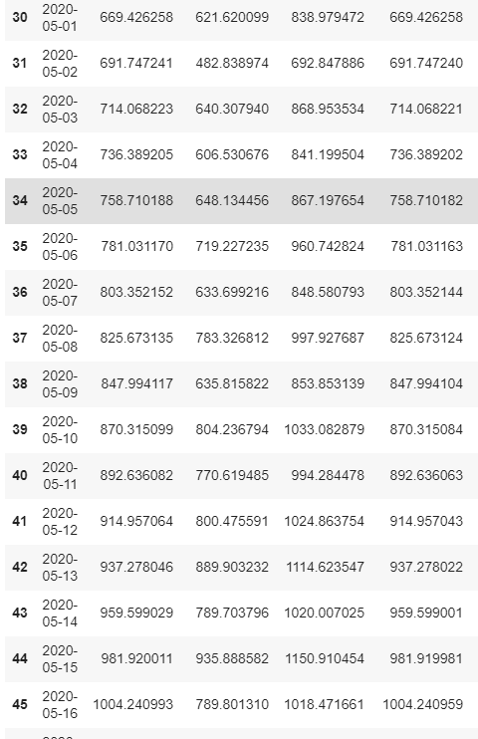

**Deaths India**

**(cumulative)**

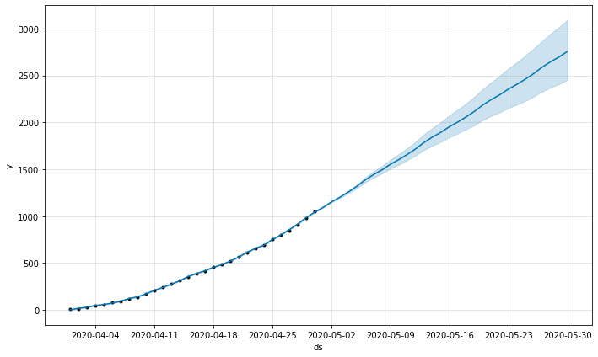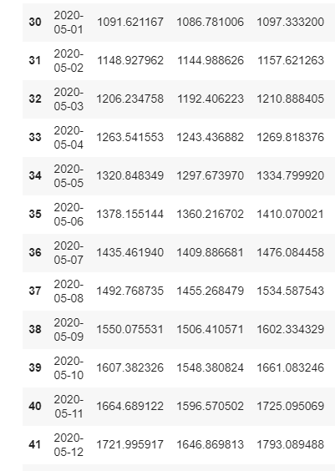

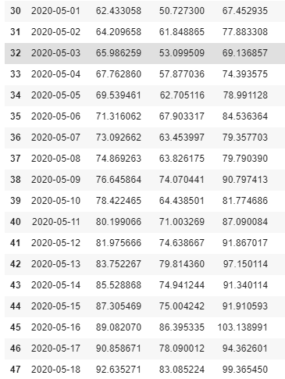**(Daily)**

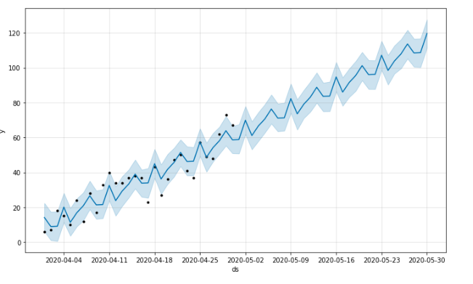

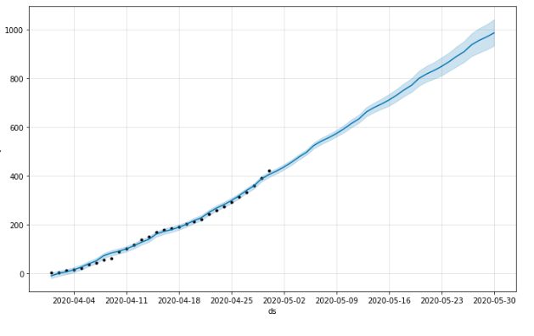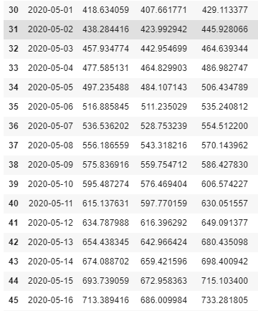**Death Maharashtra (cumulative)**

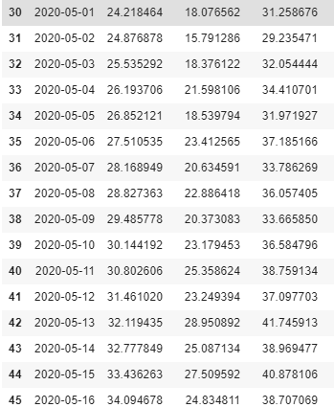**Deaths Maharashtra (daily)**

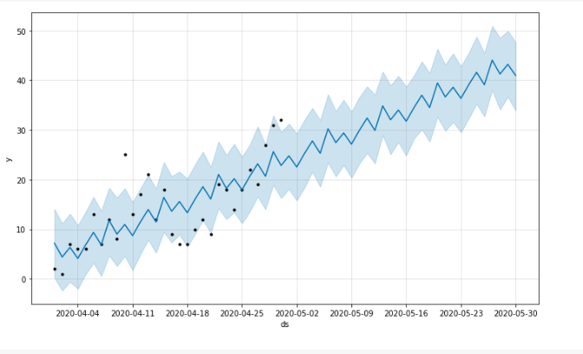

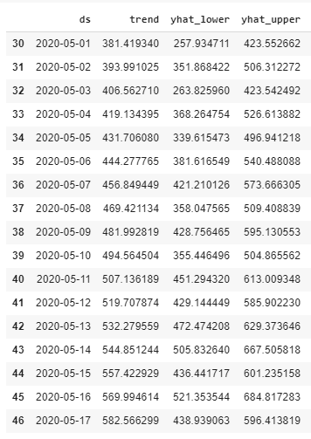**Gender Male (daily)**

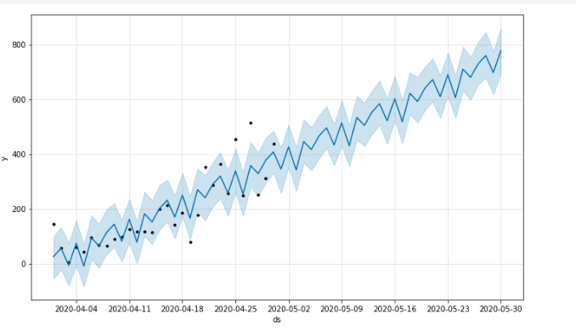

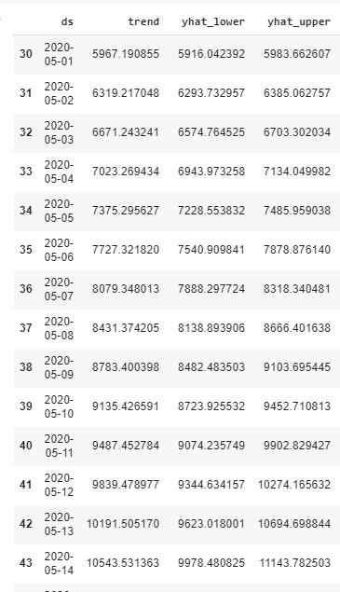**Gender Male (Cumulative)**

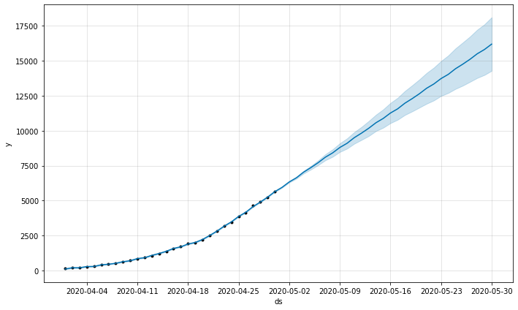

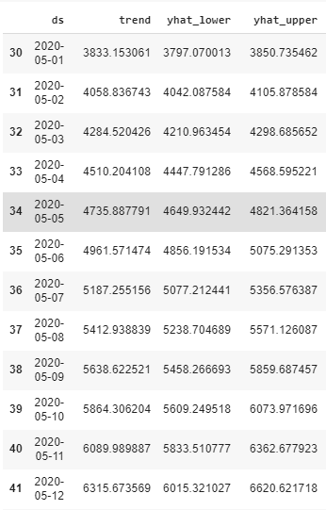**Gender Female (Cumulative)**

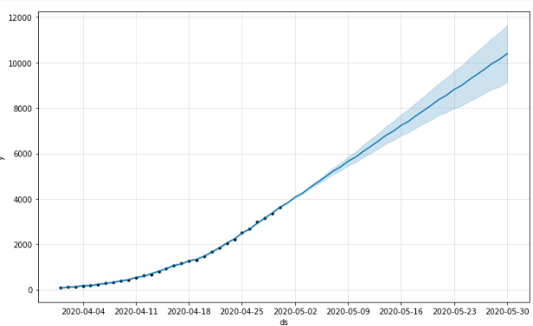

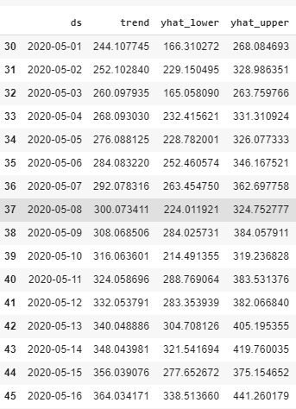**Gender Female (Daily)**

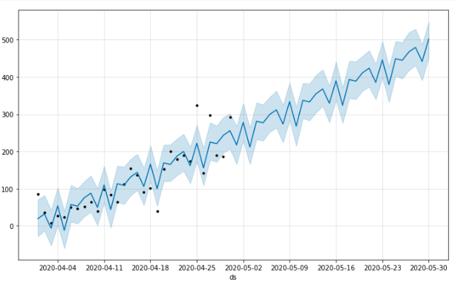

**ARIMA**

**India (each day using log)**

Arima has a stationary problem and hence I had to use log

(4,1,1)

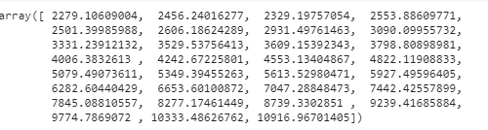

**Maharashtra (each day using log)**

Order (1,2,0)

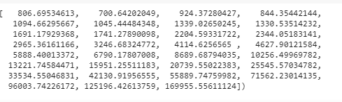

**(Cumulative)**

order(1,2,0)

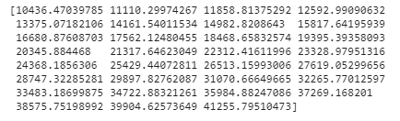

**Deaths India (daily)**

Order (4,1,1) using log

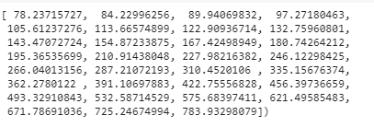

**Deaths Maharashtra (daily)**

Order (2,1,1) using log

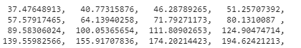

**Gender Male**

Order (2,1,1) using log

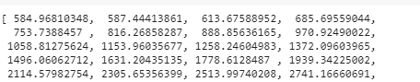

Order (2,2,1) using log

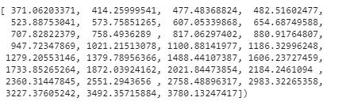

**Gender Female**

Order (2,1,1) using log

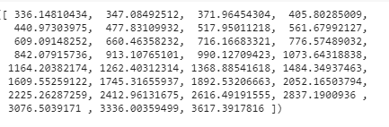

Order (4,1,1) using log

