Using Data Mining for Learning Path Recommendation and Visualization in an Intelligent Tutoring System

I. Jugo, B. Kovačić and V. Slavuj
University of Rijeka, Department of Informatics, Rijeka, Croatia
{ijugo; bkovacic; vslavuj} @ inf.uniri.hr

Abstract – Since the creation of Web-based learning systems, researchers have tried to make them adaptive to various characteristics of learners in order to increase the quality of learning. The application of data mining (DM) methods on learning system logs is often used as the basis of intelligent tutoring systems (ITS) that have the ability of automatic adaptation of some aspect of the learning process. Such a system was developed at our institution in the previous years and has been used in a number of courses. To improve our system we added an integration application which creates a continuous feedback loop with a DM tool. Our goals, from the student’s perspective, are to improve the quality of knowledge acquired by students as well as to shorten learning time by offering recommendations based on mined patterns of learning paths through the knowledge domain. From the perspective of teachers, our goal is to create a rich data visualization system (in the form of a Web application using standard Web technologies to create visualizations) to give them new insight into students’ behaviours. In this paper we present the structure of our system and the research design that will be used to verify its results.

Introduction
The lack of feedback concerning students' work is one of the main drawbacks of e-learning. The two most commonly used e-learning systems in the EU are Moodle and Blackboard, which, however, in their basic installation version do not offer many tools that could be used for tracking the work and behaviour of each student. Such information would be of great help to teachers and would enable the adaptivity of learning dynamics, make communication easier, etc. In addition, it would help teachers in identifying patterns in student’s learning paths (sequence of actions during one visit to the ITS) through the learning domain as well as in identifying possible problematic learning units.
Adaptive e-learning systems aim to improve student’s results by taking a particular aspect of the system and adapting it to the identified characteristics of the student [1]. Certain systems adapt the way they present the learning content based on the learning style of the student, others adapt content based on the assessed level of knowledge, yet others adapt the difficulty of test questions, etc.
An intelligent tutoring system for e-learning based on dialogue was developed at our institution [2]. The system guides the learner through the learning domain by alternating between sequences of learning about particular concepts from the domain and sequences of knowledge testing, in order to offer support and skip the concepts that have been learned previously. The system was further enriched by adding the module for statistical analysis of student activity [3], which aims at providing feedback to both the student and the teacher. Feedback given to the student includes an overview of his/her progress, more specifically, the number of visits for each knowledge unit (concept), the number of questions answered and tests taken, and the success rate of his/her answers. Conversely, the teacher receives detailed information on each student’s progress and knowledge, but also an overview of the entire domain, which allows him/her to take appropriate action concerning any problematic concepts in the domain. In order to assess the impact of the implemented changes on system users and their attitudes towards using the system, we have undertaken an evaluation which revealed the possibilities for further development of the system [4].
Educational Data Mining is an emerging discipline, concerned with developing methods for exploring the unique types of data that come from educational settings, and using those methods to better understand students and the settings in which they learn [5]. In the last overview paper of the state-of-the-art in EDM [6] a new set of important research objectives was set. Among them were: a) EDM tools have to be designed to be easy to use for educators or non-expert users in DM, b) the DM tool has to be integrated into the e-learning environment as one more traditional authoring tool.
In this paper we put forth our model of an adaptive ITS paired with an integrated EDM tool designed for educators and non-experts in DM. Our research aims to develop a system that offers students a better learning environment, teachers a better supervision over the teaching process, and DM experts the possibility to continue their work in a specialized tool and easily add new analyses into the system.
The paper is organized into five sections. Section 2 describes the theoretical foundations of this research and situates this work in the area. Section 3 presents the architecture of our system and points out its most important contributions. In Section 4, we describe our research plan that will be used to verify the expected results of the application of the system at our Department. Finally, we conclude the paper with an emphasis on future work.

Related work
Educational data mining (EDM) is a relatively new appellation for an area of research in which classic DM methods (originating from the areas of machine learning and artificial intelligence), along with some new ones, are used on data collected from e-learning systems in order to clarify the problems related to e-learning. The results of these methods are often used as a basis for automatic adaptation of e-learning systems to the needs, expectations, and habits of their users. Although the term EDM appeared around 2005, some authors started using DM methods to analyse or predict the behaviour of ITS users much earlier [7].
Today, EDM is a fast growing area of research with the number of papers published per year rising exponentially. Authors apply existing DM methods and develop new ones specifically for EDM to research a very wide number of topics regarding e-learning, user success prediction, user clustering, user modelling, intelligent recommendation systems, intelligent examination systems, etc. There is a small number of overview papers of the field, e.g., [8] (published in 2007), [9] (published in 2009), while the last one was published in 2010 and cites over 300 references [6].
Our research deals with and connects two main areas: a) learning path pattern analysis as a basis for creating an intelligent recommendation system, and b) visualization of those patterns, particularly data visualisation in the Web browser using standard Web technologies (to avoid the need of using plugins such as Java or Flash).
Many authors have developed applications for DM-based data visualizations, but rarely using standard Web technologies. In [10] authors developed a Flex/Flash based application in the field of Bioinformatics, while in [11] authors developed a Java/Matlab based application that accepts data file uploads and returns results from a small set of DM algorithms. In [12] authors developed a student forum activity visualization tool using the Scalable Vector Graphics (SVG) web standard. A very recent paper [13] describes a rich data visualization system for visualizing student activities in an ITS that was developed as a standalone Java application. This system will be used as a reference point for our visualization that will differ in that it will be developed as part of our Web-based Integrator application using standard Web technologies (SVG, Canvas), and emphasize real-time updates that will allow the teacher to watch users navigating through the knowledge domain and indicate their success on related exams. In [14] authors created a Java application that uses DM algorithms (namely, Hypertext Probabilistic Grammar – HPG) to discover patterns in navigation trails (paths) through the ITS content and create static visualizations using directed graphs and text labels to point out the direction and frequency of mined paths. A similar visualization approach was used in [15] where interactions with a motivationally aware tutoring system called M-Ecolab and its previous version without that capability (Ecolab 2) were mined to discover patterns in behaviour in connection with motivational feedback. In [16] authors used DM algorithms (namely, association rules and classification trees) to find rules in students usage of the ITS and visualize those rules to teachers in a tool called Author Assistant.
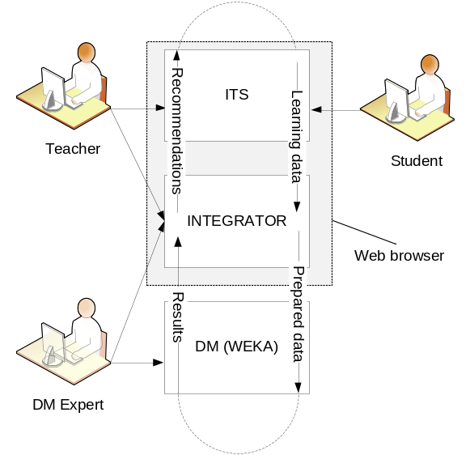
Figure 1. A DM tool integrated into a learning system [17]

Our research aims to combine these two areas of research by creating an intelligent tutoring system that will offer recommendations to students to both strengthen their knowledge acquisition process and shorten learning time. It also aims to offer relevant insight to teachers by providing real-time visualizations of learning activity patterns with additional information about students’ results in testing their knowledge. All this information will be based on an integration module that collects data from the ITS, sends it to a DM tool, retrieves results, and feeds them into modules for offering suggestions and data visualization. To the best of our knowledge this type of system was not developed previously.

System architecture
The main idea behind this integrated system is to allow non-experts to best use the potentials of DM in e-learning, as well as to improve the existing e-learning systems by introducing adaptivity through recommendations.
The use of DM in e-learning systems or everyday classrooms is far from widespread. We presume that by integrating DM tools with e-learning systems (and the educational process in general) we can help significantly in broadening the application of DM in education. This integration should be seamless to the end user. In this way, the teachers could stay in the familiar environment of the Web browser and the e-learning system they regularly use, and start using new DM-powered features that will bring novel, helpful insights to their work.
The overall process of DM defines a set of steps that have to be followed in order to apply it to the target system and gain useful insight. Although some steps of this process are very technical, we feel that it can be implemented in such a way that (once connected to the ITS) it is mostly invisible to the teacher, and that it can be done in a familiar environment of a Web browser. In the case of EDM being applied to an ITS, the result of this system would be a continuous feedback loop from the ITS (providing usage/learning data) to the Web interface (providing various prepared EDM procedures), to a DM tool (performing DM algorithms on a prepared set of features). The feedback then goes back to the Web interface (providing insight via rich data visualizations) and, finally, the user implements the suggested changes into the ITS. This process is depicted in Figure 1 [17].
We propose a system consisting of four basic modules. Block diagram of the system can be seen in Figure 2. First, the Learning Data module is used to make the connection to the ITS and define data sources needed for various EDM actions. The sources consist of attributes from multiple tables. This module monitors data sources and periodically pulls new data from the ITS. This module is used by the DM expert. For our system, the primary interest lays in knowledge domain structure analysis, so data about paths through the knowledge structure created by the students is needed. We also analyse data concerning access times, learning session duration and frequency, learning materials usage, quiz and test results, etc. Once data sources are defined, this module does not need further attention from the DM expert.
The central part of the Integrator Web application is the Actions Repository module. It is envisioned as an extensible set of DM-based operations of interest to the teachers (analysis toolbox), the primary users of this module. Every action offers a different analysis concerning the learning process, for example, prediction of student success in a course. Actions define the necessary data preparation routines, feature extraction, discretization, etc., needed for the DM algorithm to be used. Actions are run in predefined data intervals (week, month, and semester) or in an interval defined by the teacher. Concerning our system, one of the first Actions we will develop will be pattern discovery in student’s paths through the knowledge structure.
The DM expert is able to connect to the system, analyse the ways teachers use the Actions, and modify or create new Actions. As the system will be open source, other developers will be able to develop and install new Actions. Each Action employs the DM tool in the background, concealed from the end-user. The DM tool is contacted via API calls by the Input/Output module that receives data from the Action selected by the user, and creates a set of arguments to make a correctly formatted call to the Weka [18] API. It also handles the output file of the DM tool by preparing it to be used by the Data Visualization module, which also has the role of the user interface of the application. So, this module consists of a data visualization area, the Actions toolbar and a data manipulation (intervals, filter) area. The key contribution is that the user interface is not DM-oriented, i.e. it does not mimic user interfaces of common DM tools like Weka, but is instead user-oriented and optimized to bring real value in the form of insight into the learning progress of the students. Consequently, it optimizes the overall efficacy of the educational process.
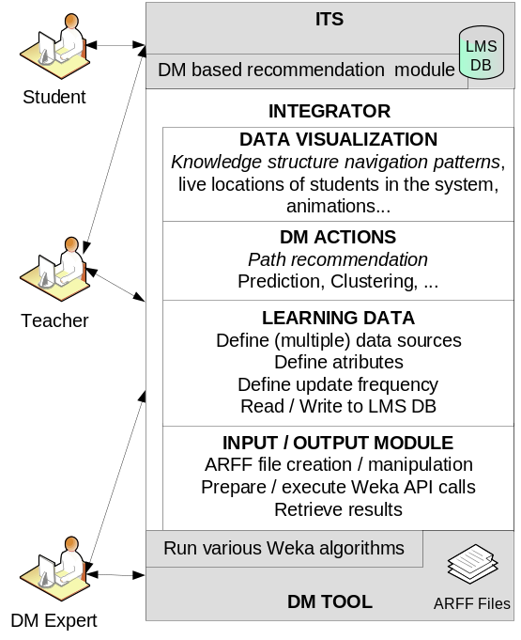
Figure 2. Block diagram of the system

Teachers can use the Data Visualization module, run various Actions and use the provided insight to modify the ITS in two Web browser tabs, without the need to learn about or even see DM tools, algorithms, database queries or any other technical details. The role of a DM expert is minimized after the initial connections with the ITS are defined in the Learning Data module. Although the system could be fully integrated into our ITS, we believe that creating a separate system with powerful connection abilities will enable other LMSs and educational data providers to use our system for their analysis and new applications.
The conceptual design of our visualization system is presented in Figure 3. Because the knowledge structure (domain) can contain hundreds of units (concepts), the objects representing them need to be kept small in order to display the whole structure on one screen. Concept names and student names will be revealed by tooltips when the teacher positions the mouse pointer over the objects. As the visualisation will be refreshed every few seconds, the teacher will be able to see students moving from concept to concept.
The number of students at each concept is displayed in a circle. The thickness of the lines and the arrow orientations display the common paths though the knowledge domain. Red lines depict returns indicating a possible problem with teaching materials or the structure of the domain. Dashed lines represent the original structure of the domain as created by the teacher. The colour of the concept depicts the average student success on exams regarding that particular concept. Grey objects represent “no-data”.
This part of the system is currently under development.
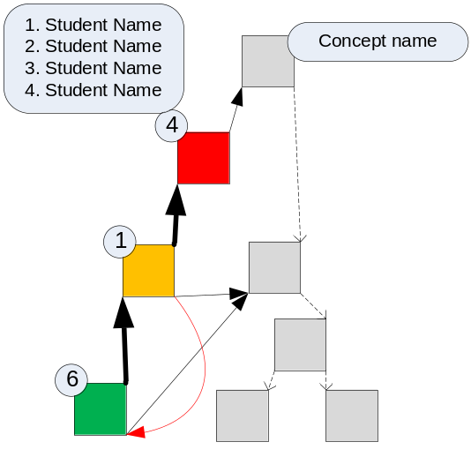
Figure 3. Visualization concept design

Research design
The development of this system is a part of an extensive research into the ways of improving the quality of acquired knowledge of students and shortening learning time. In addition, it will enable teachers to easily use DM on learning data and get a visual insight into student activities. The research phases are described below.

System development and implementation
Basic functionalities for students are: learning (through lessons or individual knowledge units), examination (can be used for pre-testing, practice and grading), and collaboration (each lesson and knowledge unit have forums where students can post/read questions for the teacher or other students).
From a technical perspective this is a MVC Web application based on the Phalcon PHP and JQuery frameworks with a responsive user interface that can be used on smartphone, tablet, and PC monitor screens without any loss of functionality.
New versions will be available at http://ditus.uniri.hr as the development progresses.

Acquiring and transforming data
To perform any kind of data analysis, we need to capture raw data from the application. There are two main approaches to this: using Web server log data or creating a custom data format and a logging service. Both approaches have their pros and cons: Web logs are “free”, i.e., they are gathered without our intervention, but contain a very large amount of unwanted/unusable entries that need to be removed before data is pre-processed. Using a custom log format and a logging service requires development time, but grants a clean set of entries that can already be prepared for DM, which saves time needed for data preparation/cleaning and, partly, pre-processing. We plan to choose the latter approach: adapt the well-known and widely used PSLC DataShop Tutoring Message Format [18] to our needs and develop a logging service as an integral part of the ITS and DM integrator application. Once the integrator application is connected to the ITS database, it can transform the relational data to our log format, which can then be used for DM.

Data mining for learning path pattern discovery and recommendation generation
There is a large number of well-known pattern discovery algorithms used today. To discover patterns in learning paths of ITS users, some authors employed the already existing algorithms, while others developed new ones. Algorithm selection depends on the overall goal of the DM process. When trying to discover daily learning patterns, Hung and Zhang in [19] used sequential association rules. In [20], the author developed an algorithm for detecting “to-be-enhanced” learning paths and used fuzzy sets to make learning recommendations more understandable to end-users. Before using mined learning path patterns for making recommendations, we need to connect them to final student results in the course or some other source of data that will help in identifying which patterns to use. In [21], authors used sequential pattern mining to extract most frequent learning patterns and then applied distance-based clustering to group students according to their learning performance. In [22], authors proposed a cross-level learning suggestion process using FP-tree and FP-growth algorithms.
In order to identify the patterns that will be the base of our path recommendation process, we will grade mined patterns according to the following two criteria: the student’s overall course success and the total time they needed to cover the course material (number of patterns, number of items in a pattern, total duration of a pattern). After this, we will have a set of preferred patterns to be used in the recommendation module of the ITS.
All the DM procedures in our system will be performed according to the CRISP-DM model [23].

System evaluation
Before we begin the final experimental phase, both the visualizations (for the teacher part of the system) and the overall user satisfaction with the system (relatively small sample of student population – testers) will be measured using the approach described in [4].
Evaluating data visualizations is a complex problem due to the fact that it cannot be measured objectively. We will implement the three step data visualization evaluation approach used in [13] which was based on [24].

Final experiment and results verification
The final stage of the research will consist of an experiment that will verify whether the initial goals of the research, from the standpoints of both students and teachers, have been met. For the previous version of the system, two knowledge domains (Operating Systems 1 and 2, consisting of approximately 80 knowledge units per domain, and approximately 200 questions per domain) have already been developed and used over 2 semesters with groups of up to 100 students. Two more domains will be developed (Web development 1 and 2) for the purposes of the experiment. Students will be divided into three groups: a control group (will not use the system), the first test group (will use the ITS without recommendations) and the second test group (will use the ITS with DM-based recommendations). The final results will be statistically analysed and used to either confirm or reject our hypothesis that this system will both improve the results of the learning process and shorten learning time required to cover the course materials.
Even though it is still being developed, at the time of writing of this paper, the system had a responsive user interface, basic learning functionalities and communication with the DM tool. We are still developing “live” data visualizations in the browser using standard Web technologies without the need for any additional plug-ins.

Conclusion
Educational data mining has developed to a point where its findings can and should be made easily available to those that can benefit from it the most, namely teachers at various levels of the educational system. As e-learning, e-classrooms, computers, and tablets are becoming more common, so should the widespread application of EDM. One of the main obstacles preventing the widespread use of DM in learning is the need for expert knowledge. We aim to overcome the obstacle by creating an easy-to-use Web-based system, integrated with an ITS used on a daily basis, which offers an extendable set of Actions providing useful information. Teachers do not have to know that these Actions run DM algorithms on ITS data in the background; they just receive useful information at the click of a button. This system, paired with rich data visualization, can bring a new dimension to the e-learning experience. Students will benefit from the suggestions given by the ITS, which aims at time saving and learning “the right way” also powered by DM algorithms. The main contribution of the system will be the continuous integration of the two systems, which will enable the overall system and its algorithms to be employed on daily updated data, and provide the teachers and students with better results as well as useful trends analysis.

Acknowledgements

This research is a part of the Project "Enhancing the efficiency of an e-learning system based on data mining", code: 13.13.1.2.02., funded by the University of Rijeka, Croatia.

References
- P. Brusilovsky, Adaptive Hypermedia, User Modeling and User-Adapted Interaction, vol. 11, pp. 87-110, 2001.
- B. Kovačić and I. Jugo, Applying a Distance Learning System Based on Dialogue in e-commerce, Proc. of the 32nd Int. Conf. on information and communication technology, electronics and microelectornics, MIPRO, pp. 36-39, 2009.
- B. Kovačić, I. Jugo, and V. Slavuj, Improvement of system for distance learning based on dialogue by appliance of statistical analysis, Proc. of the 35th Int. Conf. on information and communication technology, electronics and microelectornics, MIPRO, pp. 1794-1797, 2012.
- V. Slavuj, B. Kovačić, and I. Jugo, Assessing user satisfaction with a system for e-learning based on dialogue, Proc. of the 4th Conference Document Numerique et Societe (DOCSOC), pp. 221-236, 2013.
- International Educational Data Mining Society, http://www.educationaldatamining.org, accessed: 10.01.2014.
- C. Romero and S. Ventura, Educational data mining: A review of the state-of-the-art, Transactions on Systems, Man, and Cybernetics, Part C: Applications and Reviews, vol. 40(6), pp. 601-618, 2010.
- O. Zaïane and J. Luo, Web usage mining for a better web-based learning environment, Proceedings of Conference on Advanced Technology for Education. Banff, Alberta, pp. 60–64, 2001.
- C. Romero and S. Ventura, Educational Data Mining: a Survey from 1995 to 2005, Expert Systems with Applications, vol. 1, no. 33, pp. 135-146, 2007.
- R.S.J.D. Baker and K. Yacef, The state of educational data mining in 2009: A review and future visions, Journal of Educational Data Mining, vol. 1(1), pp. 3-17, 2009.
- J. Koelling, D. Langenkaemper, S. Abouna, M. Khan, and T.W. Nattkemper, WHIDE-a web tool for visual data mining colocation patterns in multivariate bioimages. Bioinformatics, vol. 28, no. 8, pp. 1143-1150, 2012.
- M. Zorrilla and D. García-Saiz, A service oriented architecture to provide data mining services for non-expert data miners, Decision Support Systems, vol. 55, no. 1, pp. 399-411, 2013.
- S. Jyothi, C. McAvinia, and J. Keating, A visualisation tool to aid exploration of students’ interactions in asynchronous online communication, Computers & Education, vol. 58, no. 1, pp. 30–42, 2012.
- M.W. Johnson, M. Eagle, and M. Barnes, InVis: An Interactive Visualization Tool for Exploring Interaction Networks, Proc. of Int. Conf. on EDM, pp. 82-89, 2013.
- C. Romero, S. Gutiérrez, M. Freire, and S. Ventura, Mining and visualizing visited trails in web-based educational systems, Proceedings of the 1st International Conference EDM 2008, pp. 182-186, 2008.
- G. Rebolledo-Mendez, B. du Boulay, R. Luckin, and E.I. Benitez-Guerrero, Mining Data from interactions with a motivational-aware tutoring system using data visualization, Journal of EDM, vol. 5, no. 1, pp. 72-103, 2013.
- C. Vialardi, J. Bravo, and A. Ortigosa, Improving AEH Coursed through Log Analysis, Journal of Universal Computer Science, vol. 14, no. 17, pp. 2777-2798, 2008.
- I. Jugo, B. Kovačić, and V. Slavuj, A proposal for a web based educational data mining and visualization system, Proc. of the 5th Int. Conf. on Information Technologies and Information Society IT IS, pp. 59-64, 2013.
- Weka 3: Data mining software in Java, http://www.cs.waikato.ac.nz/ml/weka/, accessed: 10.01.2014.
- Guide to the Tutor Message format (v4) - PSLC DataShop, pslcdatashop.org/dtd/guide/, accessed: 10.01.2014.
- J. Hung and K.Zhang, Revealing Online Behaviors and Activity Patterns and Making Predictions with Data Mining Techniques in Online Teaching, Journal of Online Learning and Teaching, vol. 4, no. 4, pp. 426-437, 2008.
- G. Hwang, A conceptual map model for developing intelligent tutoring systems, Computers & Education, Vol. 40, pp. 217-235, 2003.
- J. Su, S. Tseng, W. Wang, J. Weng, J.T.D. Yang, and W. Tsai, Learning Portfolio Analysis and Mining for SCORM Compliant Environment, Educational Technology & Society, vol. 9, no. 1, pp. 262-275, 2006.
- Y. Huang, J. Chen, and S. Cheng, A Method of Cross-level Frequent Pattern Mining for Web-based Instruction, Educational Technology & Society, vol. 10, no. 3, pp. 305-319, 2007.
- C. Shearer, The CRISP-DM Model: The New Blueprint for Data Mining, Journal of Data Warehousing, vol. 5, no. 4, pp. 13-22, 2000.
- C. Plaisant, The challenge of information visualization evaluation, Proc. of the Working Conference on Advanced visual interfaces ACM, pp. 109-116, 2004.

