Unit:
Designing and Developing a Website
Assignment title:
NCC Aviation
Spring – Winter 2021

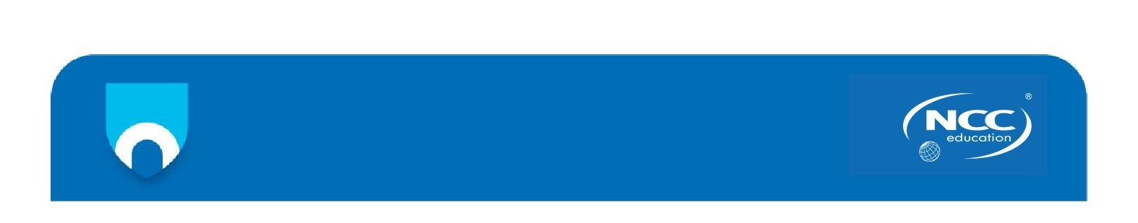

A signed copy of this form must be submitted with every assignment. If the statement is missing your work may not be marked.

Student Declaration

I confirm the following details:



Contents
Task 1 – Site Map and HTML 1
1.1 Site Map 1
Task 2 – CSS 2
Task 3 – Testing and Reporting of the Testing 3
3.1 HTML Validation 3
3.1.1 Index.html file 3
3.1.2 faq.html file 4
3.1.3 member-area.html file 4
3.1.4 community-group.html file 5
3.1.5 latest-places-to-fly.html file 6
3.1.6 training-online.html file 7
3.1.7 review.html file 7
3.2 Screen Reader Test 8
3.3 Cross-browser Testing 9
Task 4 - Critical Evaluation 12
Bibliography 16

Task 1 – Site Map and HTML

All the HTML files can be obtained within the supporting file.

Site Map
The below diagram is demonstrating the website’s Site Map
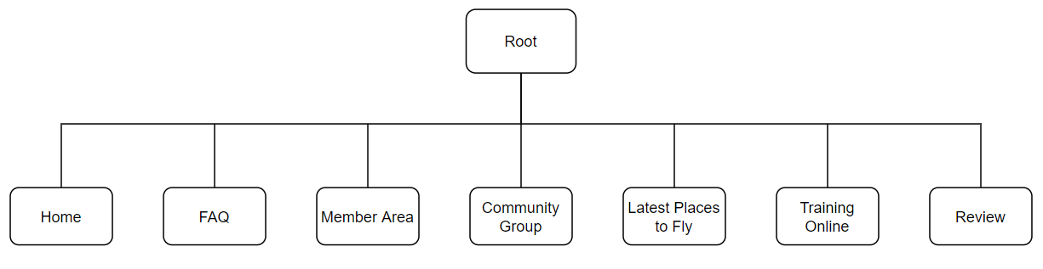
Figure 1 Website Site Map

Task 2 – CSS

The CSS file can be obtained within the supporting file.

Task 3 – Testing and Reporting of the Testing

HTML Validation
All the HTML files were submitted to W3C Validator with the output displayed below.

Index.html file
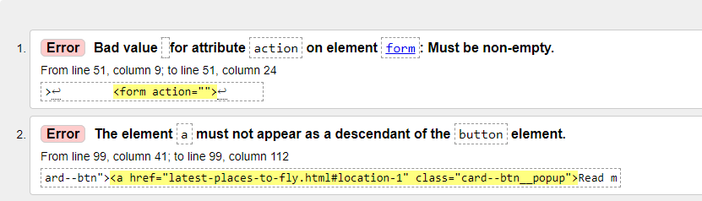
Figure 2 W3C Validator output of original index.html file
Error description:
- Due to the action attribute being left empty.
- This error cause by an anchor tag being wrapped within a button tag.
Solution for the mentioned errors provided as follows:
- Since we do not link the form to any programming languages, the action attribute was removed.
- The button which acted as parent was removed.
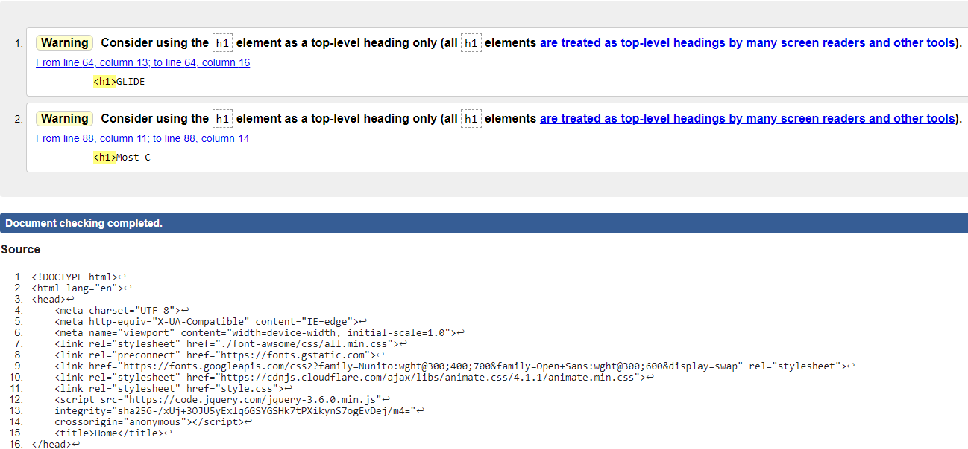
Figure 3 W3C Validator output of index.html file after modification
Note: The above 2 warning messages are an indication to utilise only h1 element as a top-level heading only. Based on the fact that in web design, h1 element can be used more than once within the same page, therefore the mentioned warning was ignored accordingly.

faq.html file
In the faq.html file no errors were detected:
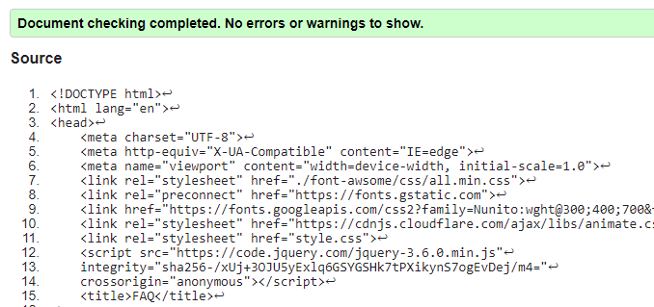Figure 4 W3C Validator output of faq.html file – no errors detected

member-area.html file
In the member-area.html file no errors were detected:
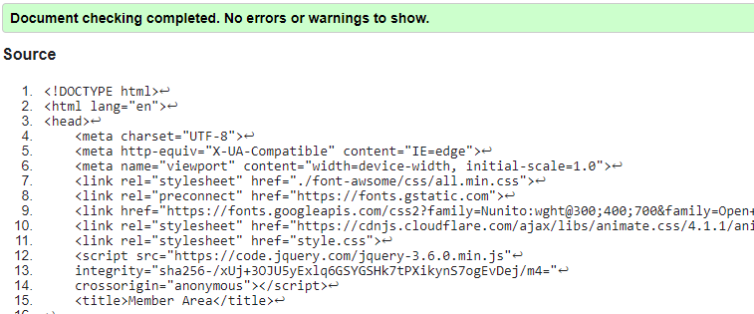
Figure 5 W3C Validator output of member-area.html file – no errors detected

community-group.html file
In the community-group.html file 3 warnings were found however no errors were detected:
1st & 2nd warnings are referring to the mentioned warning related to the h1 element in the index.html file.
3rd error is referring to the lack of heading in that particular section while we already used an h1 element within that section
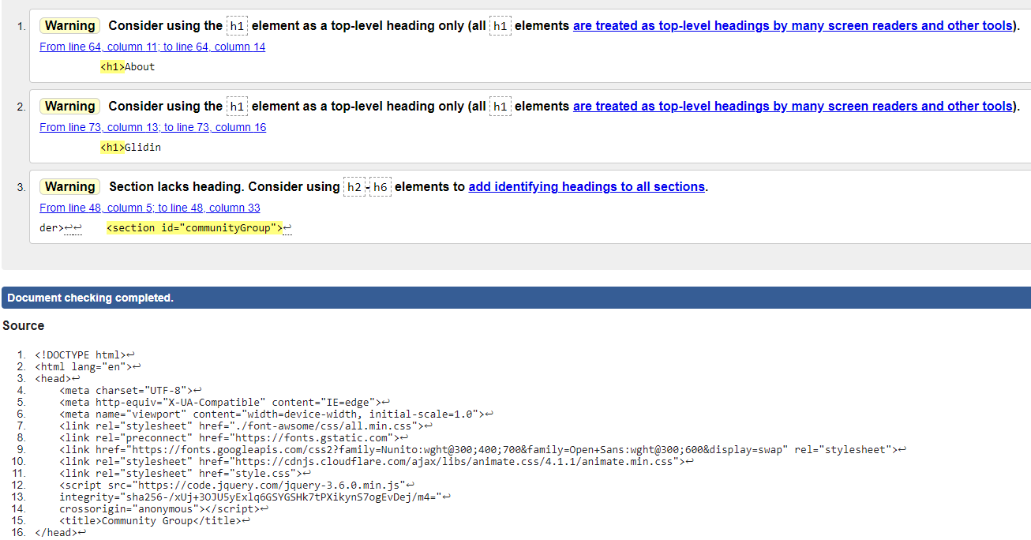Figure 6 W3C Validator output of community-group.html file – 3 warnings found

latest-places-to-fly.html file
latest-places-to-fly.html file also has the same warning as described in the previous file (community-group.html file).
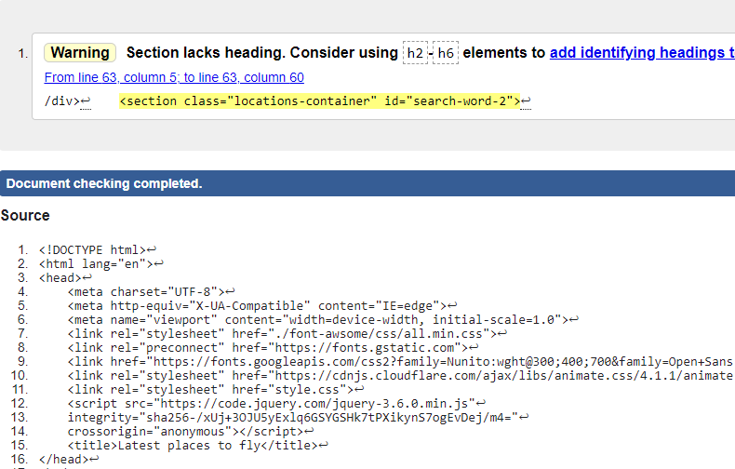
Figure 7 W3C Validator output of latest-places-to-fly.html file – 1 warning found

training-online.html file
training-online.html file also has the same warning as described in the previous file (community-group.html file).
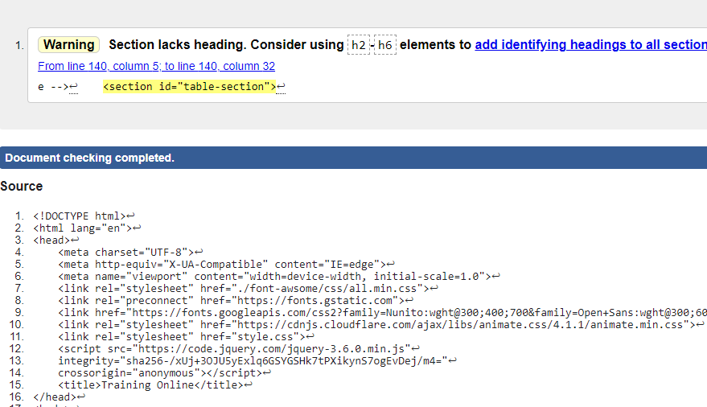
Figure 8 W3C Validator output of training-online.html file – 1 warning found

review.html file
In the review.html file no errors were detected:
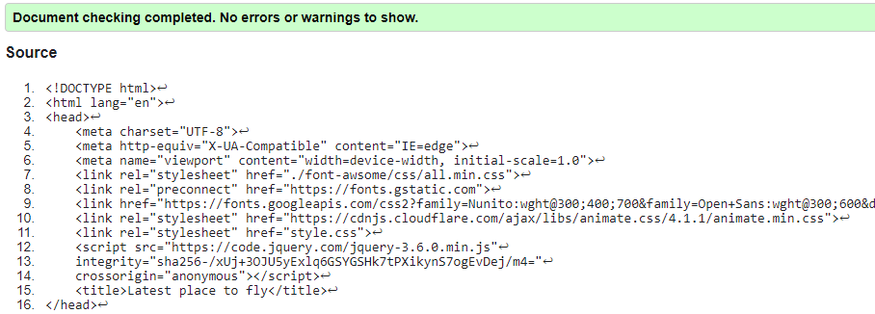
Figure 9 W3C Validator output of review.html file – no errors detected

Screen Reader Test

NVDA screen reader was used to verify how the website will react with a screen-reader and therefore assess accessibility. Hereunder are the findings observed.
- The video format is not being read by NVDA:
- A different way of navigating through the table
Recommendation:
- To allow NVDA to read Video format, a Video script should be added to each video tag.
- Besides using the mouse to hover on each sell Visual impaired people can be trained to use, ctrl + alt + arrows can be used to read each cell.

Cross-browser Testing
Both browsers Chrome and Mozilla were used to test the website and compare its functionality, design, and layout on each browser. Below are the finding observed.
Below screenshots are taken at resolutions of 1024x768

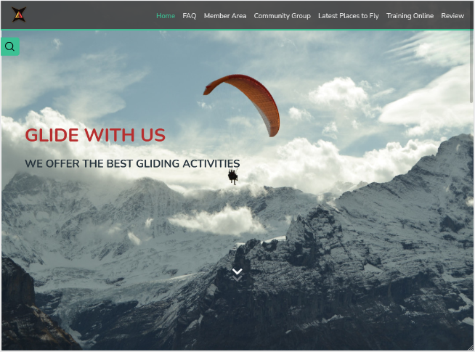
home/index page
Figure 11 Home page using Mozilla
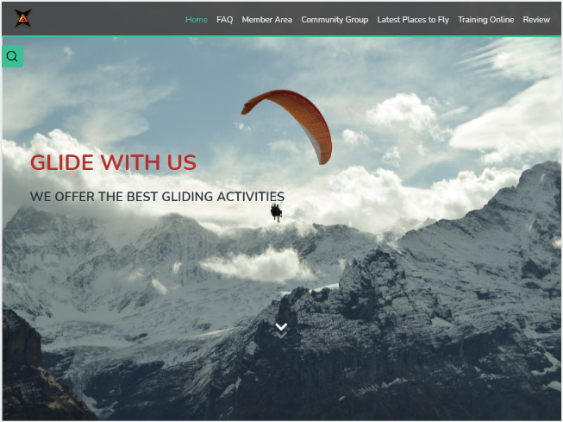
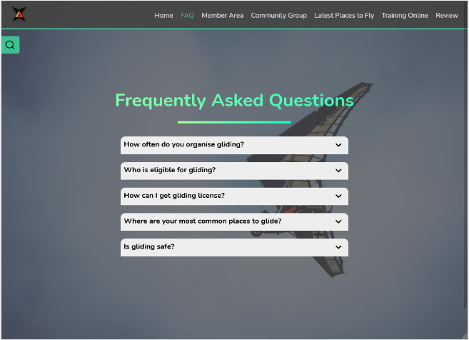
FAQ page
Figure 10 Home page using Chrome
Figure 13 FAQ page using Mozilla
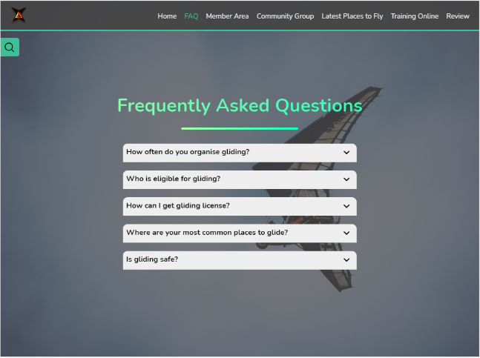
Figure 12 FAQ page using Chrome

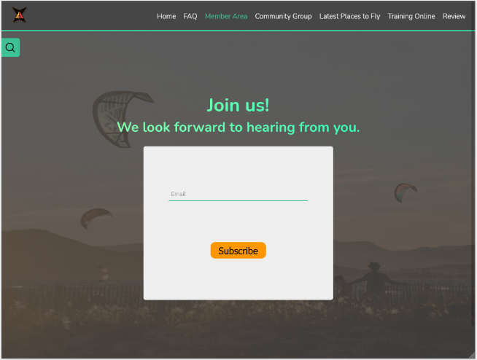
Member Area page
Figure 15 Member Area page using Mozilla
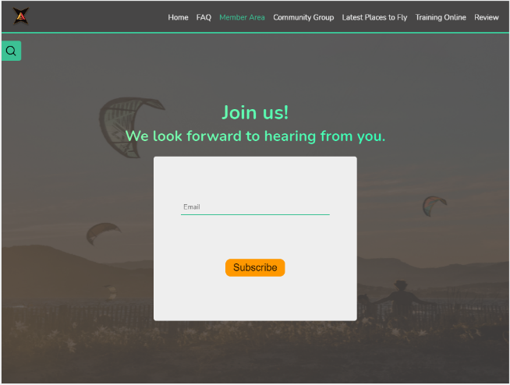
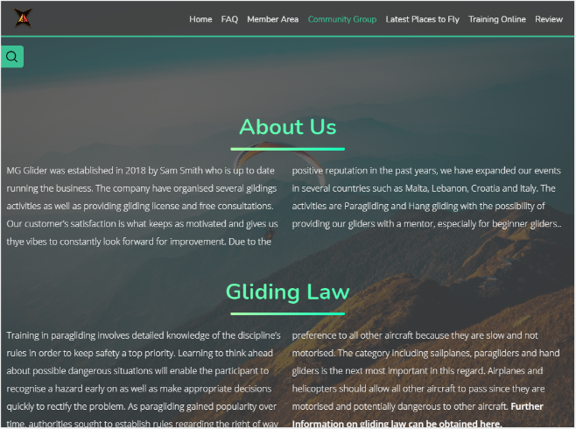
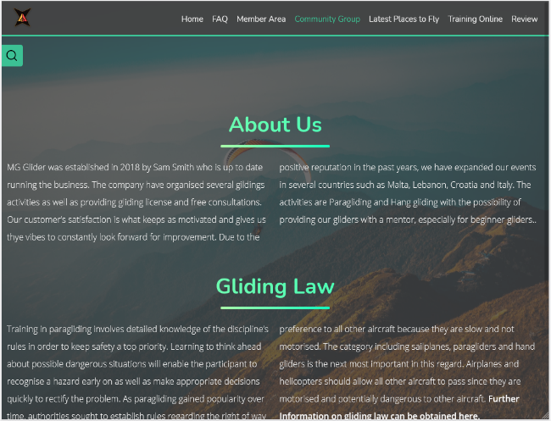
Community Group page
Figure 14 Member Area page using Chrome
Figure 16 Community Group page using Chrome
Figure 17 Community Group page using Mozilla
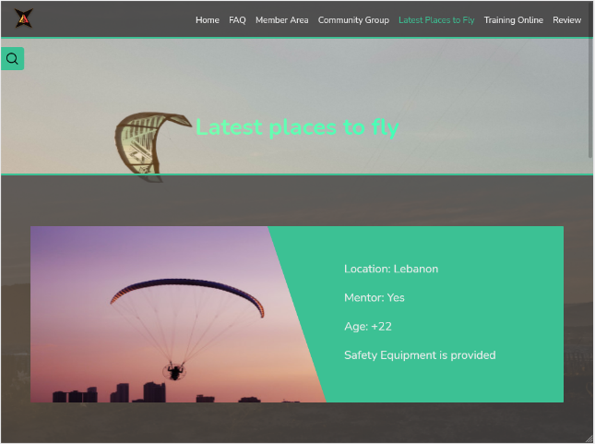
Latest Places to Fly page
Figure 19 Latest Places to Fly page using Mozilla
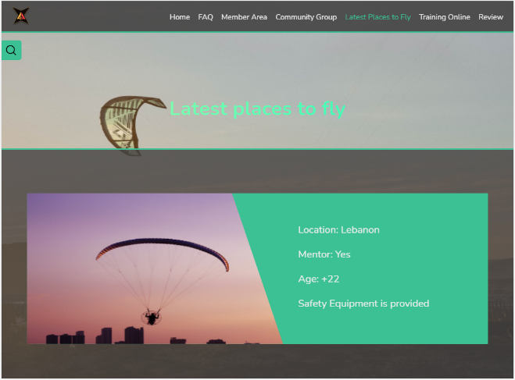
Figure 18 Latest Places to Fly Page using Chrome
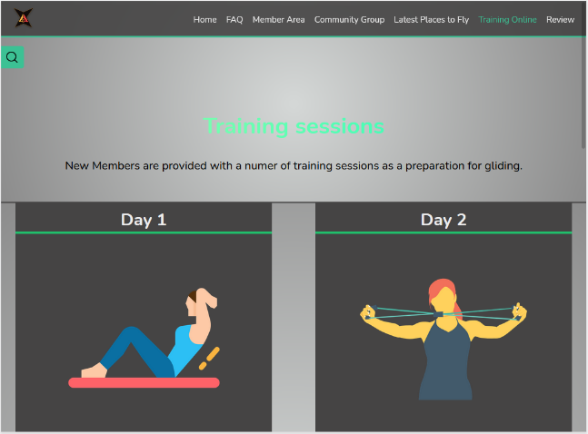
Training Online page
Figure 21 Training Online page using Chrome
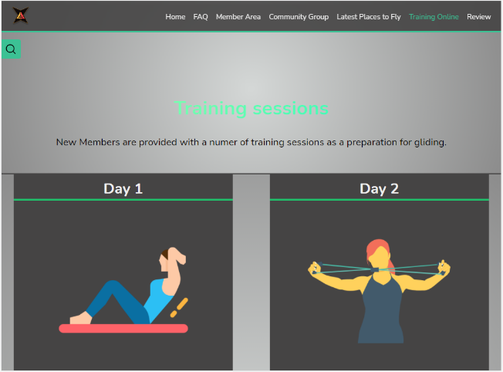
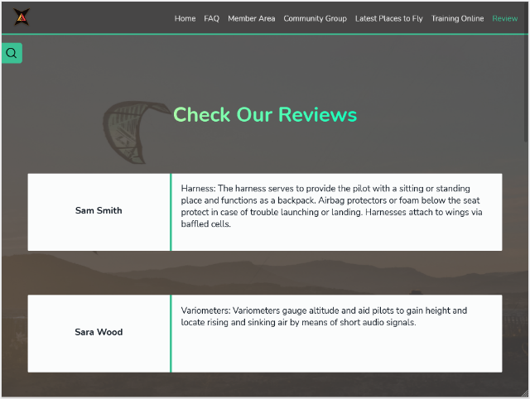
Review page
Figure 20 Training Online page using Chrome
Figure 23 Review page using Chrome
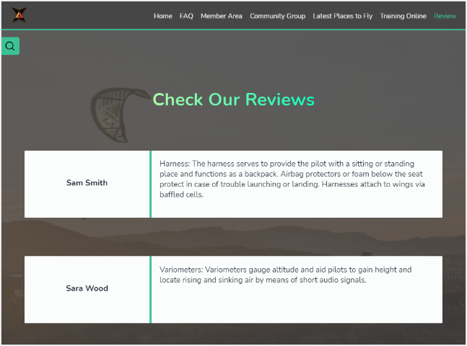
Figure 22 Review page using Chrome
After completing the cross-browser testing for the website, we came to a conclusion that the website’s layout and design, fonts and functionality is featuring the same way on both browsers.

Task 4 - Critical Evaluation

- The World Wide Web Consortium (W3C) is an international community where Member organisations, dedicated staff members, and the general public work together to develop Web standards and protocols. The purpose of these standards is to build a universal, accessible, easy-to-use website that can be entrusted globally. In addition to websites, W3C provides security and privacy guidelines for websites to follow. The advantage of these technologies is to avoid the fragmentation of the Web and enhance the infrastructures so that we can evolve towards a Web with the best organised information (Delgado, 2021).

Advantage of e-business website:

- Flexibility: e-business is 24 x 7, meaning the internet is accessible constantly. Customers and merchants can conduct transactions at their comfort and at any time.

- Quick and easy communication: e-business does not require face-to-face interactions between customers and merchants. Therefore, communication is easier and faster.

- Low cost to start a business: Unlike the traditional model, the investment for starting an e-business is lower since often it does not require physical space to trade and the additional cost that come with it such as advert fees and regular bills.

Disadvantages of e-business website:

- Transaction Risk: Due to the nature of the business and allowing online transactions, the possibility of the customer or the merchant's details getting compromised by hackers is higher compared to traditional model business.

- Often the websites offer a money-back return policy however, this policy often does not apply effectively in the case of dissatisfaction of the customer with the product. Consequently, the customer aims for a chargeback with their bank so that 3rd parties such as Visa have to interfere and investigate.

- Due to various reasons from the merchant's side, lack of delivery resources, and even restrictions between countries, customers have faced delivery issues at least once in their online shopping experience (Abimbola, 2021).

- MG glider website is made up of seven HTML files which consist of text and markup tags that are used to define the structure and appearance of information on each web page. Throughout the website as best practice, semantic HTML (also called semantic markup) was used. According to Juviler, Semantic HTML code describes the meaning of its element to both computers and users, which helps web browsers, search engines, and developers understand the components of a web page. (Juviler, 2021). Some of the semantic tags which are used in the website include (article, footer, header, main, nav, section, and video). Each tag is self-explanatory, referring to a specific area on the web page which makes it easy to understand its meaning. I.e., for the footer and the header area on the website, both semantic tags footer and header were used.
- CSS also knows as Cascading Style Sheets is an important aspect of web design. It is responsible for page layout, colors, typology, and many other visual aspects. With the help of CSS, the website is given an identity and this is done by embedding an external CSS file within the HTML file. For this purpose in the HTML <head>, we can use <link> tag and associate the external file.

To follow CSS standardisation CSS3 is the ideal way of practising and designing a website. with CSS3 we can benefit from search engine optimisation, it is easier to maintain and update as well as providing more formatting options. Our website design consists of the new and advanced CSS3 features including (grid, flex, box-sizing, column-fill, overflow-x, transform, animation, media queries, etc..).

- To achieve an interactive website, JavaScript was used along with HTML and CSS. Some advantages and disadvantages of JavaScript and CSS will be discussed hereunder.

Advantage of JavaScript:

JavaScript is supported by all modern browsers as well as by several renowned companies such as Google, Amazon, Paypal, etc.

Irrelevant of where it is hosted, JavaScript can be executed on the client environment side to save a large amount of bandwidth which makes the execution process faster

It is possible to use JavaScript through Node.js servers. Also, there are some ways to develop an application from the front-end to the back-end using only JavaScript.

Disadvantages of JavaScript:

One of the disadvantages of JavaScript is that the source code is always visible, so anyone can view and copy the code.

JavaScript is an interpreted language, the program is compiled line by line. If an error occurs while compiling the code, it can stop the rendering of the entire JavaScript. However, the browsers are extremely tolerant of these errors.

Although some HTML editors support debugging JavaScript, it is not as efficient as other editors such as C/C++ editors. Therefore, developers find debugging in JavaScript more difficult. (Agarwal, 2020)

Advantage of CSS:

An important feature of CSS is that a style can be applied across several web pages and all have the same outcome. This results in efficiency in programming and a faster load time for every page.

Besides simplifying web development, CSS also simplifies maintenance since a modification of a line of code can affect the whole website.
Disadvantages of CSS:

There are four types of CSS: CSS, CSS 1, CSS2, and CSS3 which may result in confusion among developers and web browsers and is even more complex for non-developers and beginners.

Often website compatibility is an issue with CSS. What works with one browser may not always work with another. Hence developers test for website compatibility and running the website across several browsers prior to launching it live (Agarwal, 2020).

- JPEG and PNG format are two of the image types which were used in designing the website. Below are several advantages and disadvantages of these formats.

Advantages of JPEG:
JPEG is a universal image format that is supported across web browsers and image editors. It is also supported by every digital camera.

The size of the JPEG format is small which made it popular especially years ago this aspect was important since hard drives were much smaller.

Disadvantages of JPEG:
Compression of this image format is one of the downsides. When an image is compressed, it reduces the quality of the image.

JPEG format does not support opacity or transparency, unlike PNG format. Raw digital images with dark or transparent areas are saved with a solid white colour under the JPEG format. (Staff, 2019).

Advantages of PNG:

PNG format is ideal for editing. Due to fact that this format has lossless compression, unlike JPEG format PNG format retains image quality irrelevant of the number of encoding and decoding

This format has a wide color depth which makes it suitable for different types of digital images such as photographs and graphics.

Disadvantages of PNG:

PNG compresses images at a larger file size compared to JPEG for relatively similar image quality and resolution.

PNG format is not ideal for professional quality printing since it does not support non-RGB colour spaces such as CMYK. This format was specifically designed for digital images online (Staff, 2019).

- Cross-browser testing is a crucial part of developing software provided that there is a wide range of different web browsers, devices, and operating systems available. According to Bartlett, CSS styles can perform differently in Internet Explorer 8 compared to older versions of Internet Explorer and Google Chrome. Elegant styling and effects such as image transparencies, shadows, hover states, and even fonts can differ across browsers. These visual differences can often be impossible to overcome completely especially with previous browsers. Therefore, developers must ensure that the website is supported across different browsers even if the majority of your users are accessing the website using one particular browser. The goal of cross-browser testing is to ensure your users can access all content and execute all of the basic functions on your website without any major issues (Bartlett, 2018).

Bibliography

Delgado, H., 2021. W3C Web Standards - What are standards, how do they work?. [online] Website Design akus.net. Available at: https://disenowebakus.net/en/web-standards [Accessed 25 July 2021].
Abimbola, A., 2021. The Advantages and Disadvantages of an E-Business. [online] Mauco Enterprises. Available at: https://mauconline.net/the-advantages-and-disadvantages-of-an-e-business/ [Accessed 25 July 2021].
Juviler, J., 2021. Semantic HTML: What It Is and How It Improves Your Site. [online] Blog.hubspot.com. Available at: https://blog.hubspot.com/website/semantic-html [Accessed 25 July 2021].
Agarwal, P., 2020. Advantages and Disadvantages of JavaScript - GeeksforGeeks. [online] GeeksforGeeks. Available at: https://www.geeksforgeeks.org/advantages-and-disadvantages-of-javascript/ [Accessed 25 July 2021].
Agarwal, P., 2020. Advantages and Disadvantages of CSS - GeeksforGeeks. [online] GeeksforGeeks. Available at: https://www.geeksforgeeks.org/advantages-and-disadvantages-of-css/ [Accessed 25 July 2021].
Staff, K., 2019. Advantages and Disadvantages of JPEG Standard | Konsyse. [online] Konsyse. Available at: https://www.konsyse.com/articles/advantages-and-disadvantages-of-jpeg-standard/ [Accessed 25 July 2021].
Staff, K., 2019. Advantages and Disadvantages of PNG Format | Konsyse. [online] Konsyse. Available at: https://www.konsyse.com/articles/the-advantages-and-disadvantages-of-png-format/ [Accessed 25 July 2021].
Bartlett, J., 2018. [online] Available at: https://blog.testlodge.com/why-cross-browser-testing-is-important/ [Accessed 26 July 2021].

