**Exercice**

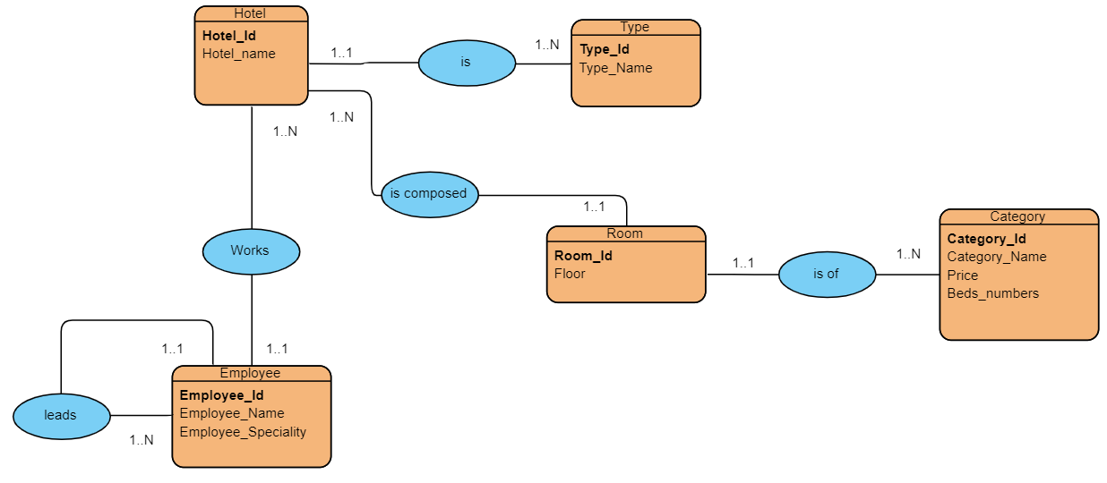

* Convertir le modèle de relation d'entité en diagramme relationnel

**Réponse**

* Hôtel (Hotel_id, Hotel_Name, #Type_id)
* Type(Type id, Type_Name)
* Employee(Employee_id, Employee_Name, Employee_Speciality, #Hotel_id , #chefHotel_id)
* Room(Room_id, floor, #hotel_id, #category_id)
* Category(Category_id , Category_Name , Price, Beds_Number)