**Checkpoint Langage SQL**

**mysql> create database checkpoint_ddl**

**mysql> use checkpoint_ddl**

**mysql> create table product(product_id varchar(20), product_name varchar(20) not null, price int, constraint price_positive check(price>0) , primary key(product_id));**

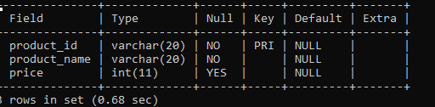

**mysql> create table customer(customer_id varchar(20), customer_name varchar(20) not null, customer_tel int, primary key(customer_id));**

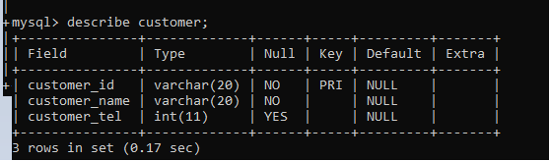

**mysql> create table orders(customer_id varchar(20), product_id varchar(20), quantity float, total_amount float, foreign key(customer_id) references customer(customer_id), foreign key(product_id) references product(product_id));**

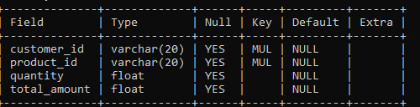

**mysql> alter table product add category varchar(20);**

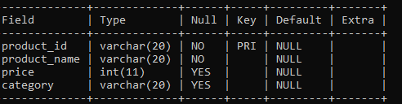

**mysql> alter table orders add orderdate datetime default now();**

