Feature measured during the blinking:

B_ear_mean
Measures the average eye opening using facial landmarks.
$$EAR=\frac{∥p_{2}-p_{6}∥+∥p_{3}-p_{5}∥}{2∥p_{1}-p_{4}∥}$$
$p_{1}…p_{6}$are facial landmarks.
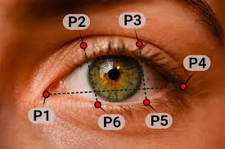
High EAR → eye open
Low EAR → eye close
Typical values:
eye open: ~0.25–0.35
blink: under ~0.18–0.22

B_ear_std
Measures the variability of eye opening (instability).

B_perclos
Percentage of time the eyes are closed more than 80% in a time window.
$$PERCLOS=\frac{T_{closed}}{T_{total}}×100$$

Typical values:
<10% → normal
10–20% → fatigue
20–30% → high fatigue

B_blink_count
Number of complete blinks in the window.

B_blink_freq
Number of blink for minute.
Typical values:
normal: 10–20 blink/min

B_ibi_mean
Average time interval between two consecutive blinks.

B_ibi_std
Regularity of the blinking pattern.

