Movies Database ERD
Ajanae Stanback
CSD310 Database Development and Use
Module 4.3 Assignment: Movies!
November 13, 2026

Entity Relationship Diagram
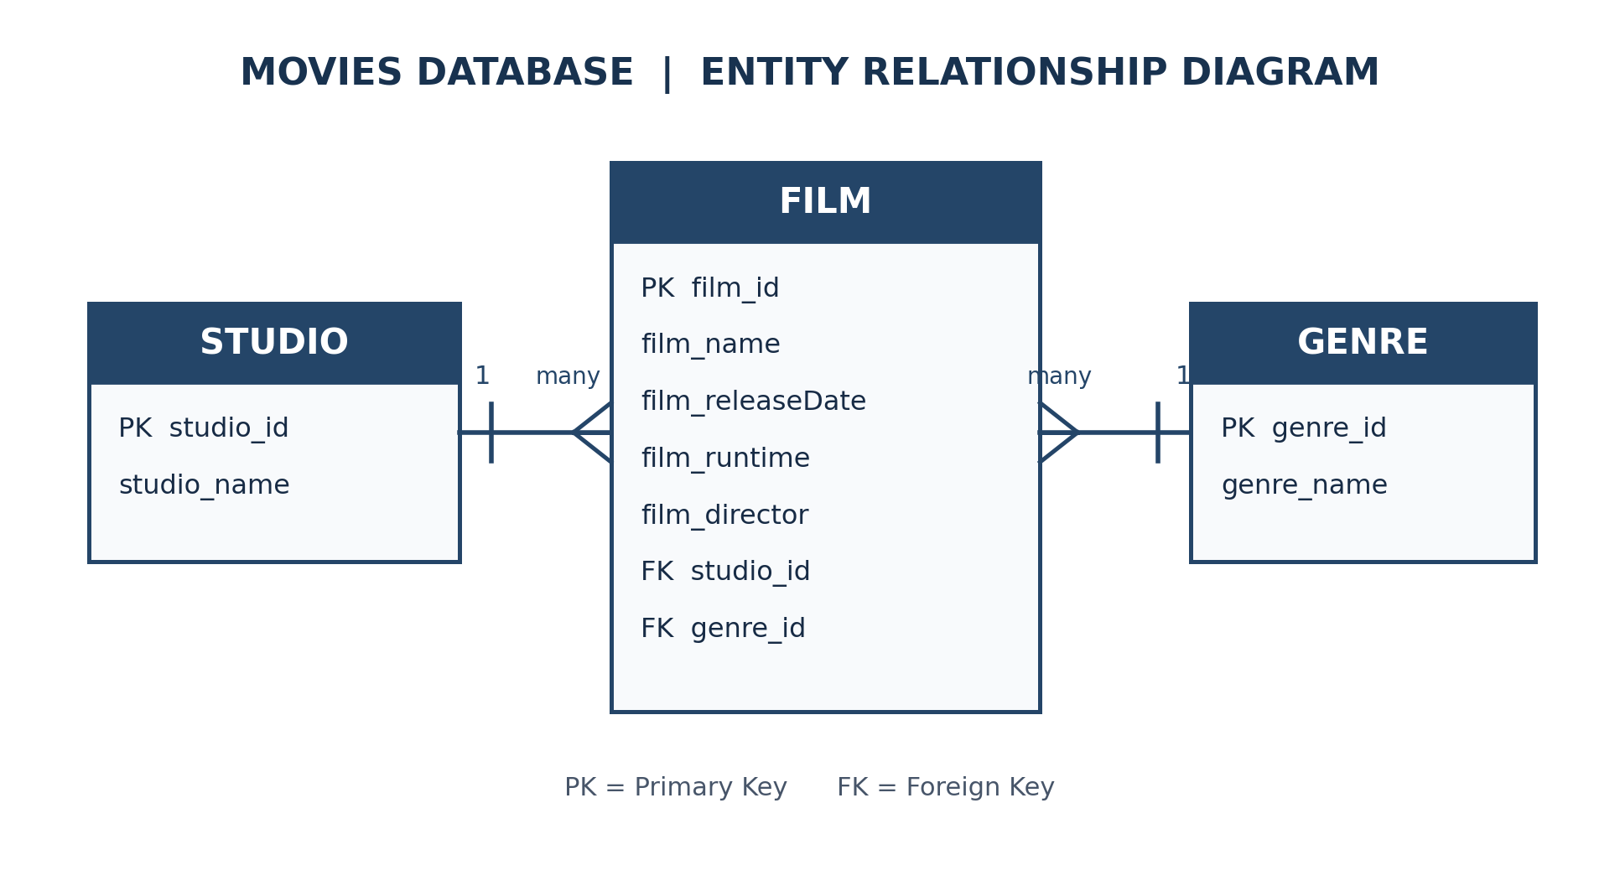
Relationships: One STUDIO produces many FILMs. Each FILM is associated with one STUDIO and one GENRE. A GENRE may describe many FILMs.
The studio_id and genre_id fields in FILM are foreign keys referencing STUDIO(studio_id) and GENRE(genre_id), respectively.

