Ajanae Stanback
CSD-310: Database Development and Use
Module 2.3 Assignment: Data Models

Entity Relationship Diagram (ERD)
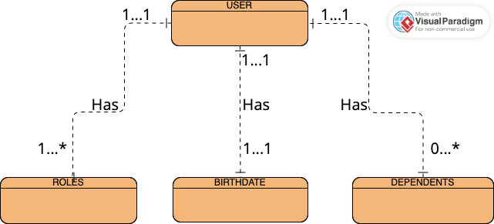

NoSQL Data Structure
