Ajanae Stanback
CSD310: Database Development and Use
Module 4.2 Assignment: MySQL Install
November 12, 2026
This assignment documents a successful MySQL connection, creation of the movies database, and three SQL functions with aliases and results.

1. Initial MySQL Database Connection
MySQL Community Server 26.10.0 was started and accessed through the macOS Terminal using the root account. The MySQL welcome screen and mysql> prompt confirm the connection.
/usr/local/mysql/bin/mysql -u root -p
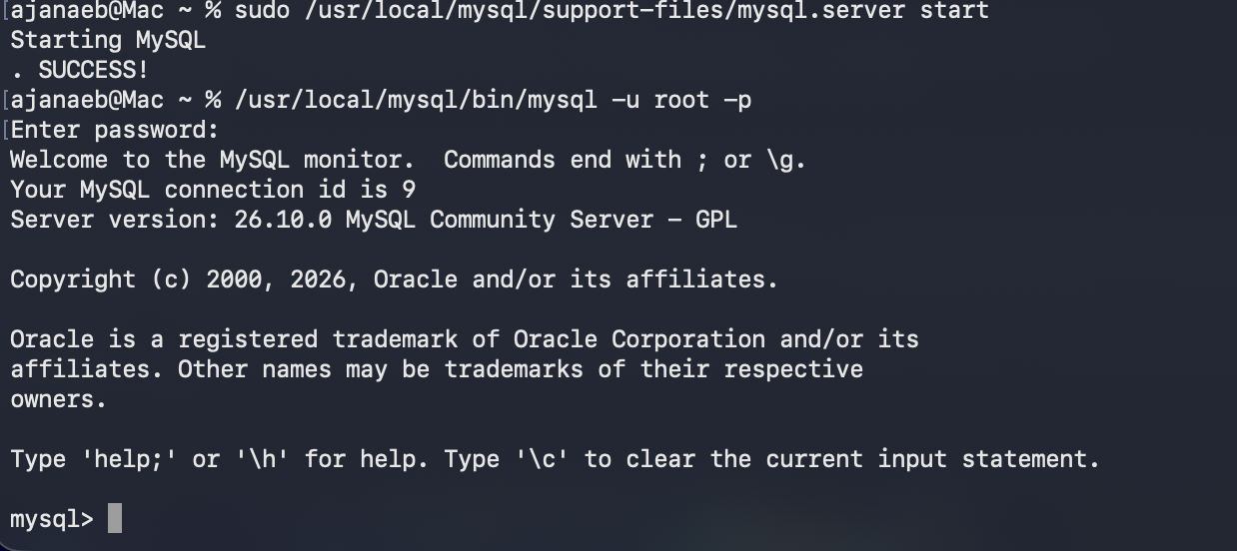

2. Create and Verify the Movies Database
The CREATE DATABASE command creates a database named movies. SHOW DATABASES lists available databases and confirms that movies was created successfully.
CREATE DATABASE movies;
SHOW DATABASES;
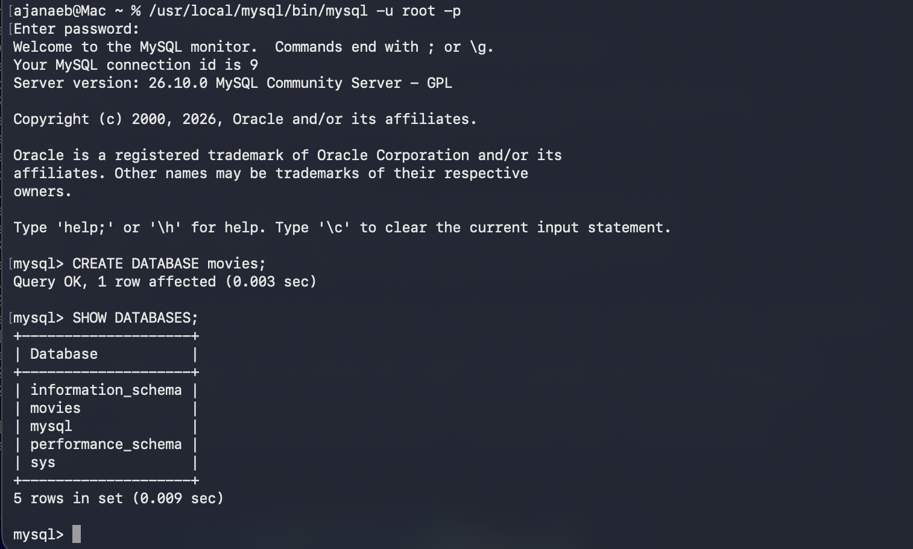

3. Function One: UPPER()
The UPPER() function converts text to uppercase. It can be used to standardize how movie titles or other text are displayed. The alias Uppercase_Text gives the result column a clear heading.
SELECT UPPER('movies database') AS Uppercase_Text;
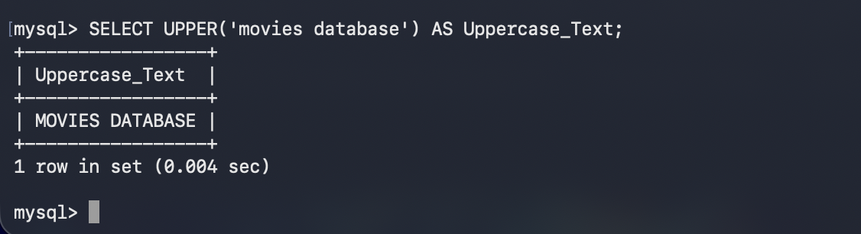

4. Function Two: LENGTH()
The LENGTH() function returns the number of bytes in a text string. It can help check text sizes before storing values in a database. For the English word Hollywood, the result is 9. The alias Text_Length identifies the output.
SELECT LENGTH('Hollywood') AS Text_Length;
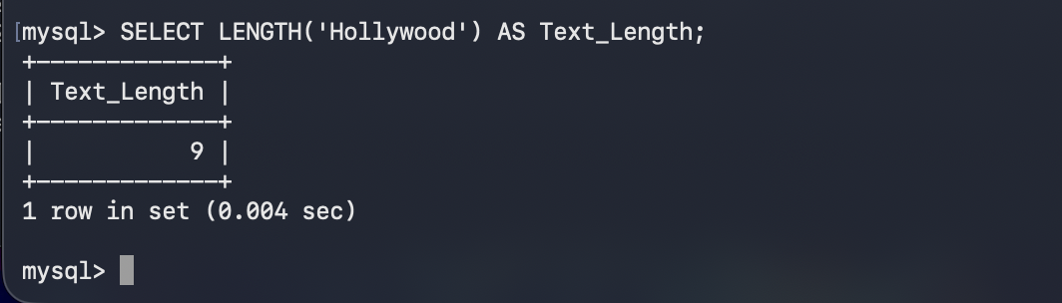

5. Function Three: ROUND()
The ROUND() function rounds numeric values to a specified number of decimal places. It is useful when displaying prices, averages, or calculations. Here, 8.756 is rounded to two decimal places, giving 8.76. The alias Rounded_Number labels the output.
SELECT ROUND(8.756, 2) AS Rounded_Number;


