CSD325 | Module 3.2: Brownfield + Flowcharts
Ajanae Stanback | Assignment 3.2 | November 7, 2026

Flowchart 1: Main Cho-Han Game
This diagram shows the betting loop, input validation, dice roll, player selection, and game-ending conditions.
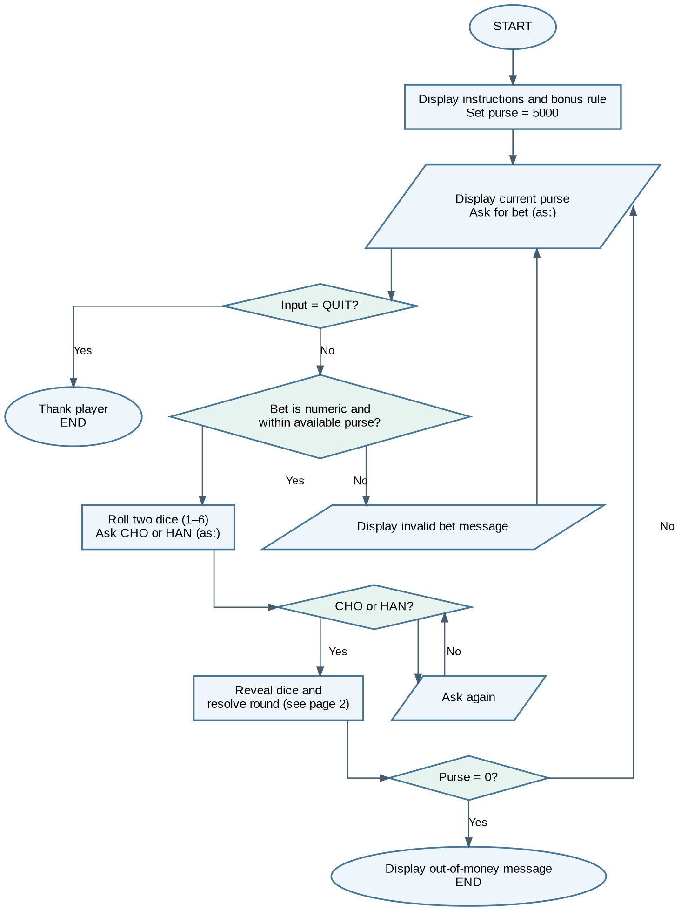

CSD325 | Module 3.2: Brownfield + Flowcharts
Ajanae Stanback | Assignment 3.2

Flowchart 2: Dice Result, Bonus, and Payout
This diagram expands the round-resolution step, including the added 10-mon bonus and updated 12% house fee.
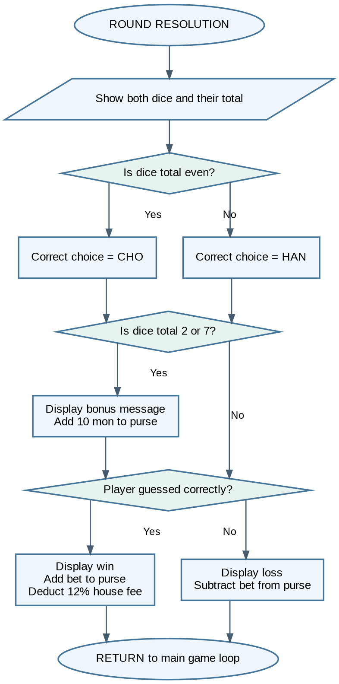
Assumptions: The game starts with 5,000 mon. Each die is rolled independently from 1 through 6. A total of 2 or 7 awards a 10-mon bonus regardless of whether the player wins the bet. A winning bet pays the bet amount minus the 12% house fee; a losing bet deducts the bet amount.

