Ajanae Stanback
CSD325 – Advanced Python
Module 1.2 – GitHub Repository Setup
GitHub Repository URL:
https://github.com/momof3613/csd-325
Local Directory Screenshot:
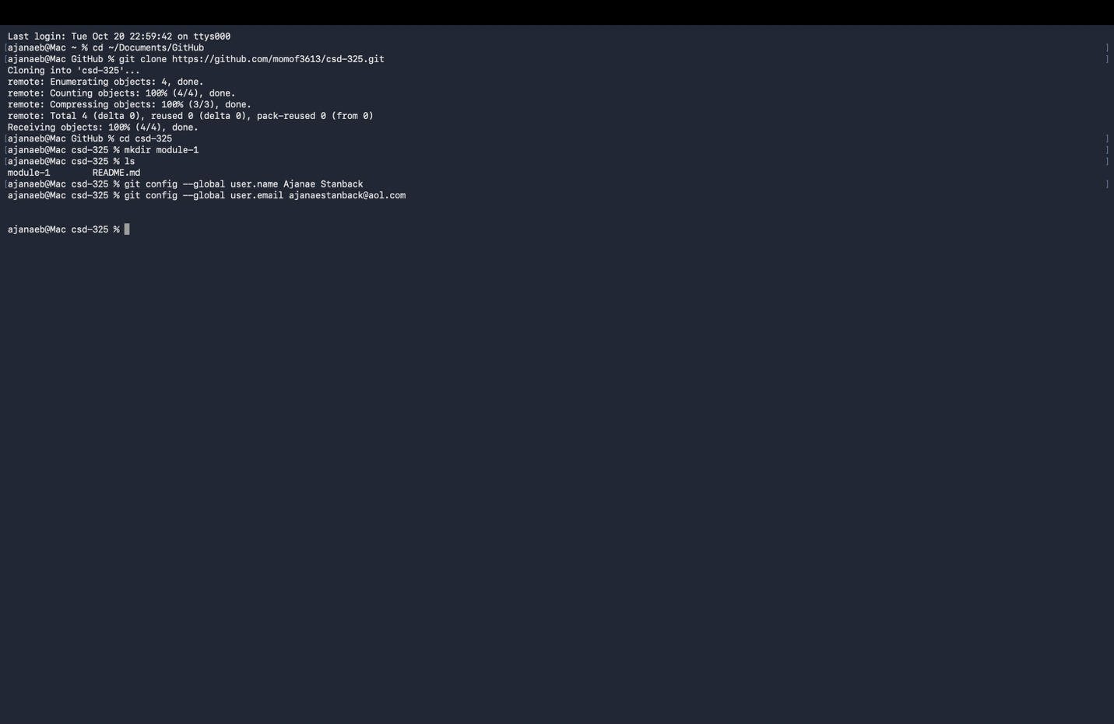
GitHub Repository Screenshot:

