Ajanae Stanback | CSD-325 | Module 2.2
Student Grade Calculator: Program Flowchart
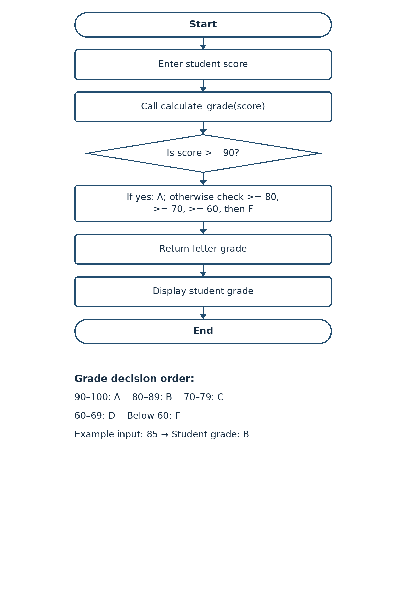
The diagram summarizes the program’s sequential grade checks. The function returns the first matching letter grade, and main() displays the result.

