Ajanae Stanback
CSD-325 | Module 2.2 | October 28, 2026

Documented Debugging — Student Grade Calculator
Program: stanback_grade_calculator.py | Environment: Geany and Python pdb
Purpose: Demonstrate setting a breakpoint, stepping into a function, moving to the next statement, and continuing execution. Test input: 85.

Screenshot 1 — Breakpoint
The program pauses in main() before calling calculate_grade(score). The (Pdb) prompt confirms the breakpoint was reached.
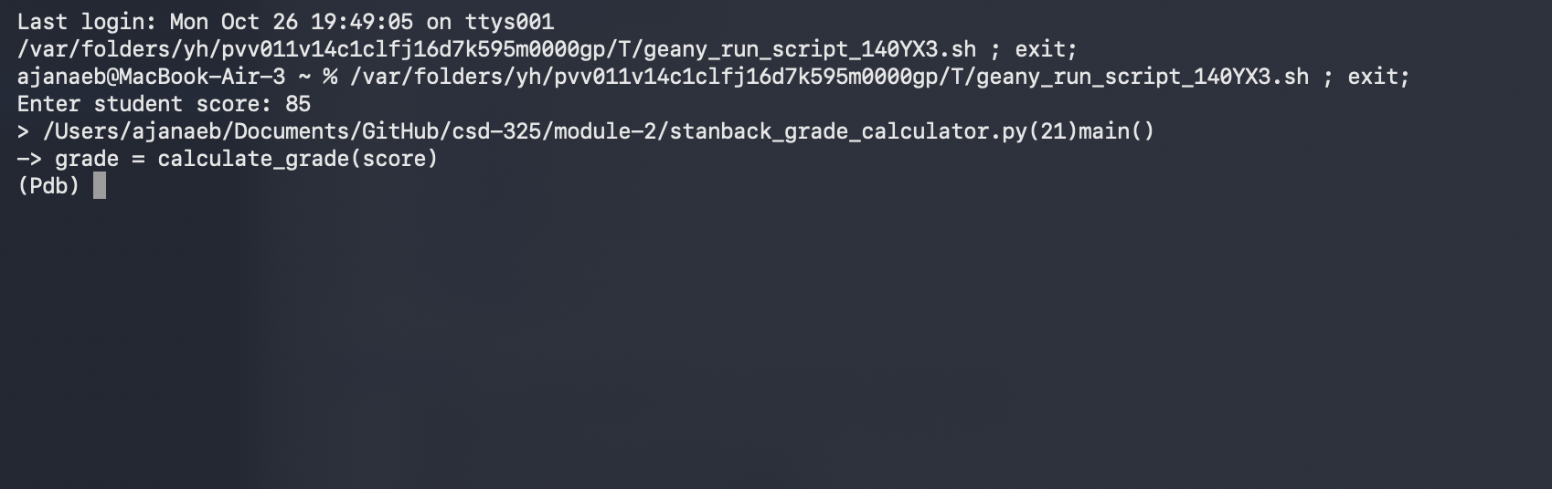

Screenshot 2 — Step Into (s)
The s command enters the calculate_grade(score) function and pauses at its definition.
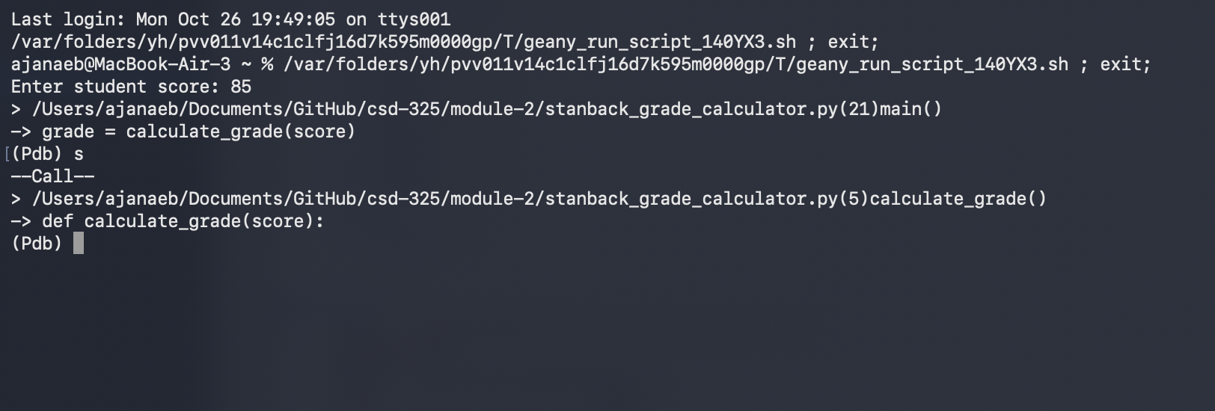

Screenshot 3 — Next (n)
The n command advances to the first conditional statement, if score >= 90.
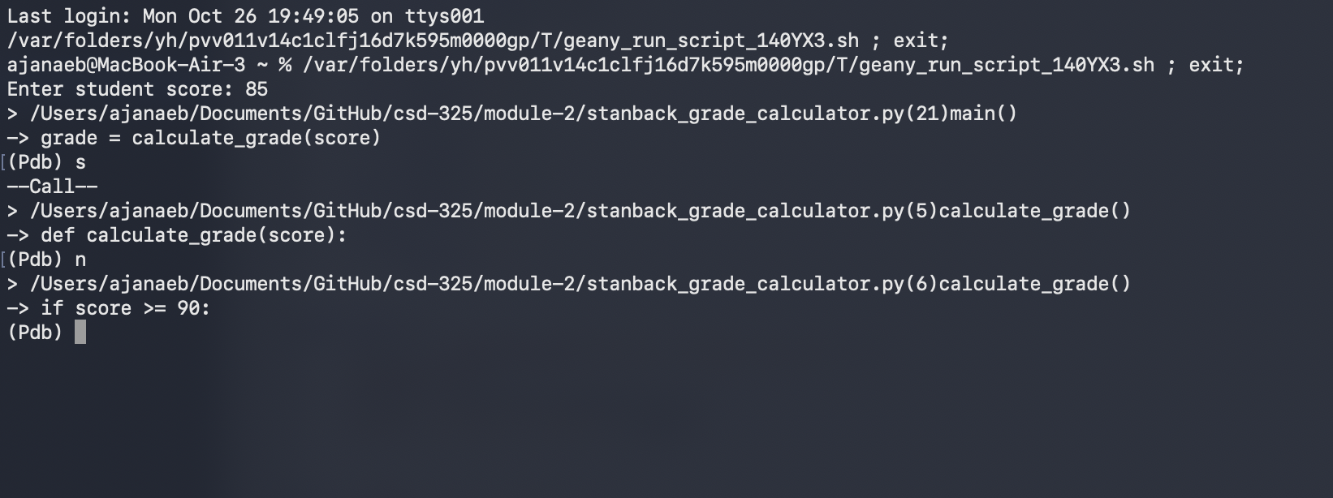

Screenshot 4 — Continue (c)
The c command resumes execution. The program outputs Student grade: B for input 85 and exits with code 0.


