PAWELIUM 2.0
SUPER_ADMIN OPERATIONAL HANDBOOK & ARCHITECTURAL MANUAL
Confidential documentation and master operator procedure guide for Pawelium luxury companion marketplace.
Covers complete platform console workflows, single-admin security governance, card-only orchestration, and bilingual content operations.
CLASSIFICATION: RESTRICTED — SUPER_ADMIN CLEARANCE ONLY
VERSION: 2.0.4 (RELEASE CANDIDATE)
DATE: NOVEMBER 2026
JURISDICTION: EUROPEAN UNION / FRANCE (RGPD COMPLIANT)

Table of Operational Modules
1. Security Architecture & Single-Admin Governance
Master authentication, IP rate limiting, anti-replay TOTP MFA, and session controls.
2. Master Account Security & Recovery Operations
Password changes, emergency recovery codes, TOTP reconfiguration, and active session revocation.
3. Animals & Live Inventory Management
Creation, veterinary biometrics, pedigree documents, pricing in integer cents, and publication toggling.
4. Breeds Registry & FCI Standards
Official breed registry, canine and feline species classifications, and bilingual breed profiles.
5. Partner Breeding Estates & Accreditation
Accredited breeding facilities directory, kennel verification, and incoming partner application review.
6. Temporary Holds & Cart Reservation Concurrency
15-minute checkout reservation locks, database uniqueness guarantees, and manual force-release procedure.
7. Adoption Orders & Commercial Lifecycle
Order state transitions, terms acceptance tracking, fulfillment progression, and item validation.
8. Payment Orchestration & Card Routing
GeniusPay card-only engine, Stripe primary processing, Paystack/PaiementPro/CinetPay fallbacks, circuit breakers.
9. Dispute Resolution & Manual Refunds
Customer refund clearance, payment exception handling, and cancellation workflows.
10. VIP Pet Deliveries & Chaperone Logistics
Doorstep pet transport scheduling, veterinary handover documentation, and carrier dispatch.
11. Adopter Client Directory & GDPR Erasure
Customer profiles, purchase histories, and irreversible GDPR Right-to-Erasure compliance protocol.
12. Review Moderation & Testimonial Curation
Adopter testimonials queue, 5-star ratings, verified purchase badges, and storefront publication.
13. Concierge Support Tickets & Client Messaging
Omnichannel inquiry resolution, customer response dispatch, and internal confidential staff notes.
14. Content Blocks & Editorial CMS
Dynamic homepage copy, legal notice revisions, announcement banners, and FAQ editing.
15. Translations Parity & Runtime Overrides
Modular EN/FR translation catalogs, zero-bloat client delivery, and hotfix translation overrides.
16. SEO & OpenGraph Social Metadata
Search engine title templates, bilingual meta descriptions, and social graph preview cards.
17. Newsletter Subscriber Management
Double-opt-in newsletter database and CSV marketing dispatch export.
18. Business Analytics & Financial KPIs
Gross transaction volumes, conversion ratios, and per-gateway payment attempt reliability metrics.
19. Immutable Security Audit Ledger
Comprehensive actor tracking, IP forensics, before/after state diffs, and compliance auditing.
20. System Settings & Gateway Health Diagnostics
Environment secret presence checks, database provider status, and operational rules parameters.

Module 1: Security Architecture & Master Authentication
Purpose & Scope: Provides single-admin authentication for Pawelium 2.0. Protects console access via sliding HMAC sessions, IP sliding-window rate limiting, and RFC 6238 TOTP two-factor authentication.
Standard Operating Procedure:
1. Navigate to /admin/login directly. Public storefront pages carry no links to this administrative portal.
2. Enter master email (admin@pawelium.fyi) and 14+ character master password.
3. If TOTP MFA is configured, input the 6-digit dynamic code from Google Authenticator or 1Password.
4. Upon 5 failed login attempts from a given IP address, an automated 15-minute security lockout engages without revealing account existence.
5. Sessions automatically slide on active usage; inactivity beyond 8 hours revokes authorization.
🔒 SECURITY & COMPLIANCE MANDATE
Zero links to /admin/login exist in customer storefront headers, footers, or client bundles. Any attempt to access protected endpoints without an authenticated __Host-pw_admin cookie redirects to login.

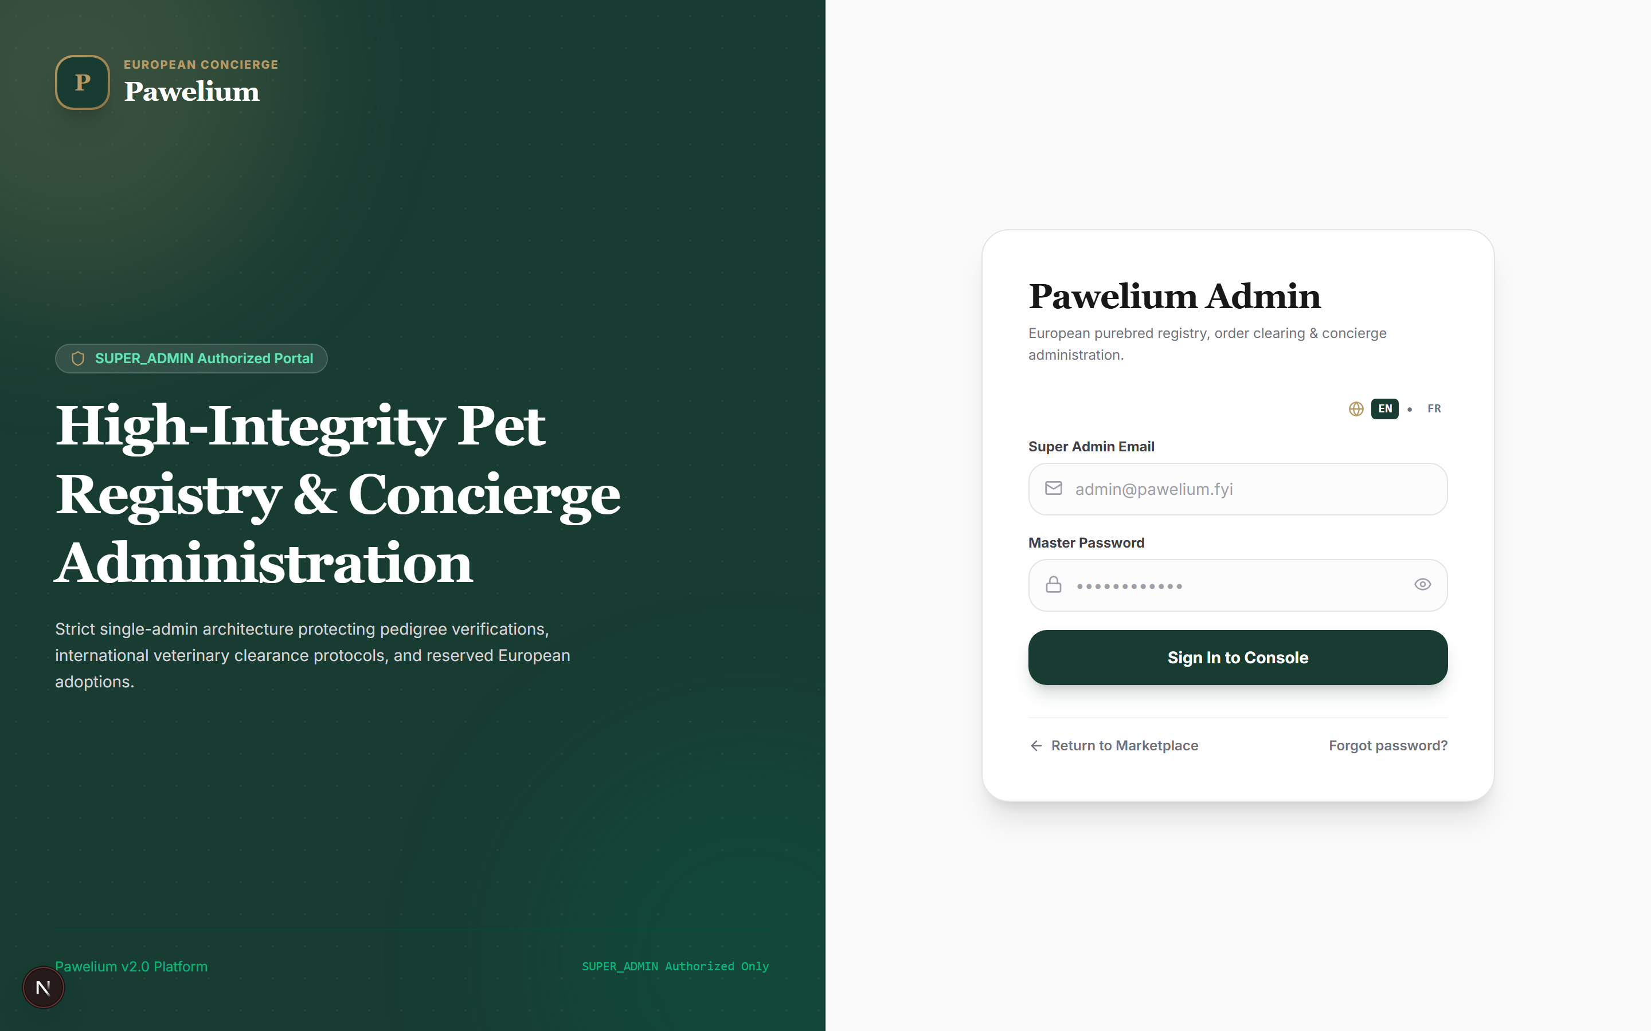
Figure: Super Administrator Authentication Screen with editorial split layout and password visibility controls.

Module 2: Master Account Security & Recovery Credentials
Purpose & Scope: Enables cryptographic password updates, emergency recovery codes generation, TOTP enrolment via server-rendered SVG QR codes, and active session termination.
Standard Operating Procedure:
1. Access /admin/account to inspect active session statistics and current security status.
2. To rotate master password, provide the existing password followed by the new 12+ character credential.
3. To enrol or reset TOTP MFA, scan the rendered SVG QR code in your authenticator app and enter the verification code.
4. Record the 8 generated emergency single-use recovery codes in a secure offline vault.
5. Inspect the active sessions table; click 'Revoke Session' on any unrecognised IP to instantly invalidate its session token.
🔒 SECURITY & COMPLIANCE MANDATE
TOTP verification strictly enforces anti-replay protection: a code step cannot be used twice within the current or past 30-second time windows. Comparisons use crypto.timingSafeEqual to prevent side-channel timing attacks.

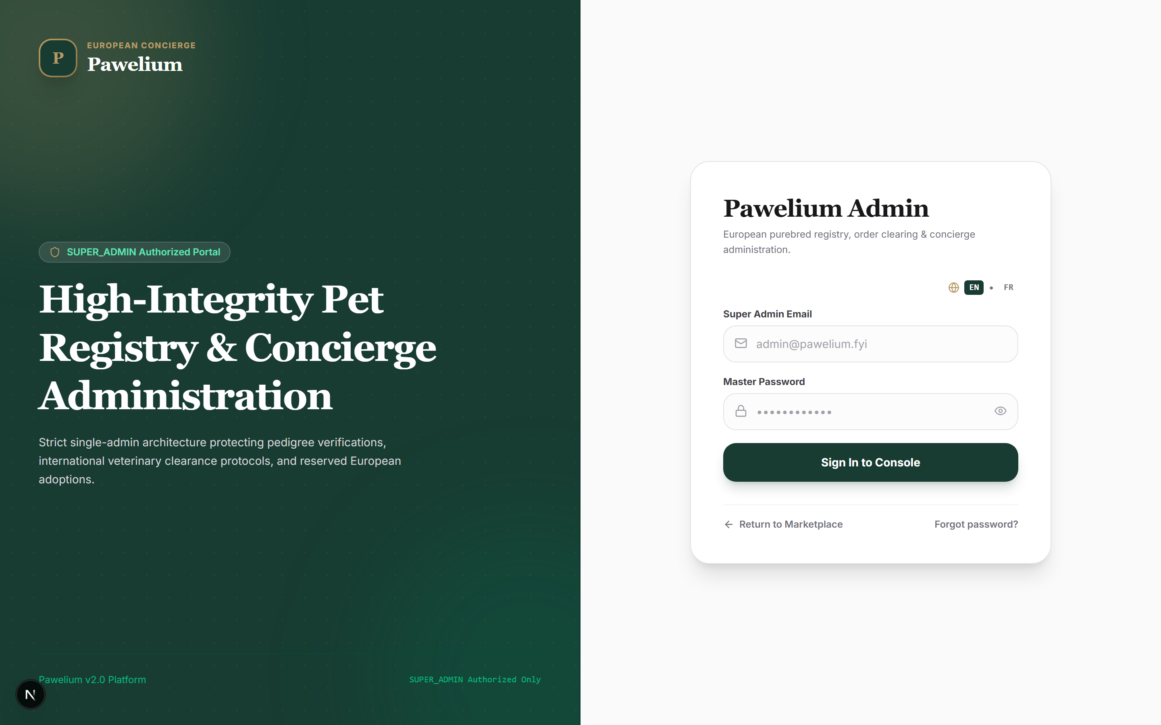
Figure: Account Security Console displaying password change, TOTP MFA configuration, and active session audit table.

Module 3: Animals & Catalogue Inventory Control
Purpose & Scope: Provides end-to-end listing lifecycle control: companion profiles, pedigree parameters, biometric records, microchip IDs, and real-time storefront publication status.
Standard Operating Procedure:
1. Navigate to /admin/animals to view the full inventory table with photos, species, pricing, and availability badges.
2. Click '+ Add Animal' to launch the profile creation form (/admin/animals/new).
3. Fill in mandatory parameters: companion name, breed selection, species (Canine/Feline), gender, price in integer cents (e.g. 150000 = 1,500.00 €), and bilingual description.
4. Upload or assign high-resolution photography. The first uploaded media automatically assigns as primary (sortOrder: 0).
5. Toggle 'Published' to immediately expose or hide the listing from the public marketplace without modifying inventory availability status.
🔒 SECURITY & COMPLIANCE MANDATE
All prices in database and API operations are strictly stored as integer cents to avoid floating-point inaccuracies. Price comparisons and display formatting utilize deterministic locale-aware rules.

Figure: Animals & Inventory Registry displaying companion thumbnails, FCI breed classification, and availability state toggles.

Module 4: Breeds Registry & FCI Standards
Purpose & Scope: Maintains the centralized canine and feline breed database, official FCI classifications, and bilingual profile content for breed-specific discovery pages.
Standard Operating Procedure:
1. Navigate to /admin/breeds to review all registered breeds and live listing counts.
2. Click 'Add Breed' to open the modal registration drawer.
3. Input English name, French name, URL slug, and species categorization (DOG or CAT).
4. Provide detailed bilingual descriptions detailing temperament, breed history, and care recommendations.
5. Click 'Save Breed' to commit changes across all public search filters and breed showcases.
🔒 SECURITY & COMPLIANCE MANDATE
Public storefront filters dynamically query prisma.breed. Deleting a breed with active animals is blocked by database foreign key constraints to prevent orphaned listings.

Figure: Breeds Registry Console showing registered canine and feline breeds with bilingual naming and listing tallies.

Module 5: Certified European Breeders & Partner Accreditation
Purpose & Scope: Governs partner breeding estates across France and Europe. Evaluates veterinary accreditation, legal kennel registrations, and incoming partner applications.
Standard Operating Procedure:
1. Navigate to /admin/breeders to inspect verified partner facilities and incoming accreditation applications.
2. Click 'Add Breeder' to register an accredited partner with contact info, municipality, country, and estate bio.
3. Under 'Incoming Partner Applications', review pending submissions from European breeders seeking platform partnership.
4. Examine applicant experience years, website URLs, and facility locations before approving or rejecting applications.
🔒 SECURITY & COMPLIANCE MANDATE
All verified breeding partners undergo strict veterinary and ethical audits prior to receiving the platform VERIFIED accreditation badge.

Figure: Breeders Console showing certified partner estates alongside incoming applicant review queue.

Module 6: Temporary Holds & Concurrency Lock Controls
Purpose & Scope: Protects single-companion marketplace integrity by enforcing strict atomic 15-minute checkout holds. Prevents double-booking through unique database constraints.
Standard Operating Procedure:
1. Navigate to /admin/reservations to inspect all active, converted, and released temporary holds.
2. Active holds feature an orange badge and real-time expiration countdown.
3. If an adopter abandons checkout or requests hold cancellation, click 'Release Hold' to force immediate de-escalation.
4. The associated animal status instantly reverts from HELD to AVAILABLE, allowing other buyers to initiate checkout.
🔒 SECURITY & COMPLIANCE MANDATE
A database-level unique constraint on activeAnimalId ensures that exactly ONE active hold can exist per companion across concurrent requests. Automated expiration cron jobs clean expired holds with an authoritative payment provider status check.

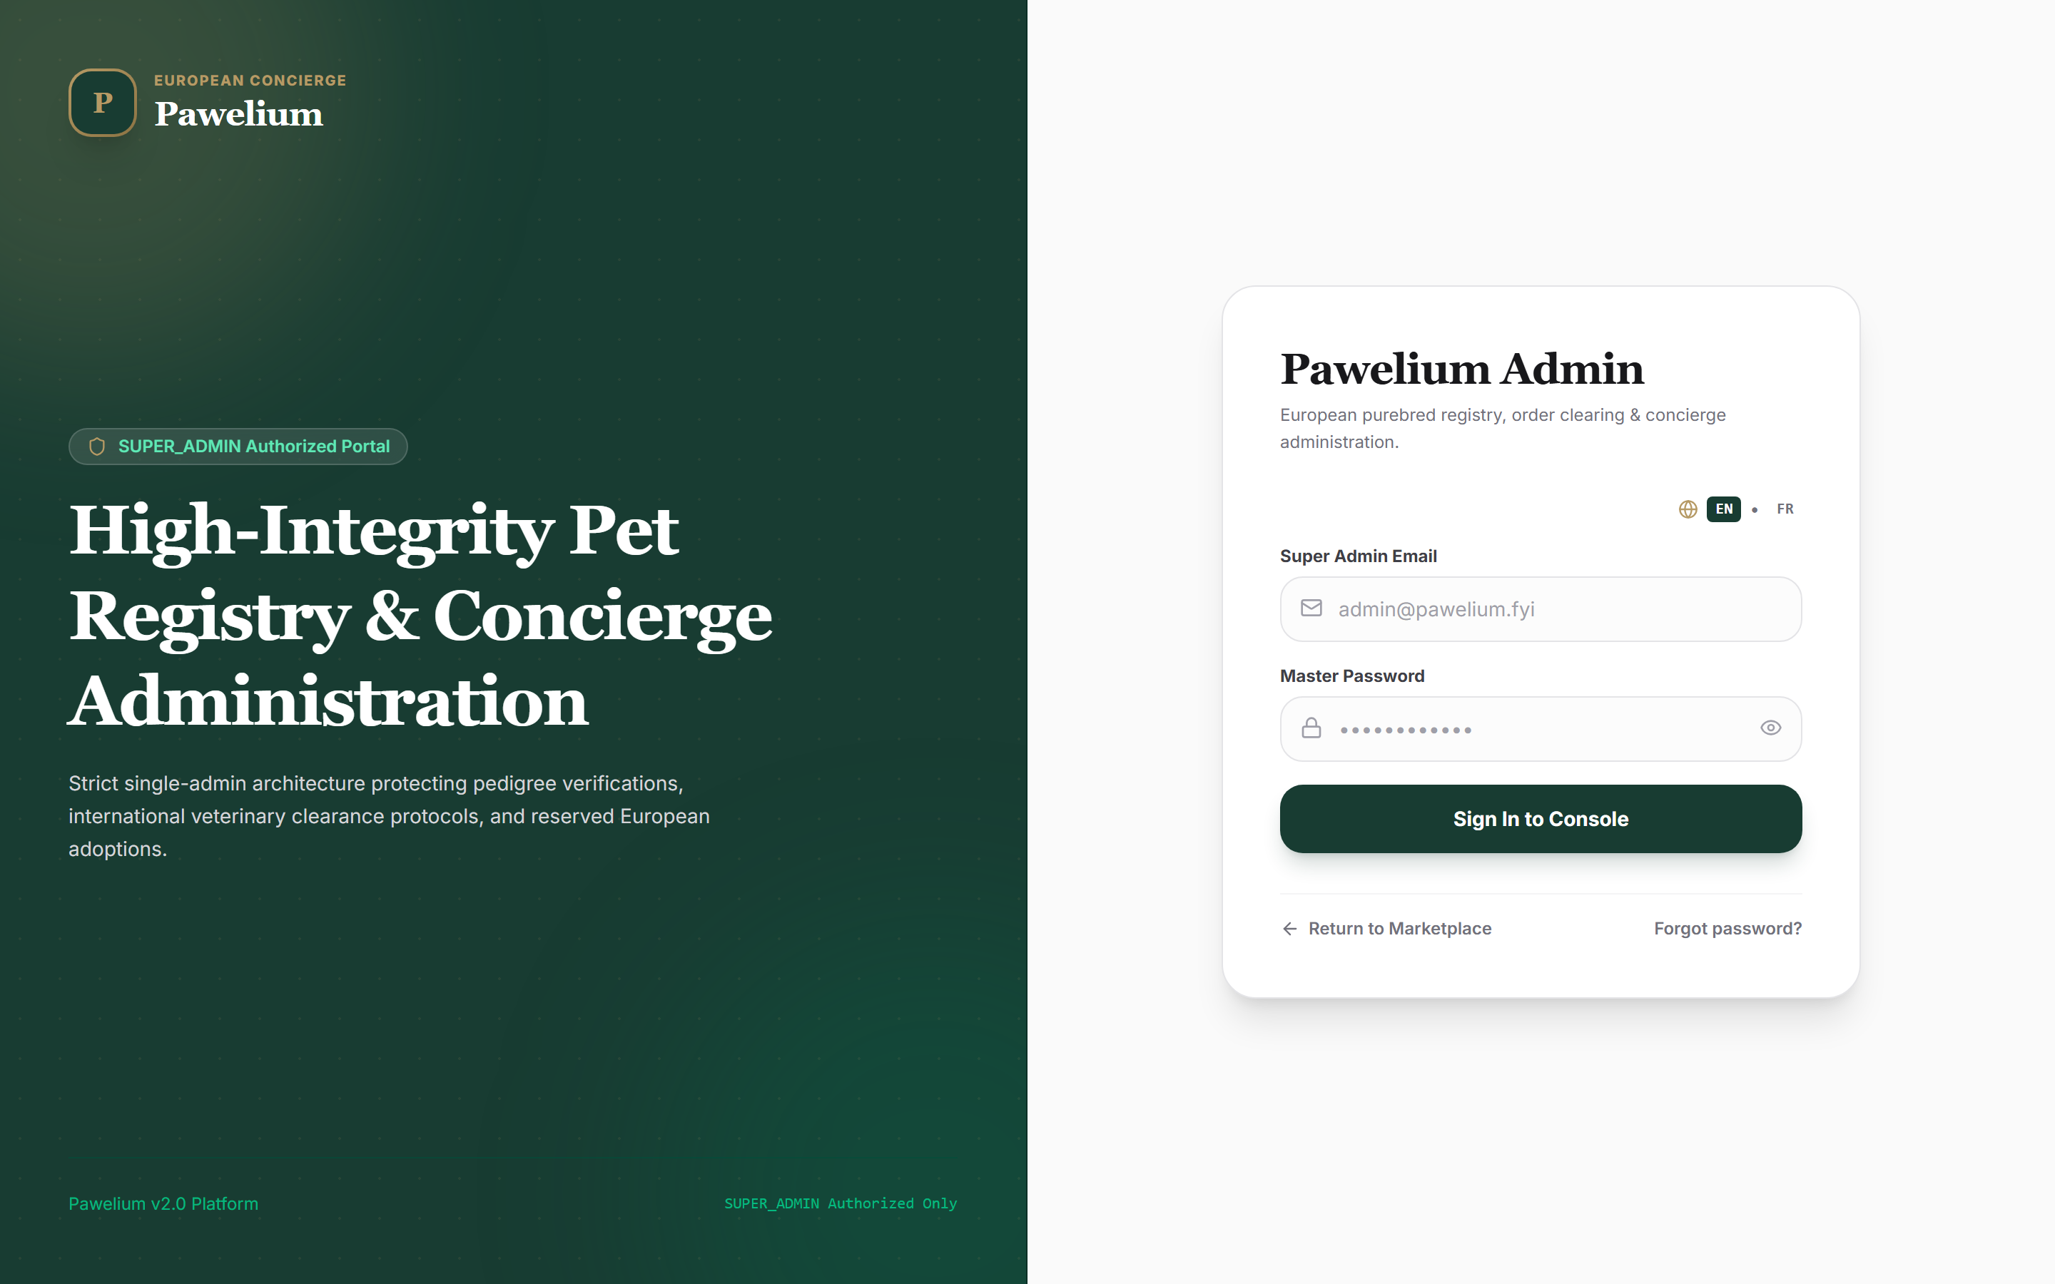
Figure: Temporary Holds Console tracking customer checkout carts, expiration timers, and manual release actions.

Module 7: Adoption Orders & Commercial Lifecycle
Purpose & Scope: Oversees the full adoption lifecycle: checkout placement, payment verification, legal terms acceptance records, and fulfillment status state transitions.
Standard Operating Procedure:
1. Navigate to /admin/orders to inspect all placed adoption orders sorted chronologically.
2. Review customer contact details, companion reference, total amount paid, and terms acceptance timestamp.
3. Click 'Actions' on an order row to advance its operational status: PENDING_PAYMENT → PAID → PREPARING → IN_TRANSIT → DELIVERED.
4. For offline concierge wire settlements, use 'Record Manual Payment' to update status while validating that the companion is not already sold.
🔒 SECURITY & COMPLIANCE MANDATE
Every order status transition is immutably recorded in the OrderStatusHistory table with timestamp and previous status for full forensic traceability.

Figure: Adoption Orders Console displaying order references, customer details, financial totals, and lifecycle progression.

Module 8: Card Payment Orchestration & Webhooks
Purpose & Scope: Controls the card-only payment layer orchestrated through GeniusPay. Routes transactions to verified card processors (Stripe first, with automated Paystack/PaiementPro/CinetPay fallbacks) while strictly excluding Mobile Money.
Standard Operating Procedure:
1. Navigate to /admin/payments to review payment transactions, provider references, and incoming webhook logs.
2. Inspect payment attempt records to verify which card gateway processed the customer checkout.
3. Check circuit breaker states: if a gateway encounters 3 consecutive failures, it opens for 15 minutes and traffic transparently diverts to the next fallback card gateway.
4. Inspect raw webhook logs to confirm valid HMAC-SHA256 signatures, timestamps within 300 seconds, and idempotent settlement execution.
🔒 SECURITY & COMPLIANCE MANDATE
CUSTOMER BRAND GUARD: Customers never see provider names (GeniusPay, Stripe, Paystack). The customer UI strictly displays 'Credit / Debit Card'. Webhooks returning HTTP 500 trigger automated provider retries without duplicate transaction loss.

Figure: Payments & Webhooks Audit Console displaying card transactions, settlement state, and raw payload audit records.

Module 9: Dispute Resolution & Manual Refunds
Purpose & Scope: Handles adoption cancellations, reconciliation exceptions, and manual refund execution with full audit tracking.
Standard Operating Procedure:
1. Navigate to /admin/refunds to inspect requested customer refunds.
2. Review associated order reference, customer email, original payment provider reference, and refund justification.
3. To disburse funds and close a ticket, execute the manual bank or card refund and click 'Mark Processed'.
4. The system records the performing Super Admin's ID and timestamp, updating refund status to COMPLETED.
🔒 SECURITY & COMPLIANCE MANDATE
GeniusPay does not provide a direct automated refund disbursement API for card checkouts; all platform refunds are processed through accredited banking channels and authoritatively logged here.

Figure: Refunds & Dispute Resolution Console tracking refund requests, disbursement amounts, and resolution status.

Module 10: VIP Pet Transport & Chaperoned Deliveries
Purpose & Scope: Coordinates white-glove European pet transport manifests, specialized climate-controlled transport vehicles, and veterinary handover protocols.
Standard Operating Procedure:
1. Navigate to /admin/deliveries to inspect all scheduled and completed companion deliveries.
2. Review recipient addresses, companion name, scheduled delivery dates, and assigned transport carrier.
3. Verify that veterinary dossiers (ICAD transfer, EU Pet Passport, rabies vaccination certificates) are physically affixed to transport crates.
4. Mark deliveries as DELIVERED upon signed client handover receipt.
🔒 SECURITY & COMPLIANCE MANDATE
Animal welfare regulations (Regulation EC 1/2005) mandate maximum transit intervals and veterinary inspection stops for all cross-border companion transport manifests.

Figure: VIP Deliveries Console detailing customer destination addresses, carriers, and scheduled handover dates.

Module 11: Customer Directory & GDPR Privacy Compliance
Purpose & Scope: Maintains verified adopter profiles while providing one-click irreversible GDPR Right-to-Erasure compliance tooling.
Standard Operating Procedure:
1. Navigate to /admin/customers to browse verified adopters, order counts, and registration dates.
2. Click 'Export Adopters' to download an authorized GDPR-compliant data export.
3. When a customer formally exercises their GDPR Article 17 Right to Erasure, locate their profile and trigger 'Anonymize & Erase'.
4. The system irreversibly replaces PII (name, email, phone, street address) with cryptographic hash placeholders while preserving anonymous accounting totals.
🔒 SECURITY & COMPLIANCE MANDATE
GDPR erasure is permanent and non-reversible. Financial records (invoices, transaction amounts) are legally retained in anonymized format under French commercial code requirements.

Figure: Customer Directory Console displaying adopter records, purchase history, and GDPR erasure controls.

Module 12: Reviews Moderation & Testimonial Curation
Purpose & Scope: Curates authentic adopter feedback, verifies purchase authenticity against order records, and publishes approved reviews to the public storefront.
Standard Operating Procedure:
1. Navigate to /admin/reviews to inspect incoming adopter reviews.
2. Inspect author name, star rating (1–5), review text, and 'Verified Adopter' badge validity.
3. Click the green checkmark to approve and publish the review to the homepage and animal profile carousels.
4. Click the red cross to reject fraudulent, abusive, or irrelevant submissions.
🔒 SECURITY & COMPLIANCE MANDATE
Only reviews in status APPROVED are ever served to public client requests. All unmoderated submissions remain invisible to customers.

Figure: Review Moderation Queue showing submitted testimonials, star ratings, and moderation action triggers.

Module 13: Concierge Support & Omnichannel Ticketing
Purpose & Scope: Manages pre-adoption inquiries, transport updates, and post-placement customer assistance with threaded email replies and private staff notes.
Standard Operating Procedure:
1. Navigate to /admin/support to view tickets categorized by General, Order, or Transport.
2. Click a ticket to view the full message thread and linked customer order.
3. To send an official reply to the customer's email, input text in 'Reply to Customer' and submit.
4. To record confidential internal notes invisible to the customer, toggle 'Internal Confidential Note' before posting.
5. Update ticket status to IN_PROGRESS or RESOLVED as milestones are achieved.
🔒 SECURITY & COMPLIANCE MANDATE
Customer email replies dispatch asynchronously via Resend. Internal notes are permanently stored with an internal flag and never leak into outgoing customer emails.

Figure: Support Ticket Desk showing active conversation threads, order context, and internal staff reply composer.

Module 14: Content Blocks CMS & Editorial Management
Purpose & Scope: Allows immediate updates to marketing headlines, promotional banners, legal policies, and concierge FAQs without triggering code deployments.
Standard Operating Procedure:
1. Navigate to /admin/content to inspect all dynamic content blocks by key and locale.
2. Click 'Add Content Block' or the edit icon on an existing block.
3. Specify the content key (e.g. 'home.hero.announcement'), target locale ('en' or 'fr'), and Markdown content body.
4. Save the block; Next.js cache revalidation immediately updates the storefront.
🔒 SECURITY & COMPLIANCE MANDATE
Content blocks override static dictionary fallbacks dynamically. If a key is absent in the database, the application gracefully renders its default compiled dictionary string.

Figure: Content Blocks CMS displaying dynamic editorial keys, locale targets, and content body previews.

Module 15: Translations Parity Health & Runtime Overrides
Purpose & Scope: Audits bilingual alignment between English (en) and French (fr) modular namespaces. Provides zero-downtime translation override capabilities.
Standard Operating Procedure:
1. Navigate to /admin/translations to review modular namespace parity metrics and active database overrides.
2. Verify that both EN and FR dictionaries report 100% key and ICU branch parity.
3. To patch a spelling mistake or phrasing in production without redeploying, click 'Add Override'.
4. Select target locale, namespace (e.g. 'Catalogue', 'Checkout'), key path, and new string value.
5. Click 'Save Override' to immediately serve the corrected text to storefront visitors.
🔒 SECURITY & COMPLIANCE MANDATE
The automated Brand Guard verifies that customer dictionaries contain zero references to payment gateway brands. Translations strictly follow the always-prefixed locale URL routing structure (/en and /fr).

Figure: Translations Parity Console displaying bilingual health metrics, brand leakage status, and active overrides.

Module 16: Global SEO & Social Graph Configuration
Purpose & Scope: Configures search engine crawler directives, dynamic title templates, bilingual meta descriptions, and OpenGraph social card previews.
Standard Operating Procedure:
1. Navigate to /admin/seo to access the global search optimization form.
2. Edit the page title templates for English and French (e.g. 'Pawelium | European Concierge Animal Adoption').
3. Review and tune meta descriptions to ensure optimal click-through rates on Google search results.
4. Configure the OpenGraph image URL used when marketplace listings are shared on WhatsApp, Facebook, or LinkedIn.
5. Click 'Save SEO Settings' to persist parameters to database site settings.
🔒 SECURITY & COMPLIANCE MANDATE
The application generates dynamic XML sitemaps (/sitemap.xml) and robots directives (/robots.txt) reflecting current animal catalogue availability.

Figure: SEO Configuration Console with bilingual title template inputs, meta descriptions, and preview image settings.

Module 17: Newsletter Subscribers & Marketing Exports
Purpose & Scope: Maintains the double-opt-in marketing subscriber database, tracks language preferences, and generates CSV exports for email campaigns.
Standard Operating Procedure:
1. Navigate to /admin/newsletter to inspect registered subscriber emails.
2. Review confirmed vs pending subscription ratios and user locale preferences.
3. Click 'Export CSV' to download a timestamped file of confirmed subscribers for importation into marketing platforms.
🔒 SECURITY & COMPLIANCE MANDATE
Subscribers register via double-opt-in confirmation links. The database stores hashed confirmation tokens to safeguard against unauthorized subscription hijacking.

Figure: Newsletter Subscriber Console displaying subscriber emails, language flags, and CSV export action.

Module 18: Business Analytics & Financial KPIs
Purpose & Scope: Provides executive visibility into gross transaction revenue, adoption conversion rates, customer acquisition velocity, and card gateway routing health.
Standard Operating Procedure:
1. Navigate to /admin/analytics to examine platform KPIs across all historical adoption transactions.
2. Inspect Gross Transaction Volume in EUR calculated authoritatively from paid and delivered orders.
3. Review the Payment Success Rate percentage and total completed transactions tally.
4. Under 'Card Gateway Performance & Route Distribution', examine attempt counts and conversion ratios across each candidate card processor (Stripe, Paystack, PaiementPro, CinetPay).
🔒 SECURITY & COMPLIANCE MANDATE
All revenue metrics are calculated strictly from database-persisted Order and Payment rows; no client-side estimations are used.

Figure: Analytics Console featuring revenue cards, payment conversion rate, and per-gateway attempt distribution table.

Module 19: Immutable Audit Ledger & Compliance Forensics
Purpose & Scope: Records every administrative modification with cryptographic actor references, client IP addresses, before/after JSON diffs, and timestamp forensics.
Standard Operating Procedure:
1. Navigate to /admin/audit to inspect the security log.
2. Every action (animal creation, status toggles, password updates, MFA changes, refund clearances) produces an append-only audit row.
3. Filter audit records by actor, target entity, action category, or date range.
4. Inspect the client IP and User-Agent metadata to verify the authorized origin of sensitive commands.
🔒 SECURITY & COMPLIANCE MANDATE
The AuditLog model has no update or delete mutations exposed in Server Actions or admin UI. It functions as an immutable compliance journal for SOC 2 and GDPR audits.

Figure: Security Audit Ledger displaying chronological administrative events, actor IDs, IPs, and action payloads.

Module 20: System Settings & Infrastructure Diagnostics
Purpose & Scope: Inspects runtime environment variables, database provider health, email service configuration, and active card routing priority rules.
Standard Operating Procedure:
1. Navigate to /admin/settings to view the system diagnostic health board.
2. Verify that Database Provider reports SQLITE (staging/local) or POSTGRESQL (production Neon Serverless).
3. Verify that GeniusPay Orchestration reports LIVE or SANDBOX with card-only mode verified.
4. Review the Card Payment Priority chain (#1 Stripe, #2 Paystack, #3 PaiementPro, #4 CinetPay) and confirm that all circuit breakers report 'CIRCUIT CLOSED (HEALTHY)'.
5. Inspect operational business rules including the 15-minute hold timer, transport tariffs, and concierge dossier fees.
🔒 SECURITY & COMPLIANCE MANDATE
NEVER PRINT SECRETS: The settings diagnostic console displays only presence flags (e.g. 'CONFIGURED', 'SECURE'). Raw API keys, database connection strings, and webhook signing secrets are strictly redacted from rendering.

Figure: System Settings Console displaying service health diagnostics, card routing chain, and operational tariffs.

