STP- Document

**-Software Test Plan**

*Version*: 1.0

*Created:* 26/02/2023

*Test Plan Template*:

Web site project – "comedy movies"

*Prepared by:*

Marjan Ikteelat

**-Introduction**

"Funny Movies" The site contains several funny movies to watch, where the user can view a picture and information about the movie he wants and is interested in knowing its details, add a comment about it, and delete or update the specific movie he wants. It can also add a new movie to the web.

.The purpose of the STP document:-

It describes the testing,

Helps the user to reference point for testing.

-

.Objectives

This test plan describes the testing approach, the objectives, scope, schedule, risks, approach, Enter&Exit criteria, Test Tree and Testing methodology.and overall framework that will drive the testing.

. Support documents

SRS documents.

Tree Testing

Types of tests:

1.acceptance

2.security

3.functional: we do a functional test to make sure that the button delete and add and alter and home page icon

4.smoke

6. Entry and Exit Criteria

Entry Criteria

Microsoft Windows 13+

6.2 Exit Criteria

- 0 critical bugs;

- 0 Regression bugs;

- MAXIMUM 3 Medium bugs;

- MAXIMUM 7 LOW bugs;

. TEST STRATEGY

7.1. Test Approach

The tests mainly targets the functional testing and validating data Requirements Specifications provided by Client. The project is using and used in Agile software development environments, where it can help ensure that software is

developed in a customer-centric way, with a focus on delivering business value. can also help teams

catch defects early in the development process, reducing the cost and complexity of fixing them later on.

7.2. Test Automation

Automated unit tests are part of the development process, focus on automated functional tests and acceptance .security , smoke .security

**-Testing Methodology**

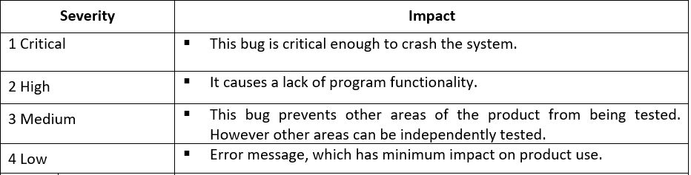

**-Defect tracking and Reporting:**

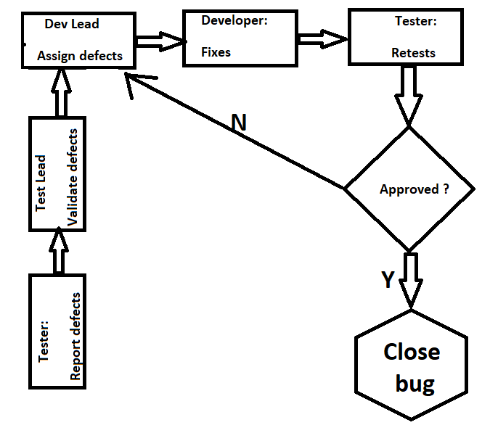

**-Status of the Bug:**

New: Just created bug

Open: Opened bug and still not solved

Rejected: Dev Lead rejected it (it's not bug)

Fixed: SOLVED bug

Closed: After bug is fixed, need close this bug

Re-Open: Bug has been fixed and closed but appear again with time

**-Test Management Process**

**-Assumptions / Risks**

**-Test Environment**

-Hardware Requirements

* Computer with 8 GB RAM, Windows 10+ and Chrome (Firefox/Edge).

**-Milestones**

**Task start date**

**26.02.2023**  **SRS document**

**25.02.2023 STP document**

**Selenium code 20.02.2023**