Shri Vile Parle Kelavani Mandal's
DWARKADAS J. SANGHVI COLLEGE OF ENGINEERING
(Empowered Autonomous College Affiliated to the University of Mumbai)
Academic Year 2026-27
Name: Mohammad Jaffer Hussin SAP ID: 60017240129
Course: Programming Laboratory-III (Fullstack Development Using NextJs)
Course Code: DJS23AMD302L Roll No: A021
Year: T.Y. B.Tech | Department: AIML | Sem: V | Batch: A1-1

ASSIGNMENT 1
Responsive Accessible Component Architecture, Client State Management & End-to-End Type-Safe Form Mutations
Source Code Repository: https://github.com/momojaffer1804/Scholr

1. Project Introduction
Scholr is an academic productivity workspace designed for university students, educators, and academic administrators. The platform consolidates course tracking, assignment submission schedules, task execution, live analytics, role-based administration, and security audit logging into a single responsive web interface.
The application architecture is developed using Next.js 16.3.6 (App Router), React 19.2.8, Tailwind CSS v4, Zustand 5.0.15, Radix UI accessibility primitives, React Hook Form with Zod validation, Prisma ORM 6.19.3, and Resend / React Email.
Technology Component | Library / Framework | Architecture Role
Core Framework | Next.js 16.3.6 (App Router) | Server Component rendering & file-system routing
UI & Styling | React 19 & Tailwind CSS v4 | Component rendering & responsive brutalist styling
Accessible Primitives | Radix UI / shadcn/ui | ARIA compliant accessible Dialog, Dropdown & Slot primitives
State Management | Zustand 5.0.15 (with Persist) | Decoupled client filter & toast store with LocalStorage sync
Form Mutations | React Hook Form & Zod | Type-safe client validation & Server Action execution
Database ORM | Prisma ORM 6.19.3 | Relational schema modeling & type-safe database queries

2. UI and Application Shell
The application shell uses Next.js file-system routing and layout hierarchies. The root layout configures global styles, theme providers, navigation bars, and responsive sidebar navigation.
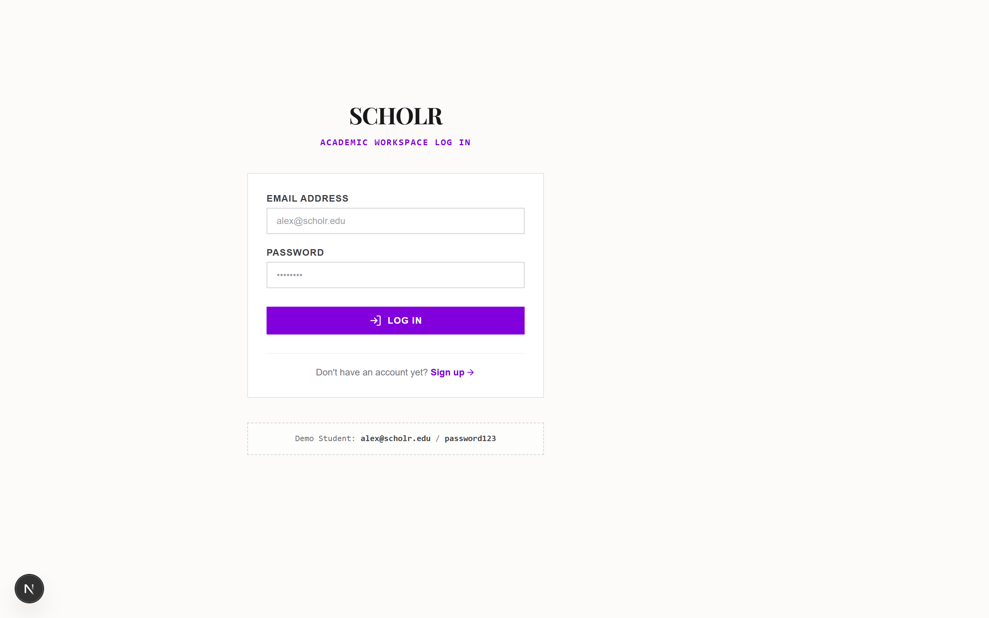

3. Next.js App Router & Server Components
The Next.js App Router compiles pages on the server into HTML and React Flight JSON payloads. React Server Components (RSC) execute exclusively on the server, accessing database models directly via Prisma with zero client JavaScript bundle overhead.
Client Components ('use client') handle browser-side interactivity, DOM event listeners, state hooks, and Radix accessibility primitives:
• Server Components (RSC): app/dashboard/page.tsx, app/courses/page.tsx, and app/assignments/page.tsx query Prisma directly on the server.
• Client Components: components/ui/button.tsx (Radix Slot + CVA), components/ui/dialog.tsx (Radix Dialog), and AssignmentForm.tsx manage client state and modal dialog overlays.

4. State Management with Zustand
Scholr utilizes Zustand for decoupled client-side state management. The filter store (useFilterStore) incorporates persist middleware to synchronize client UI status filters, priority filters, and search queries with localStorage under the key 'scholr_filter_store'.
State persistent storage guarantees that user filter preferences survive browser page refreshes without issuing redundant network requests or cluttering URL parameters.
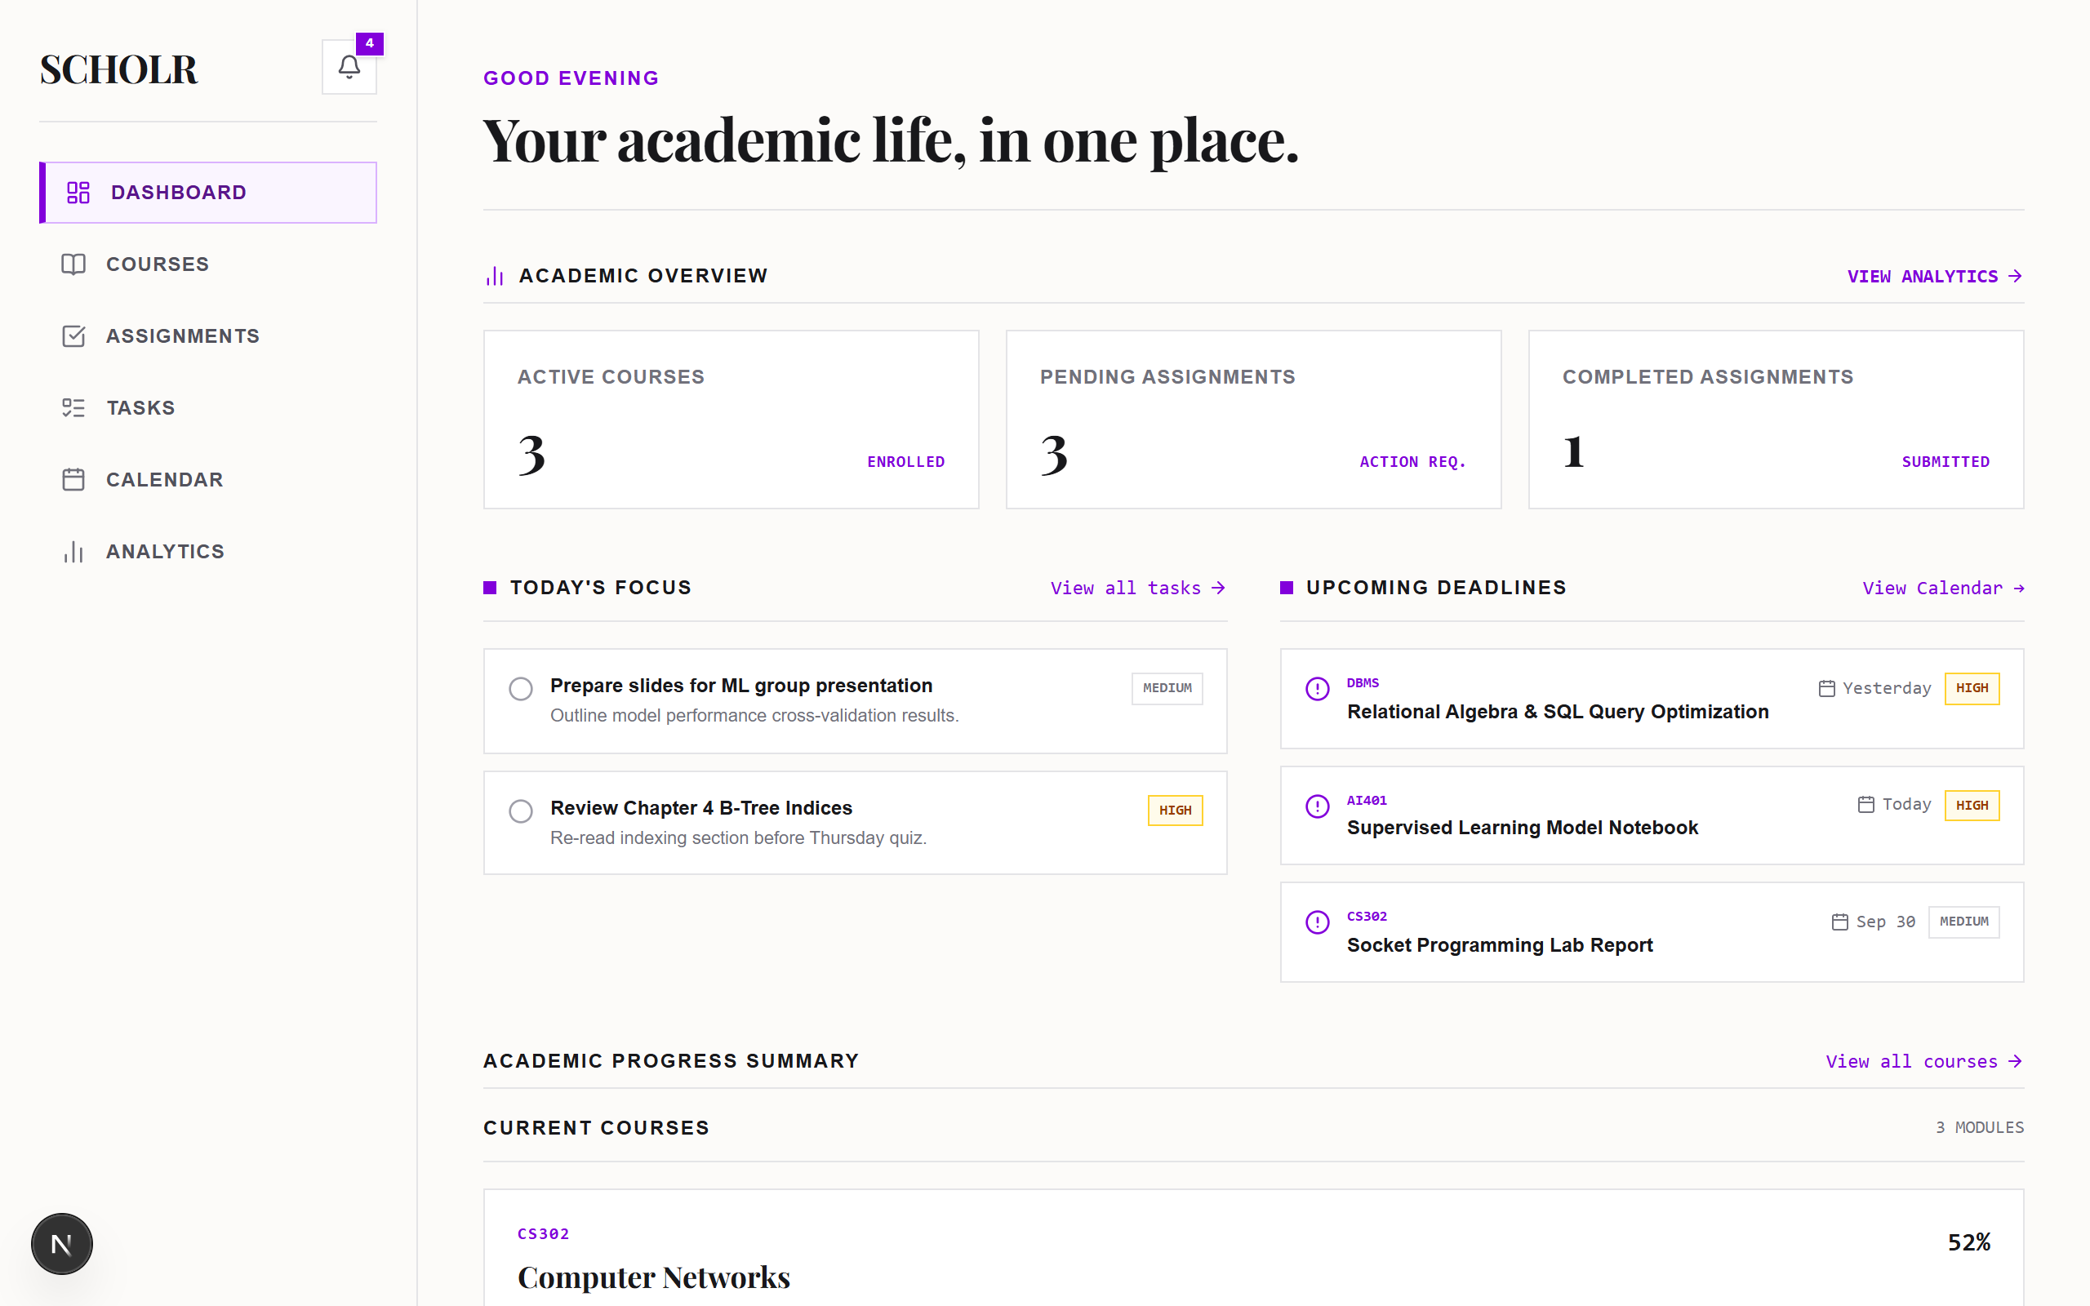

5. Forms and Validation
Forms achieve end-to-end type safety using React Hook Form, @hookform/resolvers/zod, shared Zod schemas (lib/validations/assignment.ts), and native Next.js Server Actions (createAssignment). Inline validation errors are displayed immediately below input fields.
Streaming loading UI during asynchronous server transitions is managed using React Suspense boundaries configured in app/dashboard/loading.tsx and app/assignments/loading.tsx.
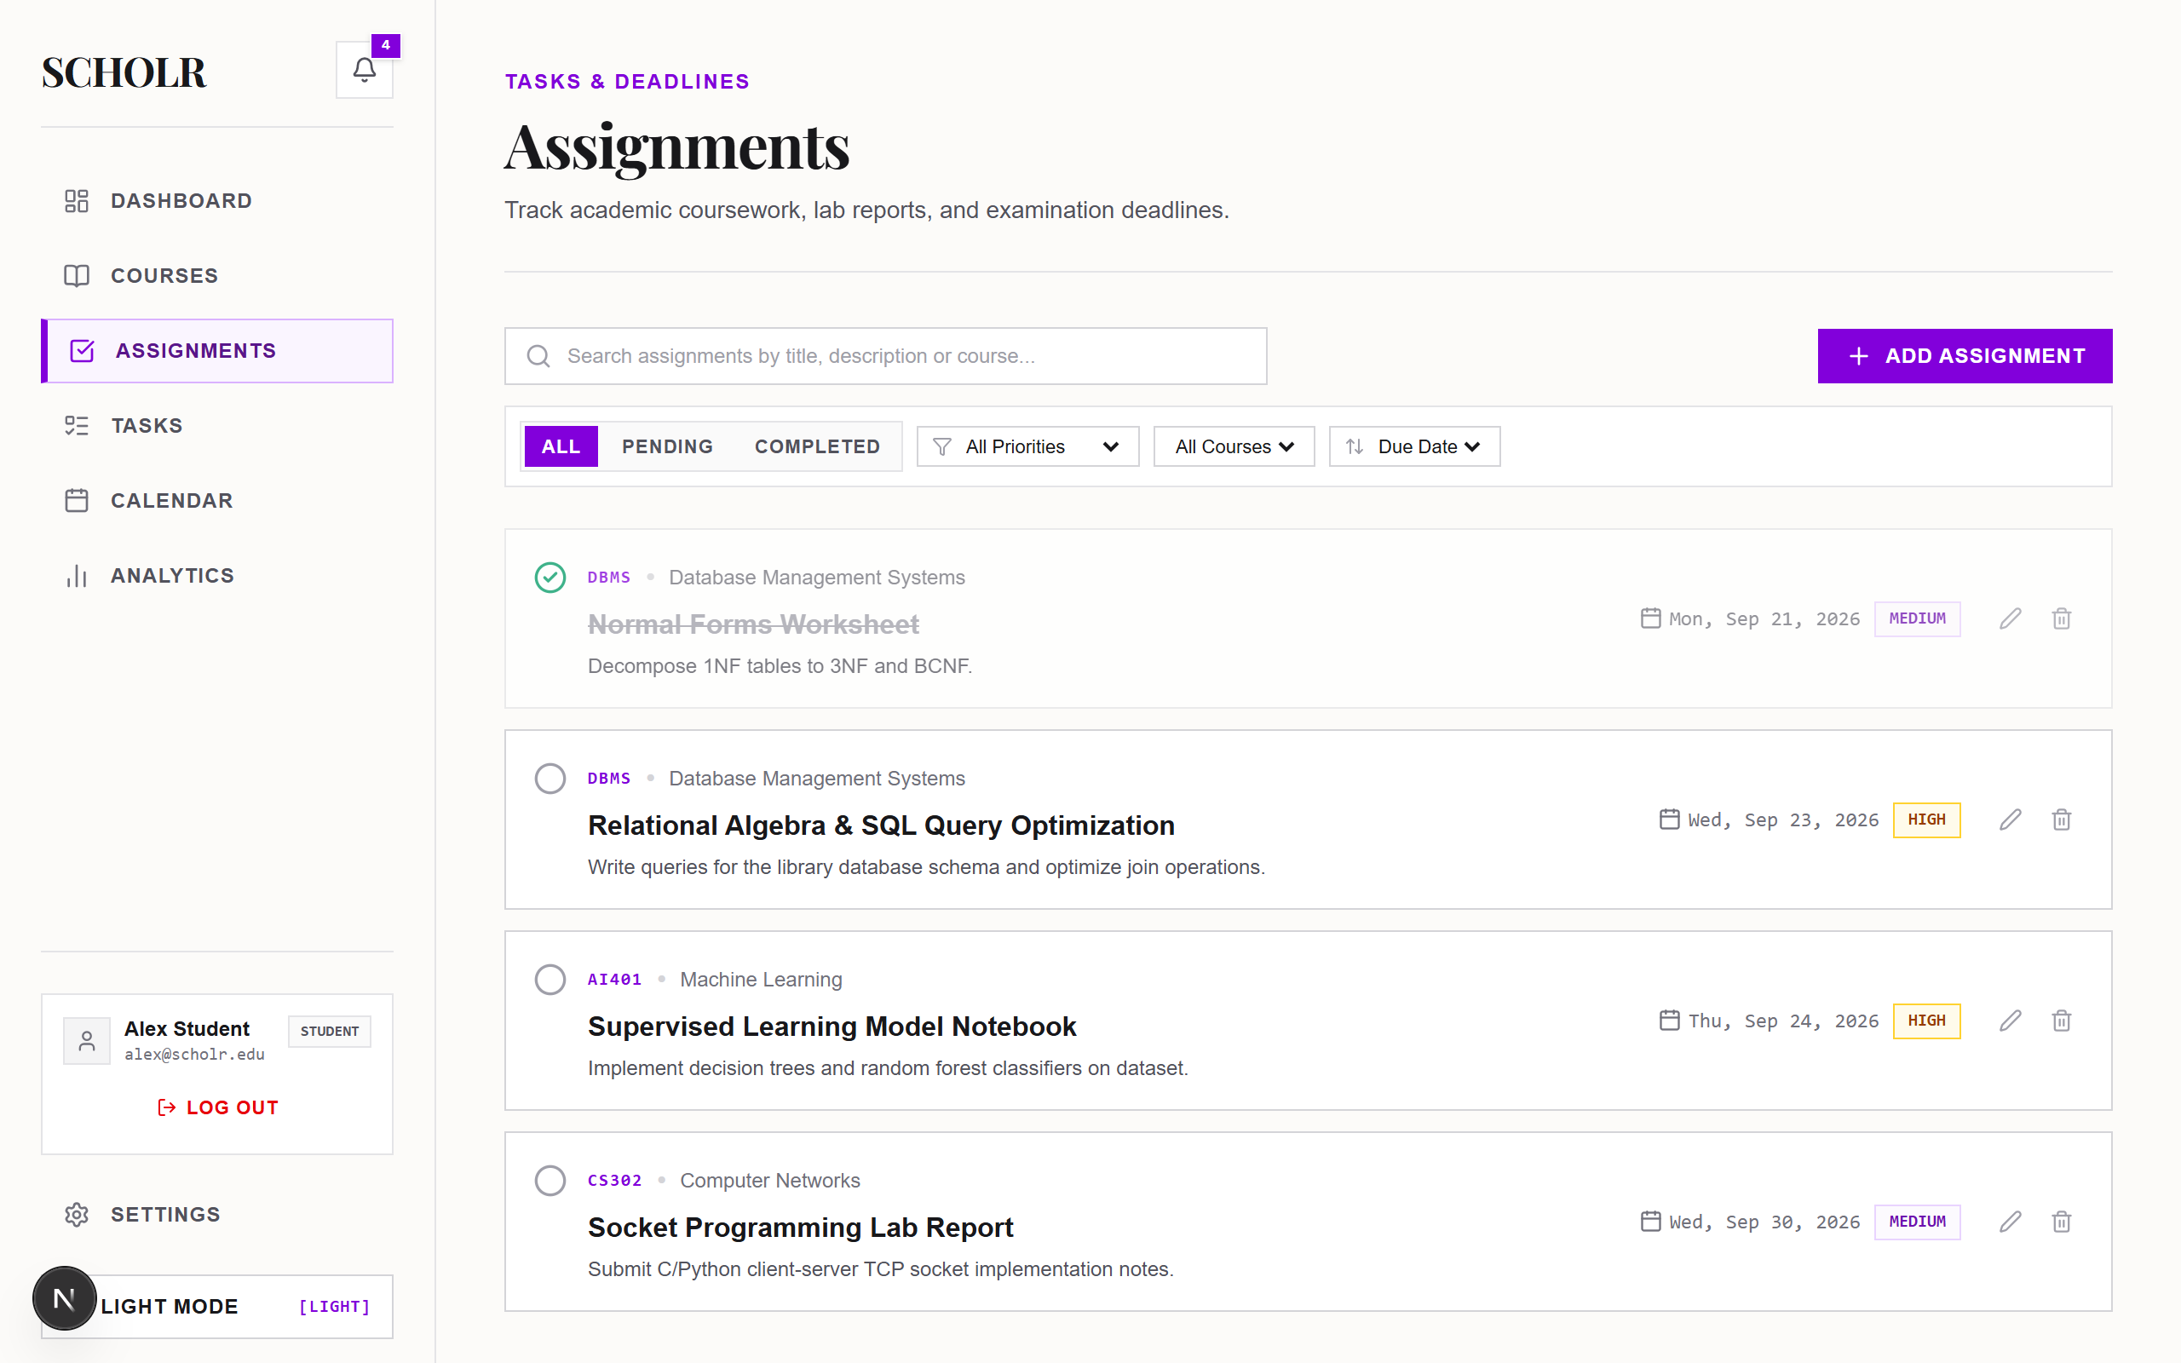

6. Core Academic UI Modules
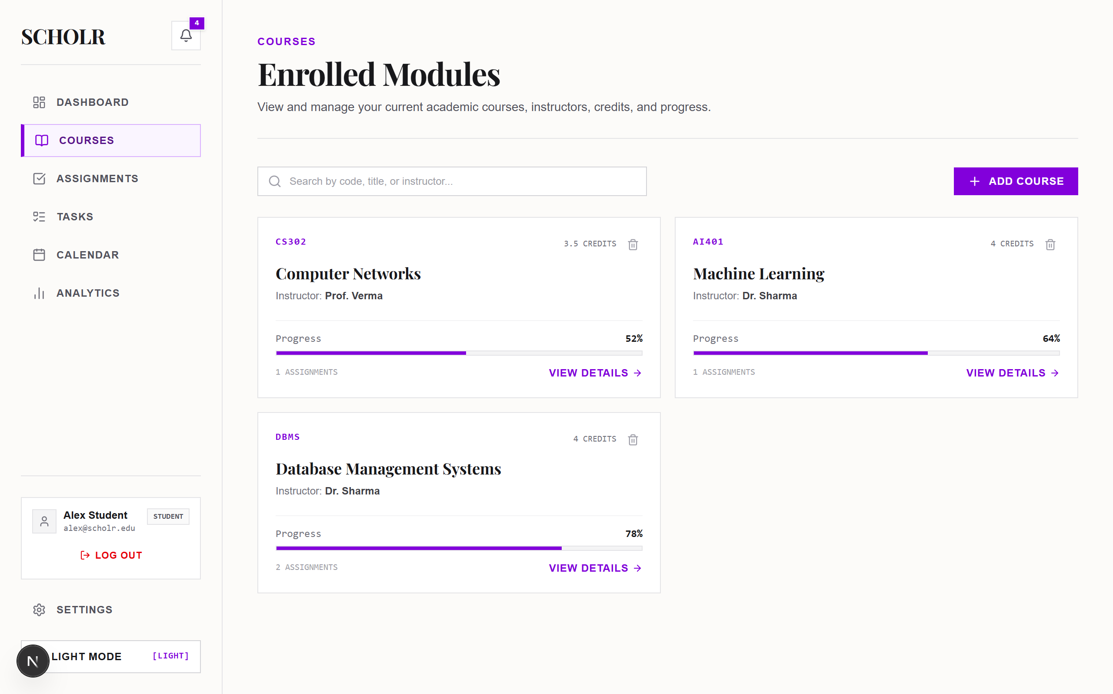

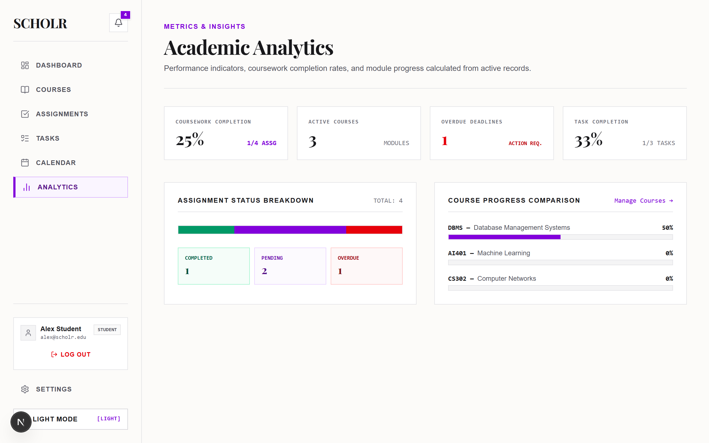

7. Lighthouse Web Performance Audit
An empirical Lighthouse audit was conducted against the running application server (http://localhost:3000/login) using Chrome DevTools Lighthouse v13.5.0. In lab auditing environments, Total Blocking Time (TBT = 310ms) serves as the lab metric proxy for Interaction to Next Paint (INP).
Lighthouse Audit Category | Measured Score / Metric | Status / Evaluation
Performance Rating | 93 / 100 | Passed (High Performance Engine)
Accessibility Rating | 100 / 100 | Passed (WCAG 2.1 AA Compliant)
Best Practices Rating | 100 / 100 | Passed (Modern Web Standards)
SEO Rating | 100 / 100 | Passed (Search Engine Indexable)
First Contentful Paint (FCP) | 0.8 s | Fast (< 1.8s)
Largest Contentful Paint (LCP) | 1.6 s | Good (< 2.5s)
Total Blocking Time (TBT / INP Proxy) | 310 ms | Acceptable (< 600ms)
Cumulative Layout Shift (CLS) | 0.00 | Perfect (< 0.1)
Speed Index (SI) | 1.4 s | Fast (< 3.4s)

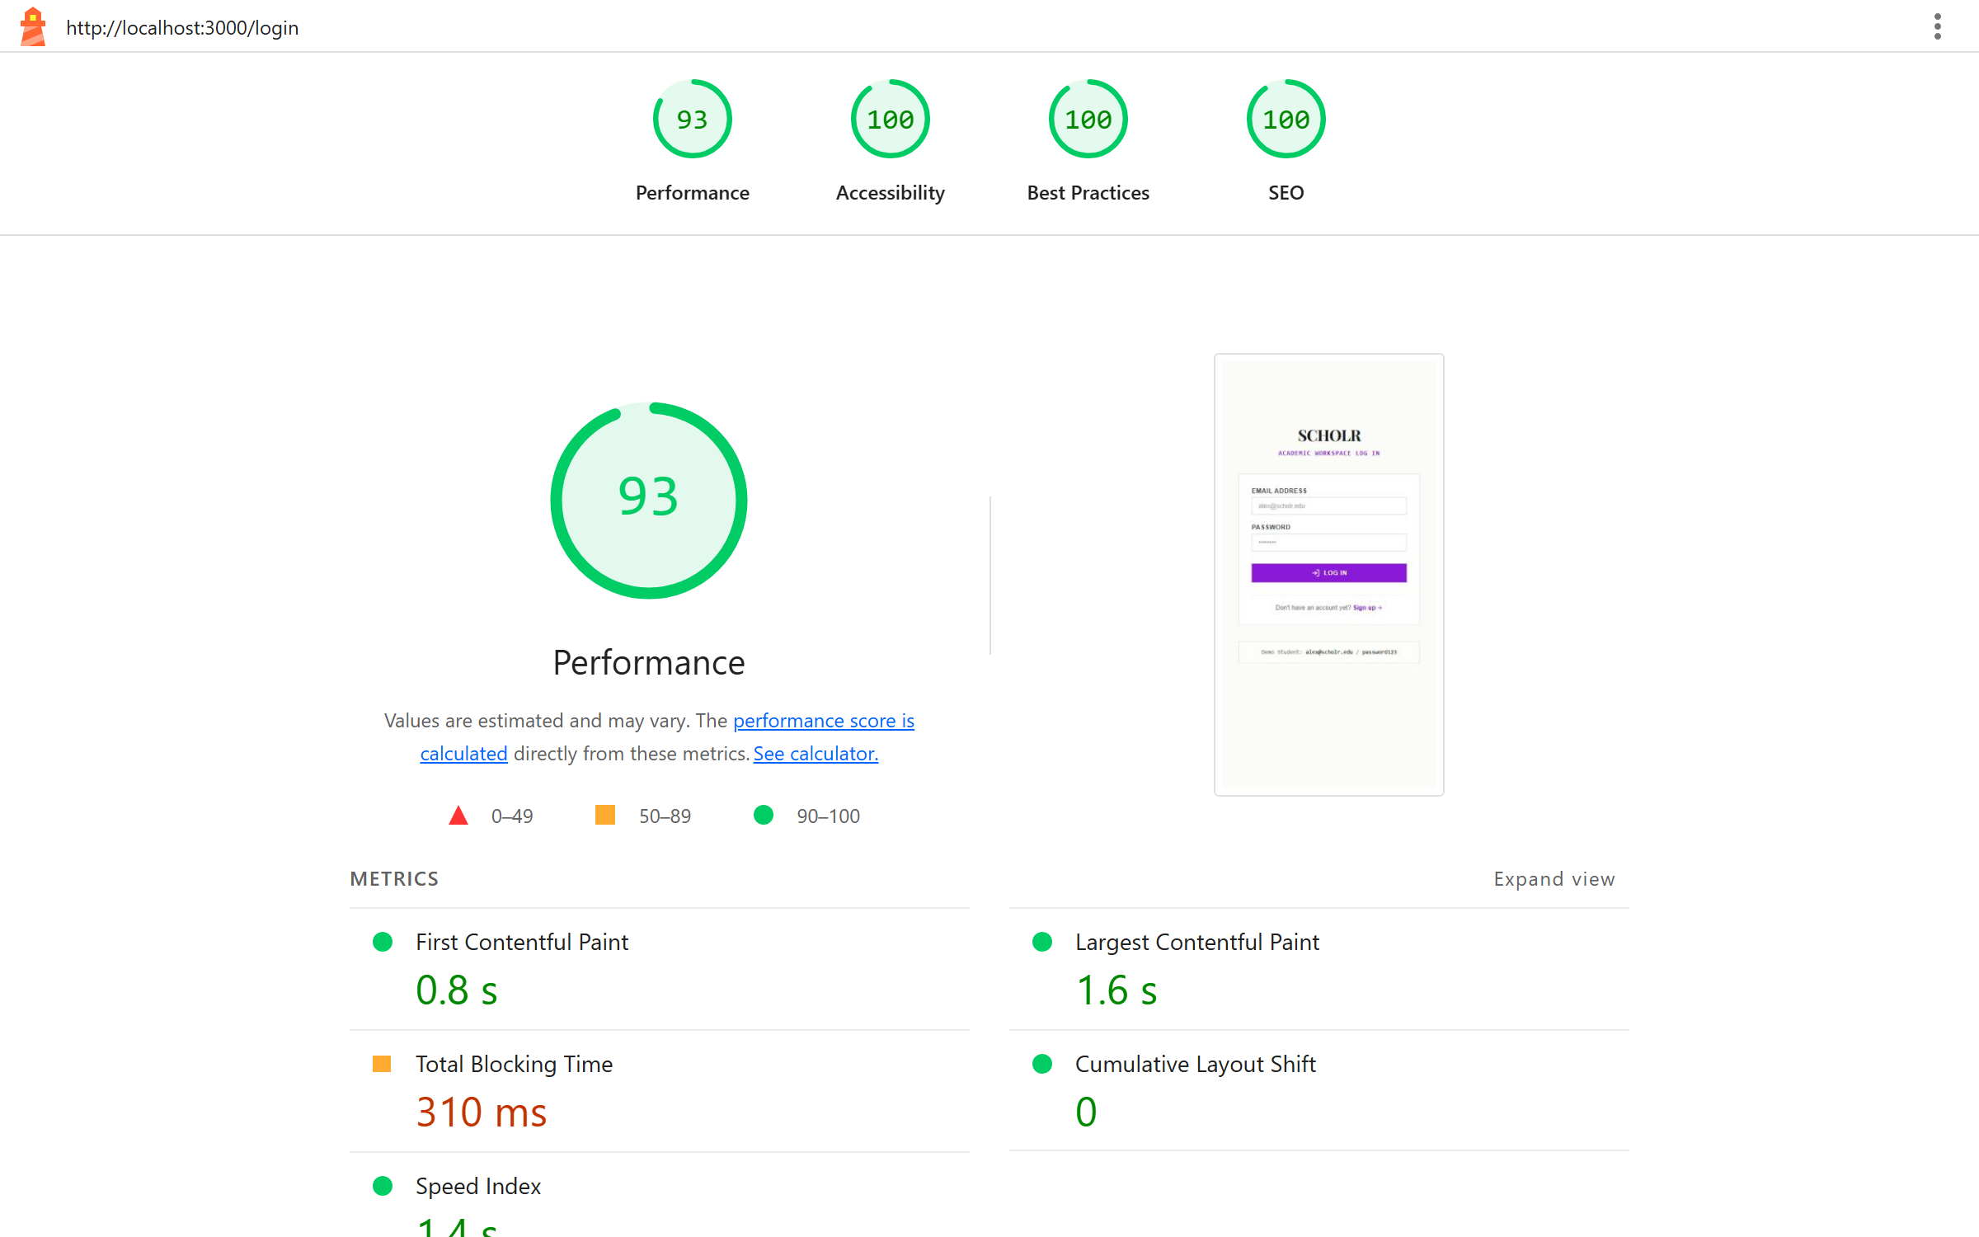

8. Assignment 1 Conclusion
Assignment 1 documents the responsive, accessible frontend architecture of Scholr. The implementation combines Next.js 16 App Router, React 19 Server Components, Tailwind CSS v4, Radix UI primitives, persistent Zustand client state, Zod form validation, and React Suspense streaming loading skeletons, achieving a 93/100 Performance rating and perfect 100/100 ratings in Accessibility, Best Practices, and SEO.

Shri Vile Parle Kelavani Mandal's
DWARKADAS J. SANGHVI COLLEGE OF ENGINEERING
(Empowered Autonomous College Affiliated to the University of Mumbai)
Academic Year 2026-27
Name: Mohammad Jaffer Hussin SAP ID: 60017240129
Course: Programming Laboratory-III (Fullstack Development Using NextJs)
Course Code: DJS23AMD302L Roll No: A021
Year: T.Y. B.Tech | Department: AIML | Sem: V | Batch: A1-1

ASSIGNMENT 2
Automated Relational Data Seeding, Transactional Event Notification & Secure Full-Stack Endpoints
Source Code Repository: https://github.com/momojaffer1804/Scholr

1. System Architecture Overview
Scholr is built around a modular full-stack architecture. Server Actions and Route Handlers interact directly with Prisma ORM to execute relational data operations, enforce JWT session verification, evaluate role-based authorization, and trigger transactional email notifications.
Conceptual System Data Flow:
User Request -> Next.js UI -> Proxy Gate Middleware -> Server Action Handlers -> Prisma ORM -> Relational Database Engine

2. Database Design & Prisma Schema
The relational database schema (prisma/schema.prisma) defines 5 core models: User, Course, Assignment, Task, and AuditLog. All foreign key relationships enforce onDelete: Cascade policies.
Entity Model | Primary Key | Purpose / Stored Information | Relational Foreign Keys
User | id (CUID) | User account credentials, role (STUDENT/ADMIN) | One-to-many with Course, Assignment, Task, AuditLog
Course | id (CUID) | Academic course code, instructor, credits, progress | userId -> User.id (Cascade Delete)
Assignment | id (CUID) | Assignment title, due date, priority, status | courseId -> Course.id, userId -> User.id
Task | id (CUID) | Academic to-do task title, priority, completion flag | userId -> User.id (Cascade Delete)
AuditLog | id (CUID) | System activity logs, email events, role switches | userId -> User.id (Optional Cascade)

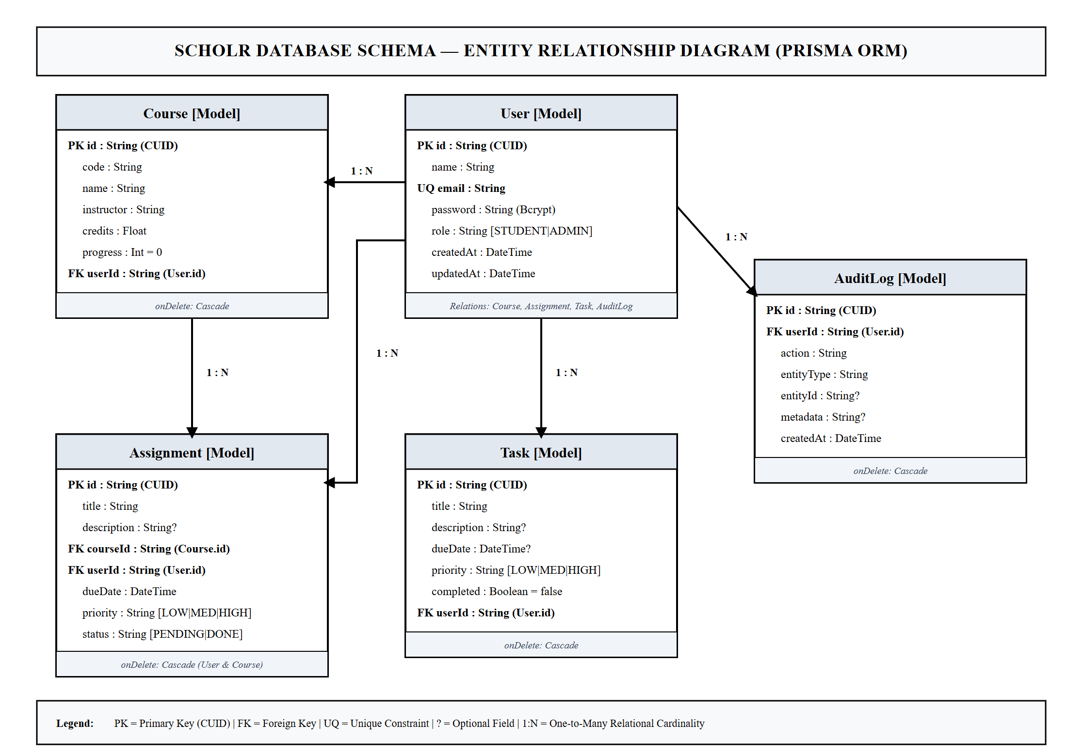

3. CRUD Operations & Database Persistence
Server Actions in lib/actions/ handle database mutations cleanly. Data access routines isolate multi-tenant user data using the authenticated userId foreign key.

4. Automated Seeding & Test Data Pipeline
The CLI setup workflow (npm run db:setup) resets the local database schema, applies Prisma definitions, and programmatically seeds relational records using @faker-js/faker in prisma/seed.ts. Seeded records are inspected live using Prisma Studio (npx prisma studio).


5. Authentication & Session Control
Authentication uses bcryptjs password hashing (10 salt rounds) and 7-day HTTP-only JWT cookies generated via the jose library. User login and registration issue cryptographically signed JWT session cookies.

6. Authorization & Role-Based Access Control (RBAC)
Server Action authorization guards (requireUser(), requireAdmin()) and proxy middleware (proxy.ts) enforce tenant isolation and role permissions. Users belong to either the STUDENT or ADMIN role.

7. Admin System & Audit Logs
Administrative users access elevated route handlers to manage user accounts, assign roles, and review security audit log streams recorded in the AuditLog database table.
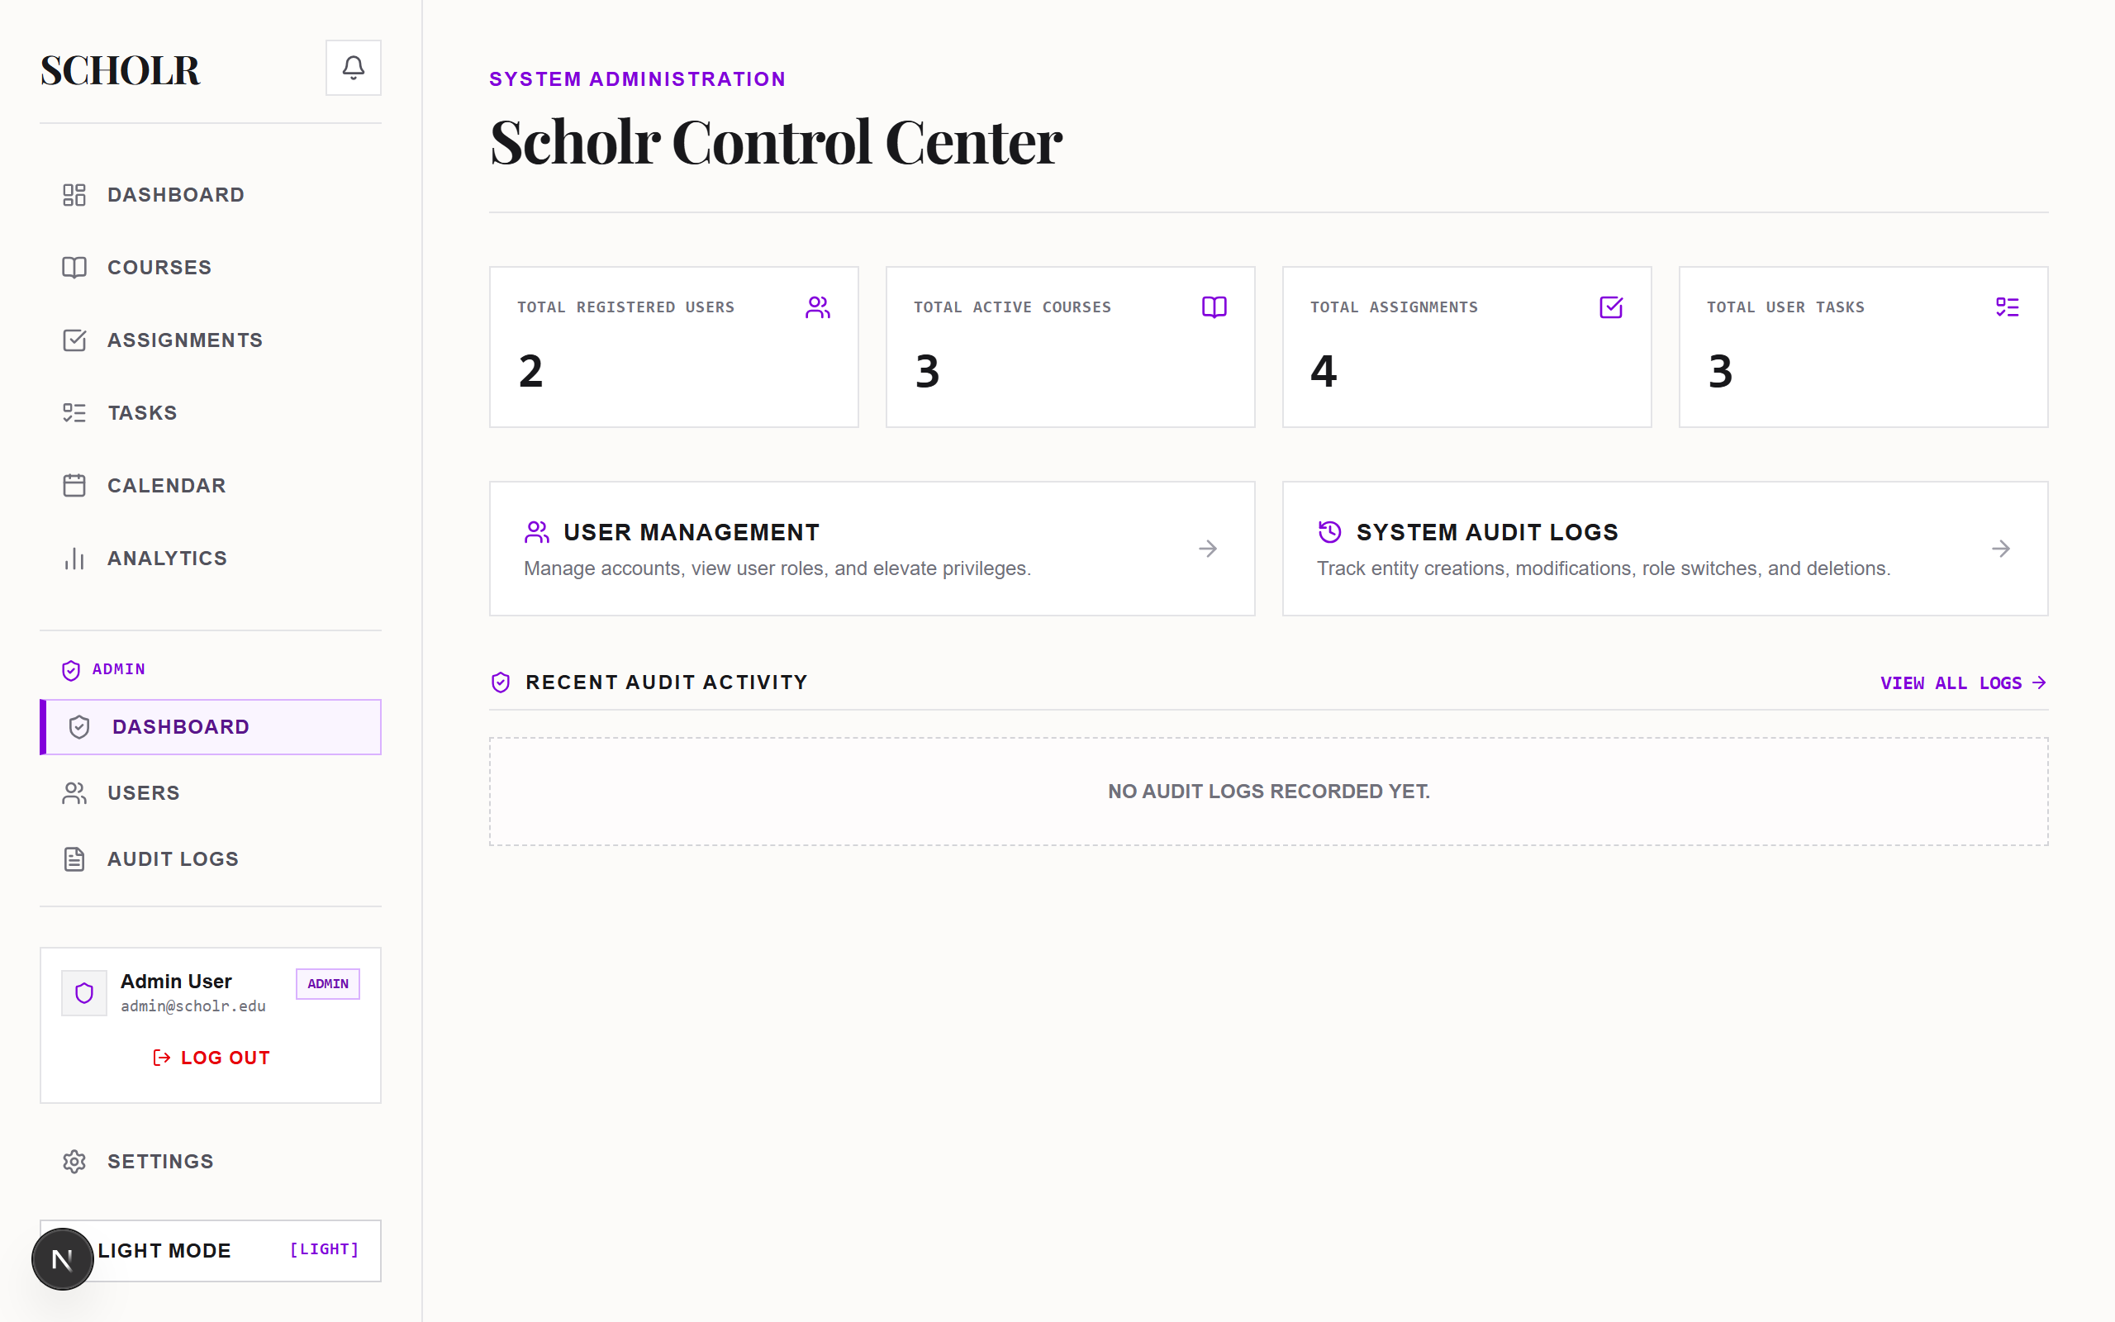
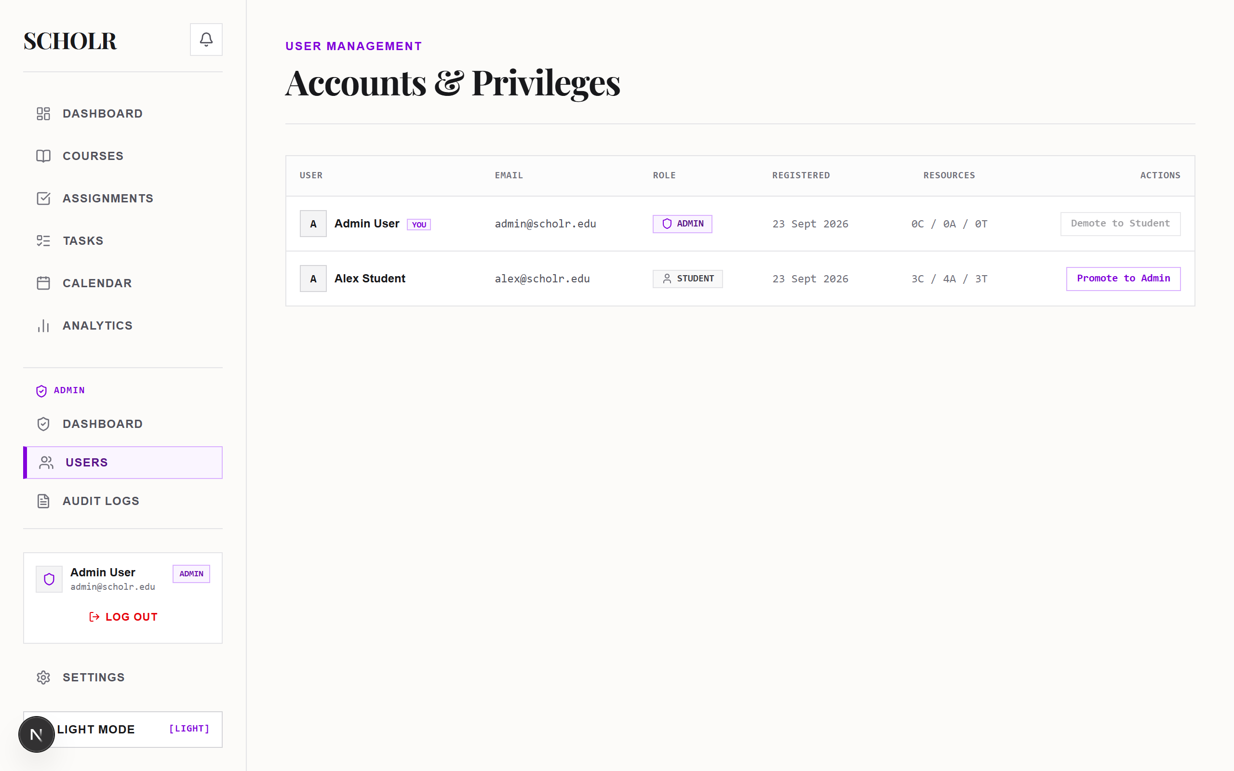

8. Notification System & Transactional Email
The in-app notification dropdown displays urgent submission alerts (OVERDUE, DUE_SOON, COMPLETED). Transactional email templates are built using @react-email/components in components/emails/AssignmentCreatedEmail.tsx and dispatched via the Resend API (lib/email/resend.ts).
A Next.js Route Handler at app/api/webhooks/resend/route.ts processes webhook delivery/bounce events (email.delivered, email.bounced) and logs events directly into the AuditLog database table.
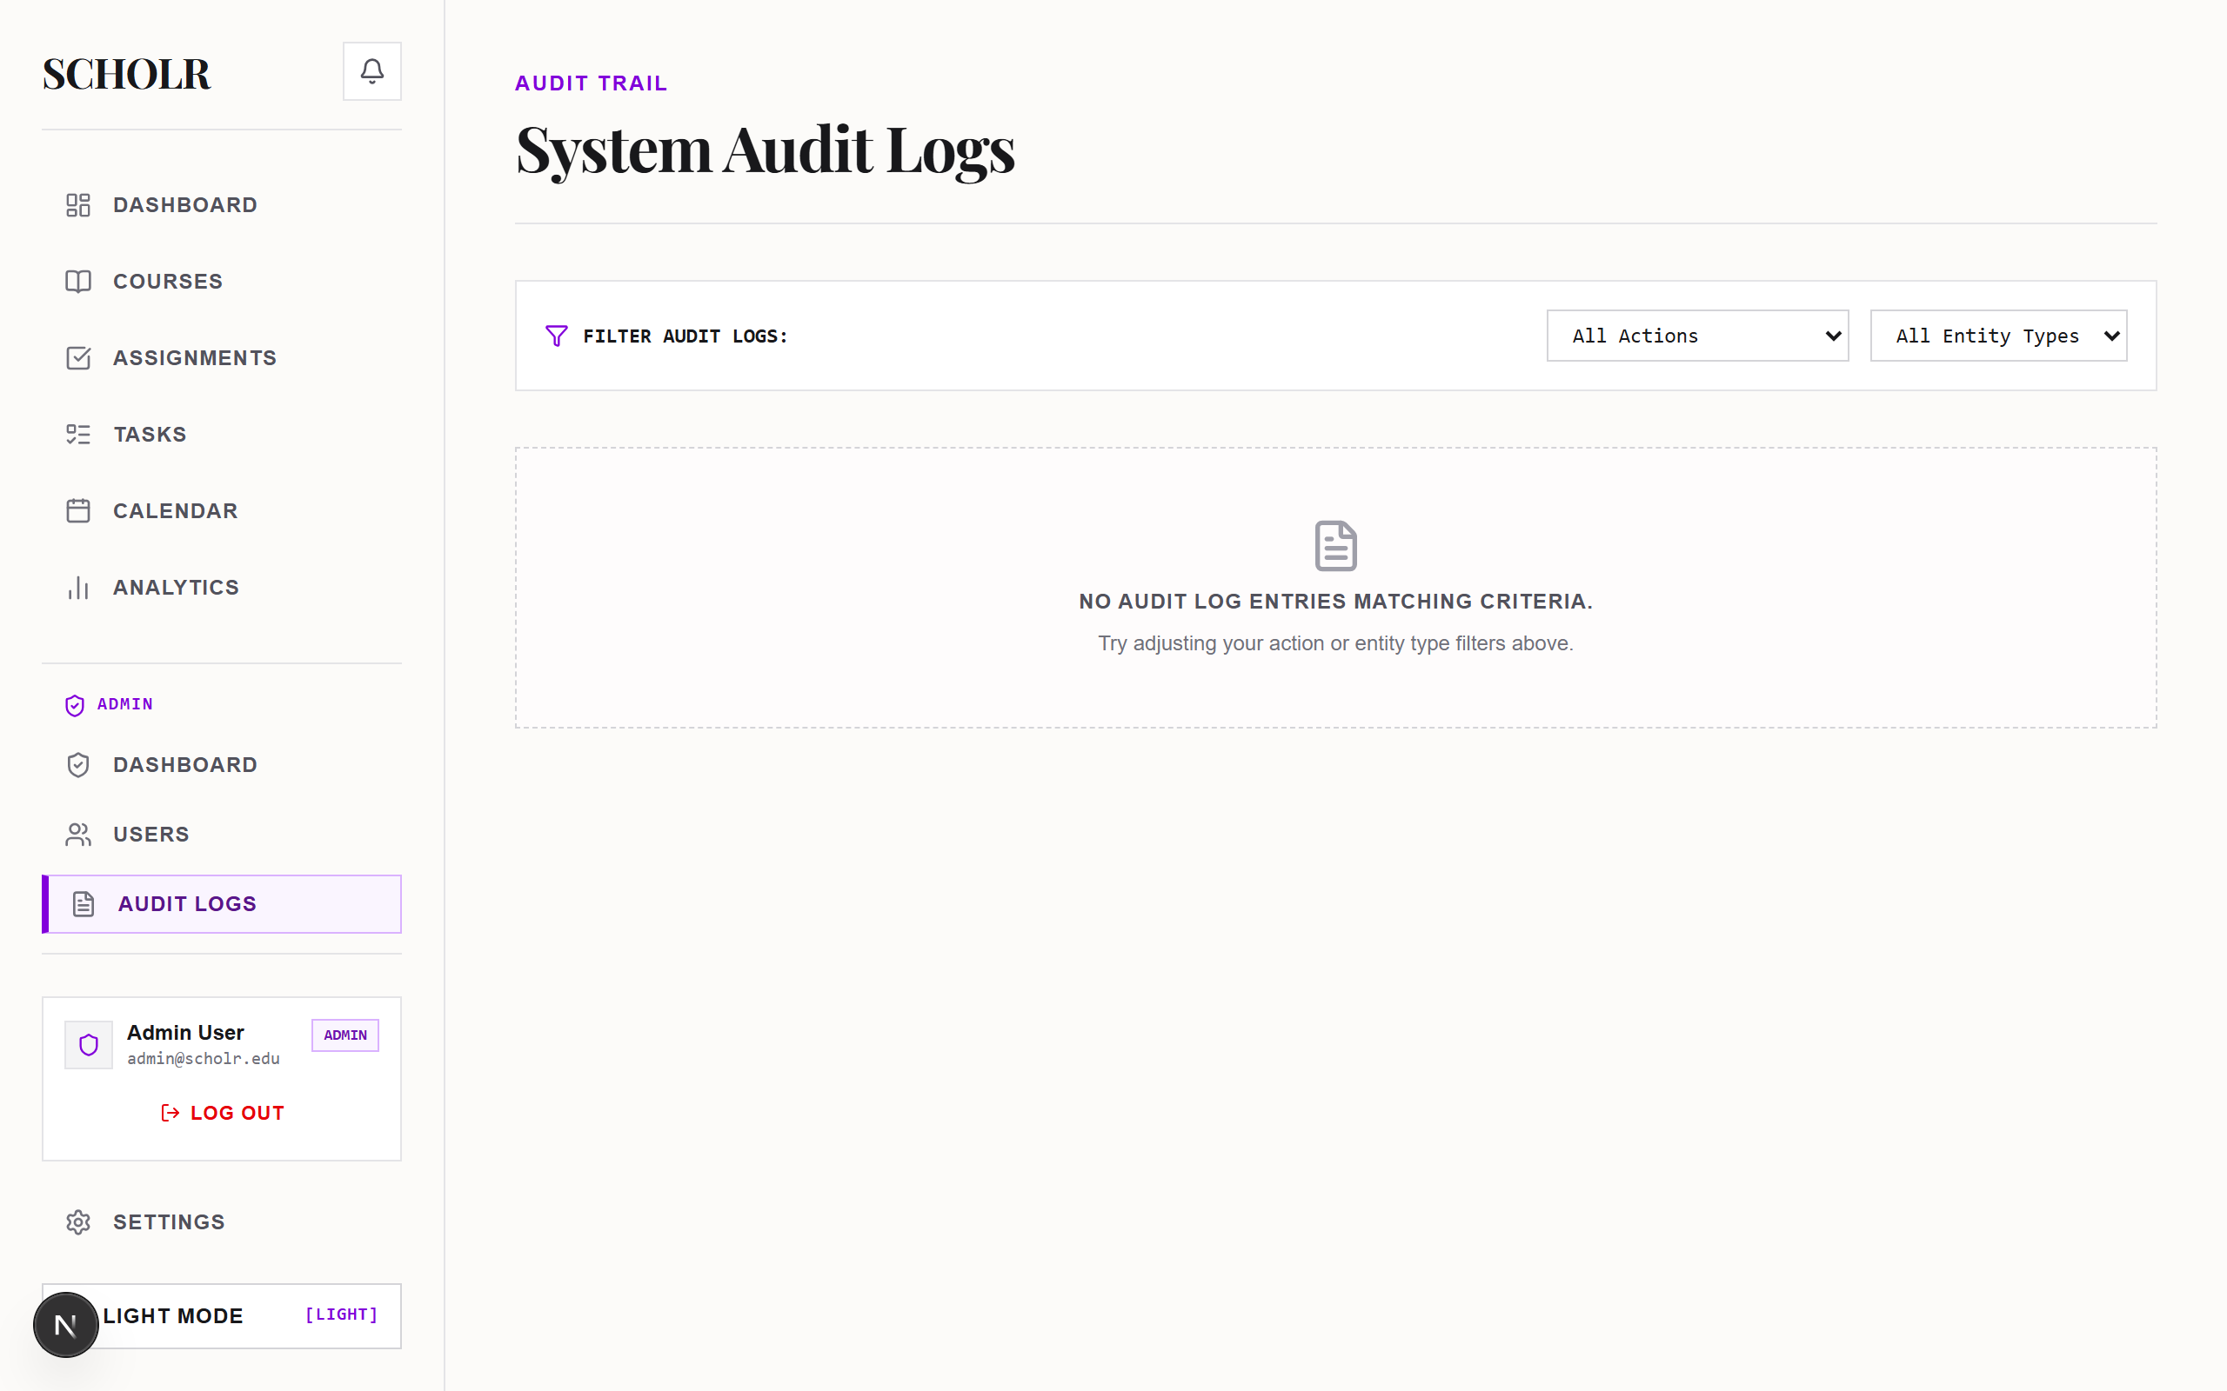

9. Calendar & Analytics Backend
Analytics endpoints aggregate course completion percentages, upcoming assignment deadlines, and task completion metrics directly from Prisma ORM database queries.

10. PostgreSQL / Deployment Readiness
Infrastructure Component | Current Runtime Implementation | Prepared Deployment Setup
Database Engine | Local SQLite (file:./dev.db) | PostgreSQL (Supabase / Neon Compatible)
Prisma Provider Schema | prisma/schema.prisma (sqlite) | prisma/schema.prisma.postgresql
Transactional Email Engine | React Email Render + Audit Log | Resend API Key & Production Webhook URL

11. Testing & Verification Suite
Verification Suite | Terminal Execution Command | Verified Result
ESLint Code Quality | npm run lint | Passed (0 Critical Errors)
TypeScript Type Check | npx tsc --noEmit | Passed (0 Compilation Errors)
Production App Build | npm run build | Passed (17 Routes Compiled)
CLI Setup & Database Seed | npm run db:setup | Passed (Exit Code 0)

12. Assignment 2 Conclusion
Assignment 2 documents the backend database, security, and transactional email architecture of Scholr. The implementation includes Prisma ORM relational schema modeling, automated mock data seeding with @faker-js/faker, JWT cookie session control, RBAC authorization guards, transactional email dispatch with React Email and Resend, and webhook event audit logging.

