GumPad User Guide

Version 3.1

<http://gumpad.org/>

Contents

What is GumPad? 1

The GumPad Editor 1

The Convert menu 2

Examples 3

The Preferences menu 4

Fonts 4

Map 4

Convert As You Type 8

Recognized file extensions 9

Add-In for Microsoft Word 10

# What is GumPad?

GumPad is a text processor that converts text in English into various Indian languages. It can also convert text back to English (Latin characters) or into another Indian language. You can use it to create, edit, view, and print simple text documents in Devanagari, Telugu, Tamil, Kannada, Malayalam, Marathi, Gujarati, Gurumukhi, Bengali and Oriya.

GumPad is published as a standalone editor as well as an Add-In for Microsoft Word 2007 and Word 2010.

# The GumPad Editor

The editor is similar to Notepad on Windows. It has a document area where you type text, make changes, and convert text between English, Indian languages and Extended Latin. There is a menu bar at the top of this document area. The menu bar has a Convert menu that is used to convert text and a Preferences menu to set conversion preferences.

## The Convert menu

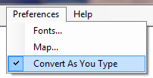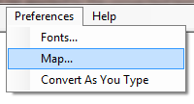

GumPad supports two conversion modes – “Convert as you type” and “Convert after you type”. You can switch between the two modes via the Convert As You Type checkbox on the Preferences menu.

The Convert menu is visible in the menu bar only in the “Convert after you type” mode.

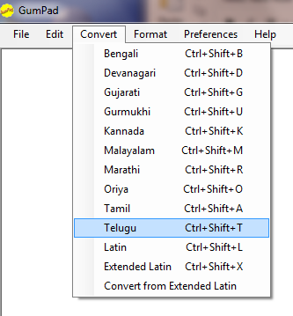Make sure the Convert As You Type checkbox is unchecked in the Preferences menu and type some text into the editor in English. Then click the Convert menu and select a language to convert the text. If you would like to convert only a portion of the text in the document, select it first and then use the convert menu.

Tip

Most menu actions can also be performed via keyboard shortcuts. Shortcuts are listed alongside menu items in each menu. For e.g., Ctrl+Shift+T is the keyboard shortcut to convert text to Telugu. To use this shortcut, type or select some text and press the Control, Shift and ‘T’ keys together at the same time.

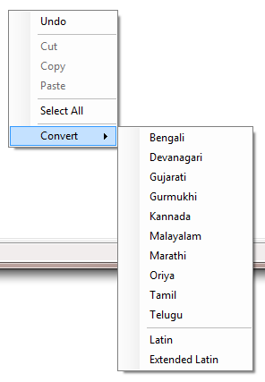

The Convert menu is also available as a context menu from the document window. Click the right mouse button in the document area to view the context menu.

### 

### Examples

1. Type **vandE maataram** (English) followed by Ctrl+Shift+D to convert it to **वन्दे मातरम्** (Devanagari) followed by Ctrl+Shift+X to convert it into **vandē mātaram** (Extended Latin).
2. Type **sau.ndarya lahari** followed by Ctrl+Shift+T to convert it to **సౌందర్య లహరి** followed by Ctrl+Shift+L to convert it back into **sau.ndaryalahari**.

Note

GumPad cannot convert text directly from English to Extended English. Convert text from English to an Indian language and then convert the text in the Indian language to Extended English.

Example

Type **himAlaya** followed by Ctrl+Shift+D to convert it to **हिमालय** followed by Ctrl+Shift+X to convert it into **himālaya**. Check the Convert from Extended Latin checkbox on the Preferences menu followed by Ctrl+Shift+D to convert **himālaya** to **हिमालय**

“Convert from Extended Latin checkbox” in the Convert menu

Leave this unchecked for normal conversion from English to other Indian languages or when converting Indian language text back to English. Leave it checked when you want to convert Extended English text to an Indian language. Extended English text is English text with diacritics.

## The Preferences menu

Use the Preferences menu to configure Font, Conversion Map and Conversion mode settings.

### Fonts

Use this menu item to set the fonts for converted text. The built-in settings are based on fonts that ship with Windows.

### 

### Map

GumPad uses a transliteration map to convert sequences of English characters into sequences of Indian characters. A unique feature of GumPad is the option to change this conversion map to suit your own purposes. In normal usage, there is no need to change the conversion map. However, there are several transliterators available for Indian languages and a few popular ones follow a slightly different transliteration scheme.

This option is useful for converting text encoded in a scheme that is different from the one provided by GumPad. Most of GumPad's built-in mappings are based on ITRANS (<http://www.aczoom.com/itrans/>) with a few differences such as "e" and "o" to allow for stretched versions of these vowels in other Indian languages.

Select the Map… menu item from the Preferences menu to change the conversion map.

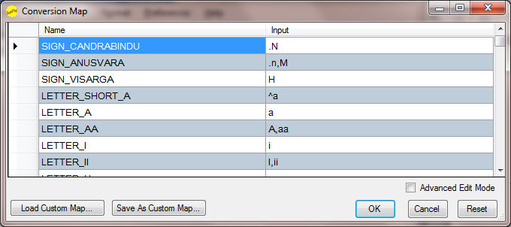

You should see a table listing the names of Indian letters corresponding to the Input English text for each letter. The Name column lists the name of the Indian character or character sequence that will be output when the text in the Input column is typed. For simple changes, click on the Input column of a letter and type in a new sequence. Click the OK button to commit your changes when you are done. Separate Input sequences using commas if you want more than one sequence of input letters to map to the same output sequence. Click Cancel to abandon changes or Reset to revert to the built-in map at any time.

Example

'a' converts to अ while 'aa' or 'A' converts to आ. This is shown in the table as 'a' for LETTER_A and 'A,aa' for LETTER_AA.

Note

Input sequences must be unique. i.e., you cannot map the same sequence to produce more than one output sequence. An error message will be displayed if a duplicate mapping is detected.

Click on the Advanced Edit Mode checkbox to view and use a more detailed version of the map editor.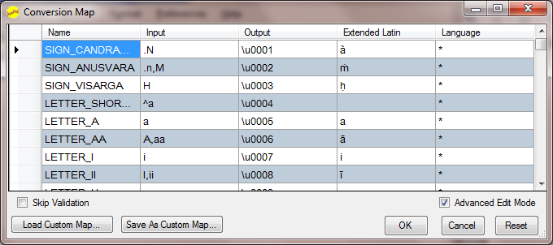

In this mode, you can change not only the Input sequence in English, but also the output sequence of Unicode characters and Extended Latin characters.

Note

The Unicode output sequence is a sequence of characters in the format \uNNNN where NNNN corresponds to a Unicode code point. For e.g., SIGN_OM corresponds to Unicode U+0950 and is entered as \u0950. There is a common block of Indian vowels and consonants that have to be entered as \u00NN where 00NN corresponds to the offset of the common block character from the starting point of the Unicode code chart for that language. GumPad will use the offset to correctly output the final Unicode character for the language it is converting to. For e.g., LETTER_A is represented as \u0005 in GumPad’s Unicode output. LETTER_A being a common block character, will be output as U+0905 in Devanagari or U+0C05 in Telugu. This is the core mechanism that GumPad leverages to transliterate common block characters between different Indian languages. Unicode also assigns U+FFFE and U+FFFF as Non-characters. Use either of these in an output sequence to suppress output for the corresponding input sequence. Unicode code charts for all languages are available at http://unicode.org/.

Conjuncts

Certain letter sequences go together and are treated as conjuncts. CONJUNCT_KSHA is a familiar example. The default input sequence for this conjunct is ksh or kSh or x. The default output sequence is \u0015\u004D\u0037, i.e. LETTER_KA followed by SIGN_VIRAMA (Halant) followed by LETTER_SHA.

The Language Column

Use this column for output sequences that are specific to a particular language. For e.g., CONJUNCT_KKA is specific to Devanagari and is associated with “hi”, the ISO language identifier for Hindi whereas LETTER_A is common to all Indian languages and is associated with a “*” in the language column.

Load and Save Custom Maps

A customized map can be saved to an external .map file via the Save As Custom Map button. Saved maps can be shared or reloaded via the Load Custom Map button.

Select the Show Map… menu item from the Help menu to view the current map.

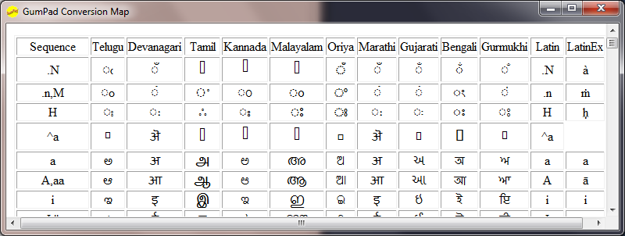

Custom Maps

Custom maps are XML files with a .map extension. These can be modified in any editor and loaded into GumPad. The XML schema is fairly straightforward. There is a <TransliterationMap> root element within which are several <mapping> elements. Each <mapping> element corresponds to a mapping rule for a single output character or character sequence. Here is an example that shows the mappings for LETTER_A, LETTER_AA and CONJUNCT_KSHA. Notice how LETTER_AA and CONJUNCT_KSHA have more than one input sequence whereas LETTER_A has only one. Notice also how the output for CONJUNCT_KSHA is defined as a Unicode sequence as opposed to a single character for LETTER_A or LETTER_AA . Study the built-in map and the sample map for ITRANS for more examples. This is a powerful mechanism to add to, modify or even completely replace the built-in transliteration map.

<TransliterationMap xmlns:xsi="http://www.w3.org/2001/XMLSchema-instance" xmlns:xsd="http://www.w3.org/2001/XMLSchema" schema-revision="2.0"

transliteration-scheme-name="ITRANS"

contributor-name="GumPad sample conversion map for ITRANS">

<mapping>

<character-name>LETTER_A</character-name>

<input-sequence>a</input-sequence>

<unicode-output-sequence>\u0005</unicode-output-sequence>

<extended-latin-output-sequence>a</extended-latin-output-sequence>

<language>*</language>

</mapping>

<mapping>

<character-name>LETTER_AA</character-name>

<input-sequence>A</input-sequence>

<input-sequence>aa</input-sequence>

<unicode-output-sequence>\u0006</unicode-output-sequence>

<extended-latin-output-sequence>ā</extended-latin-output-sequence>

<language>*</language>

</mapping>

<mapping>

<character-name>CONJUNCT_KSHA</character-name>

<input-sequence>kSh</input-sequence>

<input-sequence>ksh</input-sequence>

<input-sequence>x</input-sequence>

<unicode-output-sequence>\u0015\u004D\u0037</unicode-output-sequence>

<extended-latin-output-sequence />

<language>*</language>

</mapping>

</TransliterationMap>

### Convert As You Type

Use this checkbox to switch between convert as you type and convert after you type modes.

##### Convert as you type mode

In this mode, text is converted as you type into the editor.

The typed letters are visible on the status bar until a terminating key such as a space or delete is entered. Double click this area if you need to capture this typed text into the editor’s paste buffer.

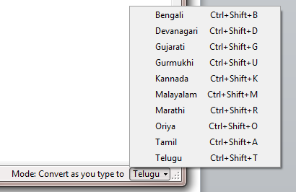The target language is visible on the right of the status bar. It can be changed by clicking on the little arrow head that appears next to the name of the current language.

Convert after you type mode

In this mode, text appears in English as you type into the editor. After typing some text you can select all or parts of it and convert it from the Convert menu.

## Recognized file extensions

GumPad recognizes the following file types. It will prompt you to specify an encoding if the file name extension does not match one of these types.

|  |  |
| --- | --- |
| Extension | File Type |
| .gpd | Files in Rich Text format. |
| .txt | Plain text files in US-ASCII format. |
| .utx | Plain text files in Unicode format. |
| .itx | Plain text files encoded in ITRANS format. |
| .rtf | Files in Rich Text format. |

# Add-In for Microsoft Word

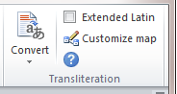GumPad is published as a standalone editor as well as an Add-In for Microsoft Word 2007 and Word 2010. The add-in appears as a Transliteration group on the Home tab of the Word Ribbon interface and provides all the features of GumPad except for Convert As You Type.

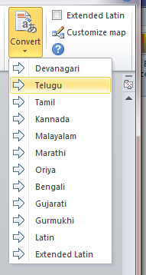The conversion process is identical to Convert after you type mode in the GumPad editor. To convert text, select it, click the Convert button and select a language from the drop down list.

Use the Extended Latin checkbox to convert from Extended Latin. This works exactly as described in The Convert menu in the GumPad editor.

Use the Customize Map button to customize the conversion map. Unlike in the standalone editor, this opens the map editor in Advanced Edit mode. The map editor is described in the Map section under The Preferences menu.

The Help button shows this User Guide in a Help window. Use Show Map and Show User Guide from the help window’s menu to switch between viewing the Conversion map and this User Guide.