We first created the signal_count variable within the PCB of each process in the sched.h folder that is found in the /include/linux directory. This will allow us to keep track of signals sent to each process.

Then in the signals.c file found in the kernel directory, we made two variables pid_counter and max_counter to update the process that was sent the most signals alongside its id.   
  
Testing for n = 10

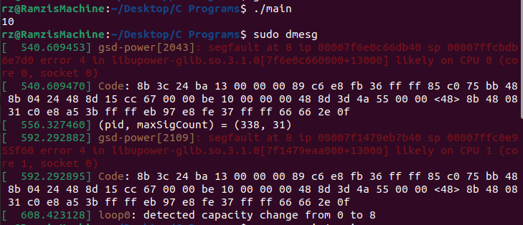Testing for n = 100

