# 报错文档

## 1 javax.crypto.BadPaddingException: pad block corrupted

详情：

at org.bouncycastle.jcajce.provider.symmetric.util.BaseBlockCipher$BufferedGenericBlockCipher.doFinal(Unknown Source)

at org.bouncycastle.jcajce.provider.symmetric.util.BaseBlockCipher.engineDoFinal(Unknown Source)

at javax.crypto.Cipher.doFinal(Cipher.java:2165)

at BCDES.decrypt(BCDES.java:44)

at BCDESTest.testBCDES(BCDESTest.java:21)

at sun.reflect.NativeMethodAccessorImpl.invoke0(Native Method)

at sun.reflect.NativeMethodAccessorImpl.invoke(NativeMethodAccessorImpl.java:62)

at sun.reflect.DelegatingMethodAccessorImpl.invoke(DelegatingMethodAccessorImpl.java:43)

at java.lang.reflect.Method.invoke(Method.java:498)

at org.junit.runners.model.FrameworkMethod$1.runReflectiveCall(FrameworkMethod.java:50)

at org.junit.internal.runners.model.ReflectiveCallable.run(ReflectiveCallable.java:12)

at org.junit.runners.model.FrameworkMethod.invokeExplosively(FrameworkMethod.java:47)

at org.junit.internal.runners.statements.InvokeMethod.evaluate(InvokeMethod.java:17)

at org.junit.runners.ParentRunner.runLeaf(ParentRunner.java:325)

at org.junit.runners.BlockJUnit4ClassRunner.runChild(BlockJUnit4ClassRunner.java:78)

at org.junit.runners.BlockJUnit4ClassRunner.runChild(BlockJUnit4ClassRunner.java:57)

at org.junit.runners.ParentRunner$3.run(ParentRunner.java:290)

at org.junit.runners.ParentRunner$1.schedule(ParentRunner.java:71)

at org.junit.runners.ParentRunner.runChildren(ParentRunner.java:288)

at org.junit.runners.ParentRunner.access$000(ParentRunner.java:58)

at org.junit.runners.ParentRunner$2.evaluate(ParentRunner.java:268)

at org.junit.runners.ParentRunner.run(ParentRunner.java:363)

at org.junit.runner.JUnitCore.run(JUnitCore.java:137)

at com.intellij.junit4.JUnit4IdeaTestRunner.startRunnerWithArgs(JUnit4IdeaTestRunner.java:68)

at com.intellij.rt.execution.junit.IdeaTestRunner$Repeater.startRunnerWithArgs(IdeaTestRunner.java:47)

at com.intellij.rt.execution.junit.JUnitStarter.prepareStreamsAndStart(JUnitStarter.java:242)

at com.intellij.rt.execution.junit.JUnitStarter.main(JUnitStarter.java:70)

解决：这是一直傻逼的错误，我把参数位置写错了，网上的报错解决方法也是doFinal参数的问题，因为它用密钥解码不了我传进去的参数。

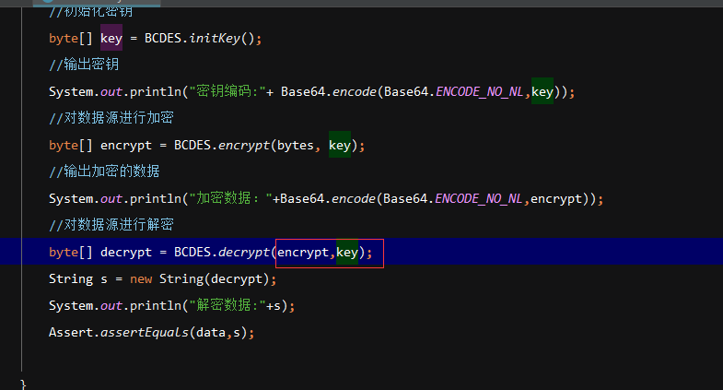

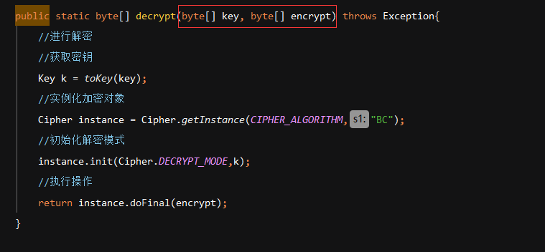

## 2 忘了复制错误，就是初始化密钥时大小不对

原因是进出口权限文件没有覆盖本地的，所以不支持密钥的长度。

## 3 IDEA的配置文件unicode编码转换为UTF-8

一开始圈红那个没勾一直不行。

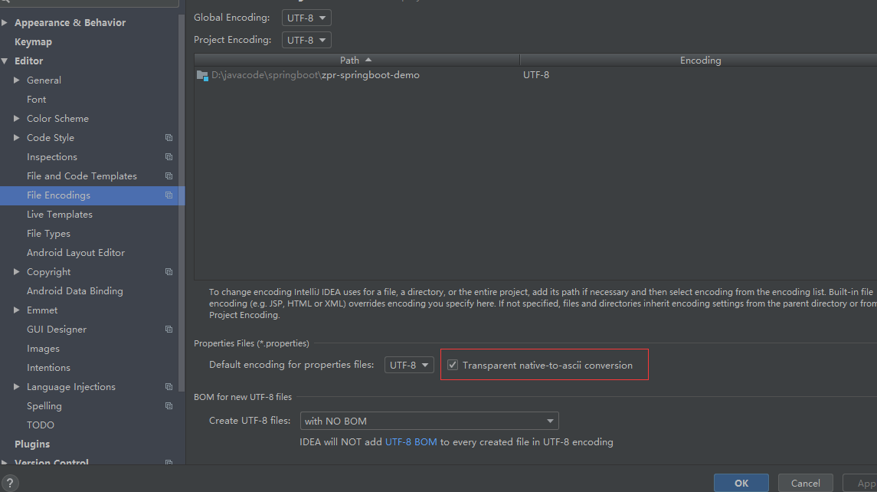

## 4 Not registered via @EnableConfigurationProperties or marked as Spring component

将@Configuration改为@Compontent

## 5 org.springframework.expression.spel.SpelEvaluationException: EL1008E: Property or field 'timestamp' cannot be found on object of type 'java.util.HashMap' - maybe not public or not valid?

将error页面放到了thymeleaf下面，应该放在templates下面，不然就要写好路径。

## 6 java.sql.SQLException: Column name pattern can not be NULL or empty.

解决：&amp;nullNamePatternMatchesAll=true

## 7 当找不到bean时，可能是容器条件比较严格，没找到适当的bean，可以去Setting中设置为warning

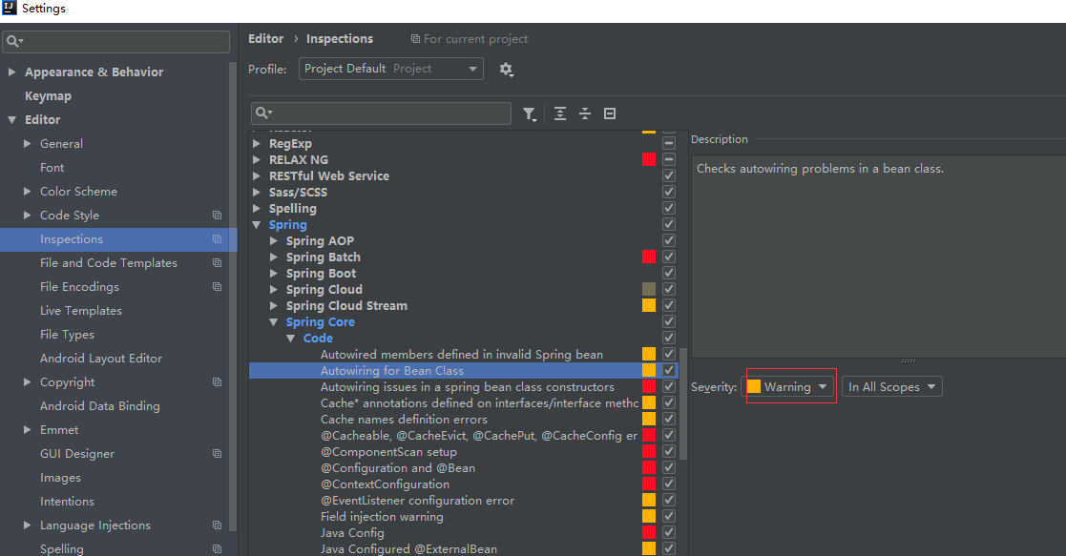

## 8 springboot中访问jsp文件报错404

解决：按照网上先添加webapp及其子目录WEB-INF，然后不要用启动类启动项目，用maven的方式，添加maven视图的项目/Plugins/spring-boot/spring-boot:run右键create Run/Debug Configuration，然后添加Command line:spring-boot:run,然后启动这个就可以访问了