**Assignment 1 Report**

**COMP 9331 – Tianwei Zhu, z5140081**

**1.** Most of works for my STP protocol function are completed by Sender.py, it handles retransmit and timeout features. The Receiver.py contains handshake and close function, then keeps the state of receiving segments until there is a FIN header, which is set to close the connection.

First of all, sender and receiver build connection by finishing **handshake**, then hold this state and wait for data transmitting. There is a **recorded sequence** in receiver, it will write file and change to next step only if there is an expected package arrived. This feature makes sure that receiver always records correct data in order.

The **default_window** is the amount of data packages to be sent according to WMS and MSS (WMS/MSS). The data to be sent are push in a list and wait for sending. The sender sends N packages at one time and wait for ACKs. If the ACK sequence corresponds the sent package, this pack will be pop from list and push next pack into list (create new window). If one pack was lost, then every next ACKs will be the same, which tells sender a lost happened. Once there are three duplicated ACKs, the sender will resend the corresponding packs list (top is the missing pack, following next some packs) to receiver. This is the fast transmit feature.

If timeout happened, sender will resend that package in a new window, following other packs together. Since timeout **only happens** to the last three packages in a window or there are less than three packs lost during the transmission, it appears sometimes in the entire process, which won’t slow down program too much.

**2.** Here is the default set for segment: **SYN=0, ACK=0, FIN=0, seq=0, acknowledgment=0, data=""**. I use a class to hold these information, they will keep zero each time if there is no need for change. SYN, ACK and FIN is flag for recognition, they are the same idea with textbook. The seq represent sequence number for each package. All these texts will be switched into bit type and decode once received.

|  |  |  |  |  |  |
| --- | --- | --- | --- | --- | --- |
| sequence number | | | | | |
| acknowledgement number | | | | | |
| head  len | not  used | SYN | ACK | FIN | not used |
| application  data  (variable length) | | | | | |

**3.**

**(a)** **pdrop = 0.1, MWS = 500 bytes, MSS = 50 bytes, seed = 300, timeout = 0.2**

Since this is a local transmit, delay will be small enough, so I set timeout = 0.2 to avoid limiting program’s efficiency.

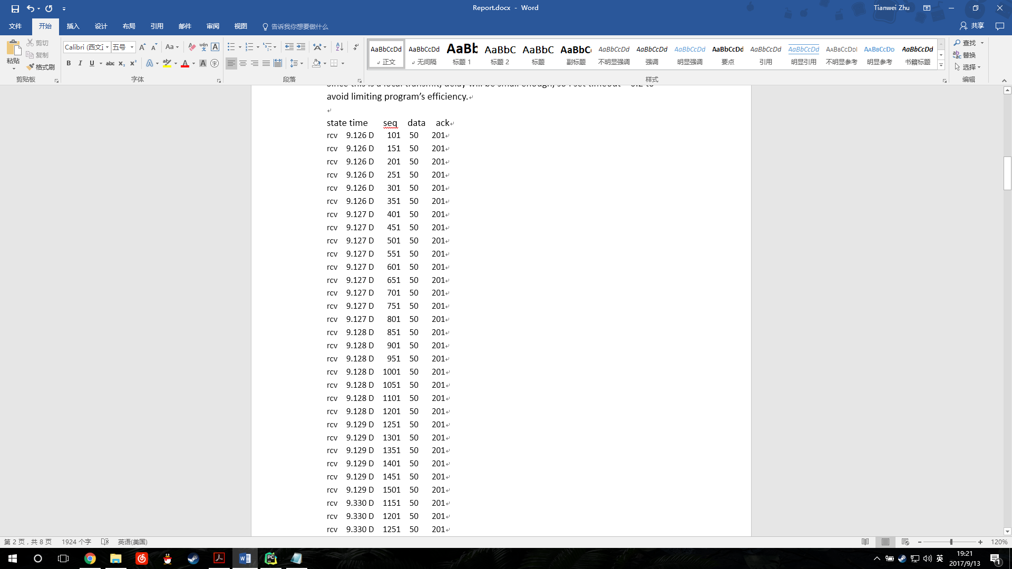 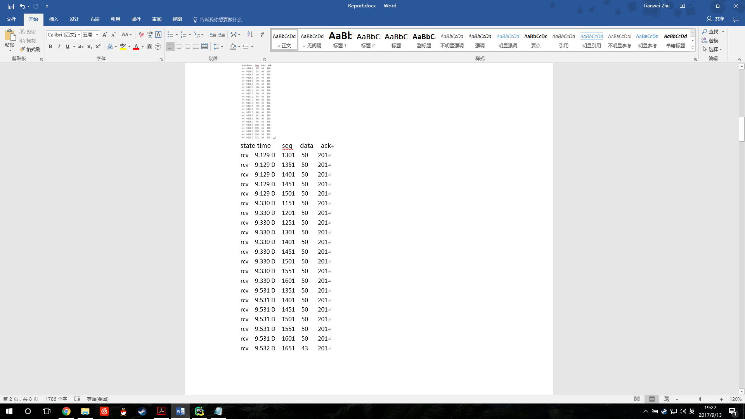

For the first experiment **pdrop=0.1**, there are drops at sequence number = 1151, 1551. After fast retransmitted, seq=1351 drop, and then fast retransmitted. (see appendix)

For the first experiment **pdrop=0.3**, seq = 301, 451 dropped but fast retransmitted.

The seq = 501 is a little tricky, it consecutively lost 4 times, but finally been retransmitted.

After that, seq = 701and 1001 lost and fast retransmitted.

Although there are some packages lost and wait for timeout, but system do fast transmit for previous packages and not wait for timeout.

**(b)**

**pdrop = 0.1, MWS = 500 bytes, MSS = 50 bytes, seed = 300, timeout = 0.2**

|  |  |  |  |
| --- | --- | --- | --- |
|  | Tcurrent | 4 x Tcurrent | Tcurrent/4 |
| STP packets transmitted | 73 | 73 | 73 |
| Time took | 0.408 | 2.409 | 0.157 |

The number of STP packets transmitted keeps constant whatever timeout setting is. The time taking for each experiment seems to be linear change as the timeout setting.

**Appendix**

Experimental for question 1 (a):

**pdrop = 0.1, MWS = 500 bytes, MSS = 50 bytes, seed = 300, timeout = 0.2, test1.txt**

state time seq data ack

snd 9.126 D 101 50 201

snd 9.126 D 151 50 201

snd 9.126 D 201 50 201

snd 9.126 D 251 50 201

snd 9.126 D 301 50 201

snd 9.126 D 351 50 201

snd 9.126 D 401 50 201

snd 9.126 D 451 50 201

snd 9.126 D 501 50 201

snd 9.126 D 551 50 201

snd 9.127 D 601 50 201

snd 9.127 D 651 50 201

snd 9.127 D 701 50 201

snd 9.127 D 751 50 201

snd 9.127 D 801 50 201

snd 9.127 D 851 50 201

snd 9.127 D 901 50 201

snd 9.127 D 951 50 201

snd 9.127 D 1001 50 201

snd 9.127 D 1051 50 201

snd 9.128 D 1101 50 201

drop 9.128 D 1151 50 201 # fast retransmitted

snd 9.128 D 1201 50 201

snd 9.128 D 1251 50 201

snd 9.128 D 1301 50 201

snd 9.129 D 1351 50 201

snd 9.129 D 1401 50 201

snd 9.129 D 1451 50 201

snd 9.129 D 1501 50 201

drop 9.129 D 1551 50 201

snd 9.330 D 1151 50 201

snd 9.330 D 1201 50 201

snd 9.330 D 1251 50 201

snd 9.330 D 1301 50 201

drop 9.330 D 1351 50 201 # fast retransmitted

snd 9.330 D 1401 50 201

snd 9.330 D 1451 50 201

snd 9.330 D 1501 50 201

snd 9.330 D 1551 50 201

snd 9.330 D 1601 50 201

snd 9.531 D 1351 50 201

snd 9.531 D 1401 50 201

snd 9.531 D 1451 50 201

snd 9.531 D 1501 50 201

snd 9.531 D 1551 50 201

snd 9.531 D 1601 50 201

snd 9.531 D 1651 43 201 # last package

**pdrop = 0.3, MWS = 500 bytes, MSS = 50 bytes, seed = 300, timeout = 0.2, test1.txt**

state time seq data ack

snd 40.953 D 101 50 201

snd 40.953 D 151 50 201

snd 40.953 D 201 50 201

snd 40.953 D 251 50 201

drop 40.953 D 301 50 201 # fast retransmitted

snd 40.953 D 351 50 201

snd 40.953 D 401 50 201

snd 40.953 D 451 50 201

snd 40.953 D 501 50 201

snd 40.954 D 551 50 201

snd 41.154 D 301 50 201

snd 41.154 D 351 50 201

snd 41.154 D 401 50 201

drop 41.154 D 451 50 201 # fast retransmitted

snd 41.154 D 501 50 201

snd 41.154 D 551 50 201

drop 41.154 D 601 50 201

snd 41.154 D 651 50 201

snd 41.154 D 701 50 201

drop 41.154 D 751 50 201

snd 41.355 D 451 50 201

drop 41.355 D 501 50 201 # fast retransmitted

snd 41.355 D 551 50 201

snd 41.355 D 601 50 201

snd 41.355 D 651 50 201

drop 41.355 D 701 50 201

snd 41.355 D 751 50 201

drop 41.355 D 801 50 201

snd 41.355 D 851 50 201

drop 41.355 D 901 50 201

drop 41.557 D 501 50 201 # fast retransmitted

drop 41.557 D 551 50 201

snd 41.557 D 601 50 201

drop 41.557 D 651 50 201

drop 41.557 D 701 50 201

drop 41.557 D 751 50 201

snd 41.557 D 801 50 201

snd 41.557 D 851 50 201

snd 41.557 D 901 50 201

snd 41.557 D 951 50 201

drop 41.758 D 501 50 201 # fast retransmitted

snd 41.758 D 551 50 201

drop 41.758 D 601 50 201

snd 41.758 D 651 50 201

snd 41.758 D 701 50 201

drop 41.758 D 751 50 201

snd 41.758 D 801 50 201

snd 41.758 D 851 50 201

snd 41.758 D 901 50 201

snd 41.758 D 951 50 201

drop 41.958 D 501 50 201 # fast retransmitted

snd 41.958 D 551 50 201

snd 41.958 D 601 50 201

drop 41.958 D 651 50 201

drop 41.958 D 701 50 201

snd 41.958 D 751 50 201

drop 41.958 D 801 50 201

snd 41.958 D 851 50 201

snd 41.958 D 901 50 201

snd 41.958 D 951 50 201

snd 42.159 D 501 50 201

snd 42.159 D 551 50 201

snd 42.159 D 601 50 201

snd 42.159 D 651 50 201

drop 42.159 D 701 50 201 # fast retransmitted

drop 42.159 D 751 50 201

snd 42.159 D 801 50 201

snd 42.159 D 851 50 201

drop 42.159 D 901 50 201

snd 42.159 D 951 50 201

drop 42.359 D 701 50 201 # fast retransmitted

snd 42.359 D 751 50 201

snd 42.359 D 801 50 201

snd 42.359 D 851 50 201

snd 42.359 D 901 50 201

snd 42.359 D 951 50 201

snd 42.359 D 1001 50 201

snd 42.359 D 1051 50 201

drop 42.359 D 1101 50 201

drop 42.359 D 1151 50 201

snd 42.559 D 701 50 201

snd 42.559 D 751 50 201

snd 42.559 D 801 50 201

snd 42.559 D 851 50 201

snd 42.559 D 901 50 201

snd 42.559 D 951 50 201

drop 42.559 D 1001 50 201 # fast retransmitted

snd 42.559 D 1051 50 201

snd 42.559 D 1101 50 201

snd 42.559 D 1151 50 201

snd 42.759 D 1001 50 201

snd 42.759 D 1051 50 201

snd 42.759 D 1101 50 201

snd 42.759 D 1151 50 201

snd 42.759 D 1201 50 201

snd 42.759 D 1251 50 201

snd 42.759 D 1301 50 201

snd 42.759 D 1351 50 201

snd 42.759 D 1401 50 201

snd 42.759 D 1451 50 201

snd 42.760 D 1501 50 201

snd 42.760 D 1551 50 201

snd 42.760 D 1601 50 201

snd 42.760 D 1651 43 201 # last package