**COMP9334 - Assignment 1**

Tianwei Zhu, z5140081

**Question 1**

1. ***Determine the service demand for each device of the system.***

For CPU: Utilization U(j1) = B/T = 2929/3600 = 81.36%

X(0) = C(0)/T = 1267/3600 = 0.35 jobs/s

**Service demand D(j1) = U(j1)/X(0) = 0.81/0.35 = 2311.8ms**

For Disk: Utilization U(j2) = B/T = 2765/3600 = 76.81%

X(0) = C(0)/T = 1267/3600 = 0.35 jobs/s

**Service demand D(j2) = U(j2)/X(0) = 0.77/0.35 = 2182.3ms**

1. ***Use bottleneck analysis to determine the asymptotic bound on the system throughput when there are 20 active terminals and the think time per job is 14 seconds.***

Considering think time(T) into calculating, the Bottleneck analysis will be:

$$Χ(0)≤min\left[\frac{1}{maxDi}, \frac{N}{\sum_{i=1}^{k}{Di+T}}\right]$$

The maximum service demand is D(cpu)=2.31ms, then $\frac{1}{maxDi}=\frac{1}{2.31}=0.43$

$$\frac{N}{\sum_{i=1}^{k}{Di+T}}=\frac{20}{2.31+2.2+14}=1.08$$

**So, the asymptotic bound will be 0.43jobs/s.**

**Question 2**

1. ***Formulate a continuous-time Markov chain for a system similar to that described above with 4 staff and n waiting slots.***

$$λ=15，μ=3$$

There may have n+5 states for the Markov chain: 0-4 staffs busy while zero in waiting; 4 staffs busy while one call waiting; 4 staffs busy while two calls in queue; 4 staff busy while n calls waiting.

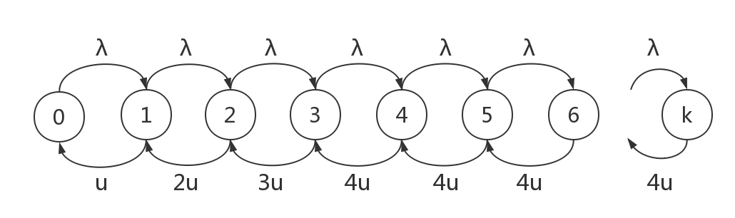

…

State 0: All staffs are idle;

State 1: Only 1 staffs are busy;

State 2: Only 2 staffs are busy;

State 3: 3 staffs are busy;

State 4: All staffs are busy;

State 5: All staffs are busy and one call in queue;

…

State k: All staffs are busy and n calls in queue. (k=n+4)

1. ***Write down the balance equations for the continuous-time Markov chain that you have formulated.***

$$λΡ_{0}=μΡ_{1}$$

$$λΡ_{0}+2μΡ_{2}=\left(μ+λ\right)Ρ_{1}⟹2μΡ_{2}={λΡ}_{1}$$

$$λΡ_{1}+3μΡ_{3}=\left(2μ+λ\right)Ρ_{2}⟹3μΡ_{3}={λΡ}_{2}$$

$$λΡ_{2}+4μΡ_{4}=\left(3μ+λ\right)Ρ_{3}⟹4μΡ_{4}={λΡ}_{3}$$

$$λΡ_{3}+4μΡ_{5}=\left(4μ+λ\right)Ρ_{4}⟹4μΡ_{5}={λΡ}_{4}$$

$$λΡ_{4}+4μΡ_{6}=\left(4μ+λ\right)Ρ_{5}⟹4μΡ_{6}={λΡ}_{5}$$

…

$4μΡ_{k}={λΡ}_{k-1}$ (k=n+4)

1. ***Derive expressions for the steady state probabilities of the continuous-time Markov chain that you have formulated.***

$$\left(1\right) Ρ_{1}=\frac{λΡ_{0}}{μ}=ρΡ_{0}$$

$$\left(2\right) Ρ_{2}=\frac{ρ^{2}}{2}Ρ_{0}$$

$$\left(3\right) Ρ_{3}=\frac{ρ^{3}}{6}Ρ_{0}$$

$$\left(4\right) Ρ_{4}=\frac{ρ^{4}}{24}Ρ_{0}$$

$$\left(5\right) Ρ_{5}=\frac{ρ^{5}}{96}Ρ_{0}$$

$$\left(6\right) Ρ_{6}=\frac{ρ^{6}}{384}Ρ_{0}$$

...

$$Ρ_{k}=\frac{ρ^{4}}{24}*{(\frac{ρ}{4})}^{k-4}Ρ_{0}$$

$${⇒Ρ}_{k}=\left\{\begin{aligned}Ρ_{0}\frac{1}{k!}ρ^{k}, k≤4 \\ Ρ_{0}\frac{1}{24*4^{k-4}}ρ^{k}, k>4 \end{aligned}\right.$$

$$\left(7\right) {Ρ_{0}+Ρ}_{1}+Ρ_{2}+Ρ_{3}+Ρ_{4}+Ρ_{5}+Ρ_{6}+…+Ρ_{k}=1$$

$$⇒Ρ_{0}=1/(1+ ρ+\frac{ρ^{2}}{2}+\frac{ρ^{3}}{6}+\frac{ρ^{4}}{24}+\frac{ρ^{4}}{24}*\sum_{i=5}^{k}{{(\frac{ρ}{4})}^{k-4}})$$

1. ***For the current configuration, i.e. for n = 2, determine:***

***(i) The probability that an arriving query will be rejected. Let us denote the result of this by x.***

When there are only 2 waiting slot, the final state will be state 6: 4 staffs are busy and 2 calls in queue. If the system is in this state, then any arriving query will be rejected. We can combine (1)-(7) equations to get the probability of $Ρ_{6}$.

*I use python program to compute result for questions, see attached file q2.py*

The probability is that an arriving query will be rejected $Ρ_{6}=0.29$

***(ii) The mean waiting time of an accepted query in the queue.***

Using the Little’s law, we can know that $N=\sum_{k=0}^{6}{k*}Ρ_{k}=6.295$

$$X\left(0\right)=λ*\left(1-P\left(reject\right)\right)=15*\left(1-0.29\right)=10.65/h$$

Hence R = N/X(0) = 6.295/10.65 = 0.59h = 2127.89 s

**The mean waiting time will be T = R-T(s) = 2127.89 – 600 = 1527.89 s**

1. ***Determine the blocking probability if you add 5, 10, 15 and 20 waiting slots.***

*I use python program to compute result for questions, see attached file q2.py*

When adding 5 waiting slots, n=7, $Ρ_{11}=0.223$

When adding 5 waiting slots, n=12, $Ρ_{16}=0.207$

When adding 5 waiting slots, n=17, $Ρ_{21}=0.202$

When adding 5 waiting slots, n=22, $Ρ_{26}=0.201$

1. ***Explain why there is little drop in blocking probability after adding 10 waiting slots. What should you do to reduce the blocking probability?***

According to Poisson Distribution, the probability drops abruptly in a specific segment, then it will drop little as increasing waiting slots.

This problem can be fixed if we increase the number of staff in the system.

**Question 3**

1. ***Formulate a continuous-time Markov chain for this computer system.***

u(CPU1) = 1/0.2 = 5/s;

u(CPU2) = 1/0.4 = 2.5/s;

u(Disk) = 1/0.2 = 5/s;

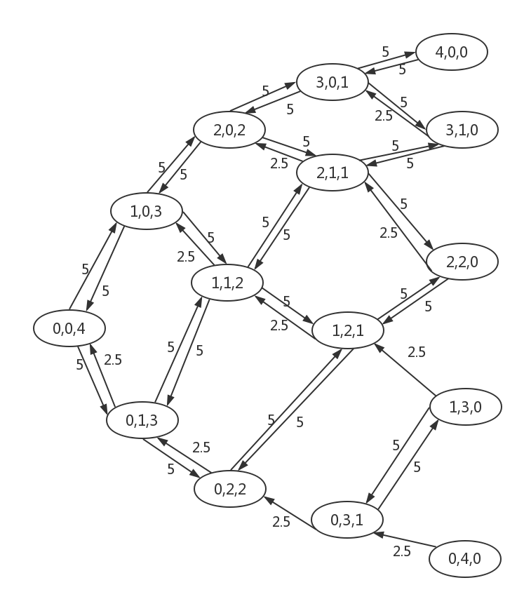

1. ***Write down the balance equations for the continuous-time Markov chain that you have formulated in Part (a).***

**10P(0,0,4)**– 5P(1,0,3) - 2.5P(0,1,3) + 0P(2,0,2) + 0P(1,1,2) + 0P(0,2,2) + 0P(3,0,1) + 0P(2,1,1) + 0P(1,2,1) + 0P(0,3,1) + 0P(4,0,0) + 0P(3,1,0) + 0P(2,2,0) + 0P(1,3,0) + 0P(0,4,0) = 0

-5P(0,0,4)+**15P(1,0,3)** + 0P(0,1,3) - 5P(2,0,2)–2.5P(1,1,2) + 0P(0,2,2) + 0P(3,0,1) + 0P(2,1,1) + 0P(1,2,1) + 0P(0,3,1) + 0P(4,0,0) + 0P(3,1,0) + 0P(2,2,0) + 0P(1,3,0) + 0P(0,4,0) = 0

-5P(0,0,4)+0P(1,0,3)+**12.5P(0,1,3)** +0P(2,0,2) -5P(1,1,2) -2.5P(0,2,2) + 0P(3,0,1) + 0P(2,1,1) + 0P(1,2,1) + 0P(0,3,1) + 0P(4,0,0) + 0P(3,1,0) + 0P(2,2,0) + 0P(1,3,0) + 0P(0,4,0) = 0

0P(0,0,4)-5P(1,0,3)+0P(0,1,3) + **15P(2,0,2)** +0P(1,1,2) +0P(0,2,2) -5P(3,0,1) -2.5P(2,1,1) + 0P(1,2,1) + 0P(0,3,1) + 0P(4,0,0) + 0P(3,1,0) + 0P(2,2,0) + 0P(1,3,0) + 0P(0,4,0) = 0

0P(0,0,4)-5P(1,0,3)-5P(0,1,3) + 0P(2,0,2) +**17.5P(1,1,2)** +0P(0,2,2) + 0P(3,0,1) -5P(2,1,1) -2.5P(1,2,1) + 0P(0,3,1) + 0P(4,0,0) + 0P(3,1,0) + 0P(2,2,0) + 0P(1,3,0) + 0P(0,4,0) = 0

0P(0,0,4)+0P(1,0,3)-5P(0,1,3) + 0P(2,0,2) -0P(1,1,2) +**7.5P(0,2,2)** + 0P(3,0,1) + 0P(2,1,1) -5P(1,2,1) -2.5P(0,3,1) + 0P(4,0,0) + 0P(3,1,0) + 0P(2,2,0) + 0P(1,3,0) + 0P(0,4,0) = 0

0P(0,0,4)+0P(1,0,3)+0P(0,1,3) -5P(2,0,2) +0P(1,1,2) +0P(0,2,2) + **15P(3,0,1)** + 0P(2,1,1) + 0P(1,2,1) + 0P(0,3,1) -5P(4,0,0) -2.5P(3,1,0) + 0P(2,2,0) + 0P(1,3,0) + 0P(0,4,0) = 0

0P(0,0,4)+0P(1,0,3)+0P(0,1,3) -5P(2,0,2) -5P(1,1,2) +0P(0,2,2) + 0P(3,0,1) + **17.5P(2,1,1)** + 0P(1,2,1) + 0P(0,3,1) + 0P(4,0,0) -5P(3,1,0) -2.5P(2,2,0) + 0P(1,3,0) + 0P(0,4,0) = 0

0P(0,0,4)+0P(1,0,3)+0P(0,1,3) + 0P(2,0,2) -5P(1,1,2) -5P(0,2,2) + 0P(3,0,1) + 0P(2,1,1) + **12.5P(1,2,1)** + 0P(0,3,1) + 0P(4,0,0) + 0P(3,1,0) -5P(2,2,0) -2.5P(1,3,0) + 0P(0,4,0) = 0

0P(0,0,4)+0P(1,0,3)+0P(0,1,3) + 0P(2,0,2) +0P(1,1,2) +0P(0,2,2) + 0P(3,0,1) + 0P(2,1,1) + 0P(1,2,1) + **7.5P(0,3,1)** + 0P(4,0,0) + 0P(3,1,0) + 0P(2,2,0) -5P(1,3,0) -2.5P(0,4,0) = 0

0P(0,0,4)+0P(1,0,3)+0P(0,1,3) + 0P(2,0,2) +0P(1,1,2) +0P(0,2,2) -5P(3,0,1) + 0P(2,1,1) + 0P(1,2,1) + 0P(0,3,1) + **5P(4,0,0)** + 0P(3,1,0) + 0P(2,2,0) + 0P(1,3,0) + 0P(0,4,0) = 0

0P(0,0,4)+0P(1,0,3)+0P(0,1,3) + 0P(2,0,2) +0P(1,1,2) +0P(0,2,2) -5P(3,0,1) -5P(2,1,1) + 0P(1,2,1) + 0P(0,3,1) + 0P(4,0,0) + **7.5P(3,1,0)** + 0P(2,2,0) + 0P(1,3,0) + 0P(0,4,0) = 0

0P(0,0,4)+0P(1,0,3)+0P(0,1,3) + 0P(2,0,2) +0P(1,1,2) +0P(0,2,2) + 0P(3,0,1) -5P(2,1,1) -5P(1,2,1) + 0P(0,3,1) + 0P(4,0,0) + 0P(3,1,0) + **7.5P(2,2,0)** + 0P(1,3,0) + 0P(0,4,0) = 0

0P(0,0,4)+0P(1,0,3)+0P(0,1,3) + 0P(2,0,2) +0P(1,1,2) +0P(0,2,2) + 0P(3,0,1) + 0P(2,1,1) + 0P(1,2,1) -5P(0,3,1) + 0P(4,0,0) +0P(3,1,0) + 0P(2,2,0) + **7.5P(1,3,0)** + 0P(0,4,0) = 0

0P(0,0,4)+0P(1,0,3)+0P(0,1,3) + 0P(2,0,2) +0P(1,1,2) +0P(0,2,2) + 0P(3,0,1) + 0P(2,1,1) + 0P(1,2,1) + 0P(0,3,1) + 0P(4,0,0) + 0P(3,1,0) + 0P(2,2,0) + 0P(1,3,0) + **2.5P(0,4,0)** = 0

**P(0,0,4)+P(1,0,3)+P(0,1,3) + P(2,0,2) +P(1,1,2) +P(0,2,2) + P(3,0,1) + P(2,1,1) + P(1,2,1) + P(0,3,1) + P(4,0,0) + P(3,1,0) + P(2,2,0) + P(1,3,0) + P(0,4,0) = 1**

1. ***What are the steady state probabilities for each state?***

*I use python program to compute result for questions, see attached file q3.py*

P(0,0,4) = 0.04

P(1,0,3) = 0.04

P(0,1,3) = 0.08

P(2,0,2) = 0.04

P(1,1,2) = 0.08

P(0,2,2) = 0.16

P(3,0,1) = 0.04

P(2,1,1) = 0.08

P(1,2,1) = 0.16

P(0,3,1) = 0.0

P(4,0,0) = 0.04

P(3,1,0) = 0.08

P(2,2,0) = 0.16

P(1,3,0) = 0.0

P(0,4,0) = 0.0

1. ***What is the throughput of the system?***

The throughput is decided by the disk, Throughput = U(disk)/S(disk)

U(disk)=1 – (P(4,0,0) + P(3,1,0) + P(2,2,0) + P(1,3,0) + P(0,4,0)) = 1-(0.04+0.08+0.16)=0.72

X(disk) = U(disk)/S(disk) = 0.72/0.2 = 3.6/s

1. ***What is the mean number of jobs in CPU1?***
$$N\left(cpu1\right)=\sum_{k=0}^{k}{n*p\left(cpu1\right)}=P\left(1,0,3\right)+2P\left(2,0,2\right)+P\left(1,1,2\right)+3P\left(3,0,1\right)+2P\left(2,1,1\right)+P\left(1,2,1\right)+4P\left(4,0,0\right)+3P\left(3,1,0\right)+2P\left(2,2,0\right)+P\left(1,3,0\right)=1.36$$

2. ***What is the mean response time of CPU1?***

$$X\left(cpu1\right)=\frac{U}{S}=\frac{P\left(1,0,3\right)+P\left(2,0,2\right)+P\left(1,1,2\right)+P\left(3,0,1\right)+P\left(2,1,1\right)+P\left(1,2,1\right)+P\left(4,0,0\right)+P\left(3,1,0\right)+P\left(2,2,0\right)+P\left(1,3,0\right)}{0.2}=\frac{0.72}{0.2}=3.6/s$$

**Mean response time is $\frac{N\left(cpu1\right)}{X\left(cpu1\right)}=\frac{1.36}{3.6}=0.38s$**