WEEK 3 TASK
Advanced Data Analysis and Visualization in Logistics
Technical Internship Report
Student Name | Aditya Kumar Yadav
Week | 3
Domain | Logistics Data Analysis & Visualization
Dataset Type | Hypothetical / Simulated Logistics Dataset

1. Introduction
This report presents an exploratory analysis and visualization workflow for logistics data. The purpose of the task was to move beyond basic data cleaning and understand how analytical methods can support logistics decision-making. A hypothetical dataset was simulated with shipment volume, route distance, delivery time, transport cost, fuel cost, transport mode, region, order volume, delays, and on-time delivery status. Python libraries including Pandas, NumPy, and Matplotlib were used to perform the analysis.
The analysis focuses on how efficiently shipments are delivered, what factors are associated with transportation cost and delivery time, and where potential operational bottlenecks may exist. Descriptive statistics were used to understand central tendency and spread, while grouped analysis compared transport modes and regions. Correlation analysis was performed to identify relationships among shipment volume, distance, delivery time, transportation cost, fuel cost, and orders.

2. Data Simulation
A simulated dataset of 180 shipment records was created for this educational exercise. It represents a simplified logistics operation with four regions and four transport modes: Road, Rail, Air, and Sea. Delivery time was generated using route distance, transport-mode characteristics, and controlled random variation. Transport cost was influenced by distance, shipment volume, and the approximate cost profile of each transport mode.
Variable | Type | Purpose
Shipment_Volume_kg | Numerical | Measures shipment size and capacity requirements
Distance_km | Numerical | Represents route length
Delivery_Time_days | Numerical | Measures delivery performance
Transport_Cost | Numerical | Measures transportation spending
Fuel_Cost | Numerical | Represents a component of transport cost
Transport_Mode | Categorical | Compares Road, Rail, Air and Sea
Region | Categorical | Supports regional comparison
On_Time | Boolean | Measures service-level performance

3. Exploratory Data Analysis

3.1 Central Tendency and Descriptive Statistics
The simulated dataset contains 180 shipments. The average shipment volume is 272.97 kg, while the average delivery time is 5.16 days. The average transport cost is 18528.66, and the total simulated transport cost is 3335158.75. These values provide a baseline for understanding overall logistics performance.
Selected descriptive statistics:
Metric | Mean | Median | Std. Dev.
Shipment Volume kg | 272.97 | 277.00 | 135.90
Distance km | 930.59 | 998.00 | 548.03
Delivery Time days | 5.16 | 4.88 | 2.55
Transport Cost | 18528.66 | 12469.51 | 19064.74
Fuel Cost | 5779.24 | 3363.37 | 6177.22

3.2 Transport Mode Analysis
Transport-mode comparison is useful because logistics managers must balance cost, speed, and service reliability. The grouped results show how average delivery time, average cost, and on-time performance vary between modes.
Mode | Shipments | Avg Delivery (days) | Avg Cost | On-Time %
Air | 25 | 2.54 | 38399.86 | 92.0%
Road | 89 | 4.14 | 19209.13 | 59.6%
Rail | 39 | 6.29 | 11380.09 | 7.7%
Sea | 27 | 9.31 | 8212.06 | 0.0%

3.3 Correlation Analysis
Correlation measures the direction and strength of a linear relationship between numerical variables. It does not prove causation, but it is useful for identifying relationships that deserve further investigation. Shipment volume and transport cost are expected to show a positive relationship because larger shipments generally require more transportation resources. Distance can also be associated with delivery time because longer routes generally take more time.

4. Visualizations and Interpretation

Delivery Time Distribution
A histogram was selected because it shows the overall distribution and spread of delivery times. It helps identify the typical delivery range and unusually long deliveries.
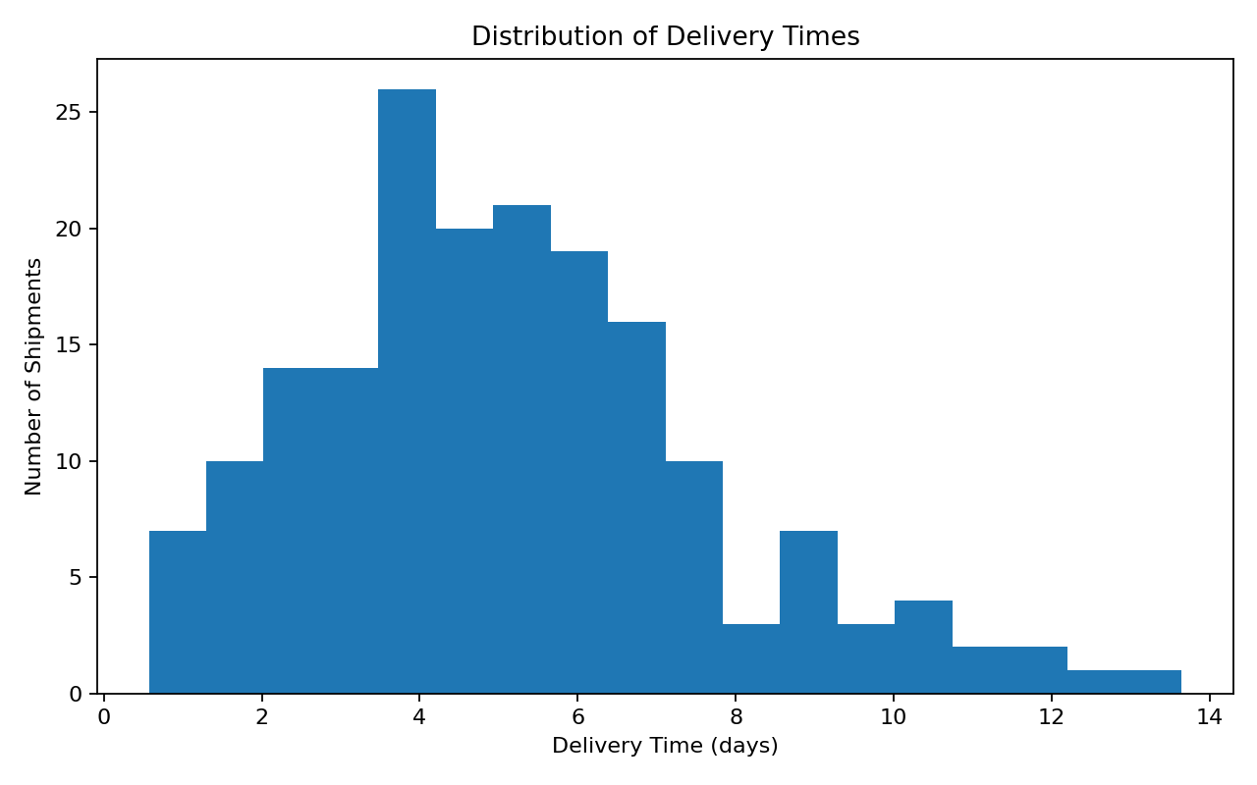

Average Delivery Time by Transport Mode
A bar chart is appropriate for comparing categories and makes differences in average delivery performance across transport modes easy to identify.
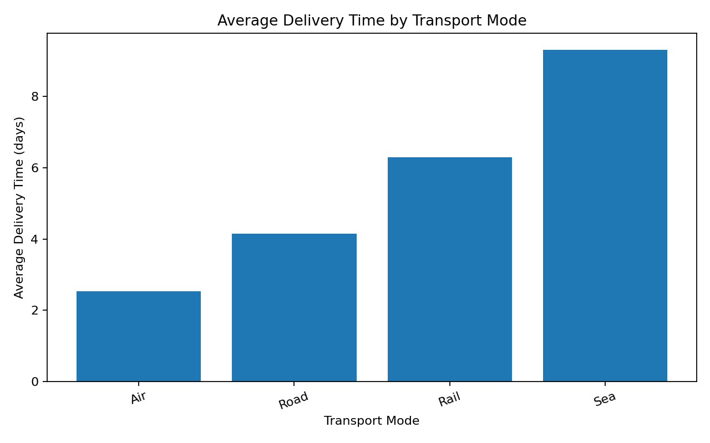

Shipment Volume vs Transport Cost
A scatter plot examines the relationship between two numerical variables. It helps show whether higher shipment volumes are associated with higher transportation spending.
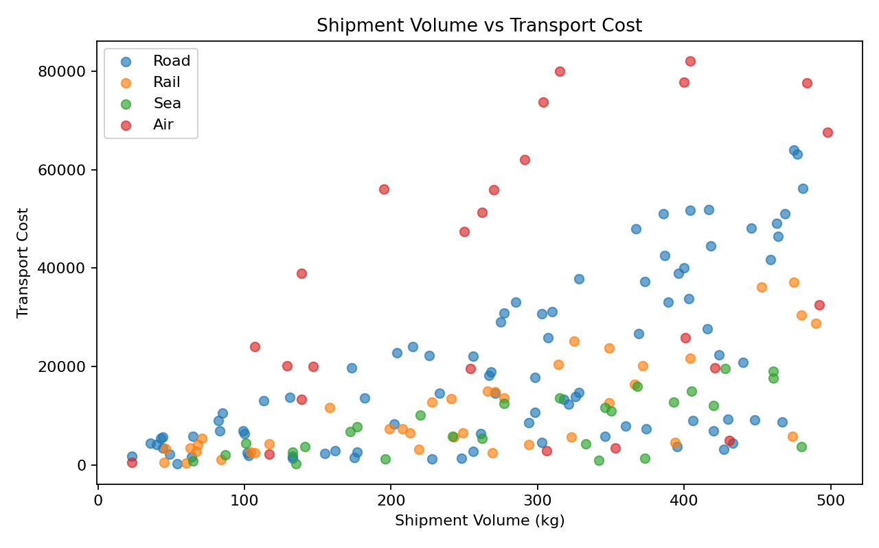

Distance vs Delivery Time
A scatter plot with a trend line examines whether longer routes tend to require more delivery time.
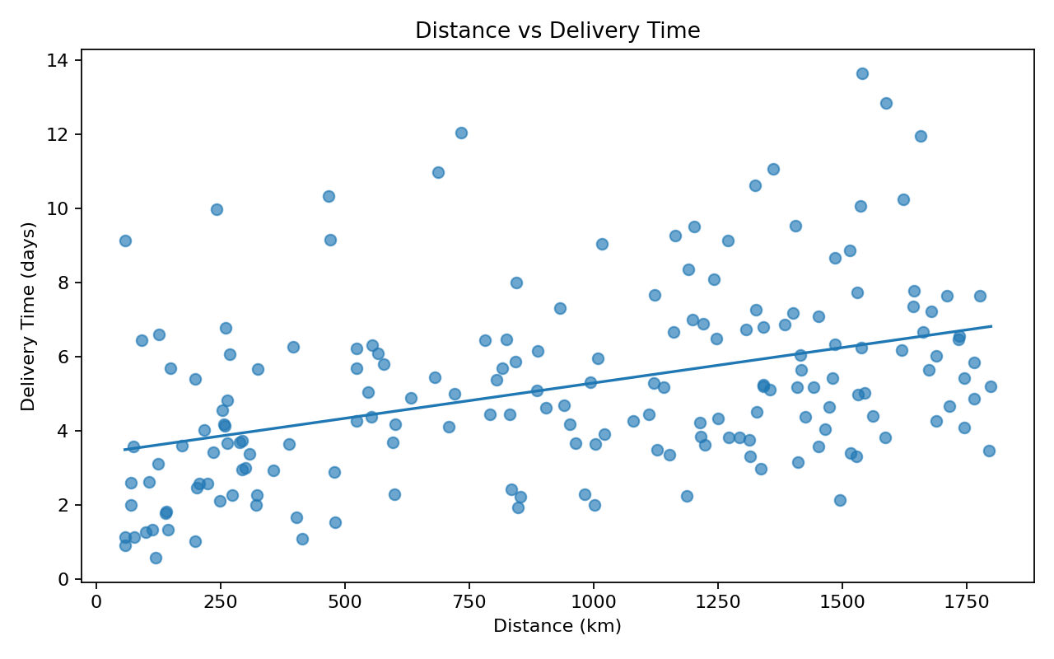

Average Transport Cost by Region
A regional bar chart compares the cost profile of operating areas and highlights regions that may need additional investigation.
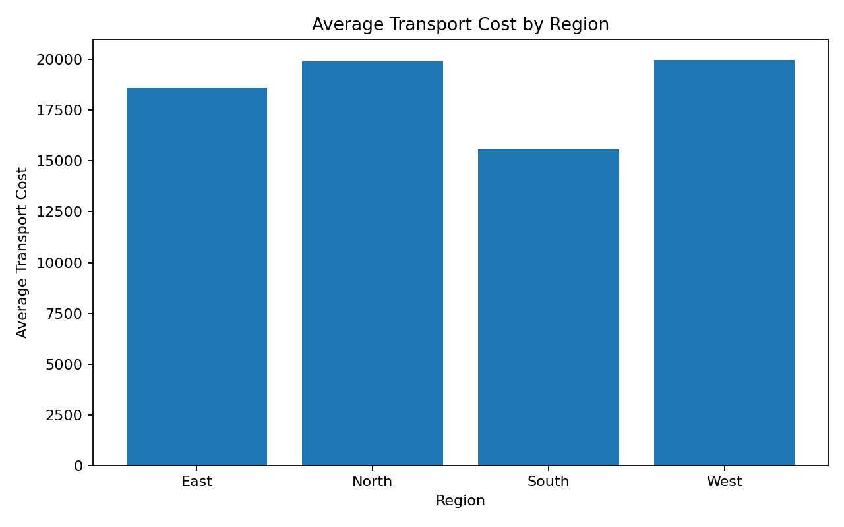

Correlation Matrix
The correlation matrix gives a compact overview of relationships among key numerical variables.
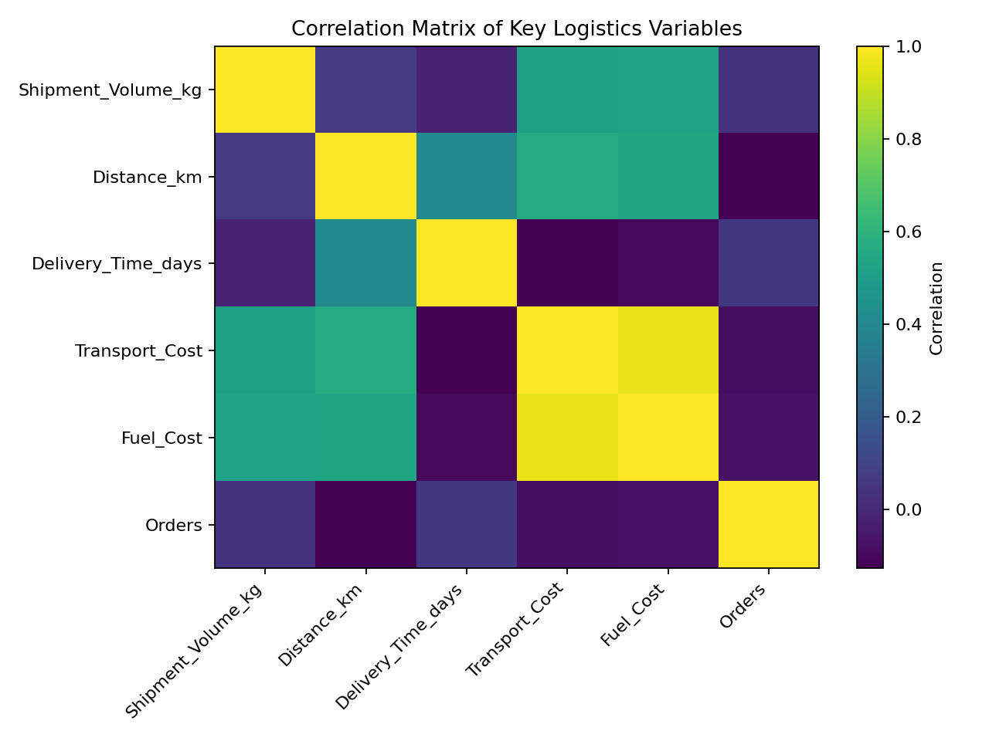

On-Time Delivery Rate by Transport Mode
On-time delivery is an important logistics KPI. Comparing rates by transport mode helps identify where service reliability is strongest or where improvements may be needed.
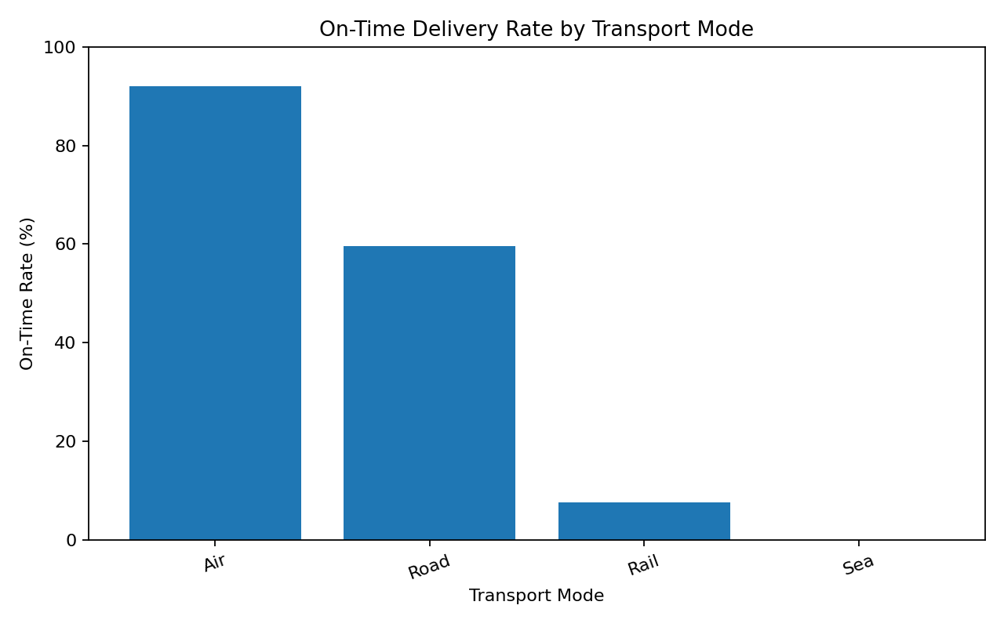

5. Analytical Insights
Based on the simulated results, Air has the highest on-time delivery rate among the transport modes, while Sea has the highest average delivery time. Air has the highest average transport cost. These differences demonstrate why logistics decisions should not be based on cost alone. A cheaper mode may have a longer delivery time, while a faster mode may require a higher transportation budget.
At the regional level, West has the highest average transport cost in the simulated data. This is a signal for further investigation rather than proof of inefficiency because cost can also depend on distance, shipment volume, route structure, and transport-mode mix.
The overall simulated on-time delivery rate is 43.89%. This KPI can be tracked over time and segmented by region, transport mode, customer, or route to identify recurring service problems.

6. Potential Bottlenecks
- Long-distance shipments may require additional scheduling and capacity planning.
- Transport modes with slower average delivery times may create service-level pressure.
- High-cost regions should be reviewed for route efficiency, distance, and transport-mode mix.
- Unexpectedly long delivery times should be investigated as possible operational exceptions.
- Fuel cost should be monitored because it contributes to total transportation spending.

7. Recommendations
- Use a balanced scorecard combining cost, delivery time, shipment volume, and on-time rate.
- Review transport-mode selection based on service requirements instead of choosing only the cheapest option.
- Analyze long-distance routes for better scheduling, consolidation, and capacity utilization.
- Investigate high-cost regions using route-level and shipment-level data.
- Create a logistics dashboard that tracks delivery time, cost, volume, delays, and on-time performance.
- Use historical data for forecasting demand and planning transportation capacity.

8. Python Code Used
The complete executable script is included in the project repository as src/week3_analysis.py. A simplified excerpt is shown below:
import pandas as pd
import matplotlib.pyplot as plt
df = pd.read_csv("data/logistics_week3_dataset.csv")
print(df.describe().T)
correlation = df[
["Shipment_Volume_kg", "Distance_km",
"Delivery_Time_days", "Transport_Cost",
"Fuel_Cost", "Orders"]
].corr()
print(correlation)
plt.hist(df["Delivery_Time_days"], bins=18)
plt.title("Distribution of Delivery Times")
plt.xlabel("Delivery Time (days)")
plt.ylabel("Number of Shipments")
plt.show()

9. Conclusion
This Week 3 task demonstrated how exploratory data analysis and visualization can turn logistics data into useful business information. Descriptive statistics provided an understanding of typical shipment behavior, while grouped comparisons highlighted differences between transport modes and regions. The visualizations made trends and relationships easier to communicate than raw tables alone.
The main learning from this task is that visualization should be connected to a specific logistics question. Histograms help understand distributions, bar charts support category comparisons, scatter plots reveal relationships between numerical variables, and correlation matrices provide a compact screening tool. Together, these methods provide a strong foundation for data-driven logistics decision-making.

10. GitHub Repository
This is a technical/software-related internship task. The project files, Python code, generated visualizations, README, and this report should be uploaded to the GitHub repository.
GitHub Repository URL: ______________________________________________

